19
WORTH A SECOND GLANCE
DEHAVILLAND (AUSTRALIA) DROVER TRIMOTORS.
Top At Australian Aviation Museum, Bankstown – Museum Issue : In service with Fiji Airways Nadi – Stinsons Suva card 1051. . Bottom. In service with the Royal Flying Doctor , Mount Isa, Queensland . Australian Colour Postcards ACP1099

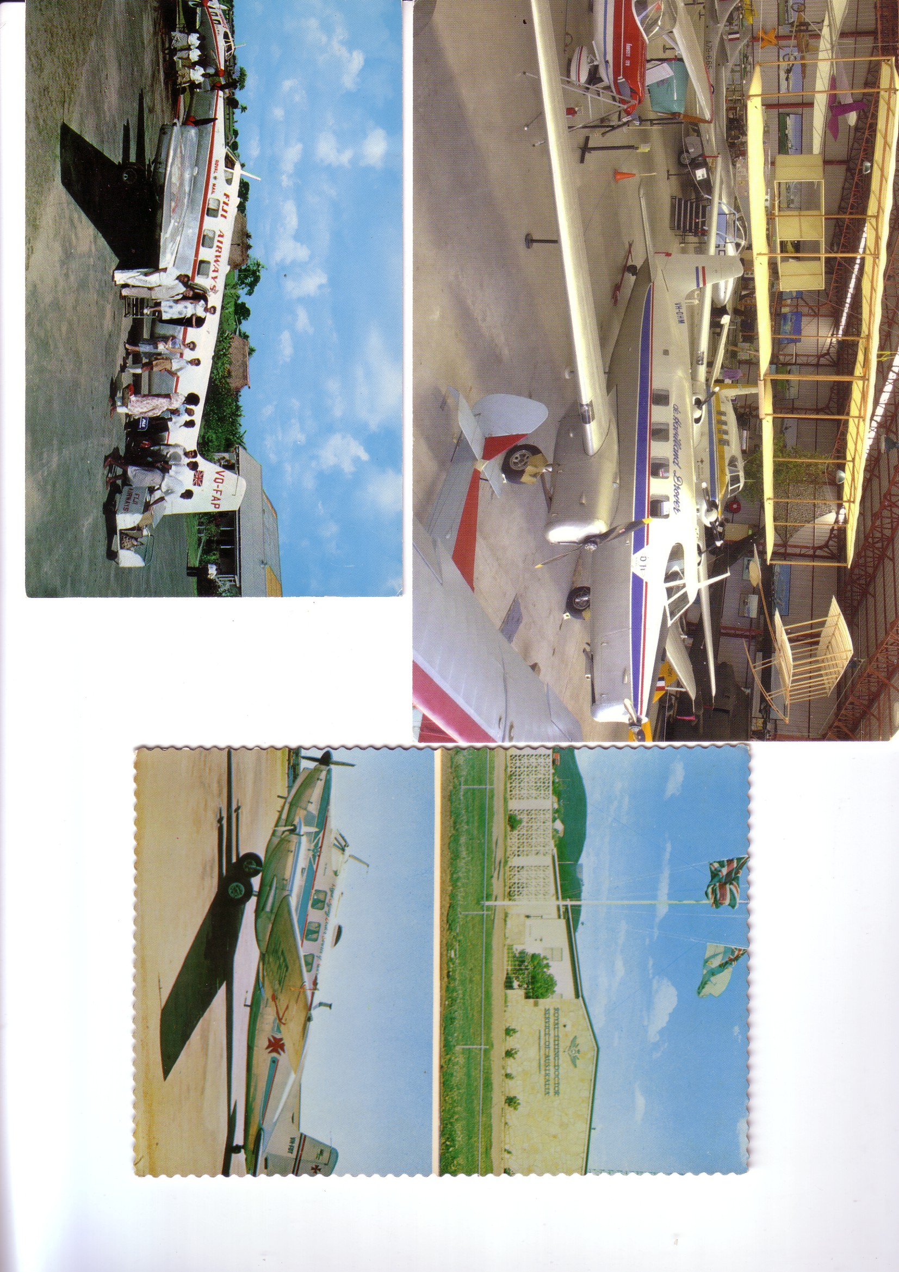

20
WORTH A SECOND GLANCE

OZ TRIMOTORS

The larger card on the previous page is of no less than two deHavilland (Australia) Drover trimotors at the Australian Aviation Museum at Bankstown, NSW. They represent 10 % of all the Drovers ever built and were themselves built at Bankstown. The trimotor was built as a replacement for the DH Dragon, itself produced in large numbers in Australia, where the later Rapide did not supplant it. Similarly the post-war Dove was considered too complex for the Australian market, so the local designed Drover included many Dove components but allied with 3 engines and a fixed tailwheel landing gear.

The Drover carried 6-8 passengers but those used by the Flying Doctor Service were fitted to handle stretcher cases. Two were based in NSW, Four in Queensland and two in the Northern Territory. Apart from these deliveries were also made to Qantas, Trans Australia and Fiji Airlines. Those supplied to the Flying Doctor Service were later re-engined with more powerful (180 v 145 hp) Lycoming engines, as shown on the Mt Isa card and also the background aircraft on the Bankstown card. This one VH-FBC was the last to be produced and the first to be re-fitted. VH-DHM at the front had previously been with Fiji as VQ-FAH. The Lycoming installation also involved the fitting of Variable pitch propellors. The original fixed pitch propellors had been ruled to have contributed to the loss of three Drovers.

At various times 3 Drovers appeared on the UK Civil register but only one physically arrived in the country. Ex Qantas VH-EAS was acquired by Blackpool based charter company Air navigation & Trading in 1961. It is not clear whether it was ever used but it ended up in the long-gone Southend Aviation Museum.

Up to the Drovers, the Flying Doctor Service had always used deHavilland types, starting with a DH.50 and then Fox Moths and Dragons. After the Drover , American types took over with various Beech, Piper and Cessna types.. Currently the service , now the Royal Flying Doctor Service, uses Beech Super King-Airs and King Airs, Cessna Conquests. It has recently also introduced the single-engined Swiss Pilatus PC.XII

