3
THE CARDS ARE OUT THERE
AVIATION SHOWS
Sept 26 Prague Airport Holiday Inn
Oct 3 Luton Vauxhall Recreation Club
Oct 17 Brussels Zaventem Village
Nov 7/8 Frankfurt Schwanheim Village
Nov 15 Kempton Park Racecourse

2010
Feb 27 Basel Euroairport
Apr 25 Gatwick/Crawley K2 Leisure
Aug 12/14 AI2010 Newark NJ USA http://www.ai2010nyc.com

The Manchester Concorde hangar show appeared to be successful from the organisers point of view and is an excellent venue, but postcard activity was minimal – further evidence of the issues raised in the editorial.

However the general postcard fairs can still come up with surprises at a cost of a lot of time grinding through waste paper, like Valentine WW2, Olympic Boeings etc. This Cambrian Viscount at Speke by Lilywhite – possibly the last commercial card produced of the old terminal, was not even in an Aviation section.
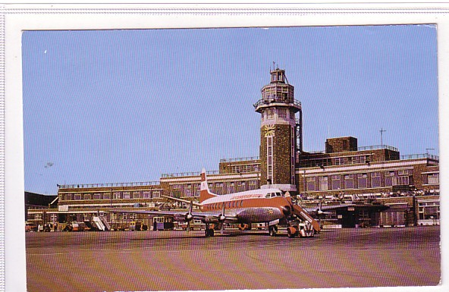

4
NEW ISSUES
Not a lot. Manx2 have reissued the Metro card with different text and Swiss have new ground view cards of A320 and BAe146, the A320 is a night view. Further cards of Barra beach airport have appeared , one in FlyBe colours. Also from Scotland, a Highland islander at Oban
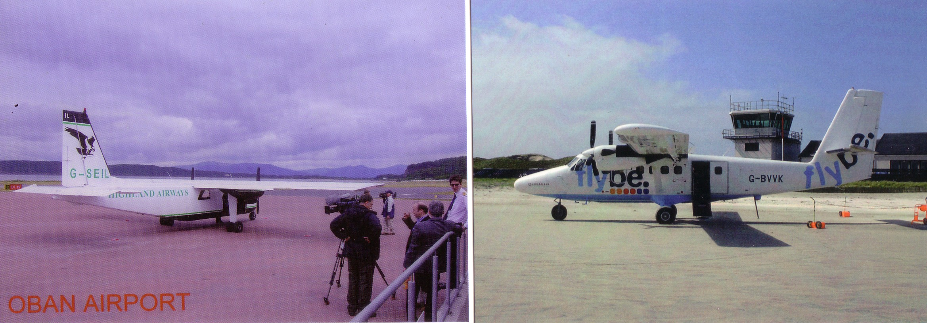

INTERNET REPORT
As usual trading was subdued over the summer. A recent oddity was that two high yields were for airline issue view cards. An LAI –Italy Vienna artist card with a small CV240 raised just uder £40, while an Iberia vertical poster-style view card got $100 (£65).

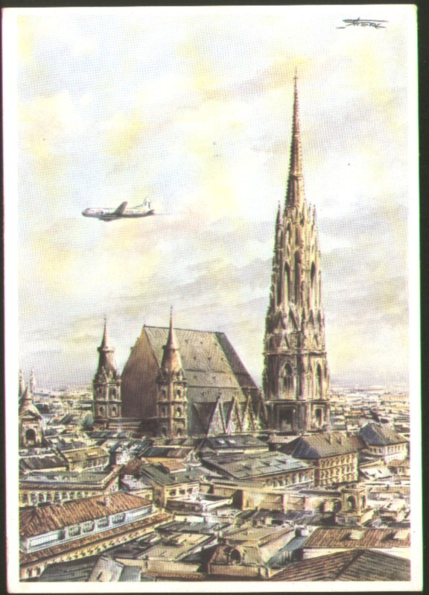

5
When pickings are sparse, there can sometimes be a tendency to be overcome by excitement when a picture of a rare item appears and not notice any other information given. Staying with Iberia, experience with this Bristol 170 at Palma prompted the following from a member who wishes to remain anonymous.
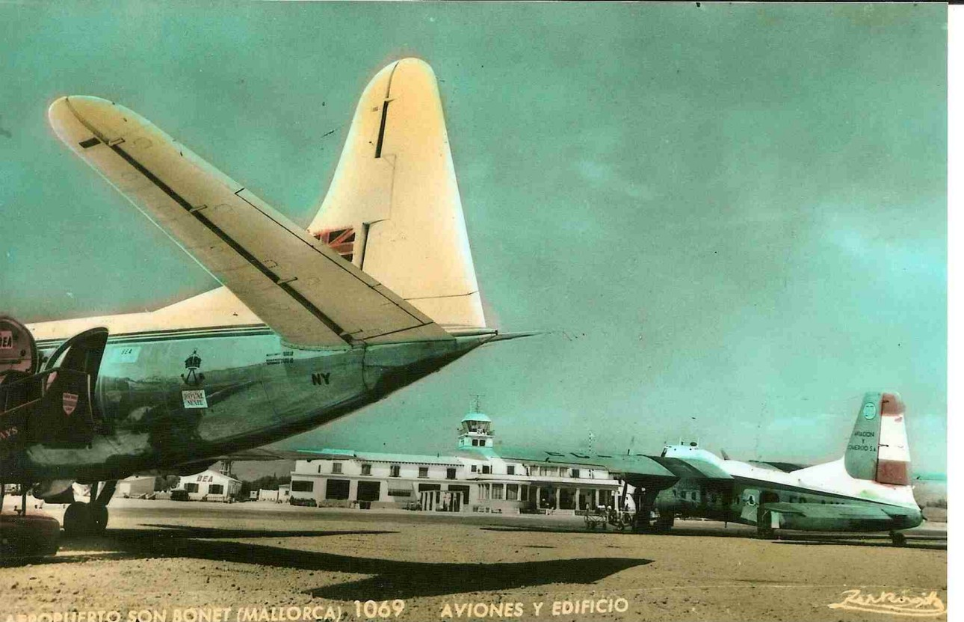

A CAUTIONARY TALE .... FROM AN ANONYMOUS MEMBER WHO SAYS HE'S BEEN AROUND LONG ENOUGH TO HAVE KNOWN BETTER!

A few months back, two quality airport cards appeared on Ebay within a few weeks of each other, one of SAA aircraft on the ramp at Capetown, the other a Palma airport shot of a Bristol B170, which happened to be the very aircraft in which our intending buyer had flown to Mallorca many years ago. Both cards attracted fairly high bids. A while afterwards, they both appeared again and this time our man was fairly determined to get them and did indeed succeed with his bids.

But when they arrived, imagine the reaction when they turned out to be photos of the afore-mentioned cards, presumably taken by the seller (a dealer who we won't identify but who operates from a location about as far South in the U.K. as you can get without falling off the edge). About to send the cards back with a strong note of complaint, our buyer first referred to the description, only to discover that the small print did indeed contain words to the effect that they were photographs. Add to that the stated refund policy, drafted in such a way that any refund was effectively out of the question, and basically that was the end of that.

The moral of this sad story in case we need to spell it out? ALWAYS READ THE SMALL PRINT and BEWARE OF IMITATIONS.

