7
WHAT DO YOU KNOW
The mystery airport in the last edition has been identified, outside of the club membership. It is/was Gravesend , Kent. The Percival Vega Gull in the foreground is outside the first factory of Percival Aircraft where it would have been built. The earlier Gulls were built under contract by Parnall at Yate, near Bristol. The success of the Vega resulted in Percival relocating to larger premises at Luton. For comparison here is a retrospective card issued by Kent County Libraries of a slightly earlier air view.
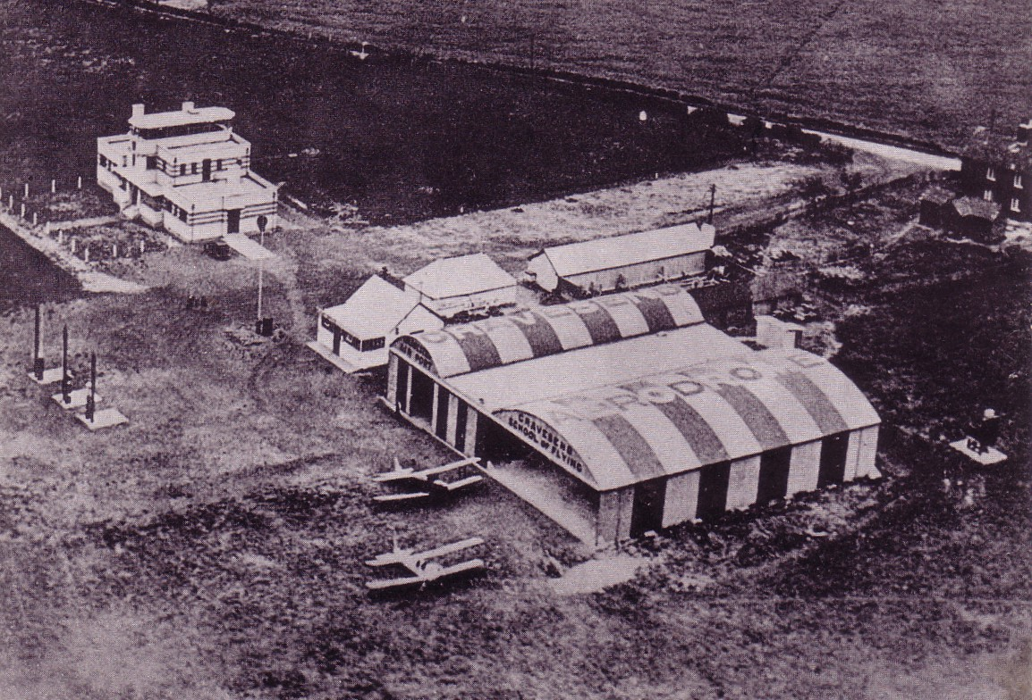
Graham Cowell found this card of the Mooring mast at Heliopolis Cairo, another like the Karachi one featured last time which was never used for the intended India airship service.
