PETER’S PUBLICATIONS

Member Peter Marson has recently had the much enhanced 3rd edition of his Lockheed Constellation History published by Air Britain. Any club members who are not members of Air Britain can purchase at a preferential rate by quoting Propliner magazine offer (£29.95 v £44.95) at www.air-britain.co.uk or to the Air Britain sales Dept 41 Penshurst Rd Leigh, Tonbridge TN11 8HL. The latest version is in two volumes with full histories of individual aircraft and civil and military service histories worldwide. These are supported by over 600 photos and 70 colour scheme drawings.

From the point of view of this newsletter it gives an excuse to show a few harder to find Constellation cards. The first is shown at Acapulco, Mexico on an airline issue by Aeronaves de Mexico.

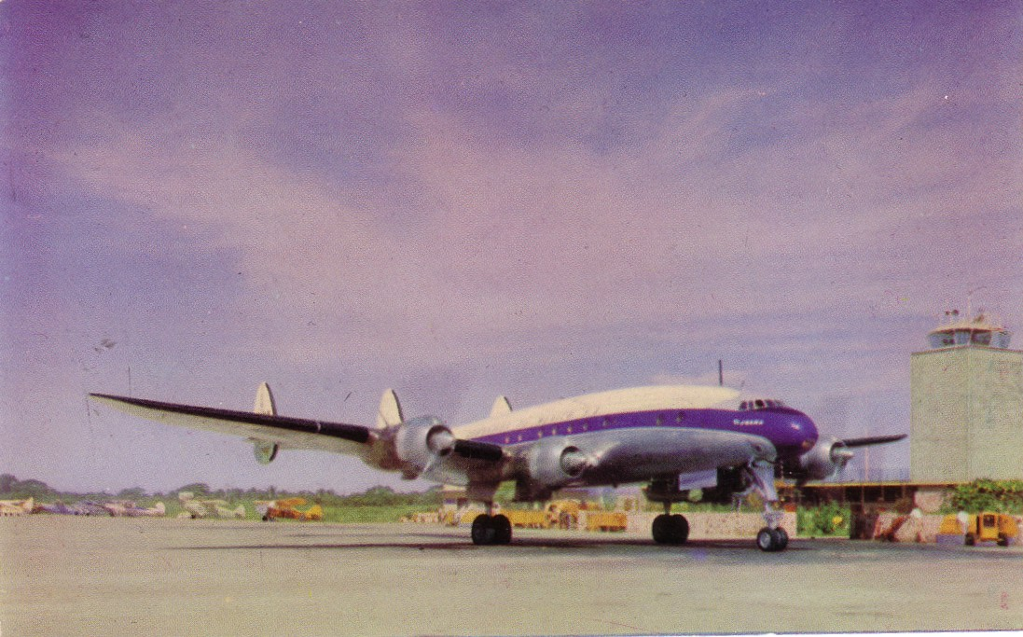

The back specifically mentions it as being an L749A which makes it one of three ex Air India which operated to Acapulco 1958 to 1960. The card was mailed from Hamburg Railway Station to Belgium in 1962.! “The book” quotes one of the 749As as being named Acapulco but the name on this one seems shorter.

The second shows that there is something different to be found even among the mass of KLM or KLM Aerofoto/Aerocarto real photo cards of the fleet and Schiphol airport. This is Aerofoto 602162 of L749 PH-TFE and is a member of the select group of livestock on airports, as distinct from “ as air cargo” cards – for more see later.

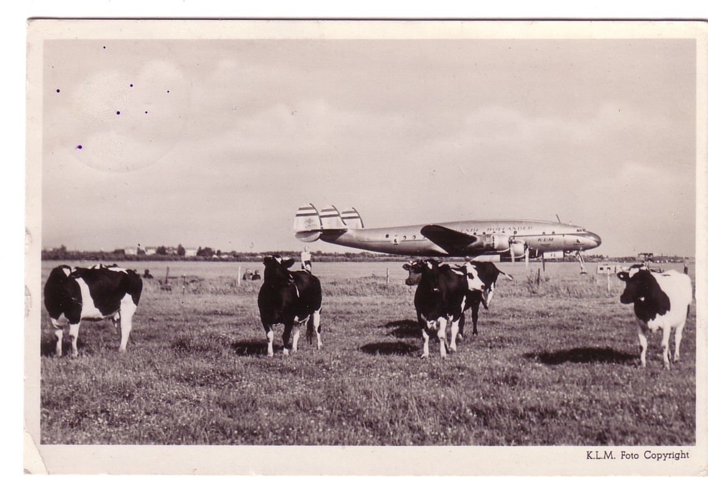
Actually most KLM Connie cards are 049’s. PH-TFE was another L749A delivered June 1950 and named Utrecht. It remained in service until 1960 and was sold to Uruguay in 1963 and was out of service by 1967.

Peter has also published a book on the Lockheed twins from L10 Electra through the Lodestar to the military Ventura and Harpoon. This was of help with the following from the same Ebay vendor as the Curtiss boats who had titled it , from the back pencil text, Westchester Airplane + Catatumbo from the front text “Campo de Aterrisage Catatumbo N de S Col Foto”.

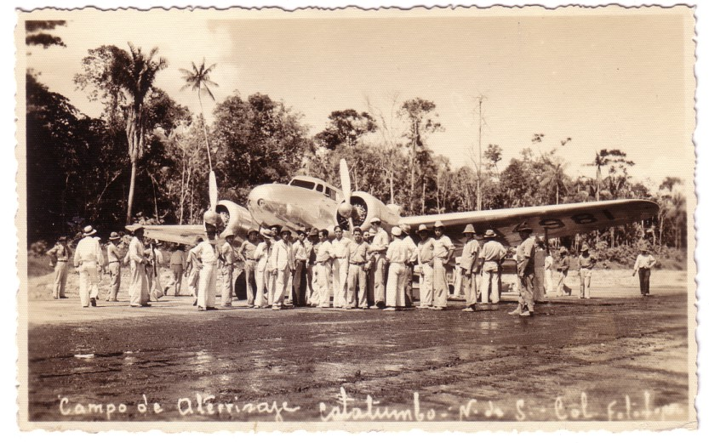

The numbers 4981 are visible underwing behind the mass of presumed local workers while a few Indiana Jones look-alikes are also present. What all these add up to is is Lockheed 10 Electra NC14981 delivered by Westchester Airplane Sales in 1935 to Gulf Oil and then Colombian Petroleum –the card is dated Dec 21 1938 on the back . It later went to Cubana , Pan American and private US owners.

AIR SHEEP

More cards that might have been filed in dealers stock under Animals other than the KLM Schiphol card shown earlier.

First two that invite some puns on Airship/Air Sheep – and as the Airport is Berlin-Tempelhof it also works in German Luftschiff – Luftshaf. The bottom one is more sheep than airport while the top is more balanced, which is a good thing as the airliner is a Transair DC-3 G-AMZG, operating without titles. This could either be on a military lease or shortly after the merger into British United. The sheep clearly survived into the jet era, as Tempelhofs unique covered ramp on the second card houses Pan Am 727s as well as Viscounts, plus a Super Constellation, DC-7C, Viking and Breguet Provence.

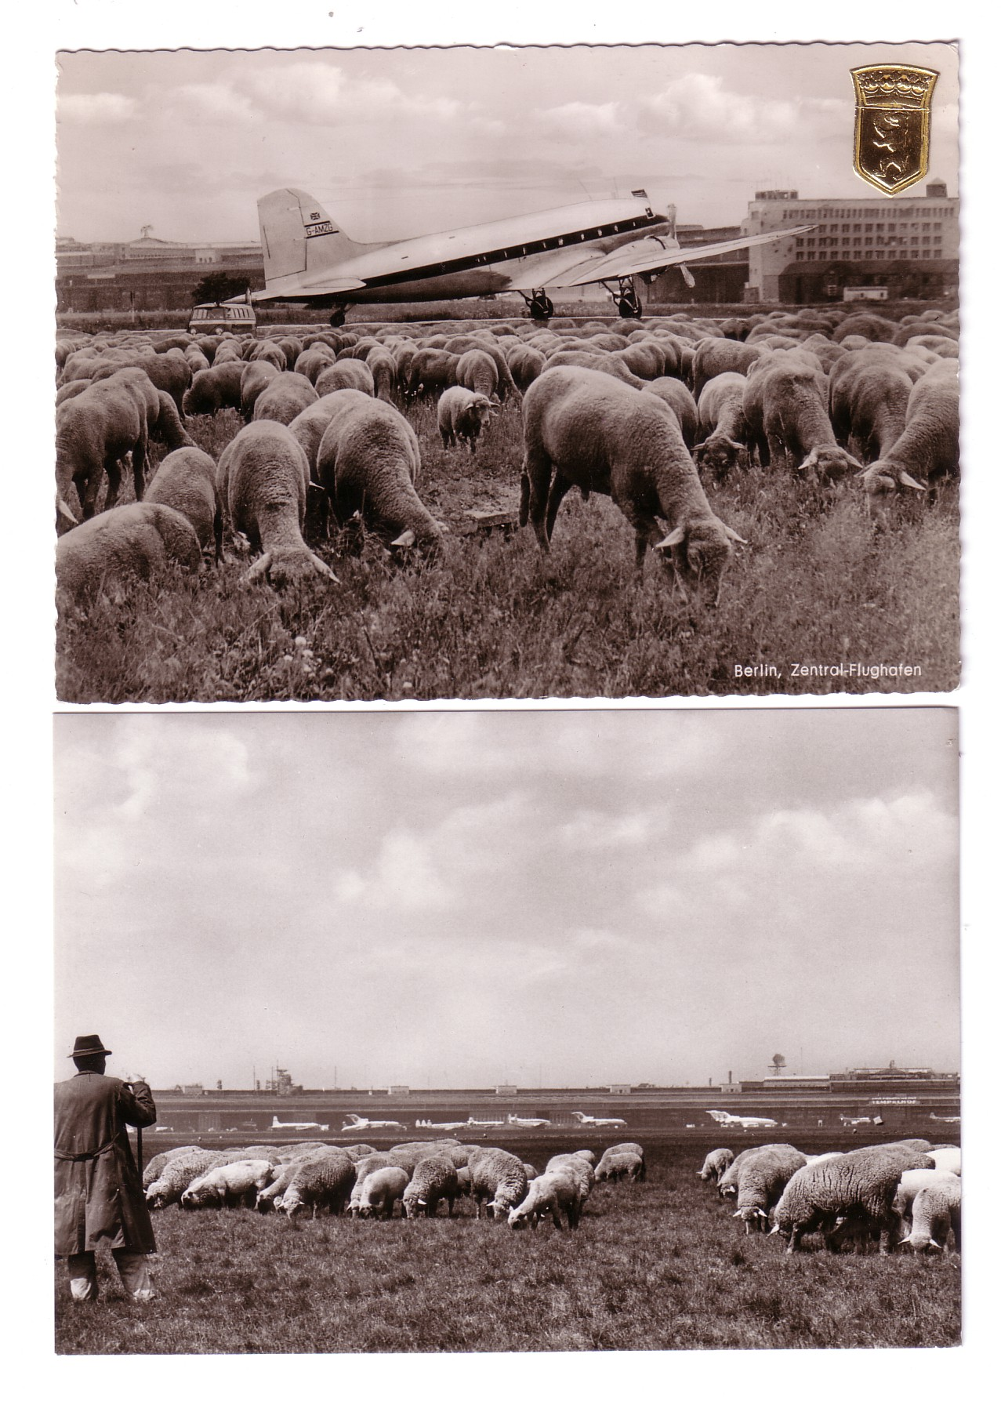
With Tempelhof due to close in 2008 it seems the sheep may have the last laugh ( or bleat) as the site may become a new park for Berlin.. Meanwhile it is the subject of probably the most impractical postcard ever produced – by Druckerei-Arnold. Unlike the Dusseldorf card featured last time, this panoramic card is not designed to fold despite being 17.5 inches (44 cms) long. It is shown in two parts below

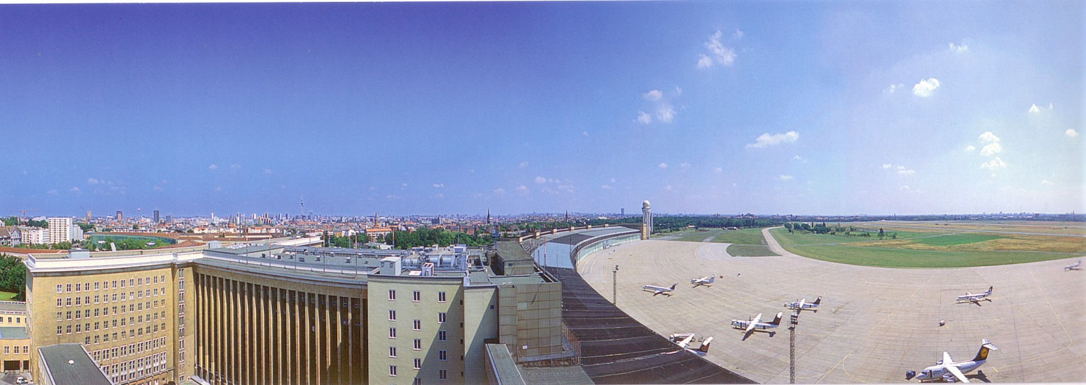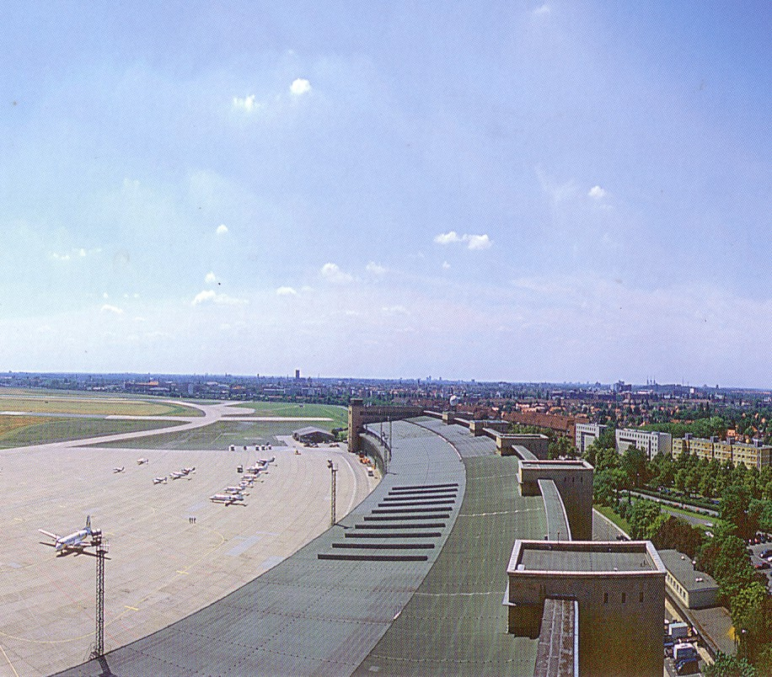

Featured now are DHC-8s, a B.Ae146, ATR,SAAB2000 & SF340 + a selection of corporate jets. There is no way this one is ever going to get through the post with “minimal corner wear” only, but it does have a genuine PC back with the address to message space ratio 7 : 1.

IMPERIAL AWAYS – THE EMPIRE

As set out in the first part of this piece on Imperial Airways away from Croydon, the Empire routes were always the priority for Imperial. As we have just seen this left Europe open to competition, especially from KLM, who were also the main competition to the Middle and Far east and India. Due to the un-developed nature of the airfields used, there are actually very few cards of Imperial airliners at identifiable Empire locations, although the Tucks series include some fine desert shots like this DH Hercules on Tuck 6. G-AARY is one of later models with enclosed cockpit.

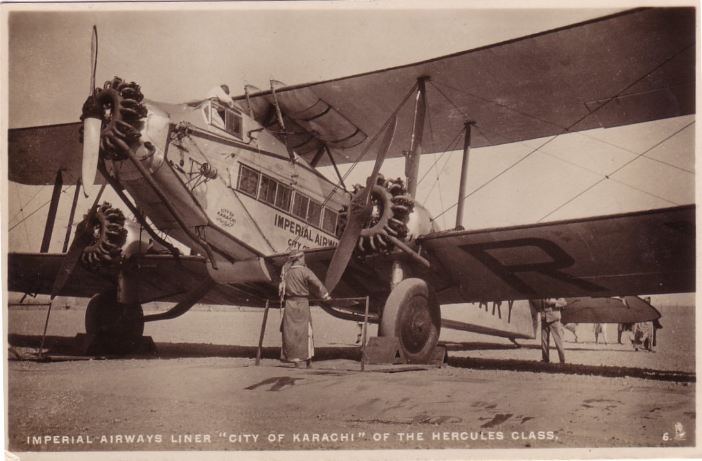

One of, if not the rarest of the Tuck set is this no.37 an HP42 “somewhere in Africa”. Possibly Imperial travellers found the “naked natives” somewhat embarrassing. This is an edited photocopy.

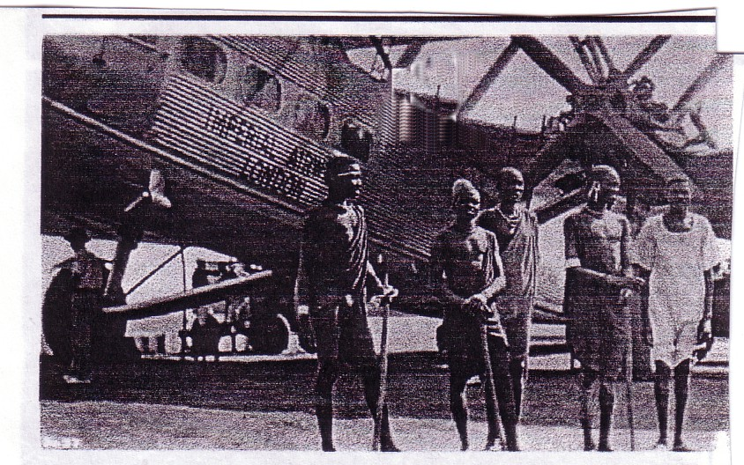

Another unusual card from the Tuck set is 29 a diorama model of Rand Airport Johannesburg reminiscent of those displaying scenes of Empire at the old Imperial Institute, Kensington.

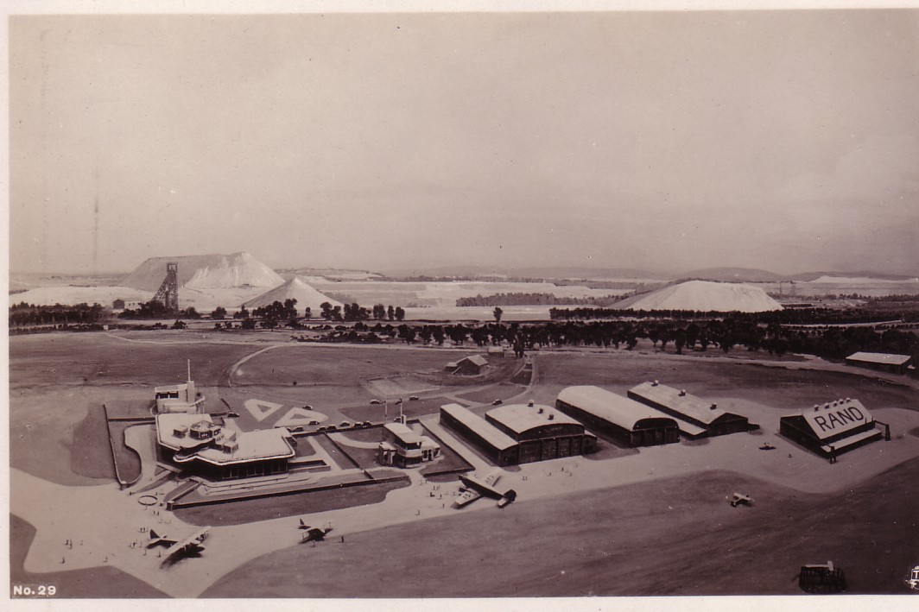

The Imperial card survey has located cards from the following locations, but images have not yet been assembled. This list excludes some cards believed to be postcard-backed private photos.
Australia Empire boat G-ADUW at Gladstone jetty. There are a few more of those operated by Qantas at Sydney-Rose bay and Townsville, Queensland.
Bermuda. Empire boat with a PanAm S42 on a Pan Am issue
Small Empire boat “Arriving in Bermuda by Air” on a linen style card
India Hercules at Drigh Rd Karachi
Hercules G-EBMX at Ambala – as below which may be a private photo but more than one copy has been seen. The back writing says “These two (?) came from England and about all of us went up in them . I had a three hours ride in this one free.”

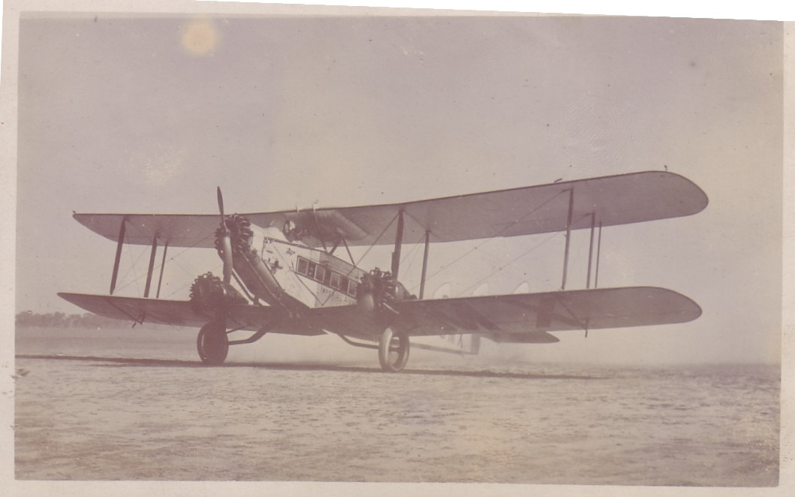

Iraq HP42 G-AAUC
Empire boat G-AEUG on the Shatt Al Arab, Basra

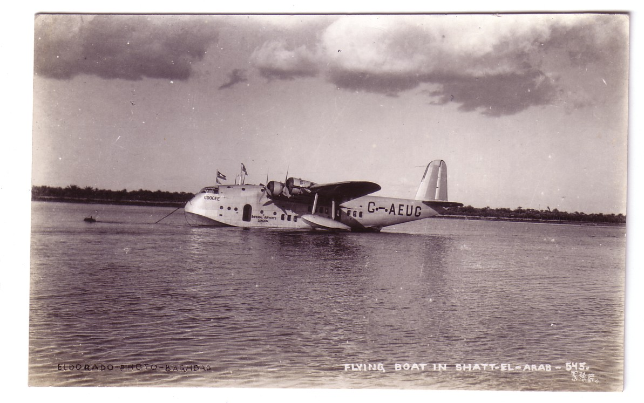

Kenya Empire G-AETW at ? Mombasa
Palestine Three All at Galilee – Empires G-ADVD, DVE and Scipio G-ABFB
South Africa . A set with an Atalanta edited over various views + Atalanta G-ABTG Amalthea at Rand Airport from the 1936 Johannesburg Empire exhibition set

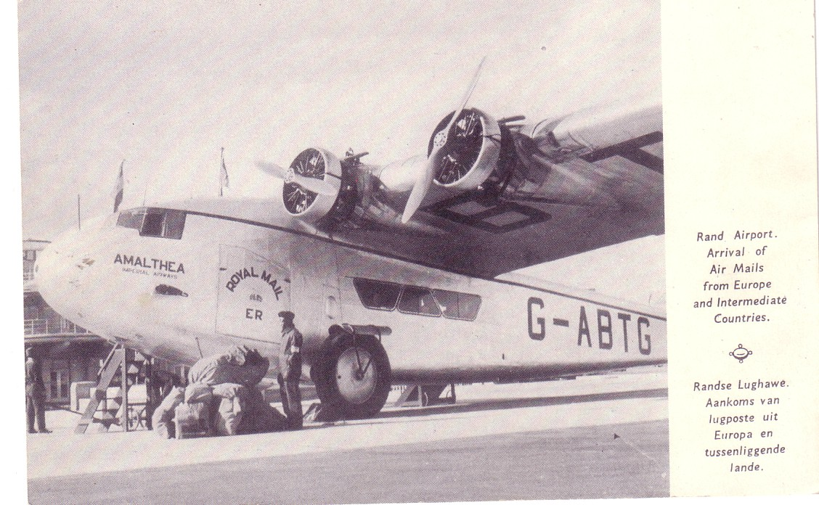
KLM – UK in the 1930s

No, its not the one that was renamed from Air Uk before vanishing into KLM Cityhopper, but some evidence of how British travellers used KLM to plug the gaps in UK carriers European services in the 1930s. To do this we will be looking at the oft neglected messages on the back of the cards. It is strange that many collectors are insistant that the card must have a PC-back ( no plain back rubbish) but then prefer it not to actually have been used as such and ignore any contextual information in the writings. Having said that, the average KLM card written by a Dutch passenger would provide little help. Whereas , some Dutch, like the English, try to cram as much information in as possible , a more typical Dutch sender seems to prefer just a signature, sometimes adds “Greetings = Groenten” and possibly adds the location from whence the greetings are coming.

Anyway here are a selection of cards and messages from British or English speaking passengers . The KLM flights may be from Croydon, or the northern Liverpool-Doncaster- Schiphol service or onward connections from Schiphol.

Fokker FXXII PH-AJR “Roerdomp”. Mailed from Berlin to a schoolboy in St Leonards, Surrey Sept 1936 “ This is the plane on which I came back. It was a lovely trip and we will do it together one day…Dad”

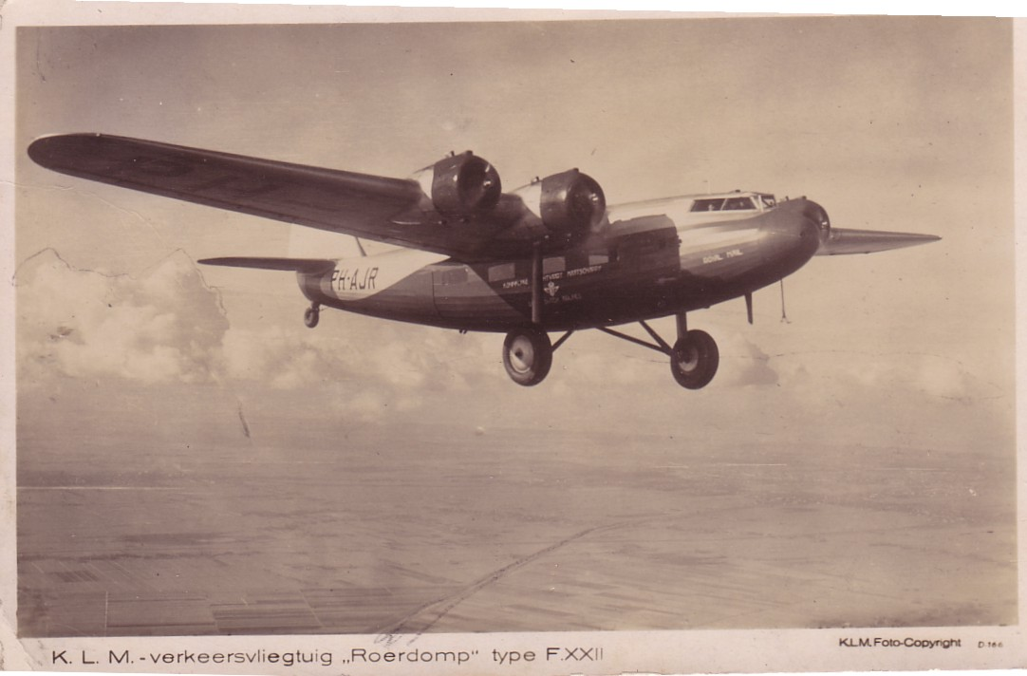

To offset any doubt as to whether the FXXII was on a Uk service here is another, PH-AJP “Parrot” . Unlike the above, this is English-captioned, Unmailed, but back pencil text “I saw this machine in hangar at Croydon.. 3rd May 1936” Both of these Fokkers were sold in the UK in 1939 , and taken over by the RAF. Operated as navigational trainers by Scottish Aviation , one crashed , but AJP (=G-AFZP) operated a few Prestwick-Belfast services up to 1947.

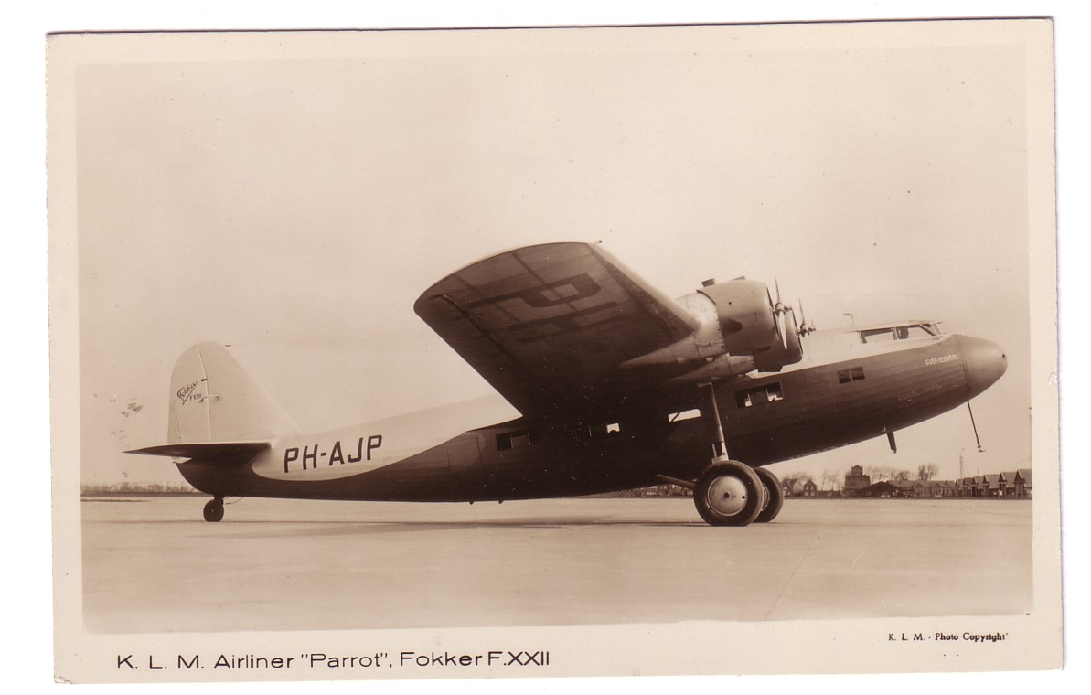

KLM gained competitive edge with the DC-2. PH-ALF “Flamingo” was delivered in April 1936 but crashed near Brussels in 1937.

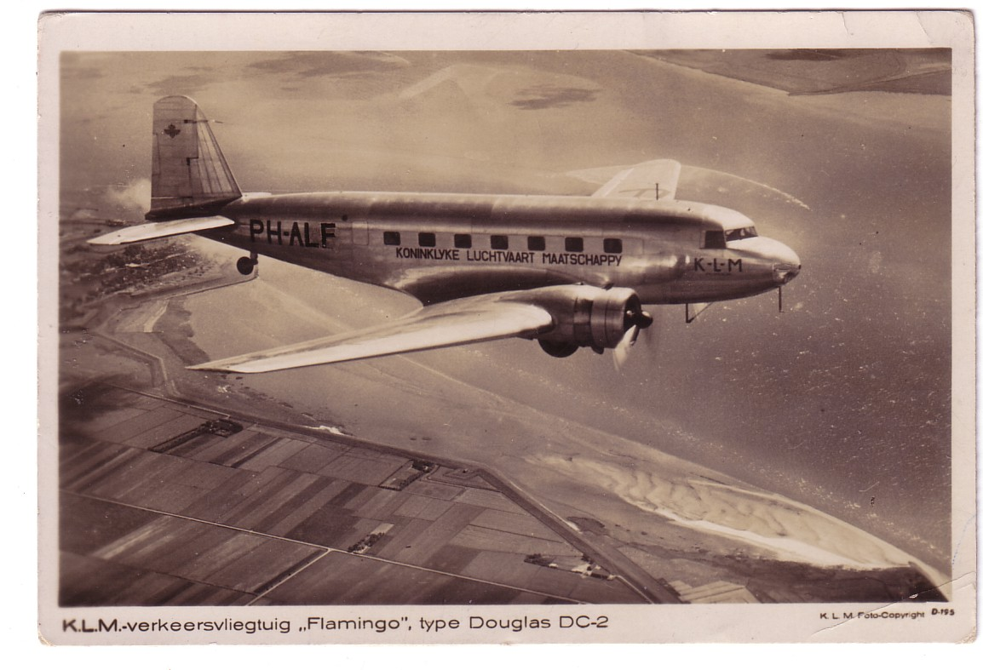

In Dec 1936 “Violet” wrote to a stereotypical Colonel and his lady in Christchurch Hants “ I am writing this while flying the channel. It is very foggy . We are flying blind in places. This is a picture of the machine we are in. They are so comfortable it is like sitting in a big ball so different to flying in civil planes (????). Leslie says he doesn’t think there will be any pictures in the English papers so I would not bother with it. Cheerio we arrive in Amsterdam in a few minutes”
But the card was mailed from Croydon on Dec 3rd, presumably on her return, with an Edward VIII stamp. Could that bit about the papers be connected with the run up to his abdication , which was finalised 7 days later on Dec 10th.

In April 1937 “John” wrote to “Mum” in Hale, Cheshire from Copenhagen. He may have changed from the KLM northern service . “Just left Amsterdam , a most enjoyable jouney so far. The plane is very comfy”….then some stuff about his bad back. This DC-2 is not identified and is either un-named or the name has been deleted.

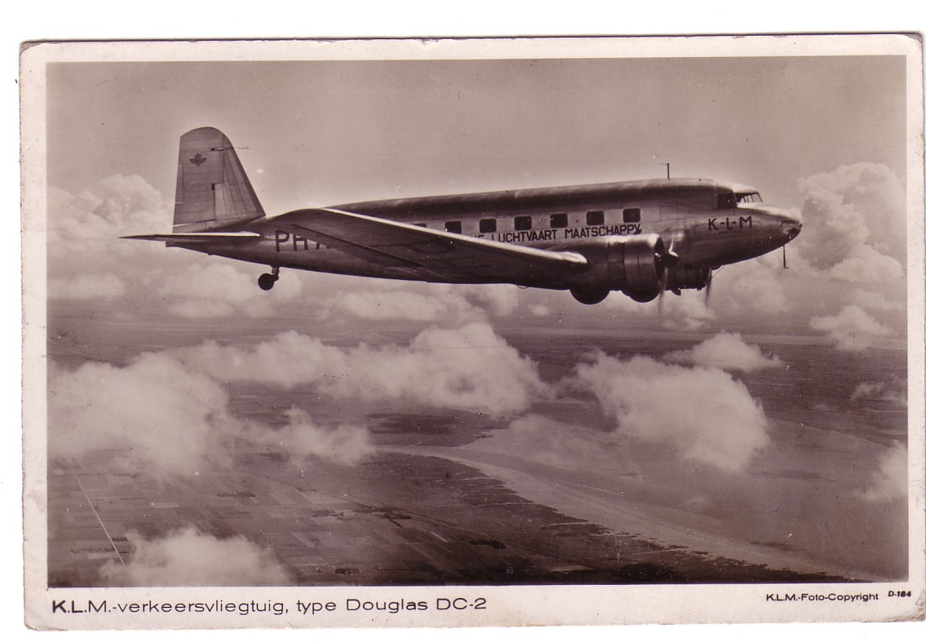

A virtually identical card but with the DC-2 a little further over the estuary and a bit more cloud was mailed to Maidstone from Denmark in July 1938

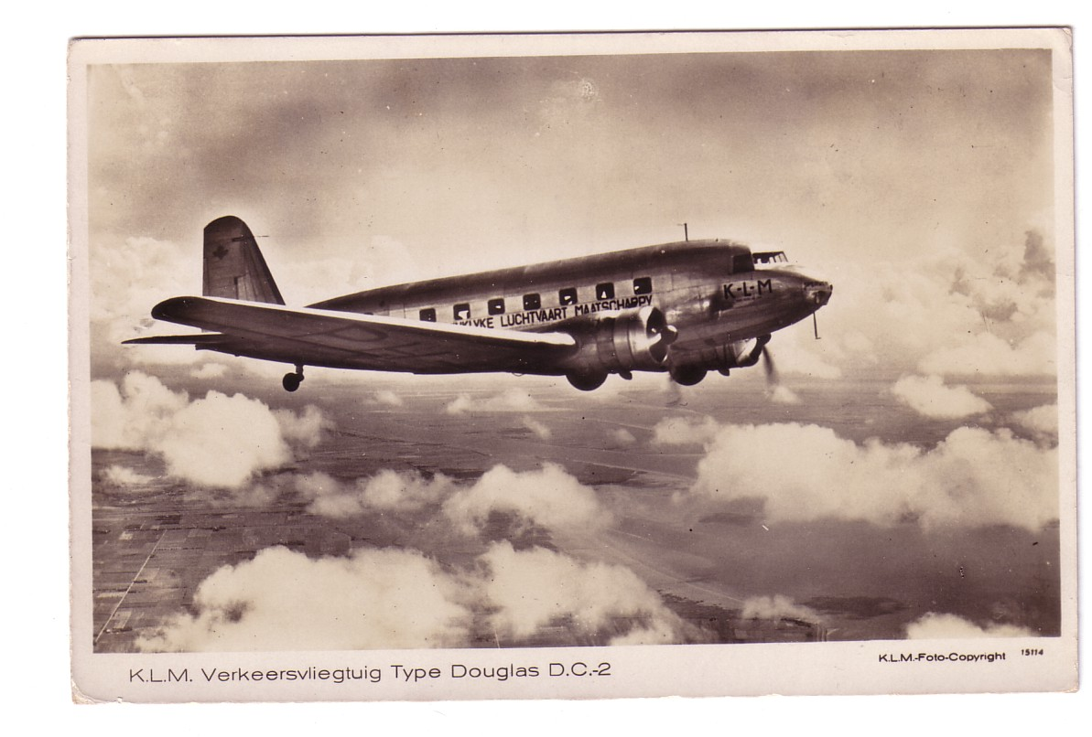

Written “Not far from Copenhagen Altitude 3500 metres This has been a very interesting jouney tho not very thrilling. The plane travels far more smoothly than a train or car. I cd see a bit of the ground in England but there has been a lot of cloud since and we travel above it – rather like exploring the Antarctic….. . A backstamp “KLM restaurant-Vliegtuig” suggests he got fed too.

One more DC-2. PH-AKQ Kwak , written but not mailed or dated.

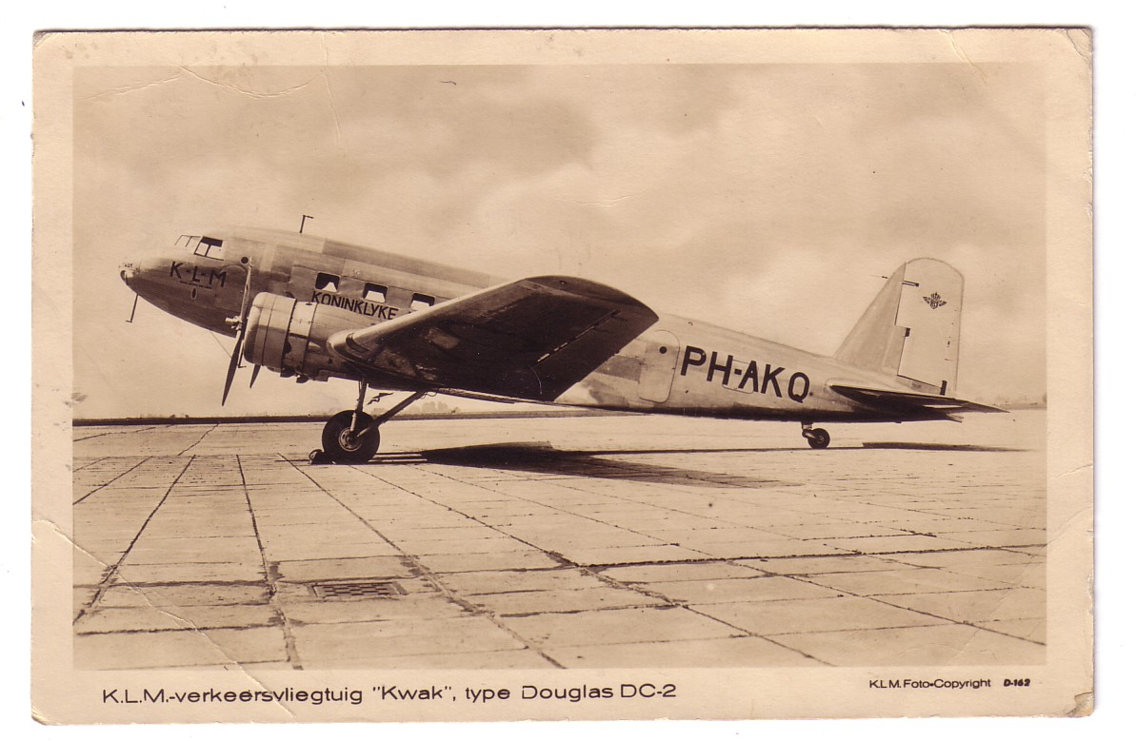

From Budapest to another schoolboy, this time in Worthing. “Just arrived Buda pest on this plane via Prague and Vienna. 750 miles. Good ship and comfortable trip…Daddy”. The card was probably unmailed because the writer did not know the Hungarian for England as it eventually appears in another hand but by then maybe too late to mail. AKQ was at Schiphol in 1940 and was taken over by Lufthansa , then by the Luftwaffe, and finally by the RAF in 1945

Finally, enter the DC-3, and the card which rivals the “abdication” one for content.

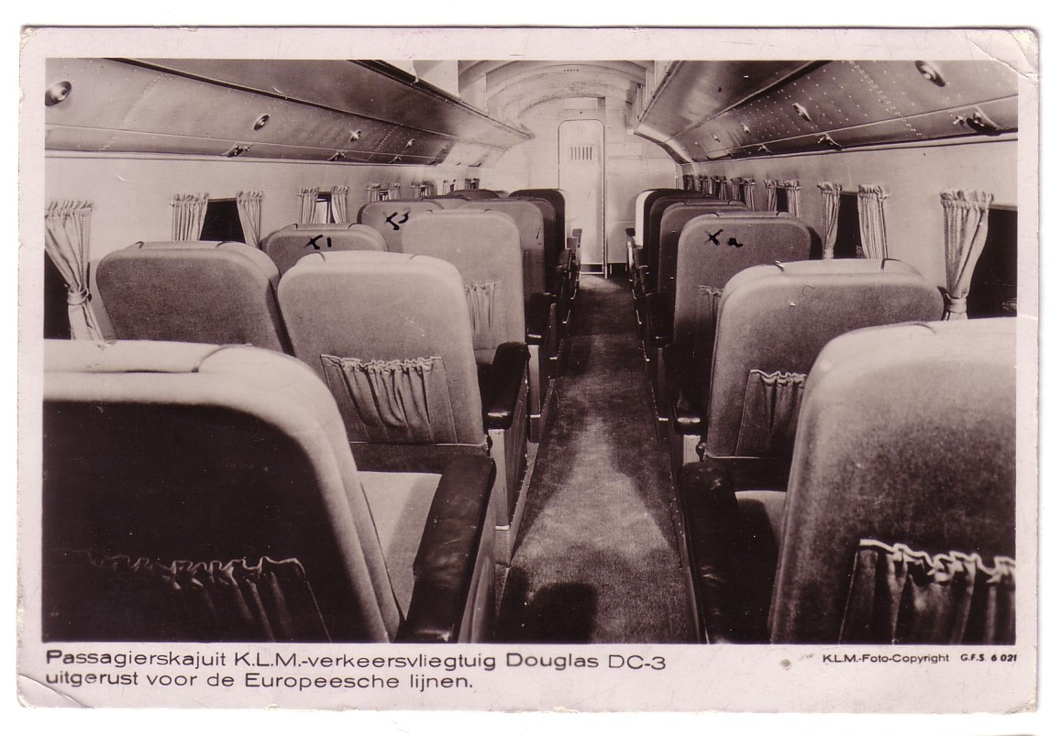

This is an interior of a DC-3 in European configuration – more seats and less leg room than the East Indies version. The card is a victim of the “I sat here” syndrome but this time three seats are marked with a cross. The key is on the back, 1 Daddy 2 Me 3 Mayor . The card is mailed from Berlin August 1937 with three swastika air mail stamps. The addressee is a Mrs Emrys Evans of Wallasey on the Wirral and is written by “Michael” presumed to be her son. It reads “6000ft up Arrived Amsterdam 1.15. had lunch and stayed Carlton Hotel . Saw Jamboree from the air .Flying to Berlin now. Returning Amster tonight. Coming home tomorrow. Time (German) 10.15”. So, it seems we have the Mayor of Wallasey off on a municipal jolly to Amsterdam and Berlin at the ratepayers expense flying on the KLM service Liverpool-Amsterdam, with a night there, then on to Berlin for a day trip then another night in Amsterdam. The wonders of Google research reveals that Emrys Evans was the town clerk who somehow wangled his son on the trip as well. Local press files may or may not disclose more . One possibility is that Berlin City was celebrating its 700th anniversary in 1937 with typical Hitler –era celebrations. Is it possible that invitations to were sent to many European cities to send representatives including a child , with the latter representatives being featured alongside Hitler Youth. ?

Finally , near to the end of the pre-war era, a card mailed 24 July 1939 from Amsterdam by LWH who was staying in the Hotel Rynders “Arrived safely at 11 a.m . The long wait at St Pancras was very tedious but the flight was allright. Weather showery still.” Given that the addressee was in Nottingham perhaps he would have been better going via Doncaster.

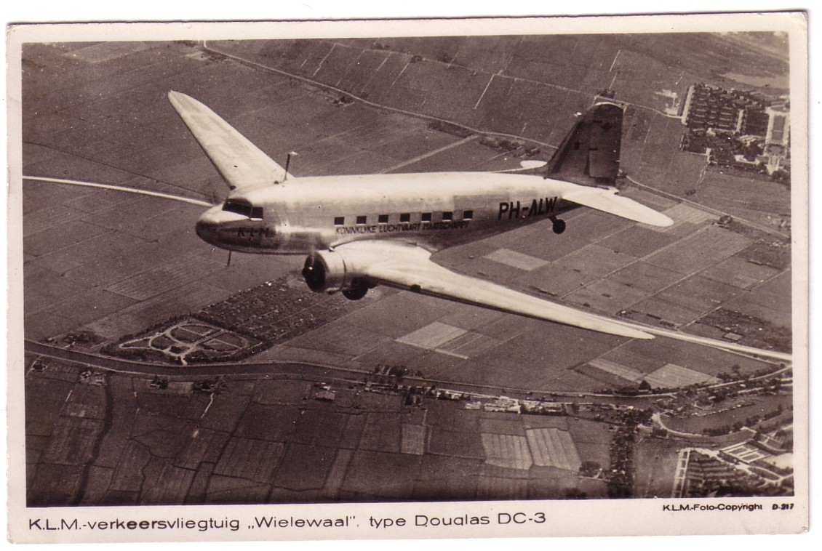

The DC-3 is PH-ALW “Wielewaal”. Unlikely to have been the DC-3 used, as it seems to have been a far East model . Caught there by the fall of Holland in 1940 it became PK-ALW, subsequently escaping again to Australia where it served with the USAAF, RAAF, ANA, Butler, Ansett and other carriers and from 2001 was in the Queensland Air Museum.

