FAREWELL TO COLIN COHEN - ON THE BACK PAGE
This is a reprint of Colin’s article from January 1993 – thanks for all your contributions since.

“It has been a busy time as far as postcard collecting is concerned. The highlight was the annual show of the World Airline Hobby Club meeting near Heathrow in November ( This was the Famous Fred Hems swop-meet which was the forerunner of all the aviation shows in the UK) . I met up with many fellow collectors and managed to trade or purchase some 200 new cards for my own collection. It was also very nice to hear from so many readers that they liked my articles. Recently I received a complete list of cards produced by Editions PI in France . I think they have been issuing cards since the late 50s. Many earlier issues are not easily available now and can fetch a heavy price. I am told that, in France , any card numbered before 200 could cost up to £10!. My own collection starts from 113.

With regard to airline issues, there have been a number of new additions that have been issued, such as Eva Air (Taiwan). They have issued another nice set of three drawing cards of their latest colour scheme. Malaysia Airlines have also issued nice sets of Boeing 747-400 cards. Cyprus Airways have cards of A310 and A320 but not yet one of their BAC 1-11 which I noted is now painted in their new livery when I visited Larnaca Airport recently. I have been informed that the TAME – Ecuador Boeing 727 for which I have been hunting has in fact been issued twice by the airline. The two cards are similar and only differ in that one has the background mountain more prominent and the aircraft is slightly closer and in darker colouring. In the last article I mentioned that Air Malta have issued a set of four new cards. In fact there are six in the series. These are Boeing 720B (old colour scheme) , 3 different Boeing 737 and 2 different Airbus A320”

This snapshot of the 1993 collecting scene pre-dated Colin’s usual Happy Collecting signoff but we wish him precisely that even though the days of getting 200 cards at a UK show are long gone. Cyprus did in fact add the 111 to their set and it became quite a common card.

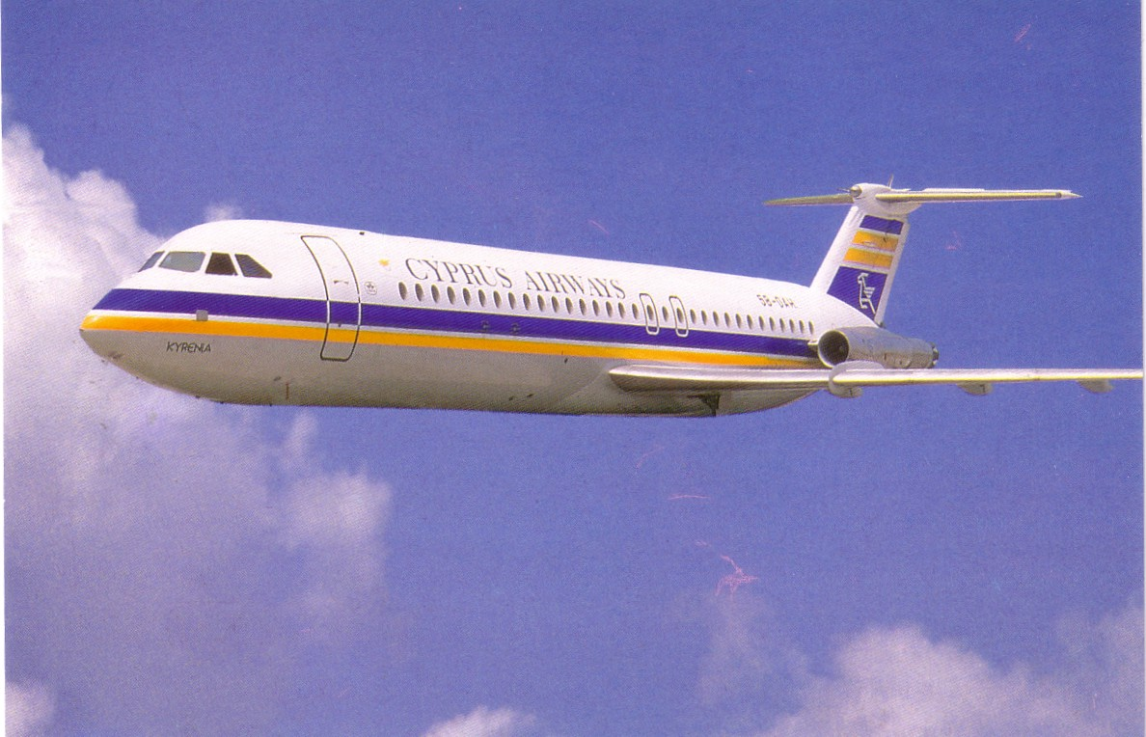

Of the other cards mentioned, the Malta set with the 720 history card became quite common , while, if anything, the TAME – Ecuador 727 and the early Editions PI got rarer. The PI’s are No.13 Air France Viscount – unusually with AEROPORT DE TOULOUSE-BLAGNAC on the back rather than the more usual AEROPORT DE PARIS on the rare Hermes V No 20.

