WORTH A SECOND GLANCE

NOT QUITE WHAT THEY SEEM

Two cards that invite the question – Why ?. First, German carrier Hamburg International is unusual in two respects, firstly that they still issue a lot of cards, and secondly that most of these have been in the “old” standard size. Not only that but the cards are numbered. From around no 29 they seem to have switched to Continental size. Most of the cards show their fleet of Boeing 737-700 s and latterly Airbus’. But this one shows a 707. Now Hamburg International did not even exist in the 707 era but the card has a 707 edited into the current colours with a bogus registration D-AHIZ.

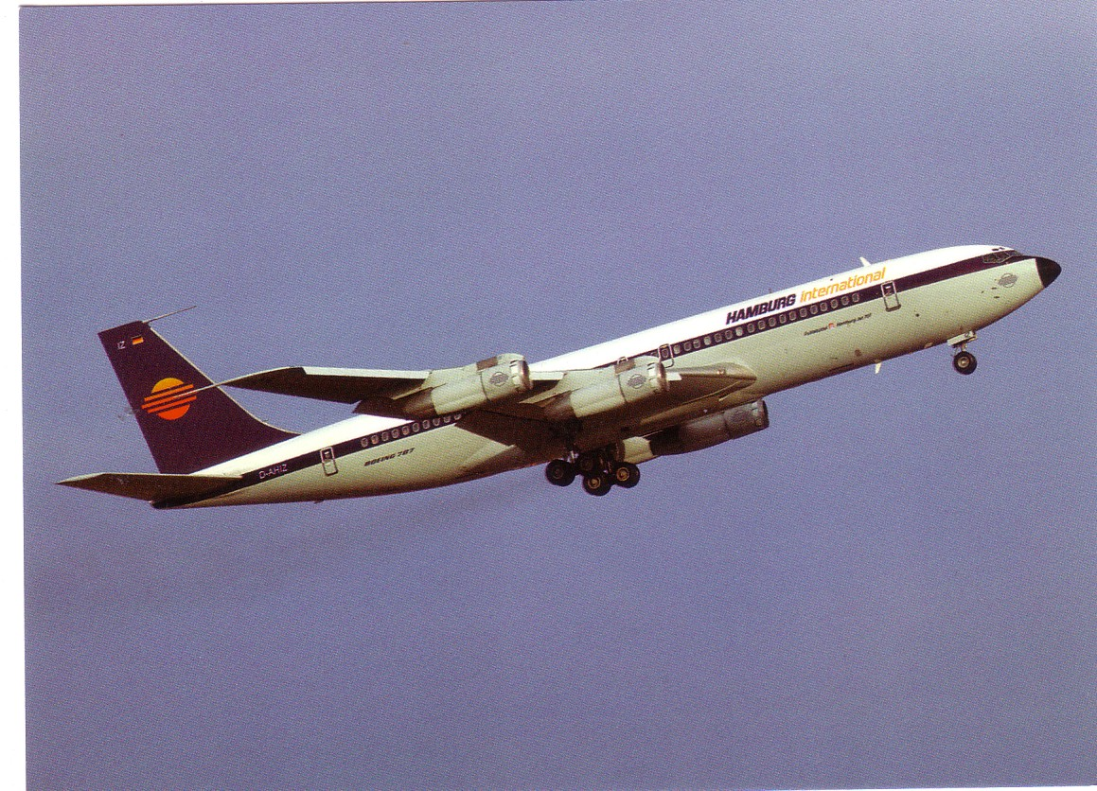

On the back it just has , in German, Boeing 707-320 , first flight July 1959 . I have not seen the full set – maybe there are also retro-edited Hamburg International DC-3s and even JU/52 s ?

The second card is a Belgian issue advertising freecard. Not for an airline – what company would issue a card of a scrap-line, but for a theatrical performance . Apparently the performance, entitled Sabenation was a dramatisation of the collapse of SABENA.

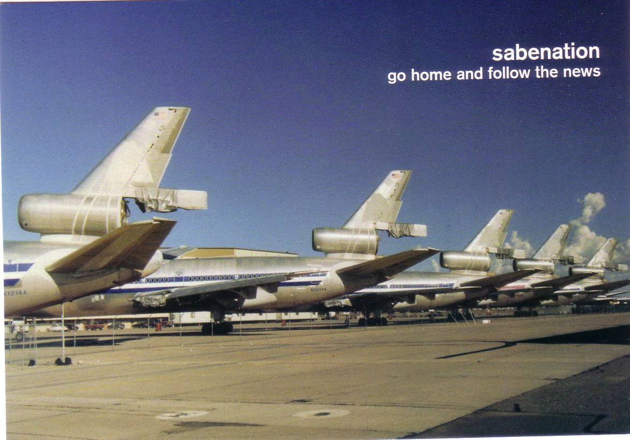

The sub-title “go home and follow the news” relates to the managements’ last message to the workforce. The back of the card, which is in English, states that the show was put on in 2004 in Brussels, Rotterdam, Hamburg, Berlin & Braunschweig. A bit of internet research reveals that it was in the style of the British WW1 musical “Oh what a lovely war” with its theme of incompetent British generals transferred to SABENA management. The fact that it existed at all says a lot about the position SABENA held in Belgian national lore. A pity therefore that the publisher could not find any stock photos of the SABENA fleet idle after the collapse but instead used a shot of some American DC-10s in one of the desert stores. These are probably some of the DC-10 fleet that spent some time at various storage sites awaiting conversion to freighters by FedEx. It thus joins the French Ailes B card of stored BA Tristars in the select group of civil desert store postcards.

Meanwhile SABENA- nostalgia in Belgium has resulted in the production of many retrospective cards under the imprint SABENA old- timer.. There was also a short-lived mini boom on SABENA cards on the internet, rather like the post retirement Concorde frenzy.

