19
WORTH A SECOND GLANCE
LINDBERGH IN LIBYA

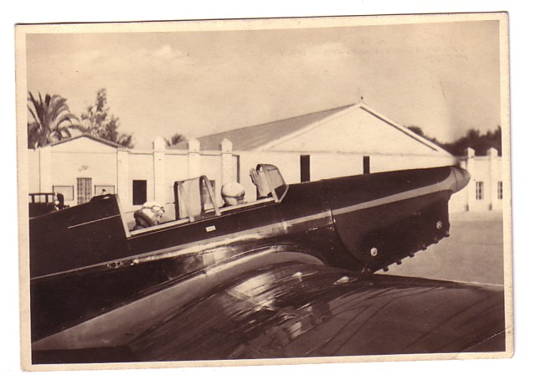

Unlike cards usually featured in this section, the subject requires no identification research other than a look at the back of the card and , maybe, a bit of Italian or Latin. The back title, translated is “ Series 1 LIBYAN EVENTS. 5. Lindburgh saluting on departing Tripoli for Egypt. The publisher is “Ente Turistico Alberchiero, Libia” in a small logo.

So we have Charles & Ann Lindbergh at Tripoli Airport en route to Egypt. So when , where and in what ? Like most things Lindbergh this is well documented. While the Lindberghs were in Europe in 1936, Miles Aircraft were commissioned to produce a special version of their Hawk monoplane for use during the visit. The resultant design, the Miles Mohawk was an enclosed cabin two-seater with a US 200 h.p Menasco engine. It was first flowen by F G Miles in August 1936 under Miles marks U-8.
The Mohawk was finished in a striking black and orange colour schme for high visibility. In Nov 1936 Lindbergh flew it to Ireland to inspect possible airfield sites including that to become Shannon. During this trip he gave President de Valera his first flight. On his return Lindbergh was forced to land at Sealand, near Chester due to fog. As he asked the RAF not to disclose this, there was a brief panic due to his being overdue.
In January the Lindberghs took official delivery of the Mohawk, now G-AEKW and departed on a trip to India, with the first leg to

20

Pisa and Rome. The whole India return trip occupied the months of Feb/April 1937 .

After a further trip to Ireland in August 1937 the Mohawk was out of service to try and cure problems with engine overheating which meant that it could not meet its range specifications due to a maximum flight time of ½ hour before overheating. A change of propellor appeared to fix the problem but the replacement was itself too heavy. Despite the problems an extensive European tour was undertaken between August 1938 and Jan 1939.
Lindbergh flew the aircraft from Lympne to Hanover, en route to Russia, via Warsaw, Moscow, Kharkov, Rostov, Kiev, Odessa, returning via Cracow on 1st September, then Prague, Stuttgart, Paris, Rotterdam, and back to Berlin, where he stayed between 23 October 1938 and 18 Jan 1939, then Paris again and finally back to Lympne on 22nd January 1939.

The Lindberghs left Europe in April 1939 and donated the Mohawk to the British Government. After a period of inactivity it was taken on by the RAF in 1941 . It was used as a station communication aircraft at various sites and also had time back with Miles to try and cure the engine/propeller problems. Post war it was restored to Southern Aircraft, Gatwick as G-AEKW. Various private owners followed, ending when a Mr Bruno Pini crashed it in Spain on return from a rally in Oran, Algeria in Aug 1949.

In 1973 the wreck was located in a Spanish scrapyard , retrieved and shipped to the US for restoration by the then curator of the Smithsonian collection, Louis Casey. Although much work was done, it was not completed and in 2000 Mr Csey donated it to the RAF Museum Hendon. In Aug 2008 restoration was finally complete and the Mohawk was delivered to Hendon, as shown

