3
THE CARDS ARE OUT THERE
AVIATION SHOWS
Apr 25 Vienna Airport T2
May 10 Kempton Park racecourse
Jun 6 Paris Holiday Inn Roissy-CDG
Jul 4 Frankfurt Schwanheim Village
Jul 23-25 AI2009 Wyndham Orlando, FL
Sept 6 Berlin Schonefeld Airport
Nov 7/8 Frankfurt Schwanheim Village

NEW ISSUES
The few new airline issues around are either from Germany or have a German connection. A selection are shown overpage.:- Two 737-800s and a crew card are from Tuifly. Tuifly have just announced a merger with Air Berlin, which will further reduce the number of issuing airlines. New F100 & SAAB2000 from Carpatair Romania. An F100 is also on another German card from OLT. ( see the US section). Two cards may be the last ever official issues for the type, Air Transat Airbus A.310 and Rossiya IL-62. Rossiya also have a 767 take off. Niki have an A321 with the usual inset of the eponymous owner + signature. Air Namibia have the cover card ( large & normal) + another large with just the A340 . Air Dolomiti have a new ATR-72 and ERJ-190.

Brno airport continues to produce sets and the latest includes another old timer, a RAF VC-10. Berlin-Tegel Airport features on this Brussels Airlines A319 card below – they previously used the now closed Tempelhof.

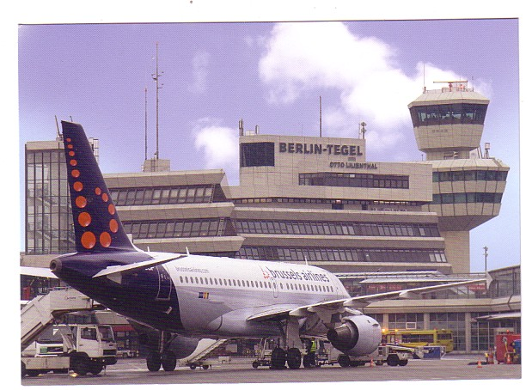

4
New issues from Tuifly & Carpatair. One 737-800 advertises Haribo sweets.The Tuifly uniform seems to feature a retro Zeppelin-era cap.

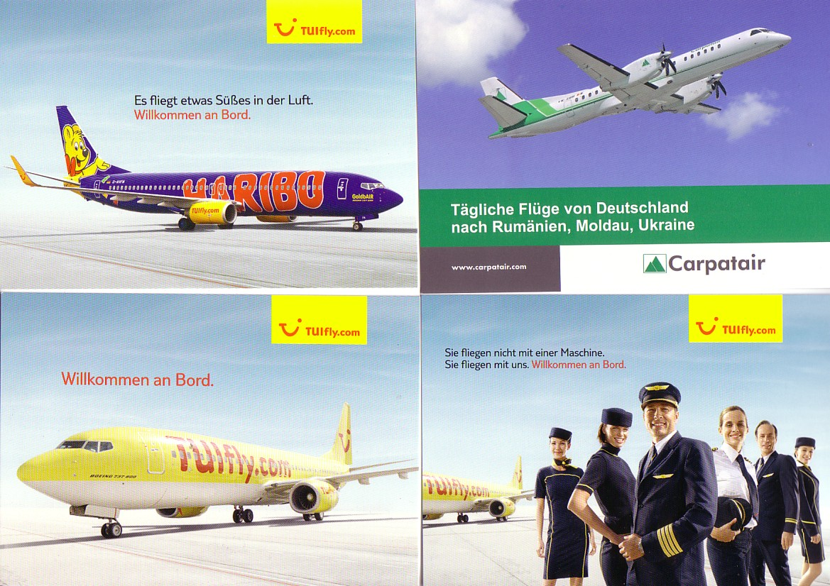

Possible last card appearances for Air Transat A310, Rossiya IL-62, RAF VC-10 + the latest from Niki.
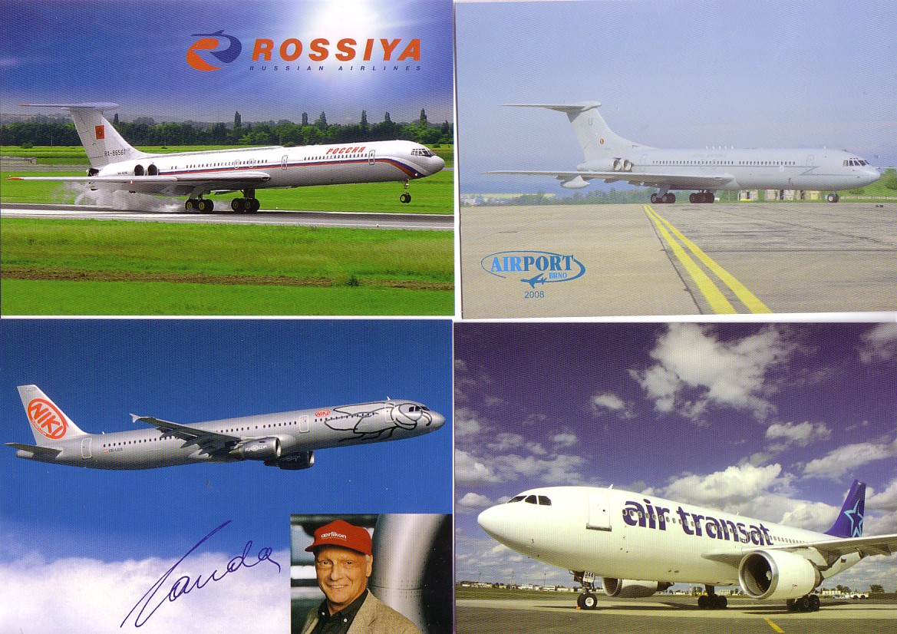
5
INTERNET REPORT

You never know which cards will set off a feeding frenzy, but Hong Kong is always a good speculation. Four collectors drove the left of these Kai Tak cards up to USD 275 , now = GBP 192, while the other with a RAF Britannia went for just under £50.

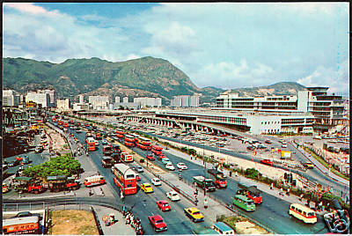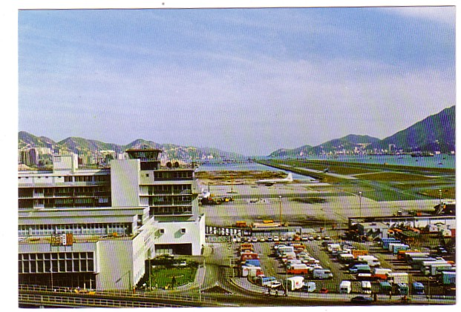

More predictable was this rare Indian Airlines issue Viscount which went for GBP 111 . As bidder details are no longer shown there is no evidence that Indian bidders were involved, but the winner was German. The only other Indian official cards from this period known are of DH Herons

