AVIATION POSTCARD CLUB INTERNATIONAL
NEWSLETTER No 66
MARCH 2009

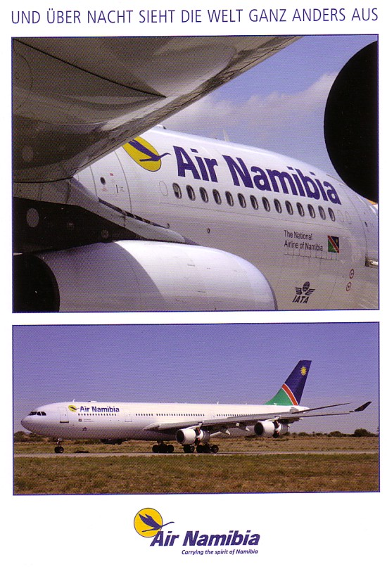
NEWSLETTER Doug Bastin, Hampton House Dee Banks, CHESTER CH3 5UU 01244-340895 E-MAIL EDITOR@AVIAPC.COM
MEMBERSHIP Phil Munson 10 Woodview SHOREHAM-BY-SEA BN43 6AG 01273-464230 members@aviapc.com
WEBSITE ; WWW.AVIAPC.COM design Andy Hutchings
andy@novembertango.co.uk

2
INTERESTING TIMES……..LESS INTEREST IN CARDS ?
Editorial Impressions by Doug Bastin

From a strictly aviation postcard perspective, we seem to be at a turning point in that new issues are few and far between and the surplus of supply over demand of most antique cards leads to price polarisation. As regards new issues, the airport card is almost extinct except for a few minor regional airports, and reprints of past views from old slides or negatives. “Security” may be one of the causes, which is strange as almost every airport layout in the world can now be examined in detail from home via the medium of Google earth. The airline issue postcard is likewise an endangered species. The Berlin travel show this year yielded few issues – Germany seems to be last market where the postcard is still used for airline promotion as witness the Air Namibia A.340 on the cover – incidentally the text reads “overnight the world looks completely different” . Even new Lufthansa issues now count as hard-to-find by contrast to those from the 80s/90s that fill the junk boxes. All this means that it is now not unknown for a new issue to outpace, say, the more common Imperial Airways cards.

As regards content for this issue, we feature the last active British class of flying boats – the Short Solent, and resume tracking the pioneers of 100 years ago with Brabazon . Another famous name, Lindburgh, features in Worth a Second Glance and there is a return of contributions from Leonardo Pinzauti with cards featured THE two classic airliners Constellation and DC-3.

On the Club front, as is now usual, not all members have rejoined. However only a very few actually resigned – others have just disappeared. If you are among the latter then this will be the last issue to be received. Please note that although contact through the members@aviapc.com address is unchanged, Phil Munson’s actual E-address has now changed from jphilmunson@aol.com to phil.munson@o2.co.uk .

By the time this issue gets out the Gatwick show will have been and gone. Aviation shows still seem to draw in the numbers but models and digital products seem to take up more and more space at the expemse of paper. While substituting electronics for paper makes a lot of sense as houses get smaller and smaller, the popularity of models is odd . Given the very few differences in airliner types it seems a very space inefficient means of collecting colour schemes but I guess the model fraternity would not see the point of collecting 2 dimensional images. Hope to see some of you at LGW/K2 – it will give an idea of how things are with the hobby in the UK.

Doug Bastin Chester March 2009

