WORTH A SECOND GLANCE
SLIPWAY SLIPS AWAY
Dutch member Dave Prins found few cards on a recent trip to New Zealand, but among them was this card of beach resort Paihia featuring a Bell jet Ranger helicopter. The card title does not mention the helicopter or any other aviation connection but previous cards of this sight tell a different story. The foreground tarmac was used for many years by a variety of Grumman amphibians off the adjacent slipway – card right. Moving back through time we can trace the companies and the changes in buildings and planting. Before the helicopter we have a Widgeon ZK-AVM of an unknown carrier and then ZK-CFA of Sea Bee Air.
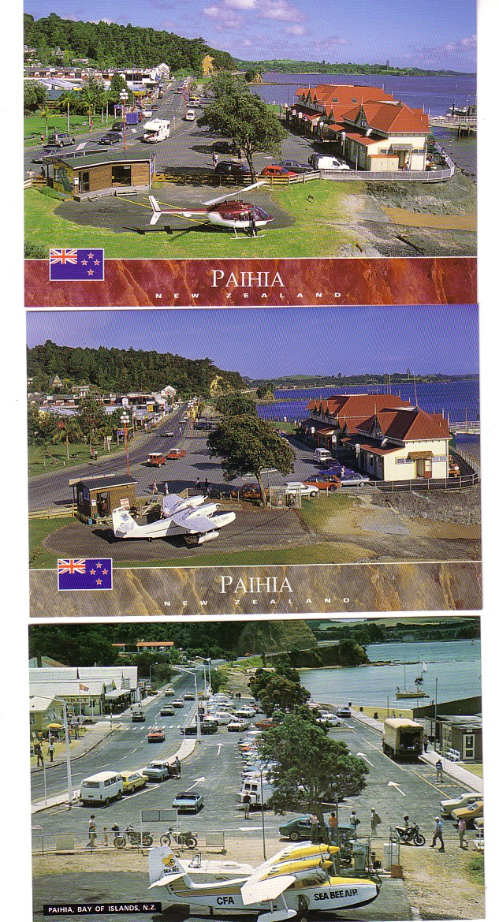

WORTH A SECOND GLANCE – PAIHIA, NZ
Smaller trees, fewer buildings. Both Sea Bee Widgeons AVM & CFA in their yellow scheme and ZK-CFA in the ex Mount Cook blue. Then two Grumman Goose of Mount Cook – both ZK-DFC.
