THE CARDS ARE OUT THERE
AVIATION SHOWS

Apr 20 Altrincham Cresta Court Hotel
Apr 27 Gatwick Crawley K2 leisure centre
May 11 Kempton Park racecourse
May 24 Paris Holiday Inn Paris-CDG
June 28 Frankfurt Schwanheim village .
June 29 Liverpool Marriott Hotel Old Airport + 75th Anniv event.
Jul 10/12 Airliners International 2008 Dallas-DFW Sheraton
Sept 13 Holiday Inn Newark Airport NJ USA
Sept 14 Berlin Schonefeld Airport
Oct 18 Brussels Zaventem Village
Nov 1-2 Frankfurt Schwanheim Village

NEW ISSUES

Relative to the UK and USA , the airline postcard is in better health in the German speaking countries, so one can expect to find new issues at the annual Berlin World Travel Market. Although there were few surprises in the issuers, there were new cards this year from Air Baltic(737) All Nippon (787) Blue express (737) Egyptair (60th anniv DH Moth) Hamburg International (A319) Icelandair (757) Lufthansa ( 747s A330s CRJ-900) Rossiya (A319 Tu154 Tu204) Mongolian (A310) Niki(A320) Swiss (BAe146 , A320 – including a Euro 08 football colour scheme, A330) TunisAir (60th Anniv multiview) Ukraine (737)
The Rossiya Tu154 means that the Belavia shown last time is NOT the last Tu154 card to be issued.

There is a new Australian publisher of airport cards – cards can be viewed and ordered at postcard@pics-sydney.co,au
Carl McQuaide’s latest Wingtip series includes a card printed from an old 1950’s photo of mine of an Aer Lingus DC-3. There is also a new UK publisher of retrospective airport cards who seems to sell most through Ebay . The cards are by Kendex Cards of Manchester.

INTERNET

There have been a few high priced sales outside the usual categories.
A photographic card of a Pan American Martin Clipper at Wake Island attracted bids from both aviation and postal history sectors as it was postally used from Hawii
Here is a selection of new cards from Lufthansa, Rossiya and Swiss at the Berlin Travel Market. Swiss have an A320 in the same drawing style.

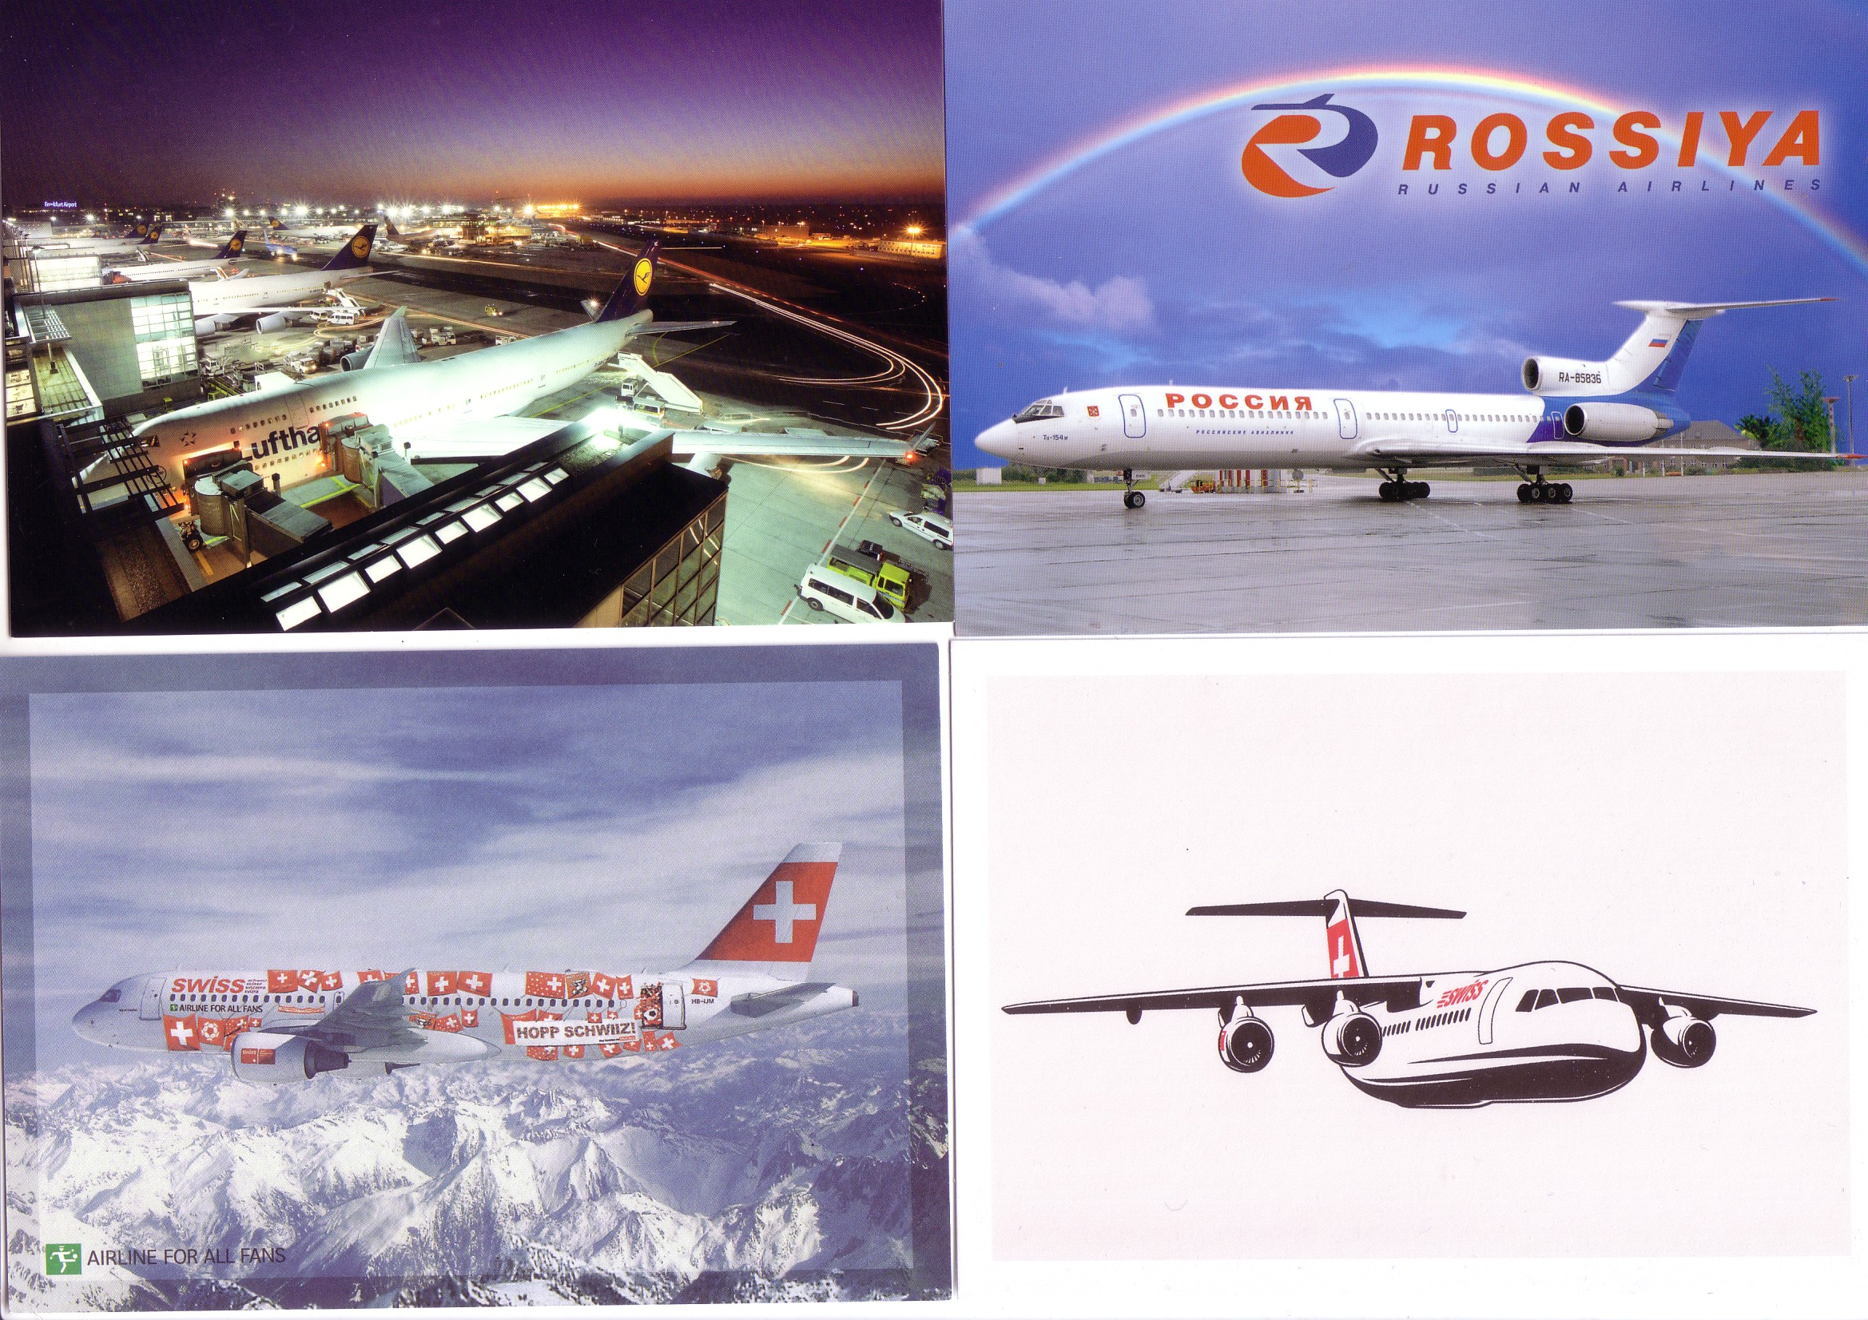

The Egyptair anniversary Moth and ANA 787 are large size.

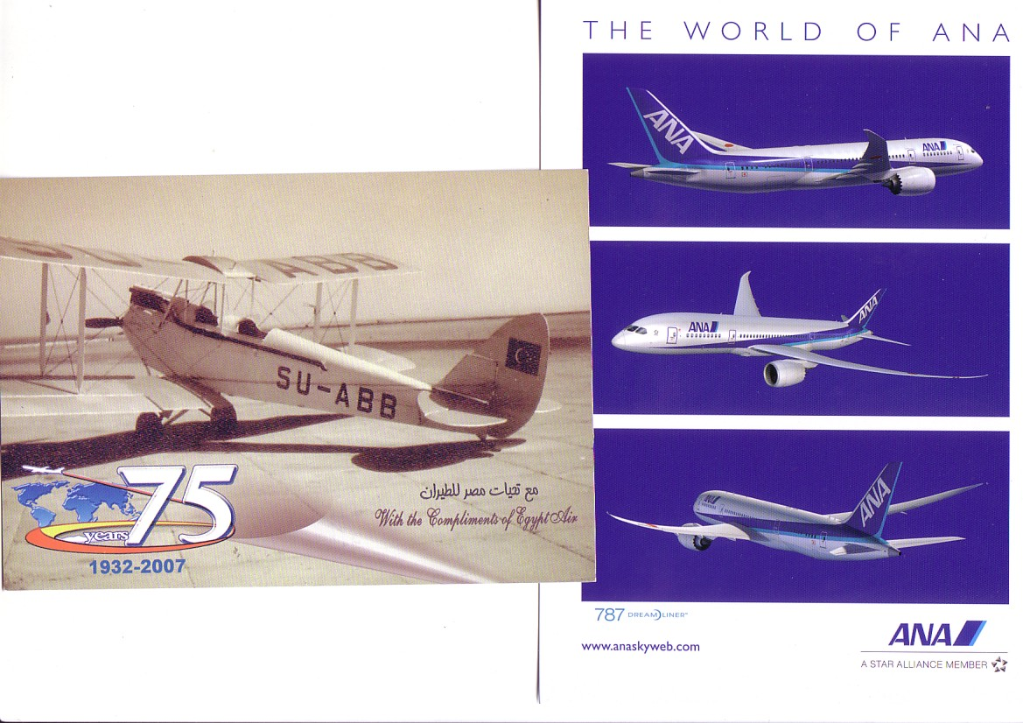

Consequently it raised over $200.
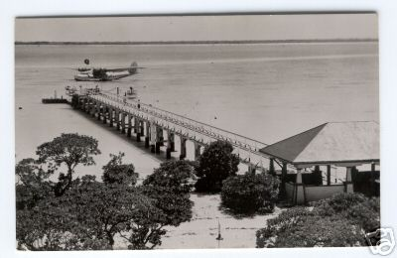

Likewise another photographic card combined aviation and Irish interest by showing the Short Mercury seaplane being crane launched or recovered at Foynes. Unfortunately the image quality was not good enough to show here but sufficient to attract bids over EUR 100.

BEWARE

The Internet plus a shortage of new airline issues has had one negative effect which is the rise of “fake” airline issues – most likely from Germany. Using digital technology and quality printing it is possible to extract images from an airline’s publicity sources and produce a plausible card with logos etc on the back. Some that have been seen have not done this all that well but we were taken in by the supposed Cargoitalia DC-10/MD-11 featured in an earlier issue. Leonardo Pinzauti has followed this up with the company who deny all knowledge of it , but in the course of the investigation he discovered a real issue from this carrier. This is the offending card below

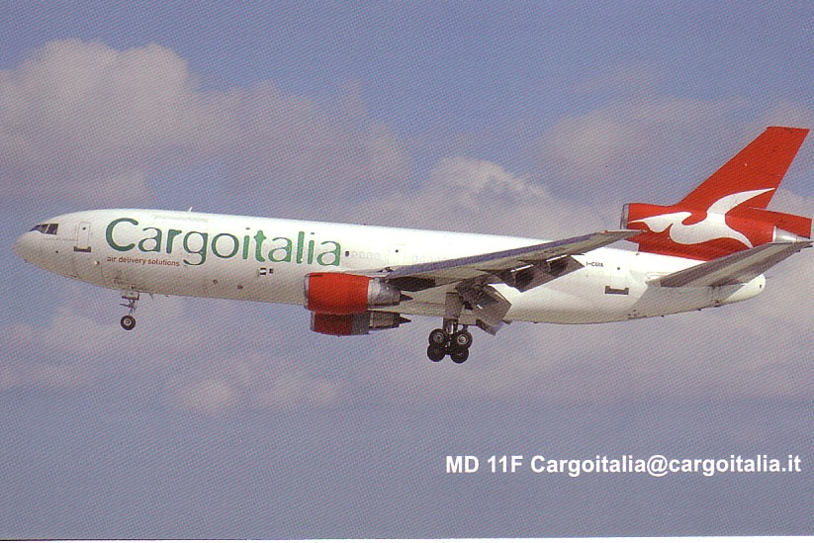

The 707 piece by Bill Demarest in December happened to coincide with the 50th anniversary of the 1st flight of the true airline 707 - as distinct from the prototype and its KC-135 derivatives. Also celebrating an anniversary – 25 years was the NATO 707 derived E-3 AWACS squadron at Geilenkirchen, Germany. For the anniversary they produced a set of cards featuring not only the E-3 in a special colour scheme, but also a support and training 707 freighter. Like all the AWACS squadron they both carry Luxemburg- ish markings, the E-3 being LX-N90459 and the 707 LX-N20000. The 707 has always been in military hands , having been previously with the Luftwaffe.

