20
WORTH A SECOND GLANCE – SO HERE IT IS

Bernardo Sclerandi has two more cards of the set documenting the visit of the Lindberghs to Libya, as featured in March. The wing of the Mohawk is visible in one but both are noteworthy in featuring Marshal Italo Balbo, by then Governer of Libya under Italian Rule but previously air minister and instigator and leader of transatlantic mass formation flights by Savoia Marchetti twin-hull flying boats.. Here are the two new views
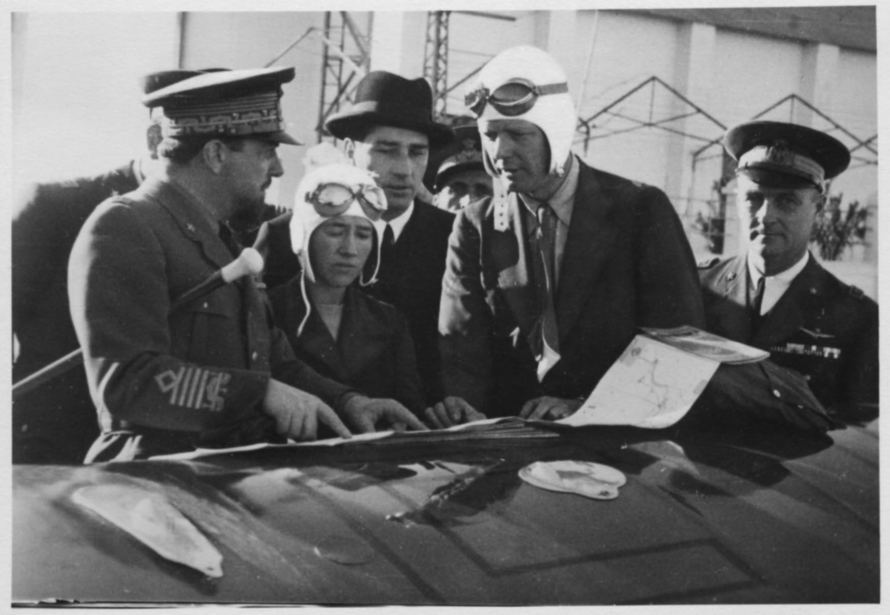
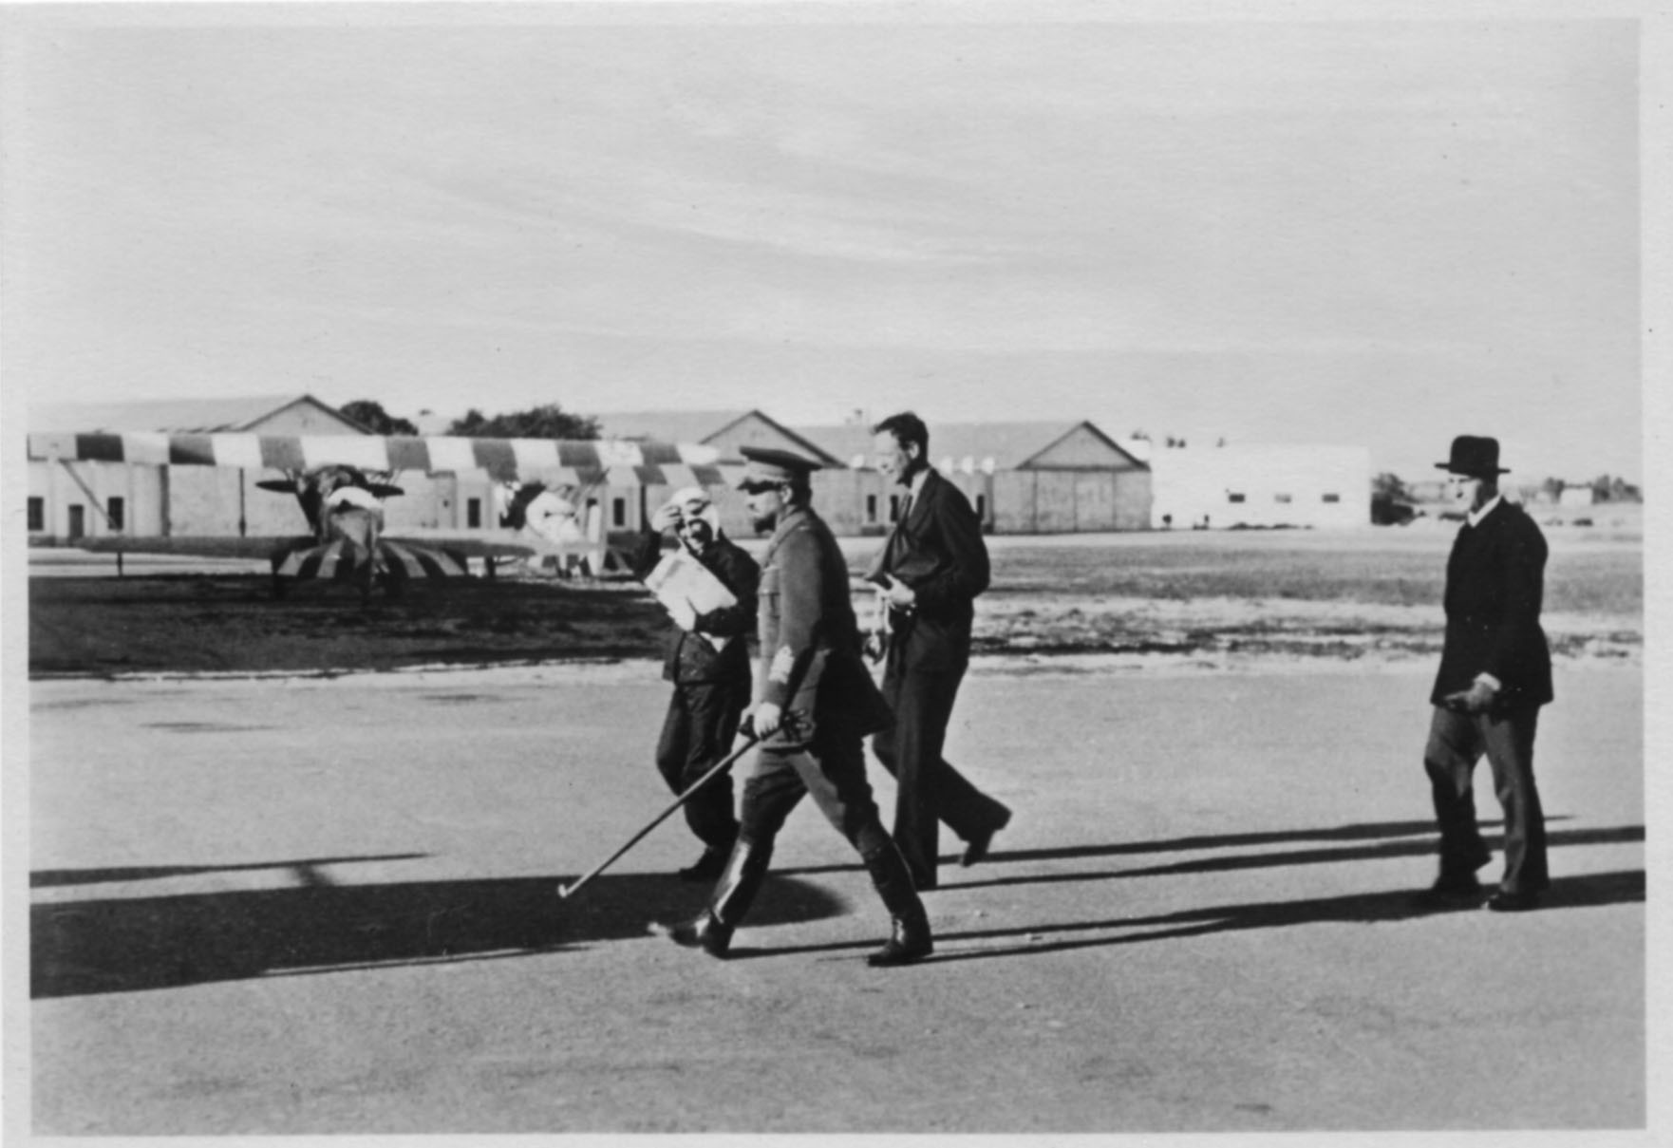

19

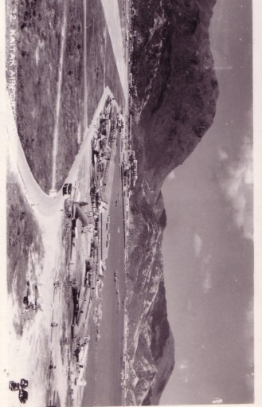

18
WORTH A SECOND GLANCE
…..AND MORE

Actually more likely one long sustained look. But to appreciate it you need a big image, so this time the card gets a whole page to itself. The trick is to identify everything there is to be seen. The location is Hong Kong Kai Tak - probably pre 1948 as the Chinese aircraft present appear to be active, not laid up after fleeing the Communist vistory. It is difficult to think of other air views with so much variety, possibly the US desert storage sites or some Alaskan combined sea/land airports might compete.

Anyway starting at the front we seem to have :-

Two Ryan STM 2 seat trainers : 3 unidentified high wing lightplanes, the leftmost with a radial engine
2 C-46s One off Chinese Airline CNAC, one military, possibly French from Indo China and a CNAC DC-3
DC-4 of Thai airline Pacific Overseas. : CNAC DC-4
DC-3 probably of Cathay Pacific :Another CNAC C-46 : Convair PBY – most likely Cathay Pacific
More Dc-3s
Sunderlands on the water – most likely RAF but could include BOAC
Far distant more DC-3s , probably RAF and other unidentified military
Then the hills, now almost completely obscured by high-rise buildings.

Linking this to the Indian piece, the same hills act as backdrop to this view of Bharat Airways VT-CZT – postcard quality paper and printing but a plain back photo. This must be between 1949-1953 when Bharat went into IAL.
