17
WHAT DO YOU KNOW ?
This postcard backed photo is a candidate for a future article on British airports that have disappeared but currently the location is unidentified despite the distinctive tower. I am of course assuming that it is indeed in the UK. The two lightplanes in the foreground appear to be a DH.60 Moth and a Percival Gull of some kind. Next to the tower is a Spartan Cruiser. This is one of the two supplied to the Czech Bata Shoe Company. My best guess so far is that it is East Cowes where the Cruiser was built, but this is only on the grounds that I have not found a photo of east Cowes to disprove it and I have not found that tower anywhere else. The Bata Cruisers, based at Zlin flew extensively in Europe and the Middle East so even the UK attribution is not certain.

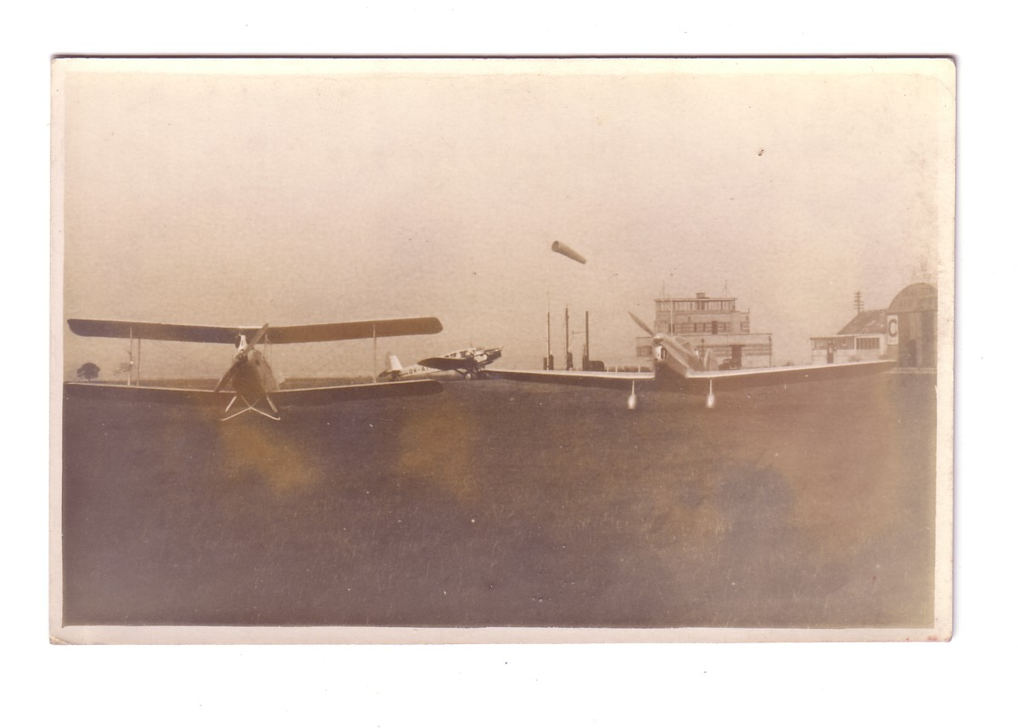
Close up the Cruiser looked like this – Real Photographs Ltd card.
