3
THE CARDS ARE OUT THERE
AVIATION SHOWS
Jul 23-25 AI2009 Wyndham Orlando, FL
Aug 22 Manchester – Concorde Hangar – Airport Viewing Park
Sept 6 Berlin Schonefeld Airport
Oct 3 Luton Vauxhall Recreation Club
Oct 17 Brussels Zaventem Village
Nov 7/8 Frankfurt Schwanheim Village

2010
Feb 27 Basel Euroairport
Apr 25 Gatwick/Crawley K2 Leisure

NEW ISSUES
A few feint signs of revival in both UK airline and airport postcards – in both cases by niche players – the main players being bent on paperless everything. The latest carrier to attempt to operate profitably from the Isle of Man, Manx2 has produced this card with a TT theme. The german-registered Metro IS operated by Manx2 – in deed none of their fleet is Manx or UK registered – the others being more German Do228s and Czech LET-410s.
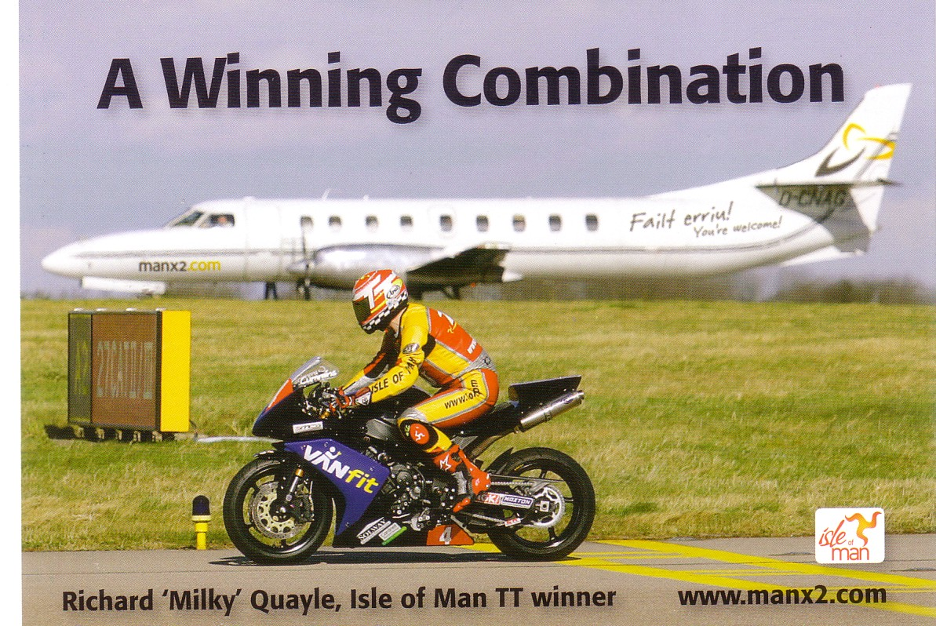
Down south, Lydd airport, the one time much-postcarded Silver City Ferryfield base has produced three artist cards of a Concorde, Comet and Virgin 747 – all + some associated pre-printed autographs. None , of course have any connection with Lydd. The Comet appears to have been copied from a picture of a Mk1 but with a 4B BEA colour scheme with difficulty in fitting in the number of windows for a 4B.

4
This will not be illustrated on grounds of not encouraging bad art but here is the Virgin 747 . Across the Channel from Lydd, the other end of the old car ferry at Le Touquet has done a more relevant history set. It includes car ferry cards but also this preserved Dragon G-ECAN. This one was actually Australian built for the RAAF in 1943.

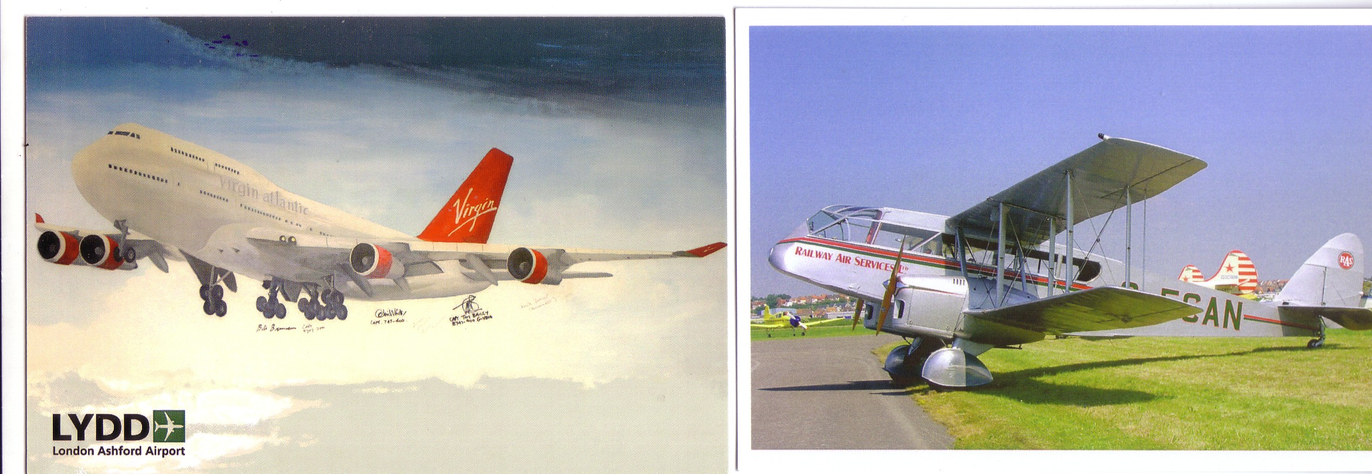
Staying in France, another history set from airline Aigle Azur for its 60th anniversary 1946-2006 but not noted before. 10 slightly oversize cards in a folder – 4 poster repros, 3 DC-3s in French Indo-China, a current A.321 and two Boeing 307 Stratoliners. Aigle Azur operated 5 of these, ex TWA, in Indo China and Europe in the 1950s.
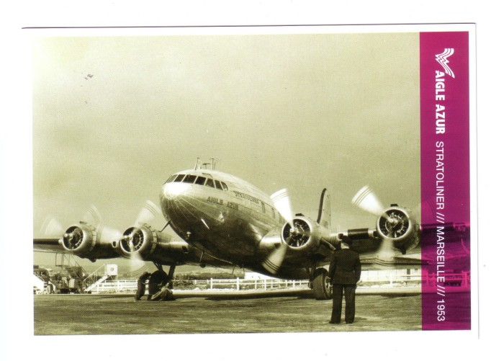

Given the lack of cards from other UK airports and its own promotion as a destination in its own right, the beach strip at Barra is moving up the league table of postcards per airport.

5
This is one of the more recent ones but more should be due as the Loganair Twin Otter has switched from BA to FlyBe colours .
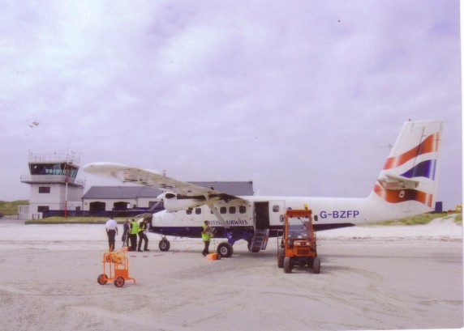

INTERNET REPORT
There is no sign of the bubble in really rare airline issue or other cult cards bursting yet. The Irish/Aer Lingus cult has been mentioned before but anything connected with Lebanon comes into this category too. One common factor must be that both Nations historically have many expatriates. Anyway, whatever the cause the Air Liban official DC-4 over Beirut made £175 ( a DC-6C also made £105) and the Aer Lingus Viscount 800 from the Vickers set £100 + -
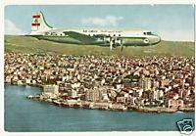

6
These prices are now starting to be noted by PPM magazine. Now although it is unlikely a general dealer would get or recognise an Air Liban issue, there must be a distinct possibility that some will start marking up any Aer Lingus Viscount to at least double figures.
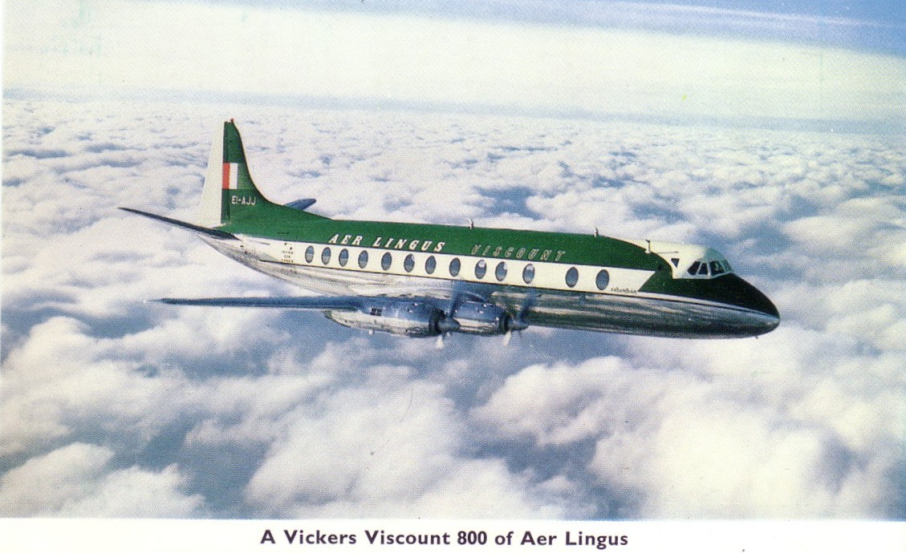

IS IT A PLANE ???
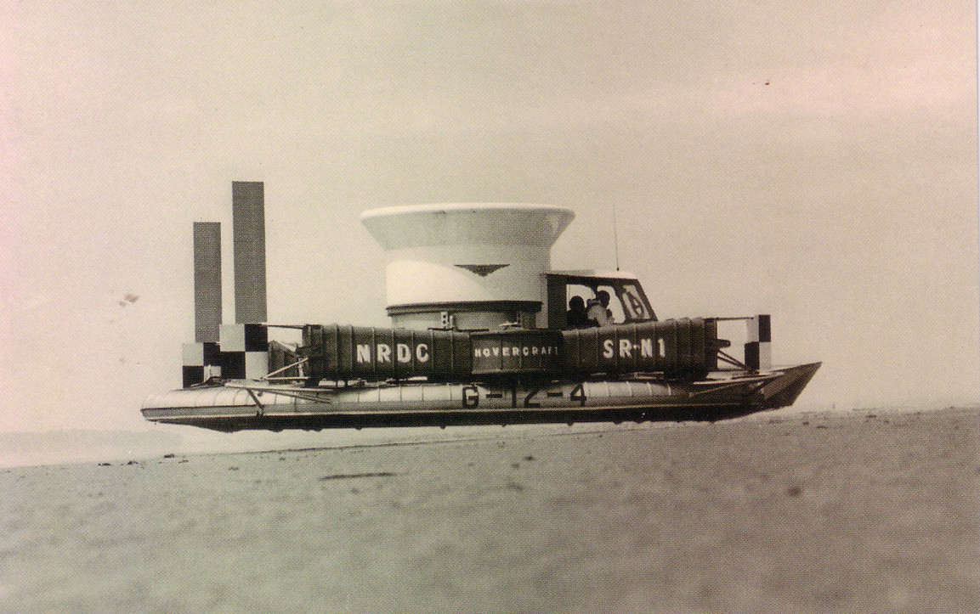
No – was the final answer, but in 1959 it could clearly lift off the ground and was built by an aircraft manufacturer, Saunders- Roe, so they gave the SRN-1 a G- number G-12-4. 50 years on The Hovercraft Society have issued a set to mark the event and Jim Colver sent this one in.

