AVIATION POSTCARD CLUB INTERNATIONAL
NEWSLETTER No 67
JUNE 2009

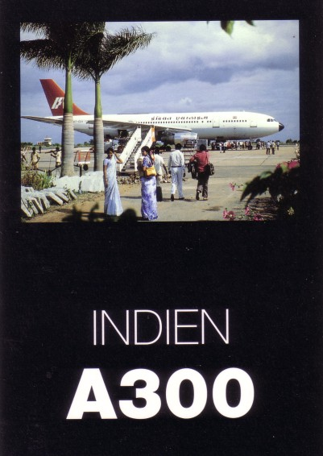
NEWSLETTER Doug Bastin, Hampton House Dee Banks, CHESTER CH3 5UU 01244-340895 E-MAIL EDITOR@AVIAPC.COM
MEMBERSHIP Phil Munson 10 Woodview SHOREHAM-BY-SEA BN43 6AG 01273-464230 members@aviapc.com
WEBSITE ; WWW.AVIAPC.COM design Andy Hutchings
andy@novembertango.co.uk

2
AVIATION OR AIRLINES ?
Editorial Impressions by Doug Bastin

Members may have noticed the trend to have one big article rather then several shorter. This is simply because it is less time consuming to research and edit one topic than several. This issue is largely taken up with an article on civil aviation in India and extended versions of Cards are out There and Worth a Second Glance – both in their different ways reflecting new material. The front picture kicks off the India theme with an early card from the Airbus series of an A300 at Bangalore airport. The Airbus VT-EDV was the 34th to be built and delivered in 1976, and the last of the fleet was scrapped in 2008.
Looking at Bill Bairds collection of new issues one might think that yellow was the new “in” colour but the fact is that the print images have under represented reds and greens.

On the Club front, please note that although contact through the members@aviapc.com address is unchanged, Phil Munson’s actual E-address has now changed again to phil.munson@live.co.uk. Irish Member John Killoran has rejoined and we have one new member, Bill Aves , I Hydethorpe Ave Edmonton N99RS, collecting Salmon & Skilton. Its terrifying to think that some of those “common” Skiltons are now about 40 years old.If anyone is still missing a 2009 membership list please contact me saying whether you require the Excel or printed versions.

The active membership seems to be more and more concentrated around the airline/airport sector. This is evidenced by the fact that whereas an appeal for material for the Wright brothers centenary produced enough for a whole issue, the same for Bleriot produced nothing so images had to be sourced from the public domain, including PPM magazine. So, non-airline articles will always be especially welcome.

.A shame to waste space in the print version , so here is the short lived Air India scheme mentioned in the main article on a typical over-mountain 747-200.
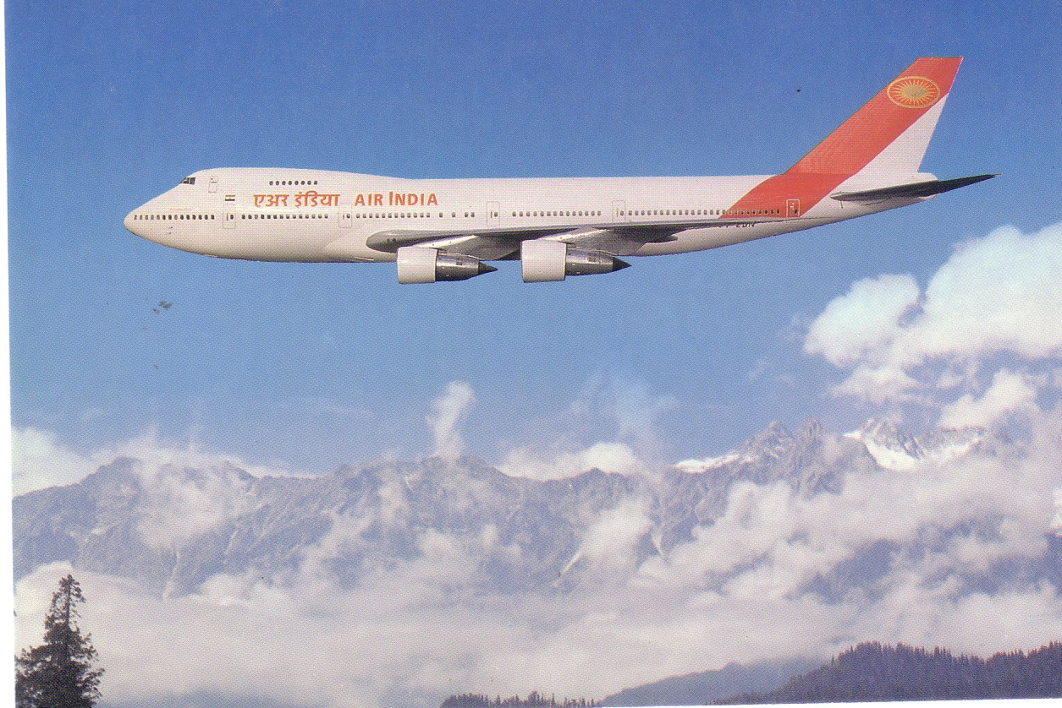

Doug Bastin Chester June 2009

