THE CARDS ARE OUT THERE
AVIATION SHOWS

June 28 Frankfurt Schwanheim village .
June 29 Liverpool Marriott Hotel Old Airport + 75th Anniv event.
Jul 10/12 Airliners International 2008 Dallas-DFW Sheraton
Sept 13 Holiday Inn Newark Airport NJ USA
Sept 14 Berlin Schonefeld Airport
Oct 4 Luton. Vauxhall recreation Club
Oct 18 Brussels Zaventem Village
Nov 1-2 Frankfurt Schwanheim Village

NEW ISSUES
Little or nothing from the airlines but Lisbon Airport has issued a history set of 48 cards in 4 folders……and another new-ish oversize airport card has been seen from, of all places, Baghdad – mailed 2005.

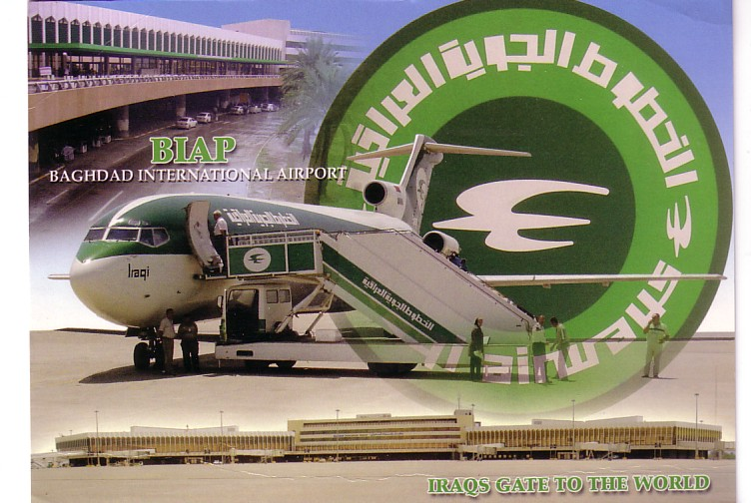

INTERNET REPORT

As a change from the usual categories, there has been a recent upswing in demand for items featuring Silver City Airways – the company featured in one of Leonardo Pinzautis recent pieces and Peter Marson sent in an example of one of the few airline-issues from this company and this map card is featured on the cover. The majority are airport views from their bases at Lympne, Lydd in the Uk and le Touquet, Calais and Cherbourg in France. General postcard publishers could not resist the sight of cards being loaded into Bristol Freighters – although a few cards also feature the company’s DC-3s and Hermes’. This is another card from Peter at one of less usual locations, Cherbourg

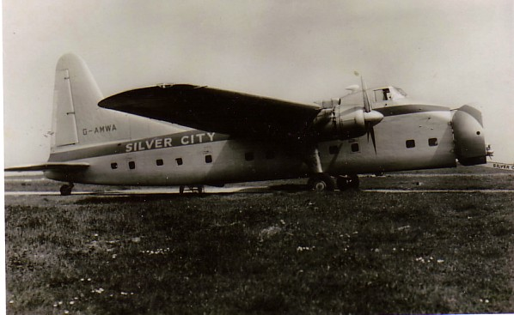

The level of interest in Irish or Aer Lingus cards suggests that new Irish collectors are either taking up aviation or the internet for the first time. Among the more familiar cards being traded, the DC-3 at Edinburgh Turnhouse is less known.

