1908 AND ALL THAT…..

Editorial impressions by Doug Bastin

In 2003 we devoted an issue to the centenary of the Wright Bros, but from this year onward there will always be some centenary to mark, as world aviation really started to take off in 1908. Perhaps the two most significant events were the arrival of the Wrights in Europe and the first flight in England by Cody.
For these reasons, and despite having fewer pioneer collectors than previously, I will revive the Pioneer Page to mark significant anniversaries – starting with a piece by Ian Hames on the Wrights in Europe. The Cody anniversary falls on October and I hope someone can submit some relevant cards for the September issue. I am sure there are some out there – indeed I think there was a quite a large real photo set of his funeral

Eleswhere in this issue we feature an aviator who was well known in his day, 1920s-40s, at least within the industry, but who is now largely forgotten, T Neville Stack. Who ??? All is revealed in the main article

Thanks to all who completed the information request on the Imperial Airways catalogue with the 2008 renewal form – details are included on how I plan to proceed with this, but I can reassure those without computers that a printed version will be produced and available at cost – paper, ink,mail.

I seem to have recently uncovered a number of cards , either physically or via on-line images, for which the term “Worth a second Glance” is particularly apposite – so I have extended this feature in this issue to feature four of them . Locations range from China & Japan to Antarctica and there is something for helicopter and flying boat enthusiasts as well.

The final 2008 membership list is issued with this newsletter – earlier circulation of an E-version has unabled the latest updates to E-Mail addresses to be included. The list also includes one new member, Colin Huxtable of Holt, Norfolk, collecting British airlines.

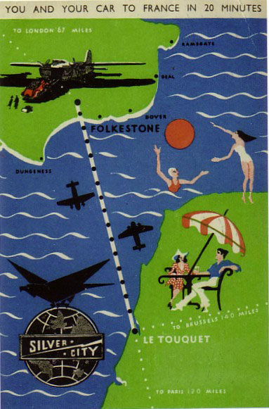

Doug Bastin.

CHESTER UK June 2008

