AVIATION POSTCARD CLUB INTERNATIONAL
NEWSLETTER No 69
DECEMBER 2009

19  WORTH A SECOND GLANCE  5 view airport postcard from Dutch New Guinea  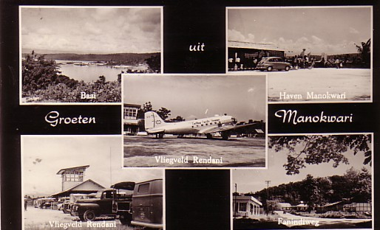  And an enlargement of the centre view – Cathay Pacific’s original DC-3 VR-HDA still in service, early 1960s  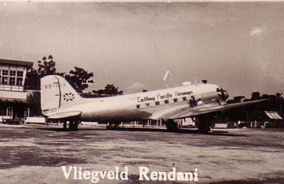 | 20  WORTH A SECOND GLANCE  “BETSY” & THE FLYING DUTCHMEN  We end this issue as it began, with KLM. The story of the development of the KLM service to the then Dutch East Indies (Indonesia) used to be well known, especially in the Netherlands, where the pilots became media celebrities and various pioneering flights were commemmorated in Delft pottery.  After WW2 the Dutch failed to re-establish effective colonial rule and most of their territories became the independent state of Indonesia. However , like most colonial powers the handover was not complete. The card shown , which features a Cathay Pacific DC-3 VR-HDA is clearly at a Dutch location. The Dutch text is Greetings from Manokwari and the insets are of the airport, Rendani, the harbour, a street, Fanindiweg and a Bay (Baai). On the other hand, the Cathay DC-3 colour scheme is similar to that used much later than the hand over to Indonesia. So where was Manokwari ?  Manokwari is certainly now in Indonesia and is the capital of a province , one of two in West New Guinea, the east of the island being the state of Papua-Niugini. Unlike the rest of the Dutch east Indies, East Papua remained in Dutch hands until 1963, when it passed to Indonesia. In the latter days the Dutch set up a local airline deKroonduif, using Twin Pioneers. The original plan was for the then Netherlands New Guinea to be given independence but pressure from Indonesia , which threatened invasion , was backed by the USA which put pressure on the Dutch to cede the territory to Indonesia. Much later a not dissimilar situation was to arise in respect of Portuguese Timor.  So this card dates from the last days of Dutch New Guinea. The Cathay DC-3 VR-HDA is in colours still in use when the first L188 Electra was delivered in 1959. It was Cathay’s first aircraft , originally named “Betsy” and remained with them to 1961 when sold to Taiwan. Subsequently Cathay purchased another DC-3 from the Phillipines and painted it to resemble VR-HDA in its original bare metal scheme for the airlines 60th anniversary in 2006. It then went to static display at the new Chep Lap Kok airport.

