3
THE CARDS ARE OUT THERE
AVIATION SHOWS

2010
Feb 27 Basel Euroairport
Mar 6 Luton Vauxhall recreation Club 10.30
Mar 20 Stuttgart Musberg
Apr 25 Gatwick/Crawley K2 Leisure
July 17 Frankfurt Schwanheim
Aug 12/14 AI2010 Newark NJ USA http://www.ai2010nyc.com
Sep 5 Berlin – Schonefeld
Nov 6/7 Frankfurt Schwanheim

NEW ISSUES
Recent is probably more accurate than new, but these have not been shown before. Sometime since adopting their new colours Eastern Airways have issued some large cards of Jetstream 41 and SAAB 2000. The backgrounds with a church and a field with cows and WW2 defences look distinctive but are unidentified.
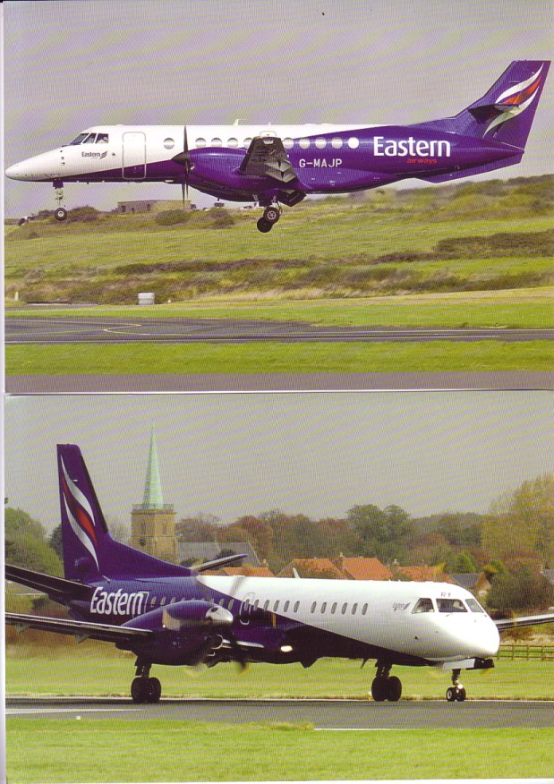

4
Eastern also have another large card with a cartoon type drawing of passengers boarding a SAAB2000. Picking up on the Indian cards featured in June, Air India also have a large card with their new colours on a 777-200.
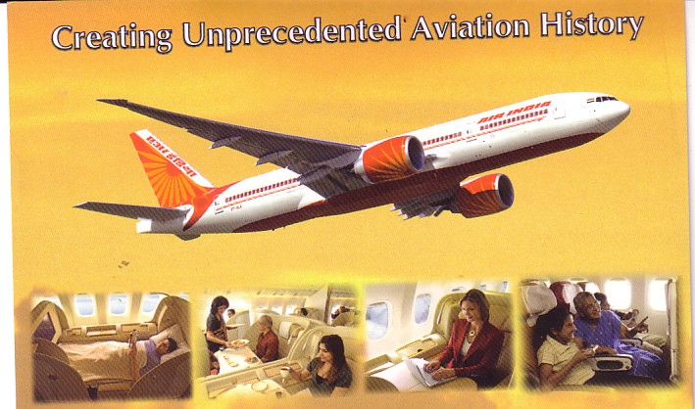

Among the surviving regular card issuers, mostly from German speaking countries, Niki has an Embraer 190, Cirrus a Do328Jet, City Air an SF340., Baboo a DHC-8-400 and Swiss a set of 3D cards of interiors and A330 ground views. Elsewhere in Europe Czech Travel Air has two 767-200s ( actually Icelandair leased) and an A320, Finnish Air Aland an SF340 and LOT an Embraer 175 and 737-400 in an 80th anniversary colour scheme. Here is a selection
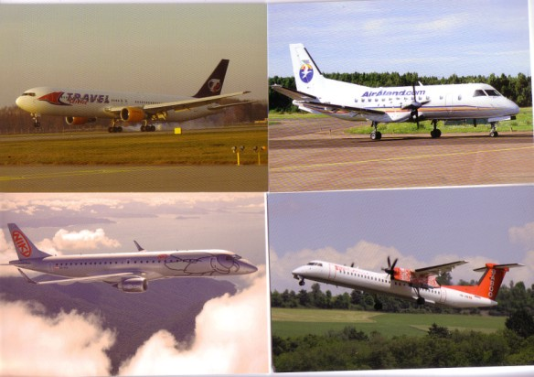

5
SAS has a set of airport cards – on the one shown, of Athens, all non-SAS airline tail coilours have been falsified – the originals were Air France, Austrian and Emirates. The others are Paris CDG, Newark, Seattle and Moscow Sheremetyevo.
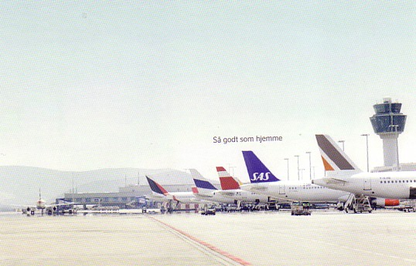

JAL has done cockpit cards of regional jets, CRJ-200 and Embraer 170. Another Embraer .a 190 comes attached to come Galapagos view cards in a joined set from TAME- Ecuador and another 175 is part of an Air Canada set which is dated 2006. Another Air Canada card features the Boeing 787. The LOT example makes up a foursome of Embraers,
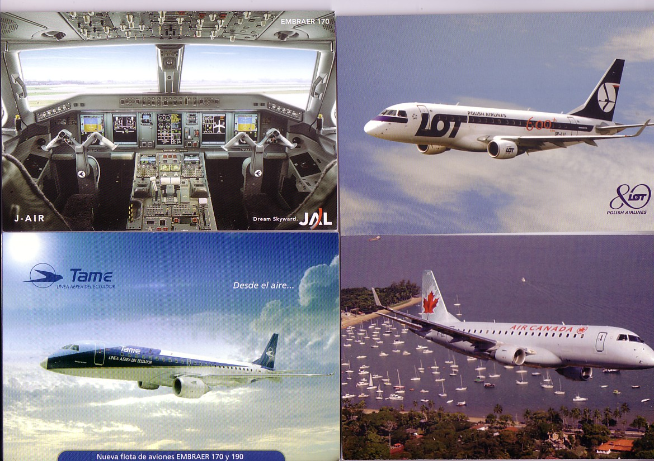

6
The scarcity of new airline issues has encouraged the appearance of cards which give the appearance of being airline issue but are not. One such, which carries the airline logo but , suspiciously these days, not the web-address is a set of the current Czech Airlines fleet ATR-42, ATR-72, A310, A319, A320, 737-400, 737-500, SF340.

More of a mystery is the following.
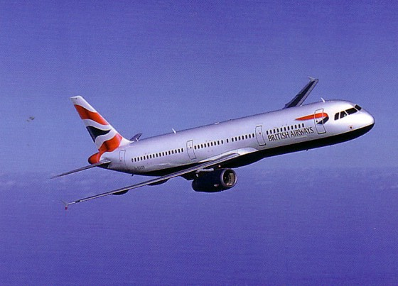

This one of BA A321 G-EUXD has an identical back to a past BA set – the one with some rather crude CGI images of 737 747 757 767 plus A319 G-EUPB – all in the current colour scheme. However since then, there has been a set, believed to be for a Training Centre, with the website address on the back + some tech details. Now EUXD was not delivered until 2004, so post dates both sets. The CGI set is now probably rarer than the latter, so less likely to be used as the basis for a fake, which would have been more credible with a faked back based on the web-addressed it. However , like some of the CGI set this one has a titling error A320 not A321 so perhaps it is bad enough to be genuine.
INTERNET ACTIVITY

Polarisation between feeding frenzies over the really rare and the collapse of demand for stuff once thought rare continues. The Delcampe site, which , unlike Ebay can leave stuff on-line for many weeks unsold diplays many examples of the latter.

One of the more frenzied events of the past period featured a rare card of a long vanished British airport, which falls in the scope of the concluding part of Lost Airports which appears later.

