6
RAY BILLINGS 1928-2008
Postcard Collector & Publisher

Founder member Ray Billings died at the end of September. Ray was a link with the aviation scene pre-1939 as evidenced from this extract from his submission to “50 cards from 50 members for issue 50”

…”During October 1934 my mother took me, a 6 year old, to Croydon Airport to see “the biggest aircraft – too big to go into a hangar”. We arrived at the viewing area as the aircraft, a DC-2 swung round to present us its tail and ran up its engines. It filled my eyes with dust so that I buried my head in Mums coat. By the time I opened my eyes the DC-2 was airborne over the distant airfield boundary I still wonder which DC-2 it was Maybe even the KLM “Uiver.”

It seems very likely that it was indeed the Uiver on its way to Mildenhall for the Melbourne Air race commencing Oct 20th . The DC-2 would come second only to the DH Comet racer – it was its speed rather than size that was key, being actually much smaller than the familiar HP42’s hangared at Croydon.

KLM until recently were prolific postcard publishers and pre WW2 often featured crews that had made significant flights. This one of the crew of Uiver features, left to right., Radio Officer Cor Van Brugge, Captain Dirk Parmentier, First officer Jan Moll, Engineer Bouwe Prins . Prins also acted as steward and cook for the 3 passengers carried as far as Batavia (Jakarta).

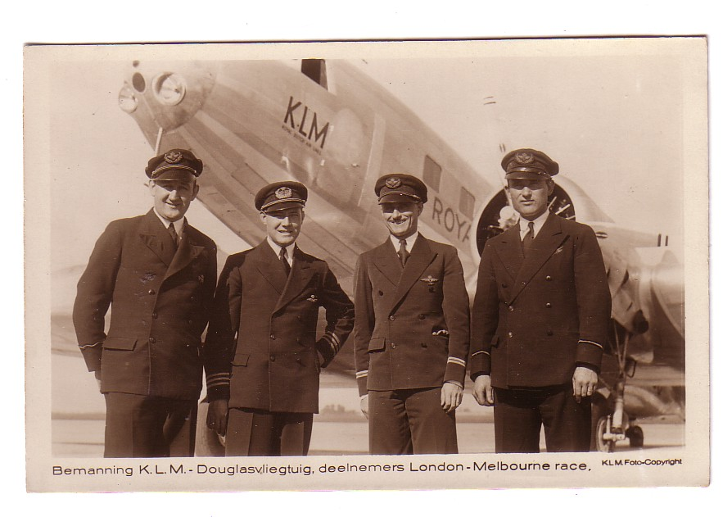
Although not as prolific as KLM, Ray himself was a small scale producer of Aviation postcards. This one, from 1998, featured aviatrix Sheila Scott, who, in the 1960s gained a little fame with a series of 1930’s style flights including.

7
, as listed on the card back ……

National Air Races
15 European intercapital flights in 36 hours
Solo round the world flight 1966
GPO Tower to Empire State Race 1969
England Australia Race 1969
1st woman equator to equator via North Pole 1971

She was awarded to OBE in 1968 and was also a qualified helicopter pilot..


Ray’s card was a two view with a portrait + Piper Comanche G-ATOY “Myth Too” shown at Oxford Airport. Written off after a crash in 1971, the remains are held by the Museum of Flight, East Fortune near Edinburgh. Its successor was a Piper Aztec “Mythre” G-AYTO which was used for the Polar flight. The equator to equator flight was used by the US Navy to test communication to a polar orbit satellite. The flight confirmed the satellite's ability to collect location data from remote mobile stations

8
THAT WAS THEN…..CRASH YEAR 1929 IN POSTCARDS

A combination of cards relating to significant events plus a few actually mailed in that year.. If there is any common theme it is the development of intercontinental routes to Asia and between the Americas and the parallel start of transcontinental service in the USA & USSR, coupled with the rebirth of German aviation with a series of new designs, mostly focussed on the issues confronting trans oceanic service.

JANUARY
LOT Polish Airlines is formed as a state company successor to Aerolot operating Junkers F13s as on this LOT issue 60th Anniversary card
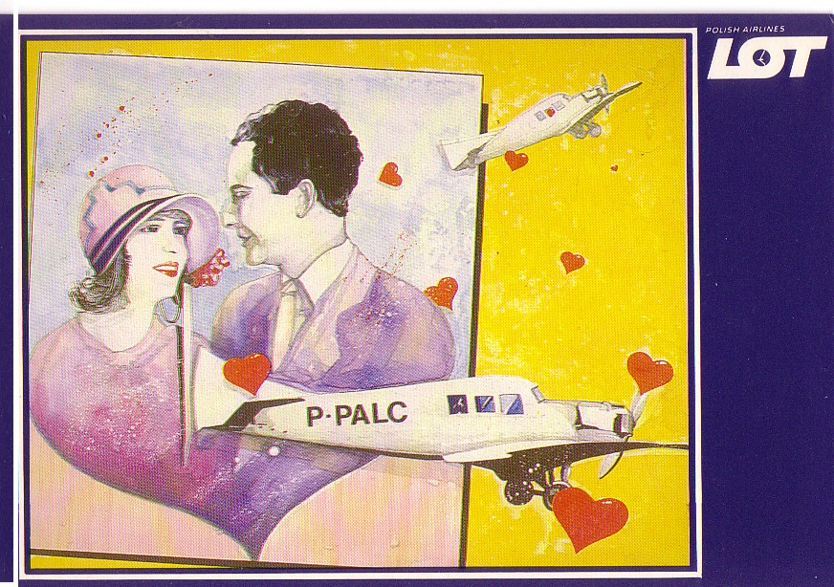

FEBRUARY
Imperial Airways ceases Guernsey service with Short Calcuttas prior to their transfer to the Mediterranean to form part of the new service to India, G-EBVG seen at Guernsey – probably postcard backed photo but professional quality.

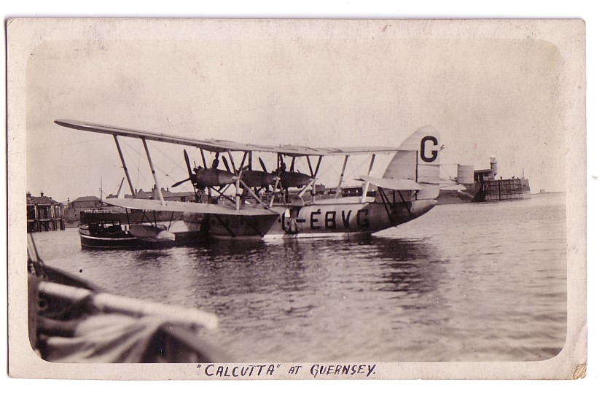

9
MARCH
Imperial Airways commence service to India using Argosy, Calcutta and DH.66 Hercules for the European, Mediterranean and Middle East legs. G-EBLF operates the first flight from Croydon. Salmon artist card 3004.
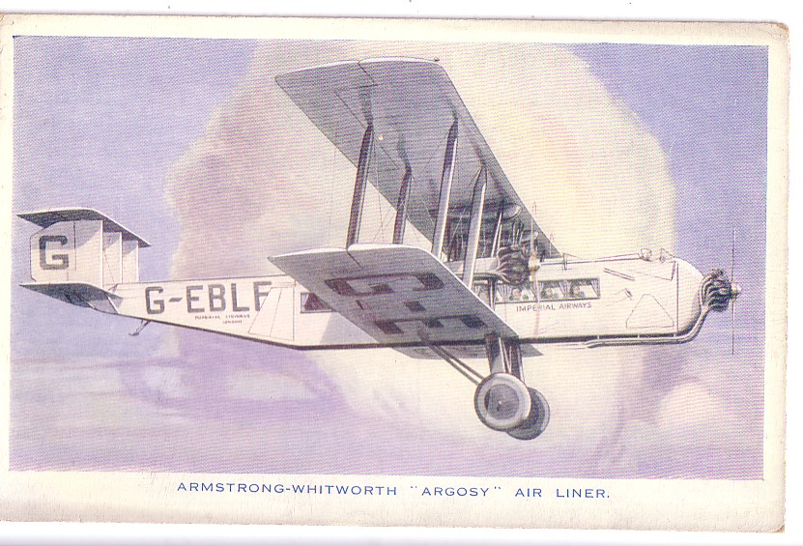

New York, Rio & Buenos Aires Airline (NYRBA) founded to operate South America service and orders Consolidated Commodore flying boats. After operating for 7 months in 1930, is forced to merge into Pan American who had secured the airmail contract by political influence. Pan American issue Ex NYRBA Commodore flying boat

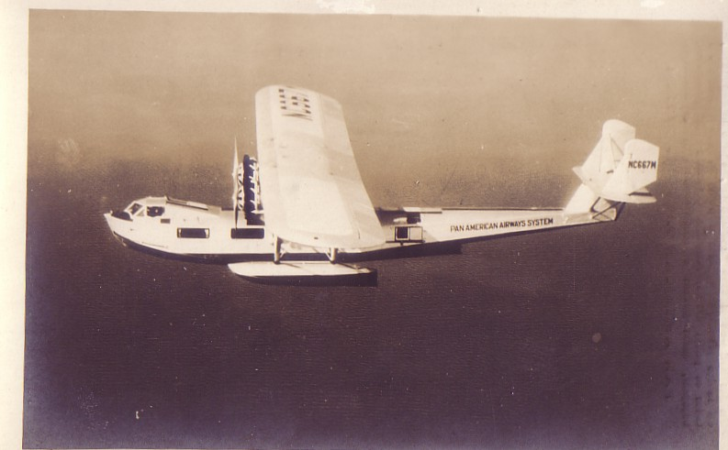

10
APRIL
1st non stop flight to India by RAF Fairey Long-range Monoplane. Real
Photographs Card 9494
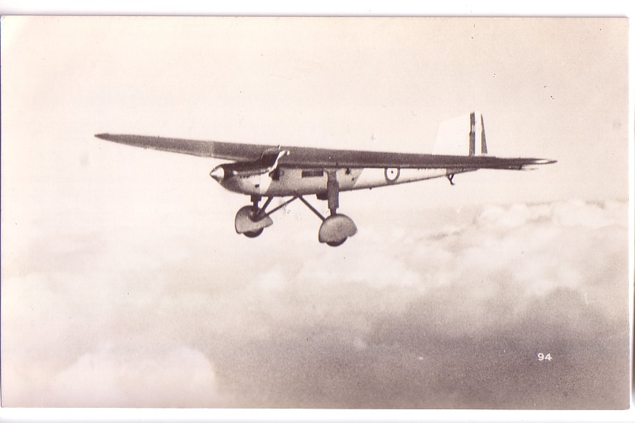

MAY
Bristol Bulldog fighter enters RAF service. Bristol Aeroplane Company issue

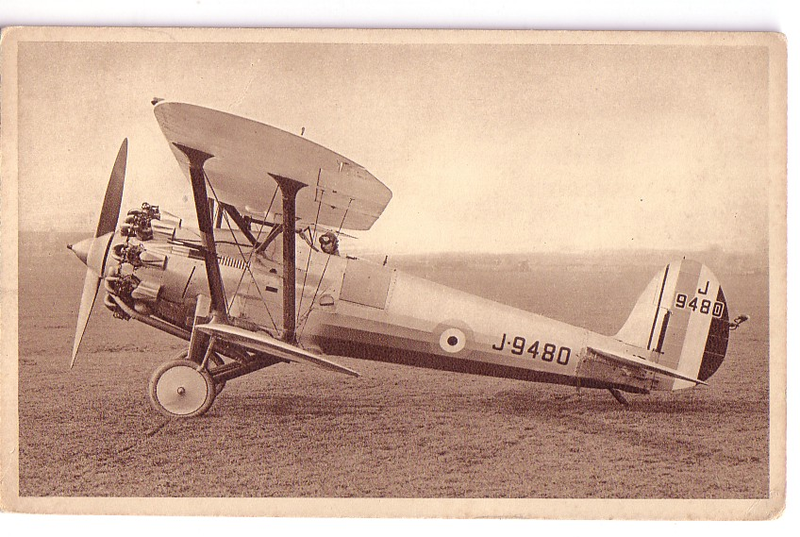

11
JUNE
In the Soviet Union, on May 15 Dobrolet commence mail only service from Moscow to Irkutsk in Siberia with Kalinin K-4 – a 35 hour journey including sections flown at night. The K-5 development featured on an Aeroflot history card. In the UK Auntie Bessie writes to Master John Mortimer Radlett, Herts “ I saw this aeroplane on Saturday and almost wished I could be a passenger and fly in it ……..” . “It” was a Surrey Flying Services Avro 504 . The one on Company Card 9756 is G-EAKM.
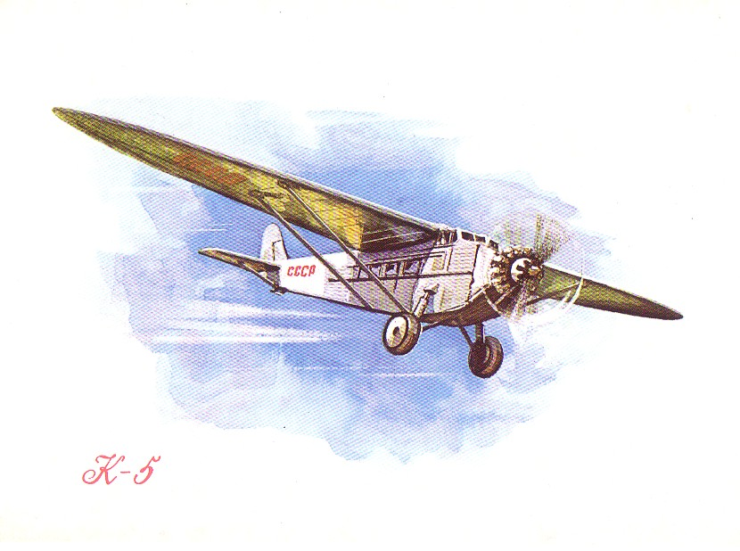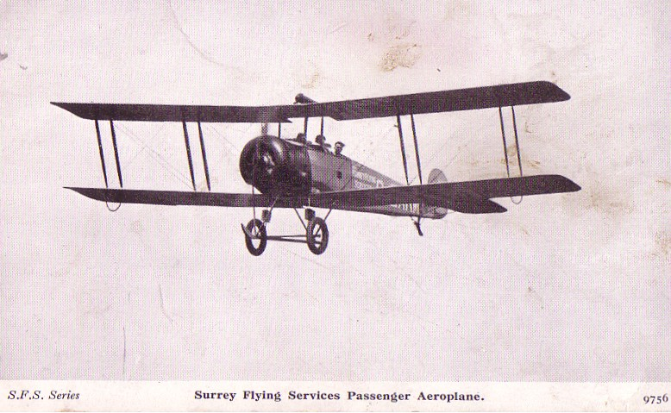

JULY
Transcontinental Air Transport (TAT) open US transcontinental service from New York to Los Angeles although the New York – Columbus Ohio and Waynoka – Sante Fe legs were by train. Company issue card of a Trimotor over the newly built Los Angeles city hall.. The Trimotor was also used for the Byrd Antarctic flight in November 1929.
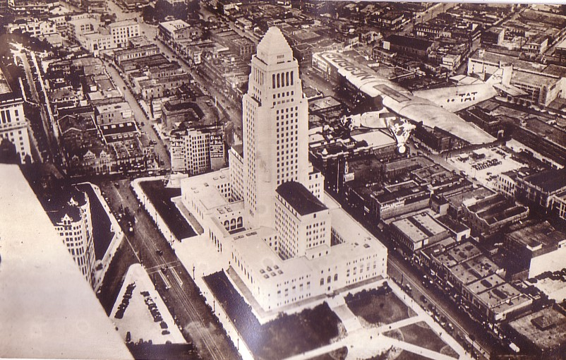

12
JULY - continued
On July 22 Lufthansa commence catapult mail service from Norddeutscher Lloyd liners with a Heinkel He12 seaplane from “Bremen” 300 miles off New York, saving 12 hours for the mail . Company card of launch .
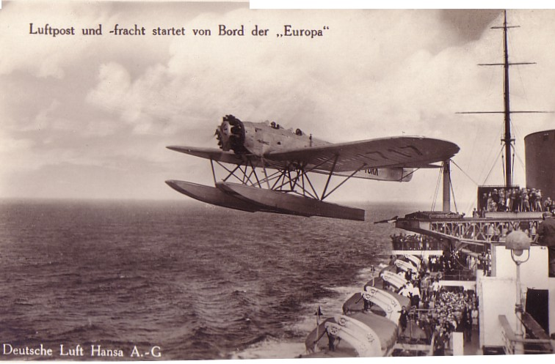

On July 12, the Dornier Do X 12 engined flying boat made its first flight at Friedrichshafen. It was part of an government backed large aircraft program along with the Junkers G38 (see November) but like many large-for-their –time designs never entered revenue service. This 1930 card is from the KLM Photo service.

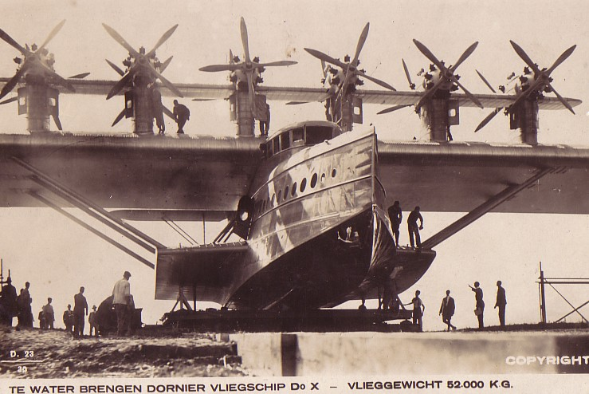

13
JULY - continued
On the 5th Paul and 4 other signatories at Brussels Haren airport send the brief message “Vliegen is plezant” To Heer Donckerwoleke (???) somewhere in Belgium. The Farman Line F.70 was still around in 1927 but may have been outlived by the card by Thill of Brussels.
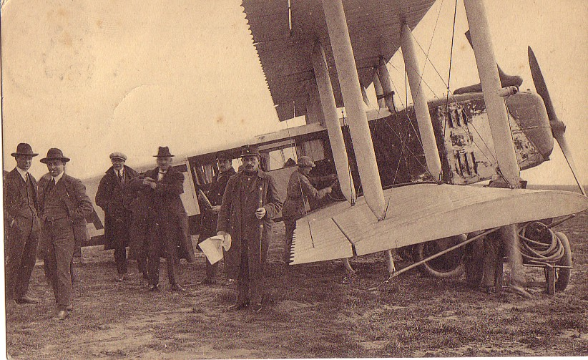

In Japan, NKKK, start service Tokyo-Osaka-Fukuoka using Fokker Super Universals as on this company card.
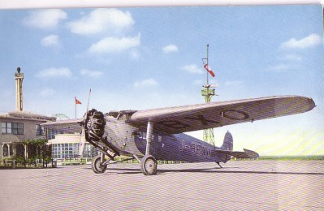

14
AUGUST
During August the Graf Zeppelin made a round-the-world flight commencing and finishing at Lakehurst, New Jersey with stops at only Friedrichshafen , Tokyo and Los Angeles. Deutsche Zeppelin Reederei card .
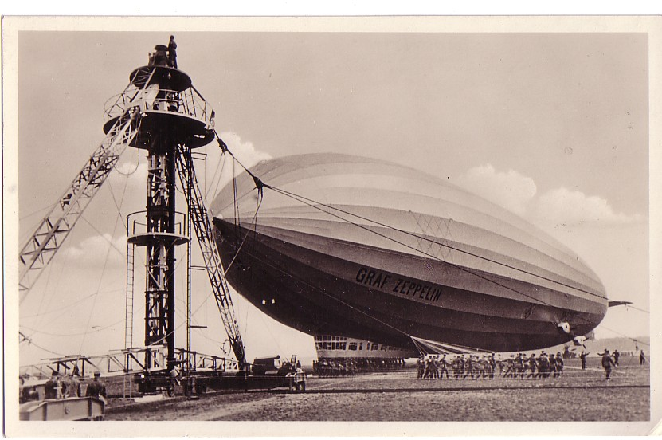
SEPTEMBER
First flight of the Puss Moth, first deHavilland light monoplane to be produced in numbers. This one G-ABIY is on a Sunshine series card for Portsmouth, Southampton & Isle of Wight Aviation, which also originated in 1929.
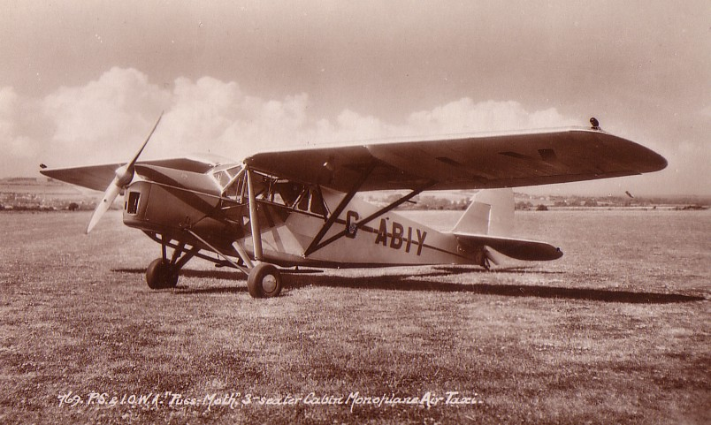

15
SEPTEMBER - continued
KLM commence regular mail service to the Dutch East Indies (Indonesia) using Fokker 7b’s as on this company card, which has back text about the trial mail flights in 1928.
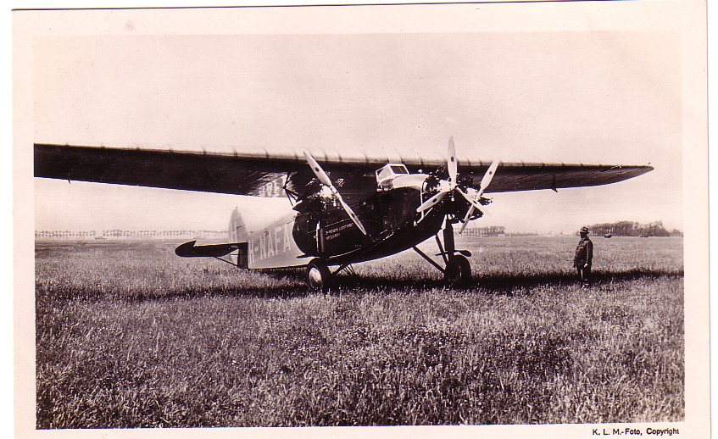

The Schneider trophy race for seaplanes is won by a Supermarine S6. Card of the trophy showing speeds up to 1927
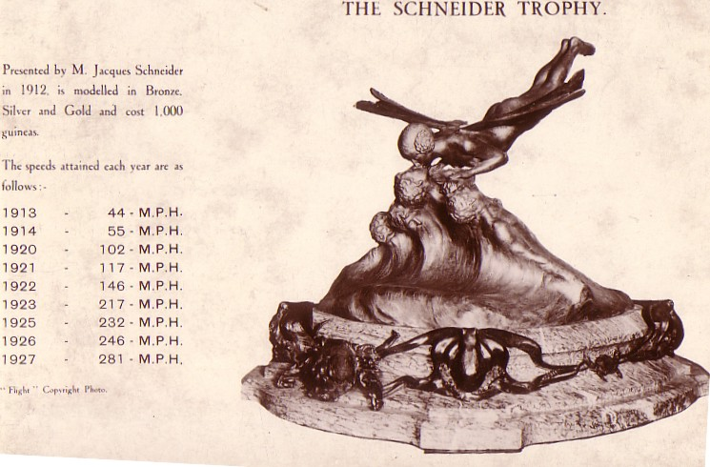
OCTOBER
In Cuba, Cubana commence service with a Curtiss robin as on this anniversary card from 1989
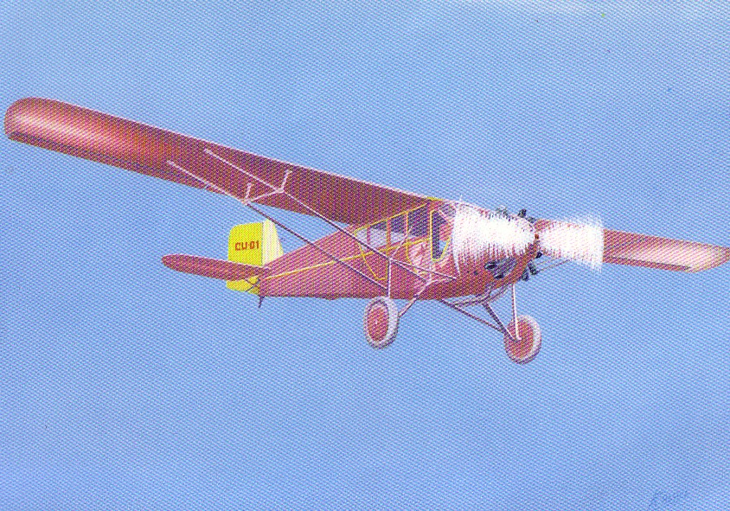

16
OCTOBER
The airship R101 made its first flight at Cardington, Beds on the 14th . On Nov 4th Charlie sent this from Bedford to Gertie in Accrington “I send you a picture of the ship just setting off, don’t you wish you were in it ……”.
Also on the 19th , somebody used this Westland Pterodactyl card to write a note “ Your Mother, Becky and Dad saw one like this flying about when they went to Hendon and said it was wonderful…..”
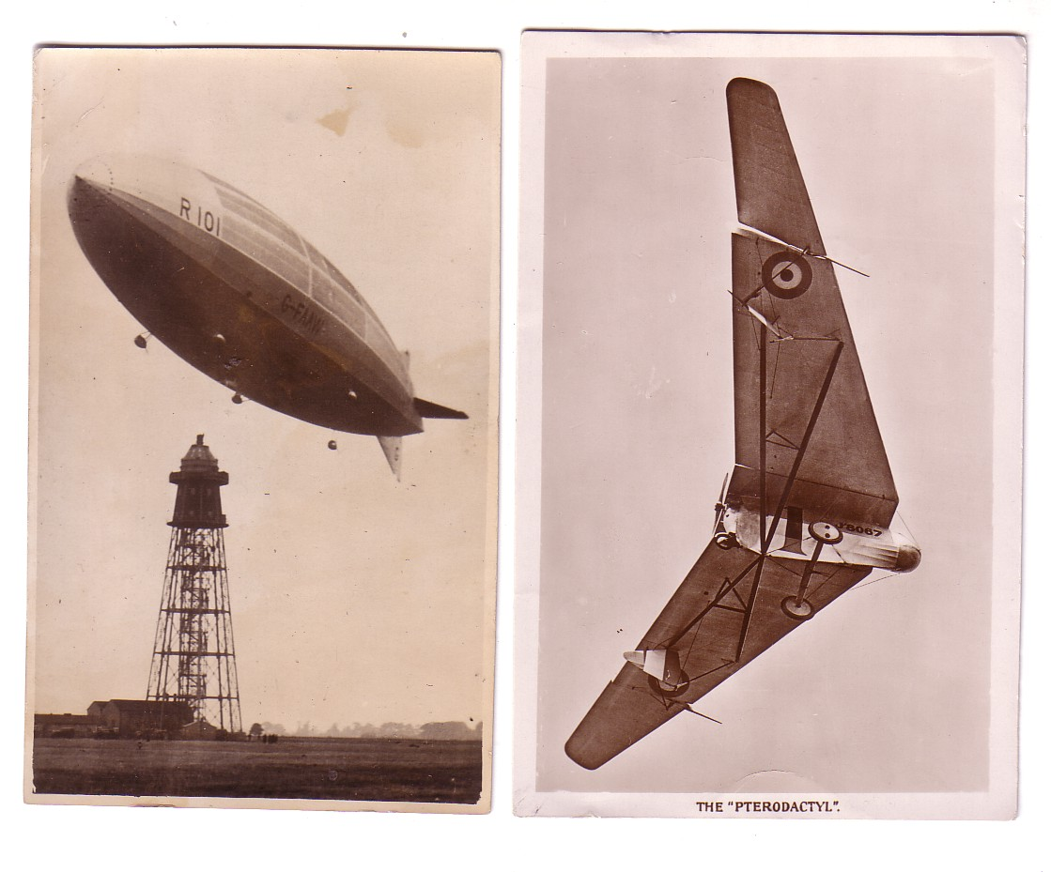
NOVEMBER
Another German “giant” the Junkers G-38 makes its first flight at Dessau. “Mum & Dad” bought this at Berlin Tempelhof in 1931 and wrote the card to send to Boreham Wood , Herts in Austrian A-100 (Junkers G-24) half an hour into the flight to Vienna, where it was mailed.
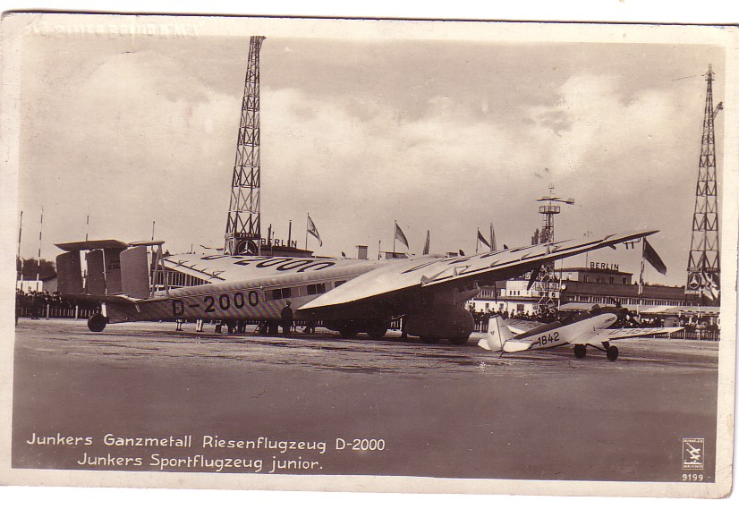

17
DECEMBER
Vickers built airship R100 makes its first flight from Howden, Yorks to Cardington. In July 1930 it will fly to Montreal St Hubert airport , shown on cards featured in Cards are Out There. A much more successful design than the R101, the destruction of the latter in October 1930 means that all British airship development ceases.

Information in this piece was largely from John Stround “Annals of british & Commonwealth Air Transport” & various airline history works by REG Davies.

