3
THE CARDS ARE OUT THERE
AVIATION SHOWS

Dec`14 Kempton Park Racecourse
Feb 7 Basel EuroAirport – French side
Mar 21 Stuttgart Musberg Village
Apr 5 Gatwick Crawley K2 leisure centre
Apr 25 Vienna Airport T2
Jun 6 Paris Holiday Inn Roissy-CDG
Jul 4 Frankfurt Schwanheim Village
Jul 23-25 AI2009 Wyndham Orlando, FL
Sept 6 Berlin Schonefeld Airport
Nov 7/8 Frankfurt Schwanheim Village

Dates are known for most European events well into 2009 , which could help in booking low-cost fares – although current trends on the £/€ exchange rate could offset this. The Manchester show listed in September was cancelled due to lack of vendors, which in turn was due to the unsuitable off-airport location. Work has started on a hangar to house the airports Concorde which would be a possible site for a revived show in 2009.

NEW ISSUES

Again Bill Baird has covered a lot of what was to be had at Frankfurt. It was noticeable that most of these are so hard to get out the airlines that anybody who was able to get spares was either offering for trade only or selling at prices that used to be only for older cards. There is a new BA history set from the Warsaw office, although like previous sets, its official status is unclear. There is a new large card set from Swiss Air Engiadina which includes helicopter and light aircraft as well as their Do328Jet. Singapore have re-issued one A380 card with revised text plus a new A380 one with a small Sydney Opera house image. A Qantas A380 issue is rumoured but not confirmed.

Among the failed airlines, Zoom of Canada issued a 767 card. This may only have become widely available from liquidators sales. Card shortages + digital rechnology encourage the production of fake airline issues but there is a genuine Cargoitalia issue as distinct from the bogus one featured previously. However even this is on the margin of “what is a postcard”. The DC-10 overpage is on thick laminated plastic card with an all-black back apart from the company address.

4
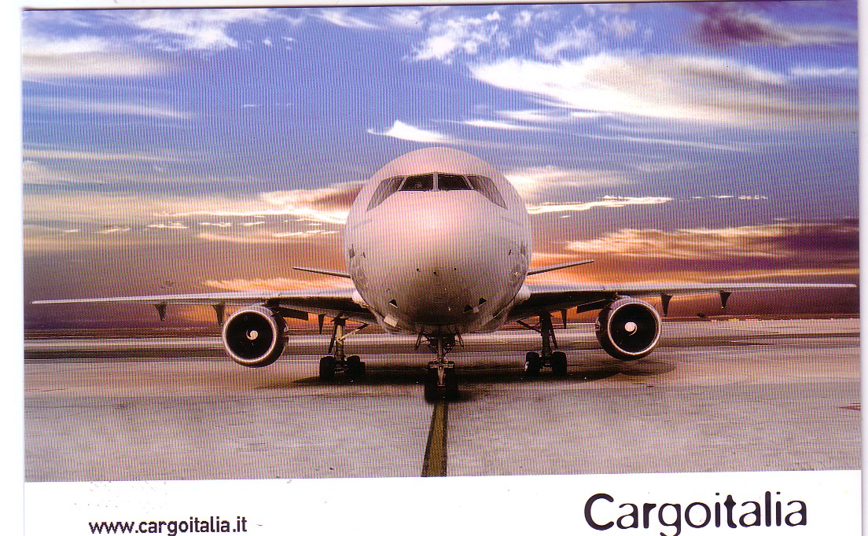

INTERNET REPORT
The great trade depression seems to have extended to the on line auction market with many items remaining unsold and the big numbers being in predictable categories. One such , in the UK market, is the Bridge House early Heathrow photographic cards, one of which, a BSAAC Tudor went for £100+.

Also predictable was that real photo cards of the opening of Singapore Kallang airport, 1937 would be well contested. The figures ended up at £90 for within-Uk sales of an Imperial Atalanta and KLM DC-3
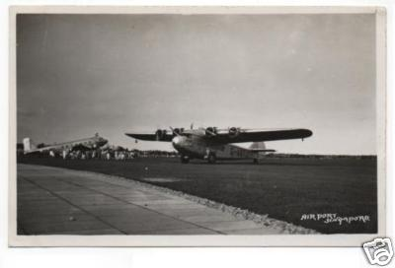

5
….and £79 for some bicycles outside the terminal.
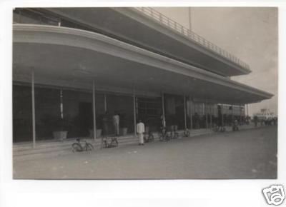
Lastly, while looking for some card images to illustrate the R-100 airship, I came across this collection of four, plus a commemorative metal button. I would not normally have searched for R-100 . The title used was such was that it probably would not have been found by many searches which explains why it only went for USD 10. The four cards, showing the Montreal Mooring Mast, Special Post Office, Mooring mast + a Ford Trimotor, and crowds are shown in an album page. Now if I had started on the Newsletter earlier I might have made a bid on it !

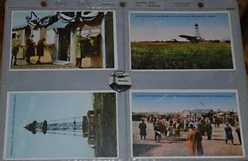

It seems a shame to waste this space so here are some more recent issues featuring the Airbus A380.

After a long break , a new Frankfurt Airport card from Michel & Co – large size.

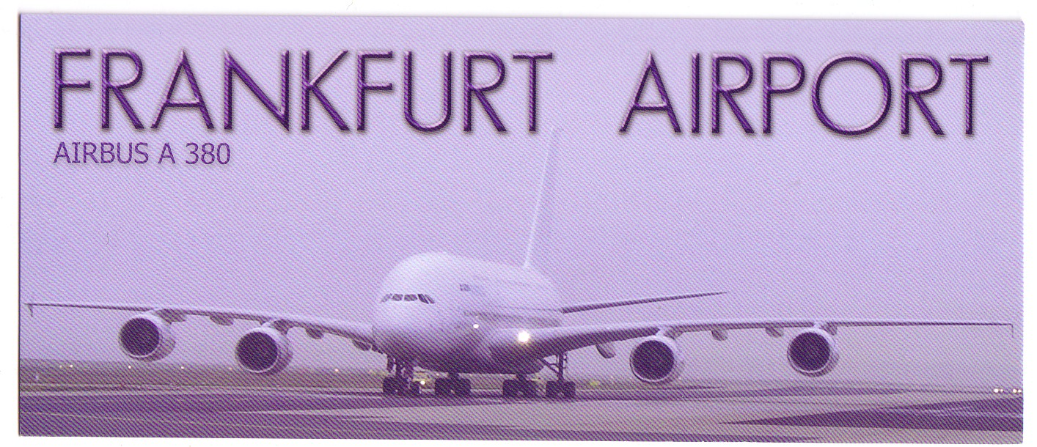

And the latest from Singapore, as mentioned in Cards are out there

