2
THAT WAS THEN……………
Editorial Impressions by Doug Bastin

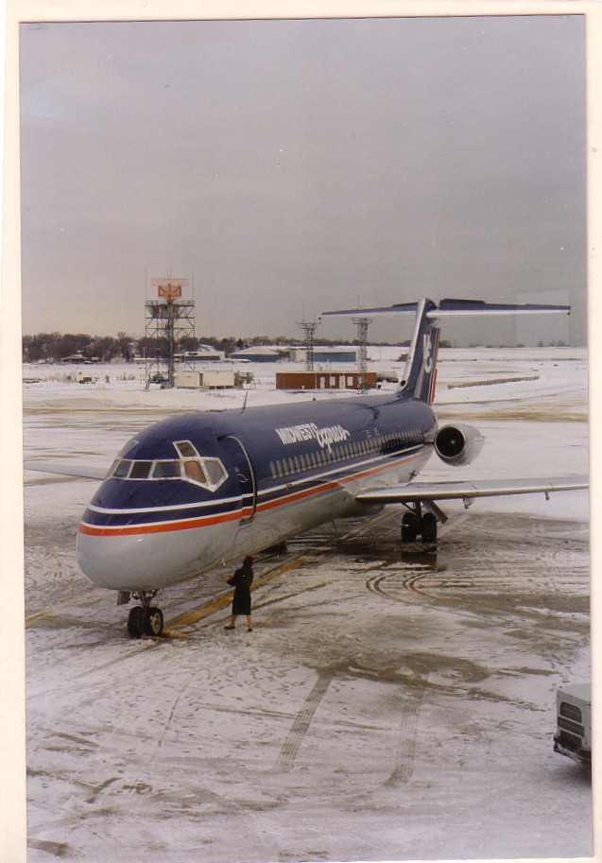

No events from 100 years ago this time. Instead a review of the events of 70 years ago – actually not quite. It seemed more appropriate to look at a year when the last October financial collapse happened - 1929. This will take up most of the special feature space. What Do You Know features some follow up on past features on 30s artist Howard Leigh, so there is a general 1930s theme here.

Another link to the 1930s was founder member Ray Billings who died at the end of September. A short piece recalls his own memories of Croydon and his postcard publishing activities.

On the Club News front, it is subscription time again and a renewal form is enclosed with this issue. No changes in UK rates but exchange rates have some benefit for those paying in other currencies although postal increases will offset this.

Once again , can I put in a plea for early payment by Cheque to Phil Munson or by PAYPAL to myself. Tracking late payers and sending reminders is by far the most onerous task in keeping the Club going and detracts from possible more worthy enterprises like the Imperial catalogue. Progress has again been slow on this – take up of the un-illustrated version was minimal. I guess it may be a case of analysis paralysis in trying to decide the best means of presention – to use another cliché, the best is the enemy of the good , so maybe its best to get something out and sort out any problems of whether the chosen digital format suits all takers.

Meanwhile researchers on Heathrow History and Hangar Construction have contacted me through Air Britain and found images from the Heathrow catalogue useful. Another outside link has been to the Polish Aviation Enthusiasts Soc – member Robert Stachyra asked for a piece on the Club for their magazine, which he edits – he will provide the translation.

I have got so far without mentioning Christmas. The cover picture of a Midway Express DC-9 at Milwaukee, April 1993 , is sort of seasonal. It is actually a private photo by myself , but converted to a postcard by a method copyrighted by a French company, Picty whereby a photo is mounted on a pC-backed card and overlaid with a plastic laminate. A modern version of the old postcard-backed-private photo which individual collectors may or may not regard as legitimate postcards. So, it just remains to wish all a happy Christmas and that, given that the most severe Chinese curse was supposed to be “May you live in interesting times”, 2009 t be less interesting.

Doug Bastin Chester December 2008

AVIATION POSTCARD CLUB INTERNATIONAL

Please renew my membership for year 2009 Tick class as applicable . Mail payment PAYPAL
UK membership £6 £6.50 ( )
Overseas Mail membership $16/€15/£11 $17,€16,£11.50 ( )
Overseas On-Line membership $9/€7 $10,€8,£6.50 ( )

Overseas postal members will receive printed newsletters by airmail. On line members do not receive printed copies but can download from www.aviapc.com.

Name …………………………………………………………….

Please include updates to any details held, Address, Phone, E-Mail or collecting interest

…………………………………………………………………………………….

…………………………………………………………………………………….

Payment can be made by £UK cheque (payable to Aviation Postcard Club) or $US / € CASH only , and enclosing this notice, to :-
Phil Munson, 10 Woodview, SHOREHAM BY SEA BN43 6AG, UK,

PAYPAL users worldwide can send to bastindw@aol.com.

PLEASE RENEW EARLY TO SAVE TIME AND COSTS IN MAILING REMINDERS

