WHAT DO YOU KNOW ?

As pioneer aviation is not my field, any queries relating to this period are likely to end up here – although web-searches can usually provide some basic details – but then in turn often offer contradictory information.

Clive Ginett asked if anything was known about the subject of this card of a Farman at Hendon – one of the huge number of cards issued linked to this first London aerodrome.
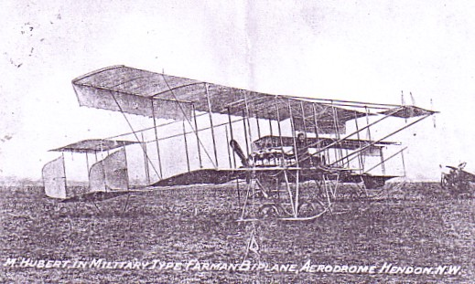

The title is M Hubert in Military Type Farman Biplane, Aerodrome Hendon NW. It appear that Monsieur Hubert ( Charles or Claude – both have been quoted) was born in Cherbourg in 1889. He must have been an experienced pilot by 1911 when he was selected to be one of four who would make the first air mail flights in the Uk from Windsor to Hendon. He was due to carry 8 bags of mail with a total weight of 200lbs. This load may have been responsible for the fact that he crashed on take off and broke both legs. For this he was compensated by a payment of £500 – an incredible sum. In 1911 the wages of an ordinary postman would probably have been about £70 per annum – and certainly no compensation for a broken leg if he fell of his bicycle. So Hubert got about 7 years pay for an ordinary postman. I suppose the mail from his crashed Farman is theoretically “crash mail” so maybe aerophilatelist members as well as those collecting pioneers , may be able to add to the Hubert story or correct any of the above.

The Hendon picture is from a photocopy but this, even rougher picture is from a postcard, or more accurately the remains of a postcard, found at Frankfurt in a load of ephemera. It is clearly of US origin and an equivalent to the cards issued by the many Avro 504 based outfits who toured the UK post 1914 offering pleasure flights.
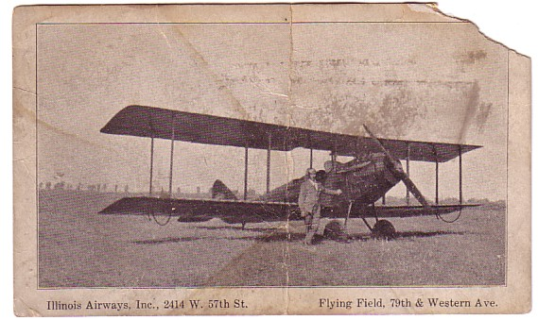
On the back is preprinted “ This is the Ship I Rode In” but it is unwritten and unmailed. The front has some identity clues. It says” Illinois Airways Inc, located at 2414 W 57th Street “ and also “Flying Field 79th & Western Ave”. So where were these ?. Obviously a major city by the street and building numbers, so , if its Illinois Airways, I would guess Chicago. Hopefully some Chicago area members can confirm these are Chicago addresses – I would guess that 79th & Western is now well built over.

The classic US barnstorming aeroplane was the Curtiss JN-4 Jenny and the Illinois Airways machine is similar but does not have the Jenny’s overhanging upper wing. This is a case when the Internet is pretty useless , unless you can guess a type and then look for a picture. Resorting to paper sources however has come up with a possible. An incredible paperback published 1946 by James Fahey has thumbnail pictures of almost every USArmy aircraft 1908-46 and this one looks like a Springfield-Vought VE-7 trainer. I guess this Springfield was the Illinois one ( not the Simpsons one !).
