THE CARDS ARE OUT THERE
AVIATION SHOWS

Show organisers seem to be getting their dates publicised earlier than in past years

Jan 6 Croydon. Old Airport 10.30
Jan 26 Los Angeles Hacienda Hotel LAX
Feb 16 Basel-Mulhouse EuroAirport
Mar 1 Luton Vauxhall Recreation Club
Mar 15 Stuttgart Musberg Village
Mar 29 Vienna Airport T2
Apr 27 Gatwick Crawley K2 leisure centre
May 11 Kempton Park racecourse
May 24 Paris Holiday Inn Paris-CDG
June Frankfurt Schwanheim village . Exact date TBA.
Jul 10/12 Airliners International 2008 Dallas-DFW Sheraton
Nov 1-2 Frankfurt Schwanheim Village

NEW ISSUES

The autumn Frankfurt show can be relied upon to identify many new issues. Here is a selection of those to be found this year from airlines in addition to those shown by Bill Baird last time
Austrian 777 ; Niki A320 “Vienna” ; TuiFly 737-800, 737 tail, crew Icelandair 10 card 70th anniversary set, 3D 787/DC-3 ; Belavia 737 CRJ Tu-134 Tu-154 ; Finncomm EMB-145 ATR-42.; TAROM large size set featuring current equipment + Romanian pioneers.

The Belavia cards are on nice stiff card and will probably be the last official cards of both Tupolev models. The backs have route maps. Here is the 154 EW-85706

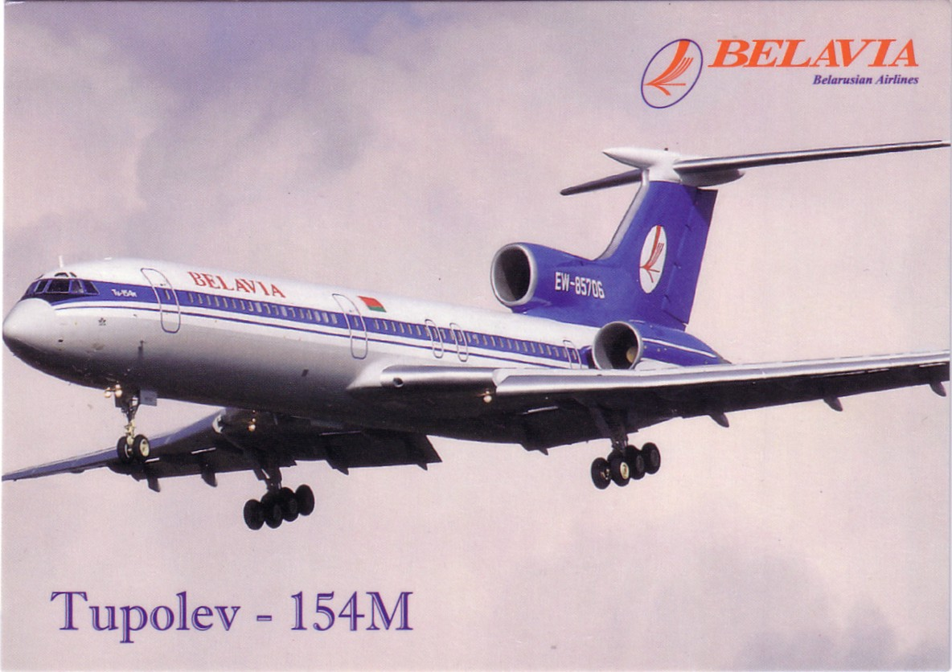

As usual the Frankfurt show attracted collectors worldwide.
Here is this years selection of pictures. Member/collector/publisher Carl McQuaide…………



Looks like someone may have dropped a card at Chris Slimmers table , L to R, Canadian Buice Charkow, Leonardo Pinzauti, Frank Litaudon.

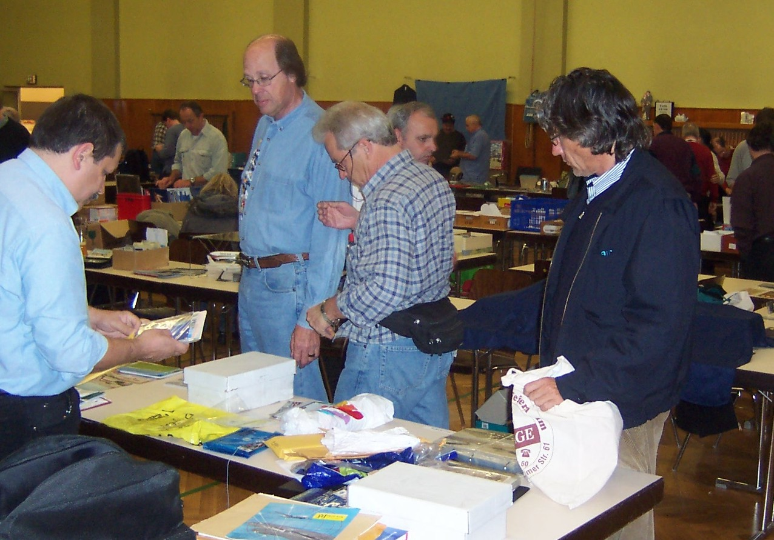

This 787 image is part of the Icelandair 70th anniversary set and also doubles up with preserved DC-3 TF-NPK on a 3D card with the viewing angle determining which you see. Again route maps on the back.

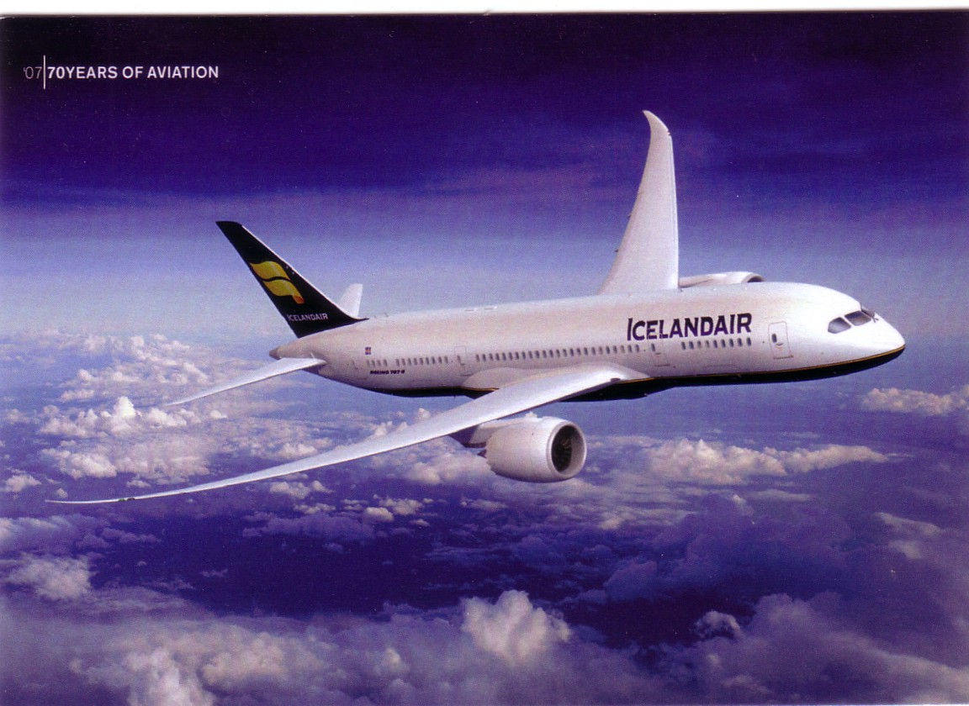

INTERNET REPORT
No surprises but, for international buyers and sellers the good news is that Ebay has restored default visibility USA to UK and vice versa for items in any “Collectables” category – but only if the seller lists detailed mail costs for the target continent.

Lastly, don’t under-rate the 50p or $1 boxes at postcard shows/fleamarkets Chris Slimmer found this Bali Airport card at one in Kansas City
