WHAT DO YOU KNOW

Last month we asked
“So, did the Prince of Wales inspect the riverside Supermarine works at Woolston, Southampton, and if so when, and was there a Supermarine boat serialed N179 and if so what type?”
Despite the mis-quoting of the serial number, which on inspection proved to be N174, Alan Leonard, from Southampton provided the answers. Also a card image is now available as below.
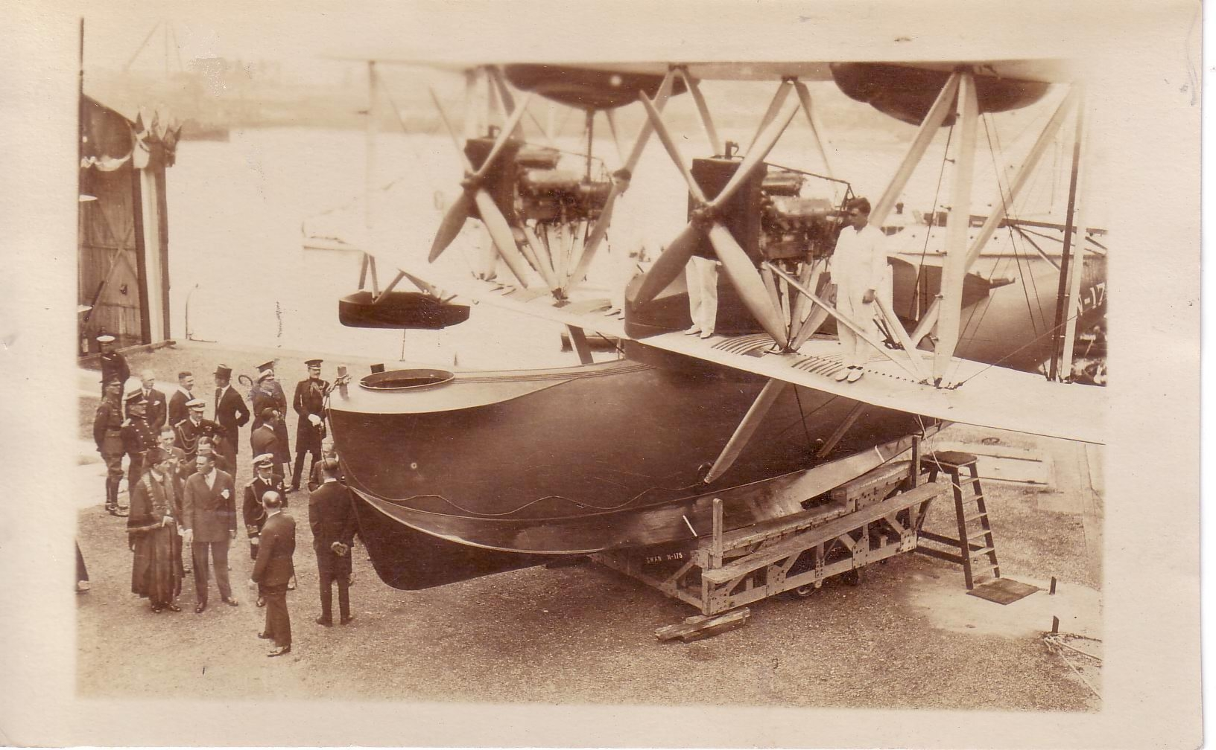
It was the Prince of Wales, it was Woolston and the flying boat N174 was a Supermarine Swan. The date was June 27 1924 and the Supermarine visit was an add-on to a visit to Southampton to open the then world’s largest floating dock. While at Woolston he also visited the Imperial Airways base for their Channel Islands service. Also identified in the party is future Spitfire designer R J Mitchell., although it is not clear which is he.
The same source came up with another mystery card. This is a group of the first Womens Royal Air Force, which, previously the Womens Royal Flying Corps was established to provide support and maintenance workers in WW1.
This group is shown with what is presumed to be an instructional airframe – on the back it says “Ascot”. Was the racecourse used by the RFC/RAF in WW1 ?

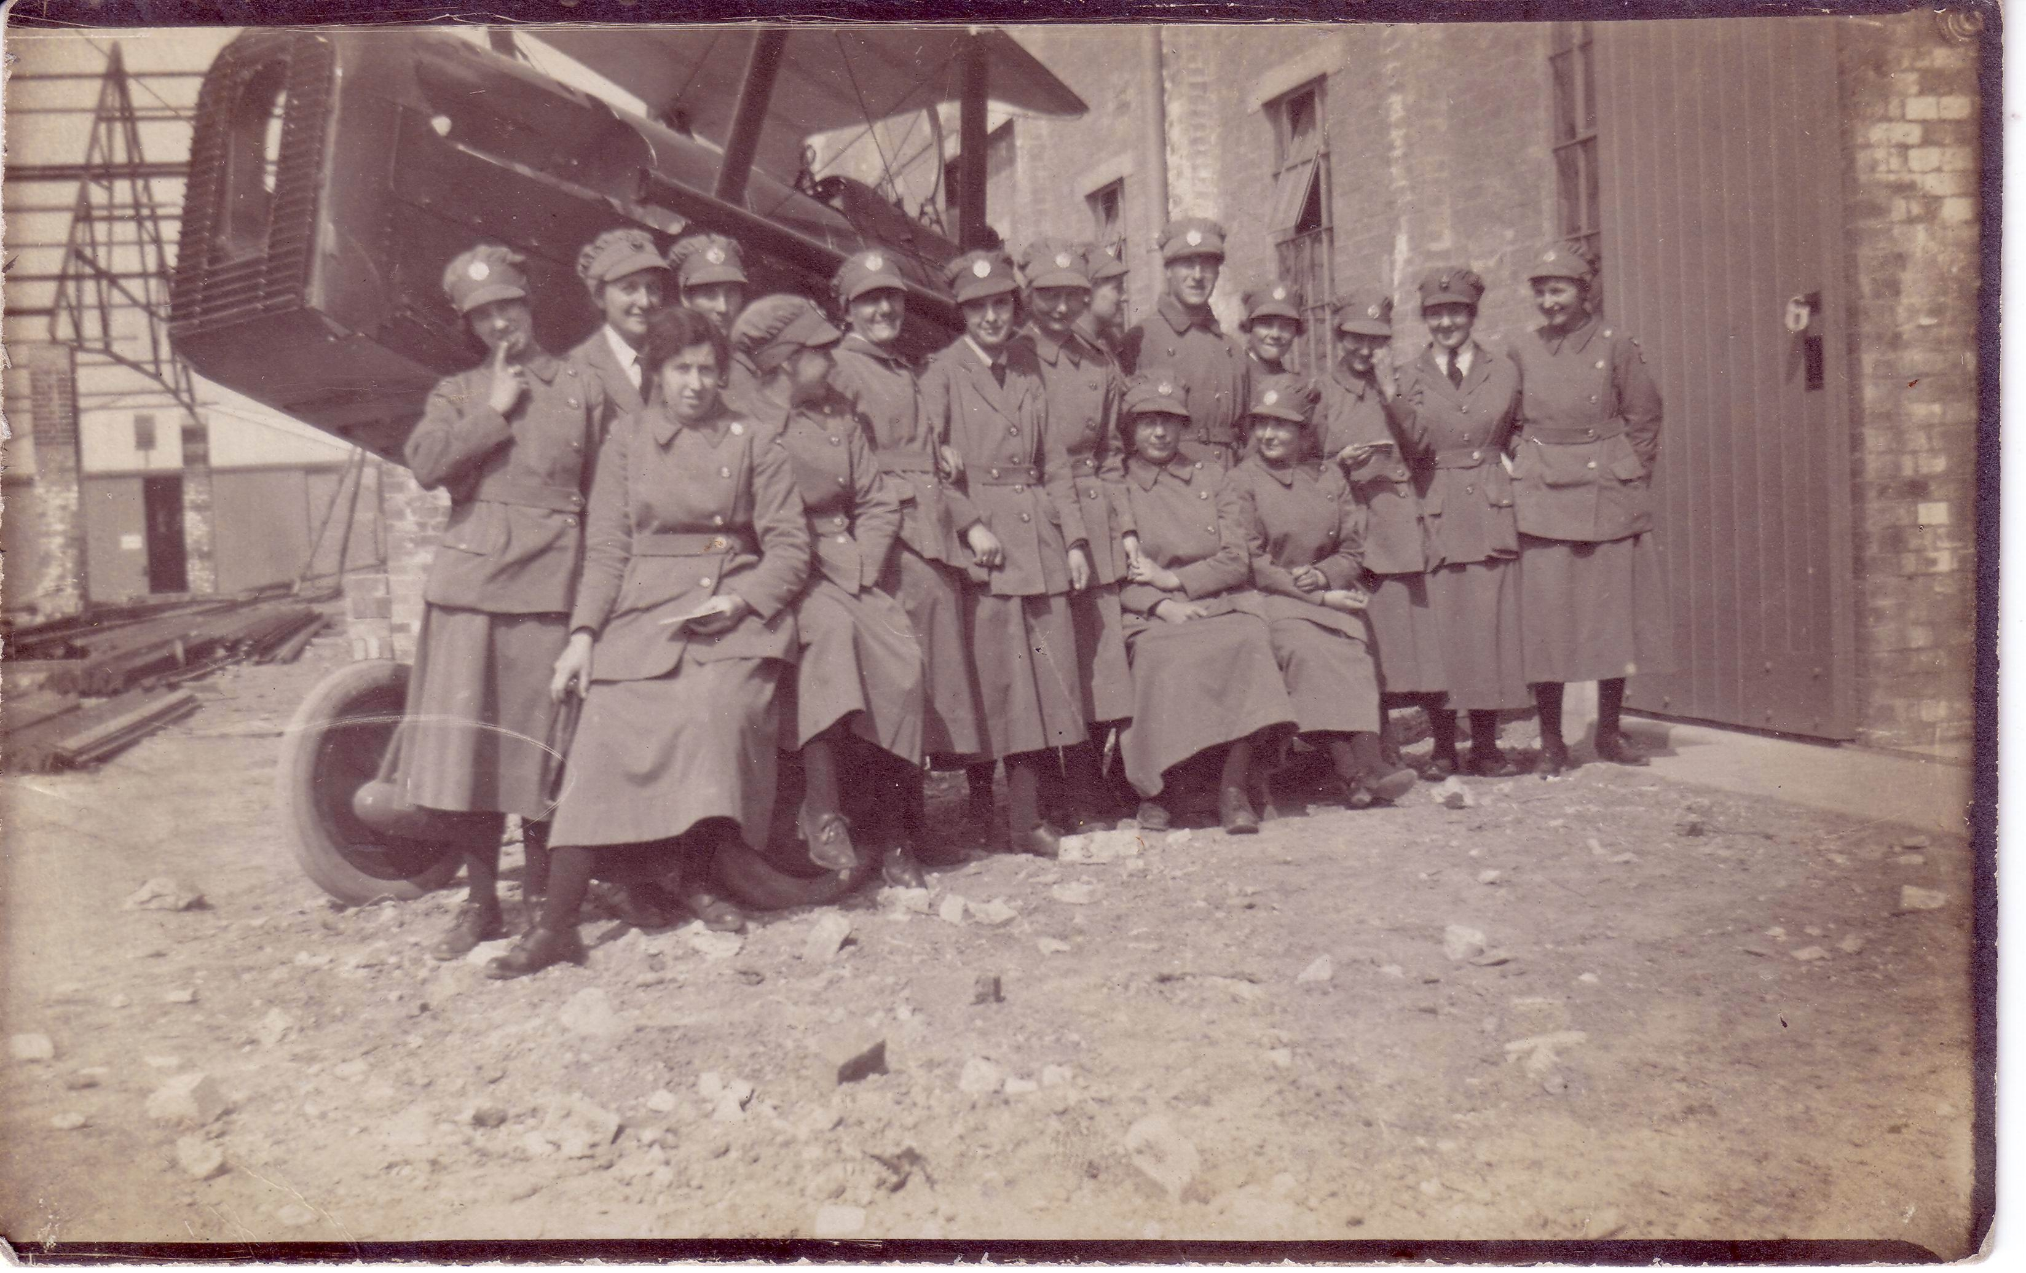
Lastly , one more unidentified, this time from Germany. This is an aerial view of an airfield with a number of Lufthansa Junkers F.13 visible. The style of radio masts and tower is similar to that on 1920 s cards of Berlin-Tempelhof. No clues at all. Other than typed text on the back which is oddly spaced and reads as follows ”WilhelmOb rberfg igentuhm”. Could be meant to be “Wilhem oberflug…. i.e William flying over…. But the “igentuhm” is a mystery.
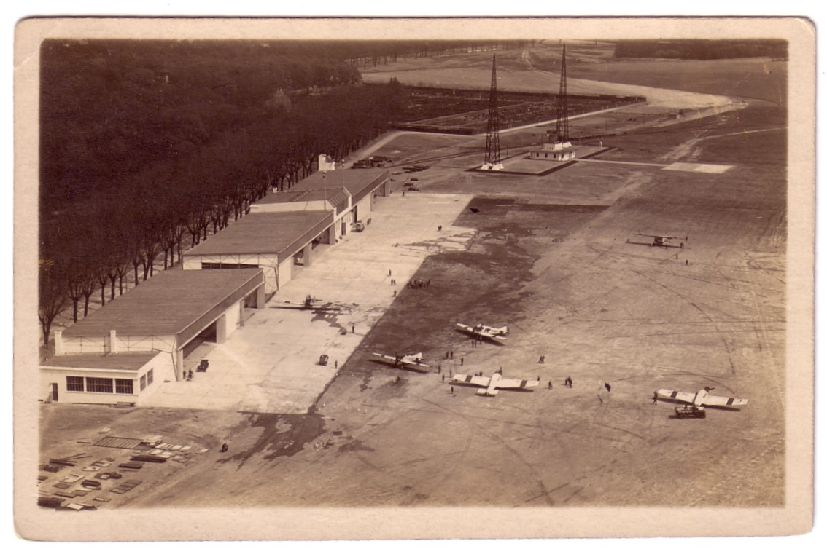
Two more intriguing cards. This untitled Short Calcutta G-EBVH is by photographer M Cooper but lacks any other identification. G-EBVH operated a Mersey to Belfast service for a few weeks in 1928 and the skyline could be the Mersey North shore before the Anglican cathedral had its tower.
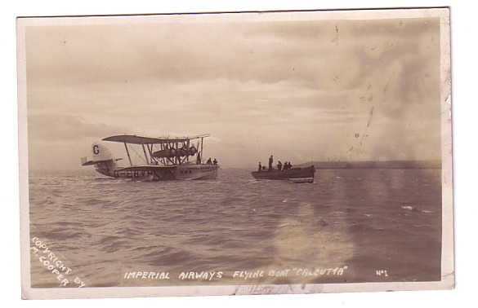
This snow shot is enlarged from a pre-war 3 view photographic postcard from Norway. The card is titled Jotunheimer – Tyin Hotell and the other views show close and distant views of the Hotel in the snow. The aircraft is Avro Avian LN-ABF which was used by the Norwegian Antarctic expedition of 1933. One of the figures is holding a can of Mobil Oil and their logo is also on the Avian. Pre or post expedition publicity shot ? Some connection with the hotel as training camp ? Who knows ?


