MONTHLY FEATURES

SEPTEMBER 2003 NEWSLETTER US DIVISION
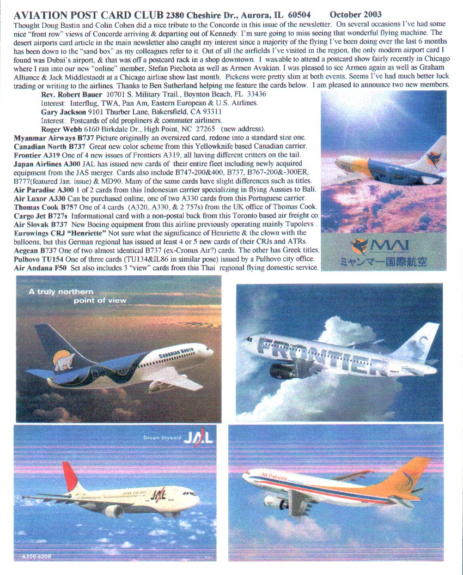

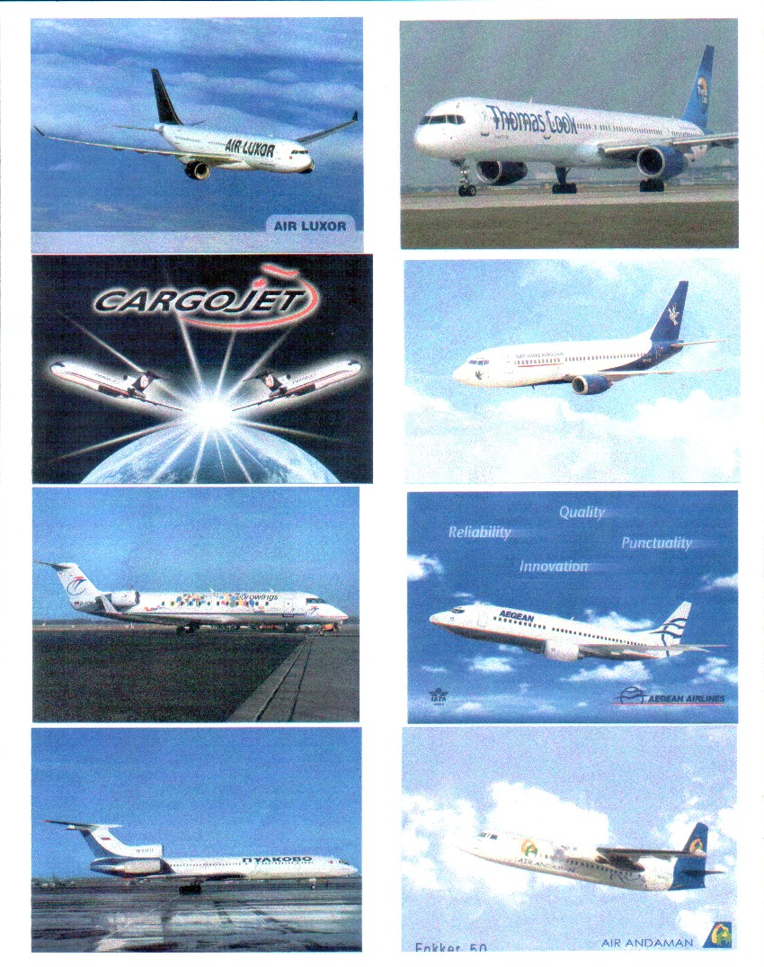
Members will have noticed that the US pages carry an earlier date than the main newsletter. This is because the US page is added to the main paper newsletter when it is circulated in the US in arrear of the UK edition, so it is actually published between UK paper editions. So this month we have US pages dated September

THE WRIGHT BROTHERS
THE EUROPEAN POSTCARD CONNECTION
Compiled by John Worsley & The Pioneer Study group

The centenary celebrations of the Wrights’ first powered flight in 1903 have covered most aspects of this remarkable event, so what else is there to say ? The Pioneer Study Group felt that a tribute based on items from our collections might be of interest particularly when there are messages about the events involving the Wrights and their pilots.
Any collector of aviation cards who wishes to have a few examples of “How it all started” will soon discover that there are no contemporary cards for most of the period 1903/8. The reasons for this are numerous: the secretive behaviour of the brothers as they strove to patent their work, the lack of interest from the local and national press and the total failure of the costly Langley “Aerodrome” all led to a belief that flying machines just were not going to work. So there are just museum cards and a shoddy commercial series produced at a much later date. So, ironically, the widest range of cards showing the Wright “Flyers” were produced between 1908/10 in Europe. It is these cards which form the basis of this extended article.

1908 : THE WRIGHTS SHOW THE WORLD
The brothers had spent a good deal of time trying to set up a commercial future for their work. By 1908 negotiations with the US Army and European groups meant that a series of trials/demonstrations were needed. Using the model developed from 1905 onward (known at the time as Standard models, Type A was a title given at a later stage) Wilbur and Orville established themselves in France and Fort Myer respectively. It was then that most postcard studies began. Wilbur’s sensational flights during Aug-Dec 1908 inspired hundreds of different views that were quickly taken up by the public. This was the “Golden Age” of postcards and, even if many of the flying scenes are, to our more educated eyes, clearly inaccurate or heavily edited, nobody cared ! Orville’s flights in the US while also well received did not produce as many cards and consequently these are relatively scarce with even the more ordinary scenes having reached $100 on Ebay Net auctions.
Between September and December Wilbur was based at Auvours near Paris and made over a hundred flights, mostly with passengers. He trained three French pilots, de Lambert, Tissander and de Gerardville. At this time Wilbur continued to use the rail launched method of take off, which is shown on three cards below.
A typical scene at Auvours where crowds would come from Paris and beyond on the off-chance of seeing a flight or going up as a passenger – dated 10 Oct 1908 with the Flyer leaving its hangar.
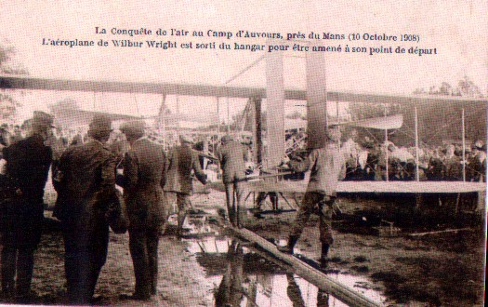

Possibly the most flown pioneer aircraft, this A type was shipped to France in 1907 and made over 170 flights from August 1908. It was powered by a 30 h.p Wright engine. Its longest flight was of 77 miles on Dec 31 1908. Here Wilbur stands by the two seats as the mechanics prepare to start the engine. The forward elevators were kept until 1910.

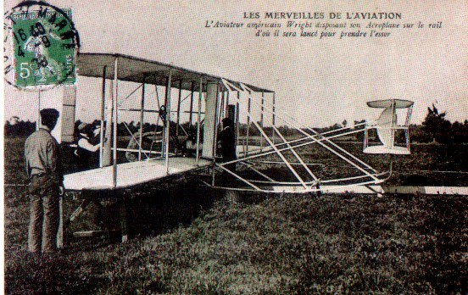

The elaborate derrick/weight launching aid is often cited as a deficiency of the Wrights’ early flying , although it was not developed until 1904. It was out of use by 1910 but the overall design of the A type was so good that Wilbur easily won two prizes after use of the launch machinery had been prohibited
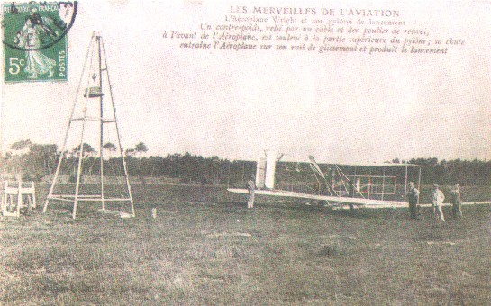
Two prominent supporters of the Wrights at Auvours were Leon Bollee (front) and Hart Berg. Bollee helped with workshop space and mechanics while Berg, as agent, made sure that many influential people came to see the flights. Wilbur looks on, wearing his “trademark” cap and the seated figure may be Tissandier, one of the pilots trained by Wilbur. Note ,at this time, skids rather than wheels were used on the A type
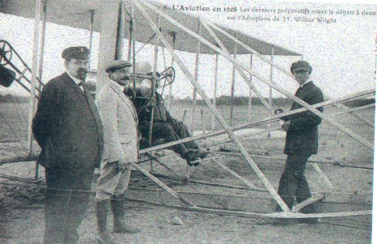

PAU – L‘ECOLE D’AVIATION 1909
Wilbur moved to Pau in January 1909 and was soon joined by Orville and their sister Katharine. By February the “Ecole” was carrying on with the training started at Auvours. The demand for postcards of the brothers continued undiminished.
Here Tissandier features again and even shots of Wilbur “playing” were included – although the title claims he is checking the state of the launch rail. Orville and the “President of the Aviation Committee” look on.

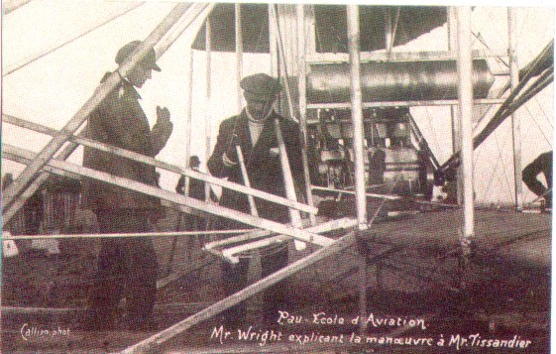

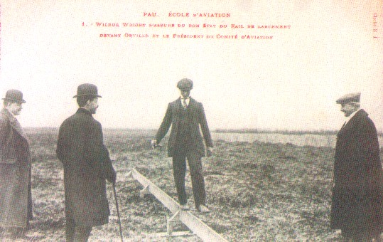

Pau became an important centre for flying with Bleriot also setting up a school in November. This card from a local photographer gives a good idea of what the crowds came to see. The hand-stamp suggests it was possibly sold in a local souvenir shop.
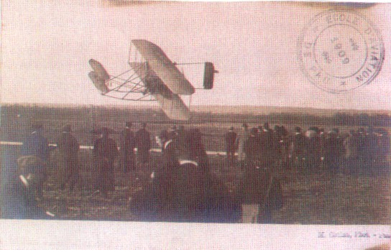

Visitors came from far and wide. This card, once more featuring Wilbur and Tissandier, was posted from the nearby resort of Biarritz to England on 18 March 1909.. The message includes …I thought you would like to see “W” . We went last Friday to see him…most wonderful”

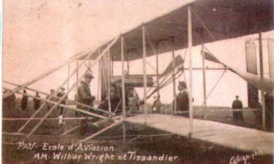

..and not just the general public. A steady stream of VI.P s visited Wilbur , including Edward VII. A particularly fine set of at least six cards featured the King of Spain. Another card posted overseas from Pau, this time to Scotland, says “The King of Spain did not go up with Mr Wright as he had promised the Queen he would not” (11 March 1909)

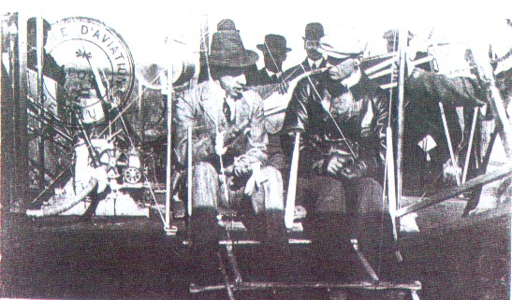

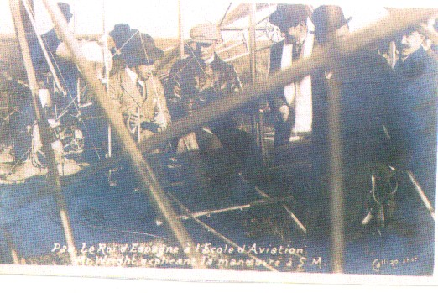

ROME & BERLIN
The Wrights moved to Rome in April 1909 to train two Italian officers. The plane used was shipped from the US and was similar to the Auvours/Pau flyer. During one of the flights on April 24 1909 a cine-film was shot, the first one ever taken in-flight.

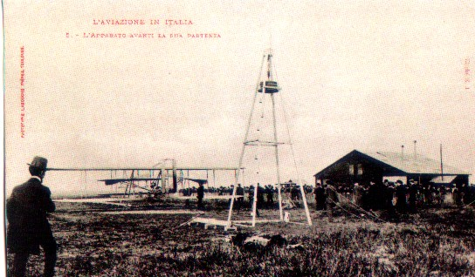

After returning to the US, Wilbur never returned to Europe. Orville , after the successful trials with the US Army Signal Corps travelled to Berlin with yet another Dayton built Flyer. This aircraft was to be the only surviving A type. A popular card series showed the visit of the Crown Prince and , on October 2 he became the first “Royal” to go up as a passenger.

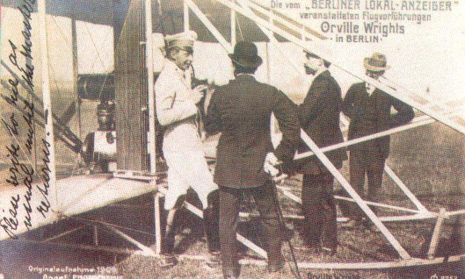

THE RHEIMS MEETING (Aug 22-29 1909)
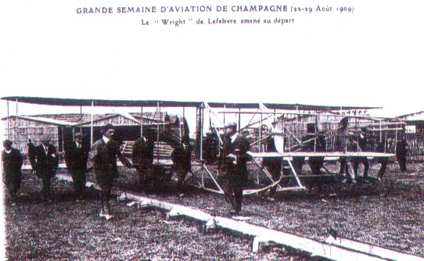
It is sometimes forgotten that this event took place almost a year from the day that Wilbur amazed all those who were at his French debut at Hunaudieres and later Auvours. Many questions remain as to why the Wrights did not participate. The success of the Army trials had consolidated their position n the US and Orville was in Europe on his way to Berlin. Wilbur’s dislike of “showmanship” is well known and the fact that Glen Curtiss was to be the official US entry for the Gordon Bennett Trophy could have contributed to the decision not to attend. But also likely was their awareness of the way Bleriot Farman and Curtiss had progressed their designs over the previous year – highlighting the shortcomings of the Wrights design. However three capable Wright pilots did take part , Lefebvre, Lambert and Tissandier.
Lefebvre was one of the stars of the show, not for winning any prizes, but for keeping the huge crown entertained – ironic in view of Wilbur’s attitude to such frivolity. The correspondent of “The Aero” remarked “ when he found that his machine was not fast enough to compete…he kept to his métier of amusing people. The promoters owe a debt of gratitude, for he provided just the necessary comic relief (This apparently included diving on both photographers and startled cavalry-men)

………AND AFTER
The surge of interest in aviation after the Rheims meeting led to a steady increase in fatal accidents. Lefebvre becae the first pilot to be killed testing a French-built Wright. DeLambert made a well received flight varound the Eifel Tower in 1909 but more perceptive commentators, writing later, dismissed it as an “aerial theatricality
Although the Wrights licensed Short Bros to produce their designs in England, the Flyer used by Charles Rolls in his double crossing of the Channel in June 1910 was French built. Sadly Rolls was another casualty, being killed in a crash at the Bournemouth meeting a few weeks later.
Count de Lambert in his Wright Biplane.

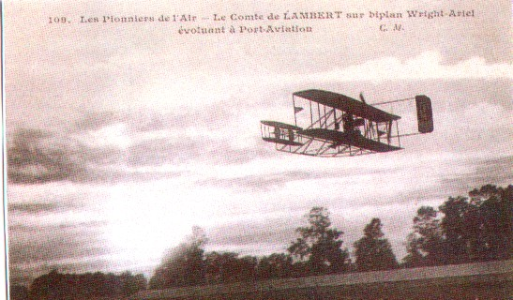

Rolls at Dover on his Channel Flight of 2nd June 1910

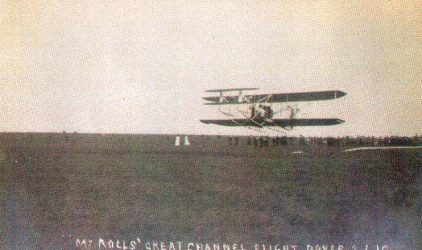

THE EUROPEAN CONNECTION FADES AWAY
The planned developments of Wright approved companies never really materialised and by 1911 all manufacture of the new B and later R types, including the”Baby Wright” was based in the USA. The “Baby” that Ogilvie flew as part of the British team competing for the Gordon Bennett Cup in 1911 had been built for him in the US. In this event the Wright was quite outclassed and this was probably the last entry of a Wright machine in this competition. The card shows the Baby Wright at Christchurch.
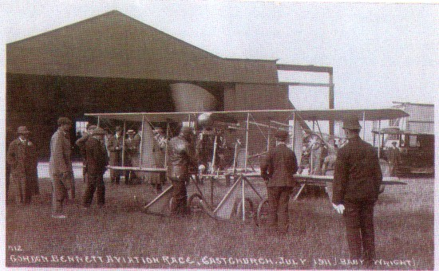
Although numerous fatalities had occurred in Wright crashes in the US and Europe, there were some flying schools that saw the side-by-side Wright seat configuration as an advantage. The Beatty School at Hendon trained only a few pilots in 1913/4 but , for some reason, generated several postcards showing Beatty and his associate Baumann training potential aviators.
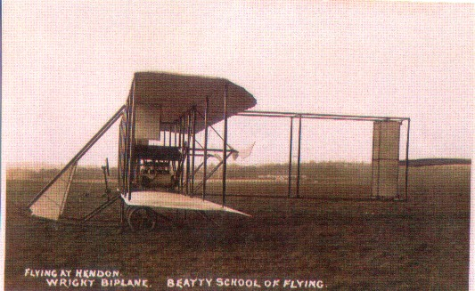

CASHING IN ON THE WRIGHTS
As the most famous aviators around, many promoters of the early Aviation Meetings hoped to gain publicity by linking their show with an appearance by a Wright machine, or even one of the brothers ! There is some evidence that the Blackpool organizers approached Baratruex, one of the Wright aviators, and his name does appear in a programme and a Wright biplane was pictured on a “Blackpool Aviators”card. But, no Wright actually flew at the meeting.

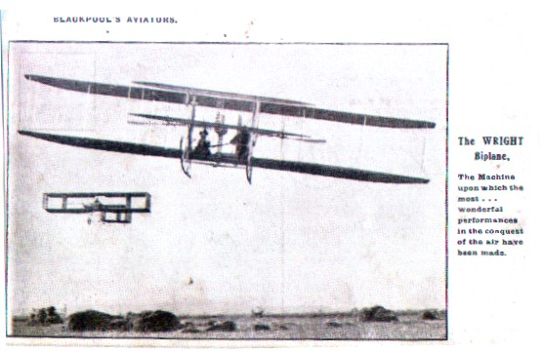

Likewise in the US, the organizers of the 1909 St Louis show had every hope that Orville would appear – not realizing that he would be in Europe to fly at Berlin. This card, with a caution rare in such claims , says “Orville Wright…has been invited to compete in the flying machine contests at St Louis Centennial Week”

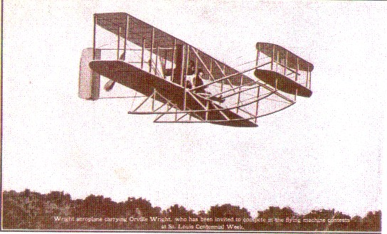

WILBUR WRIGHT 1867 -1912
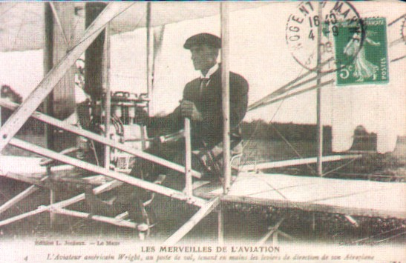
The death of Wilbur Wright from complications following an attack of Typhoid, was a tragedy. But by then the Wright’s work had been overtaken. This commentary, taken from H. Penrose “British Aviation – The Pioneer Years” (Putnam 1967) is accepted as a fair appraisal of his work.
“But in Europe Wilbur was largely forgotten. The new generation of flying men were boys when Wilbur and Orville made their first flights. Perhaps in the years during which the two brothers had devoted all their energies to reap financial reward they lost too much ground through leaving their machine undeveloped. Probably its crude and amateur construction indicates that they were incapable of developing it further. Yet their unchallengeable achievement was that they devised the first heavier-than-air flying machine with which man was able to sustain himself for prolonged periods under such complete control that turns could be executed with accuracy and distances travelled with certainty. But the design was based on misconceptions, even in the derived form demonstrated in Europe in 1908, for the Wrights had not perceived that stability must go hand-in-hand with controllability. Their European contemporaries understood this requirement, and, even before they had seen the “Flyer” had gone some way towards achieving this goal. It is true they were amazed at the dexterity with which Wilbur flew his unstable machine and, in their emotional way, the French pilots showered exaggerated praise on the man many had believed a charlatan. Yet no one attempted to copy the injudicious elements of Wilbur’s machine – it was the Wrights who presently began to modify their own conception, bringing it into line with established European practice; eliminating the forward elevator with its short leverage and substituting a moveable tail on a longer arm; increasing the engine power; strengthening the structure and rendering the machine more practicable by incorporating wheels to escape the tedious task of using a launching-derrick catapult. Although Cody, in England ….has been criticized …as having produced a dead-end aeroplane, his first machine was a better engineered job than the “Flyer” and successive versions were strengthened and improved until the latest was one of the ablest aeroplanes in the world. This had been done by a man entirely dependent on his own private enterprise and finance – whereas the Wrights had, by 1912, acquired large sums of money through their patent battles and thus had no obstacle to development. But, if it was they who had fallen into the trap of producing a machine which they personally had not the ability to develop in pace with the Europeans, there is no doubt that Orville and Wilbur were unique , and for ever hold the most honoured place in aviation because of their devoted and painstaking research, their trust in their own powers, their bravery in hazarding their own lives in their experiments and their final achievment of being the first full masters of the air.”
This piece was compiled by the Pioneer study group. John Worsley will accept any blame for mistakes etc. Ken Jones, our convenor, would be delighted to hear from any members who would like to know about our activities.
If your appetite for early aviation history has been whetted, the Pioneer Group suggest the following further reading – or just key any Pioneer Aviator or Event into the Google search engine – and then let it all flow !
1) The Wright Brothers Aviation Pioneers and their Work 1899-1911. C H Gibbs Smith 2002 (revised) NMSI Trading ISBN 1900747448. A must have – short, to the point, many useful images. All for £4.95.
2) Directory and Nomenclature of the First Aeroplanes 1809-1909 Also by Gibbs Smith. HMSO 1966. Horrible title – very useful reference.
3) First to Fly The Unlikely Triumph of Wilbur & Orville Wright J Tobin Murray 2002. ISBN 0 7195 57275 One of several for the centenary. Rather long winded but well researched with substantial notes and references.
4) The Wright Brothers FC Kelly Harcourt Brace New York 1943. The only authorized biography. Good account of the European visits but rather “gushing”
5) One Day at Kitty Hawk JE Walsh Crowell NY 1973 An example of the “revisionist” view. Such works highlight the less positive aspects of the Wrights business practices and the behaviour of Orville in seeking to take greater credit for his role in the early days. None now challenge the status of the 1903 flights however.
6) Pedulum 2 J Carpenter Arsdalen USA ISBN 9600736 2 0 (2003) This work argues that Curtiss should be given greater recognition for developing the US aircraft industry

