MONTHLY FEATURES

SEPTEMBER 2005 NEWSLETTER US DIVISION
Members will have noticed that the US pages carry an earlier date than the main newsletter. This is because the US page is added to the main paper newsletter when it is circulated in the US in arrear of the UK edition, so it is actually published between UK paper editions.
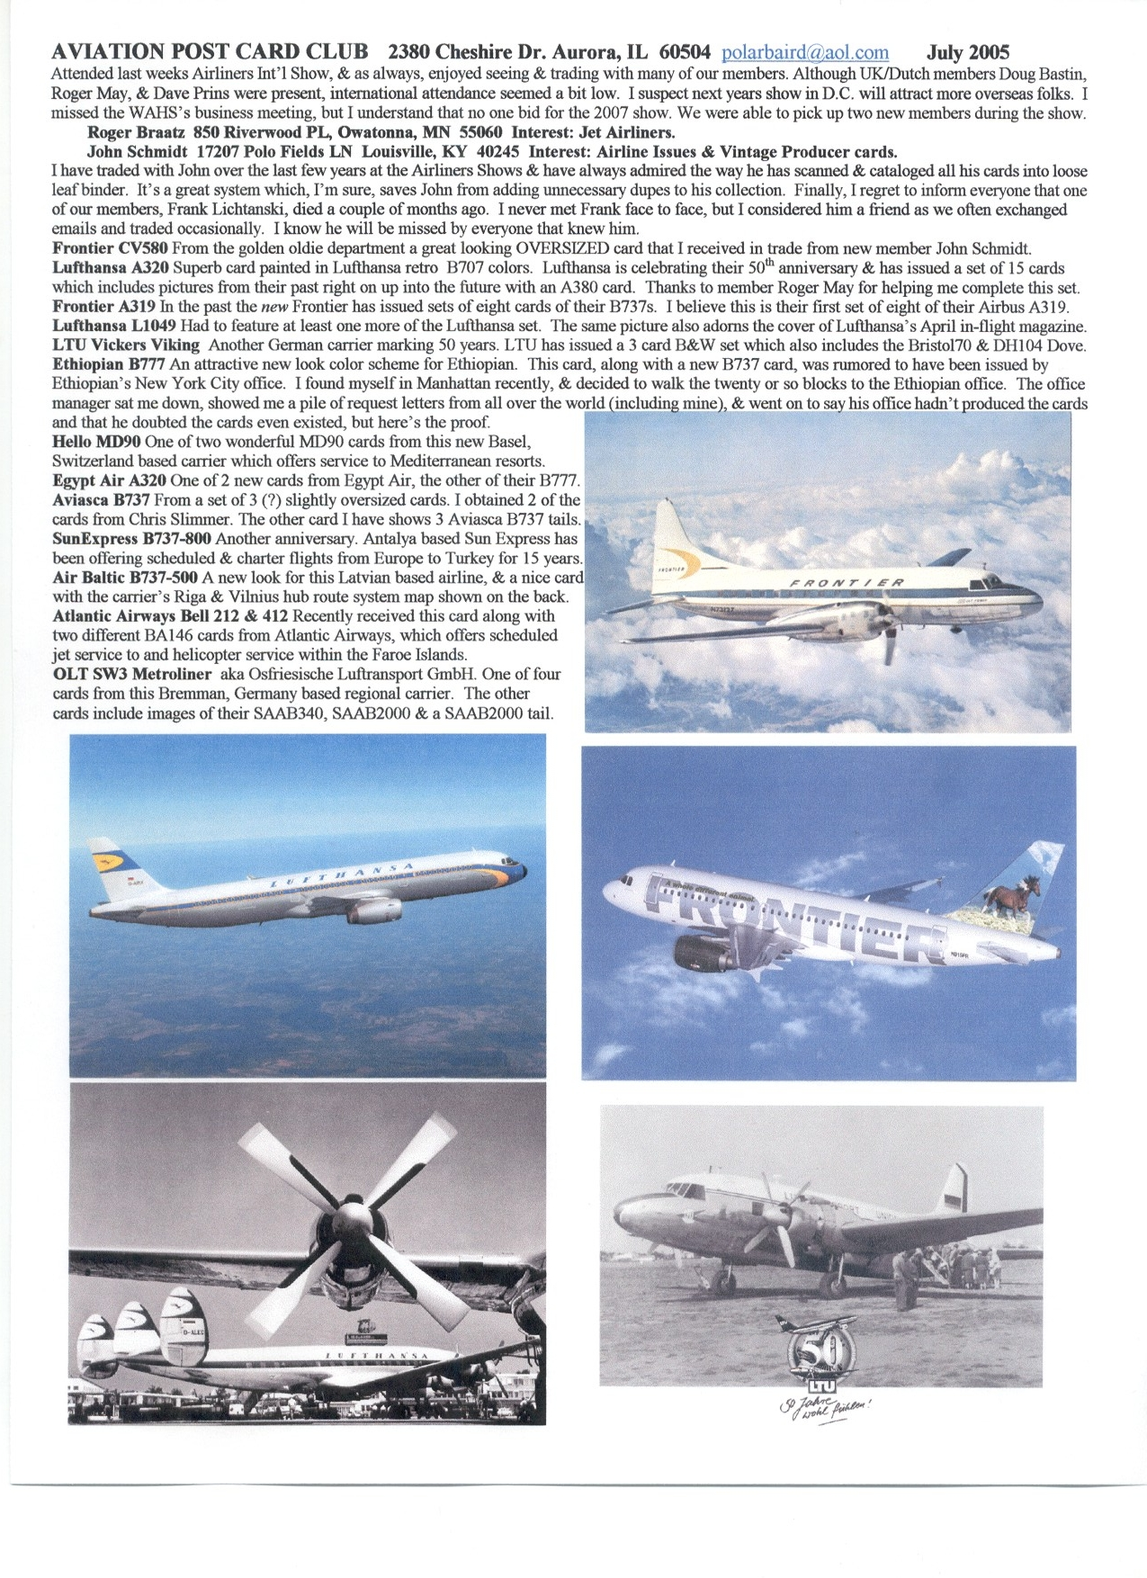
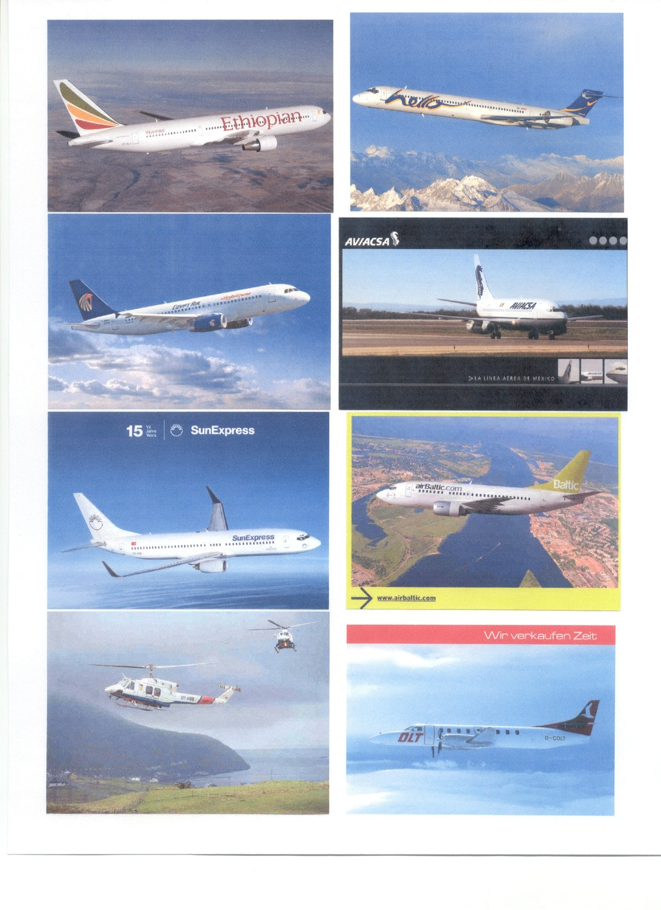

PIONEER PAGES
CODY'S FIRST
This is the last piece of pioneer material left over from issue 50. Frank Worsley submitted this card titled “British Military Aeroplane” by photographer F Scovell who went on to be a prolific photographer of early military aviation activity in the Farnborough/Aldershot area. The subject is Samuel Cody’s first powered aircraft , entitled British Army Aeroplane No 1, in which Cody was able to make a series of very short 'flights' over the period September to October 1908. On 16 October 1908, the fifth, which ended in a crash, was the first officially recorded powered flight in Britain - a length of 1,390 feet. The card was posted on Oct 24th from Aldershot with message “What do you think of this little beauty”
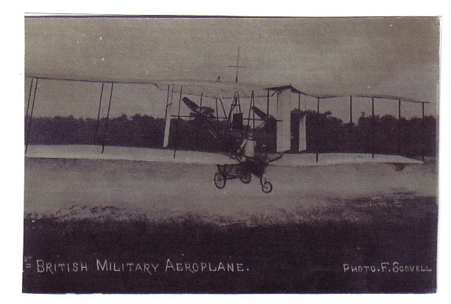
Like his namesake, Buffalo Bill Cody, the American Samuel Cody had first come to Britain as a cowboy showman, who may or may not have actually frequented the “wild west”. Prior to leaving the US, he had carried out experiments with man-lifting kites. He revived this in Britain and was highly successful in selling the idea of man-lifting kites for observation purposes to the Army. The Army were sufficiently impressed to engage Cody as Chief Instructor in Kiting at the Balloon School in Aldershot (1906). Cody was charged with the formation of two kite sections of the Royal Engineers (these were later to form the nucleus of Air Battalion RE, later to become No 1 Squadron Flying Corps, then finally No 1 Squadron RAF). He then moved on to a kite glider and also, with Col J E Capper, worked on the design of the first British military airship Nulli Secundus. The pair plus Lt C M Waterloo on board, made a world record-breaking flight of 3 hours 25 minutes from Aldershot to London. After circling St Paul's, they attempted to return to Aldershot, but were defeated by 18 mph headwinds and forced to land at Crystal Palace. The card shown was an early example from publisher Valentine, almost certainly with a crude representation of the airship edited onto an existing St Pauls view.
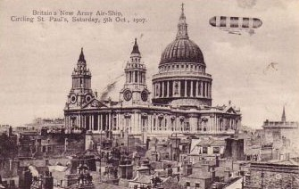
Cody's exploits came to the attention of Haldane, Secretary of State for War who promptly terminated Cody's contract, as he could see no future or military use for aircraft. Cody continued on his own. He was allowed to use Laffan's Plain for his test flights using his rebuilt plane. Cody carried passengers for the first time (14 August 1909) - Col Capper, first passenger, Lela Cody, first female passenger (both world records). Cody then made a world-record cross-country flight of 1 hour 3 minutes (5 September 1909). Laffans plain appears to be the site of this photographic postcard by the Rotary company.
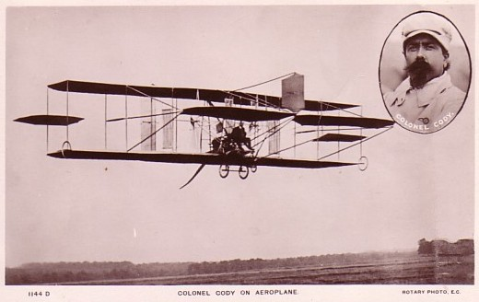
In 1910, using a newly-built aircraft, Cody won the prestigious Michelin Cup with a flight of 4 hours 47 minutes. In the same year, with a different aircraft, Cody's was the only British plane to complete the round-England race - finishing fourth. On 7 August 1913, Samuel Cody was killed in a crash whilst joy-riding across Laffan's Plain. His aircraft broke in half 500 ft above Ball Hill. Cody and his passenger, the cricketer W H B Evans, were pronounced dead on arrival at the Connaught Hospital.

The funeral procession, with his coffin was on a gun carriage drawn by six coal-black horses, drew an estimated crowd of 100,000. He was buried with full honours in the Aldershot Military Cemetary..
Another memorial at Farnborough which stood at the end of the runway, was a tree , known as Cody's Tree, to which Cody used to tie his plane. It was later moved and replaced by a cast aluminium replica made by RAE apprentices.

THE FILMS ARE OUT THERE
On the same theme about realising value already touched on in the Editorial, the club has been approached by a company seeking old aviation film for transcription to and marketing on DVD. It is particularly interested in amateur film taken at airports, airshows or other aviation events. The material may be in original format or already transcribed to video. At very least this is an opportunity to get old material transcribed on to a modern format and possibly also to realise some value. If anybody has such material and wishes to hear more, then please contact the editor initially via any of the means, written, phone or E-mail set out on the front page. Basic information required would be subject, date, duration, current medium and condition. Depending on the response, a means of evaluating your material and capturing any information to add commentary can be sorted out. As a guideline, material from events covered by commercial news or other film such as Farnborough airshows is less likely to be of interest than material from more obscure events or just a “day at the airport”.

This set off a train of thought on how little interaction there had been between aviation on films and aviation on postcards. Despite the many and various aviation themed films I am unaware of any film publicity cards apart from the battle of Britain set as featured on the cover. This despite the many overlaps between the two industries due largely to both exploiting the climate of California and the money of Howard Hughes. However here are a few connections.

In the 1940s/50s American Airlines produced a number of stewardess cards . Who knows if these were actually employees but one certainly was not. This 1951 card doubled as a advert for a comedy called “3 Guys named Mike” and featured actress Jane Wyman, who was married to Ronald Reagan 1940-48. The background is presumably a DC-6 as aAmerican would have wished wish to feature their “top of range” although, it would have been likely to have taken off as such, flown as a DC-3 and landed as a Convair if following the general standard of accuracy of the time.
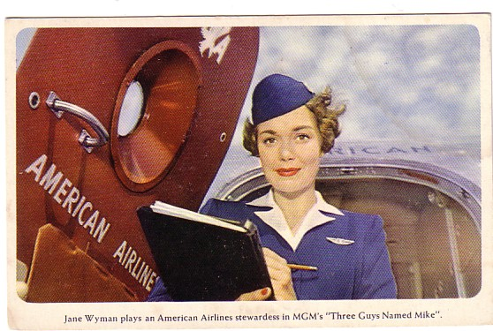
Curiously the next film-linked card also features a flight attendant, in this case an Imperial Airways steward on the Croydon-Paris Silver Wing service operated by AW Argosy trimotors. This is one of a number of 1930s cards from the French newsreel company Pathe featuring extracts from news film – the company “cock” motif familiar up to the end of cinema newsreels is shown very small on either side of the titles.

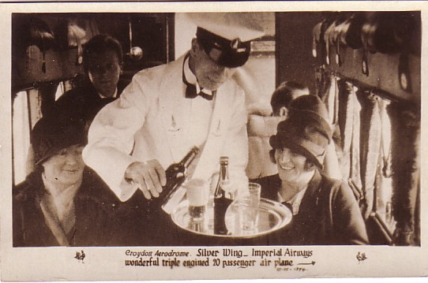
Lastly two other cards, both will a filmstrip motif, both featuring 747s, both featuring freighters and both shot at Hong Kong Kai Tak. The first is one of Luxemburg carrier Cargolux’s many cards. This one is slightly oversize and shows a 747-200F landing. The other by Hong Kong publisher Frank Samuel is VERY oversize at 7 x 10 inch (13 x 25cms) and shows a Polar Air Cargo 747F (but with hybrid Southern Air Transport, alias CIA, markings) on take-off. Bill Baird, who flies for them (His E-address Polarbaird – gettit!) may know what it was about but will probably plead the 5th amendment.
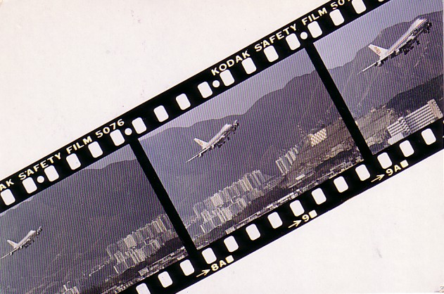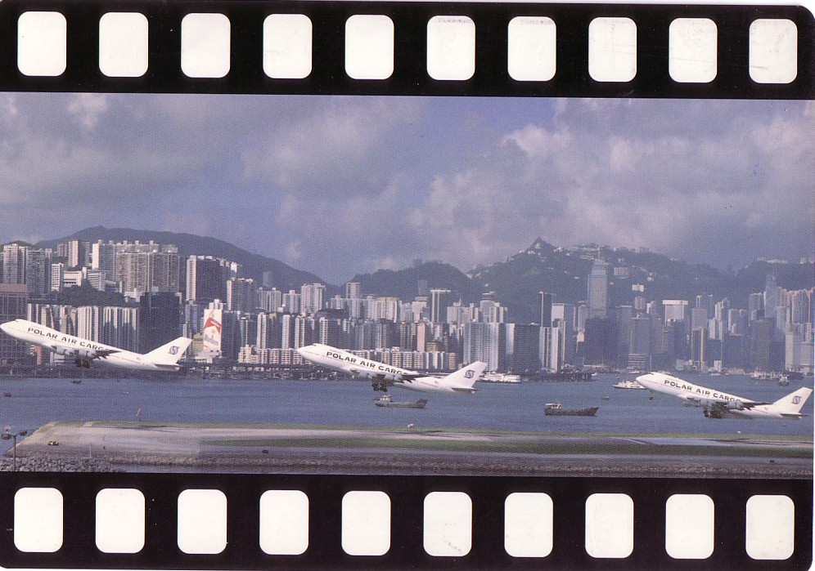
And there are the many film derived cards from Movifoto of Colombia but we told their story in issue 50.

EARLY AUSTRALIANS
AUSTRALIAN AIRLINES OF THE 1930s
Many of earliest Australians, namely the aboriginal population, are likely to have seen aeroplanes before any other form of mechanical transport. It would be some time before their art was to adorn the 747 s of the country’s main international carrier (see Colin Cohen on Qantas ).

However Australia was early to appreciate the contribution that air transport could make to a continent whose cities were located at some distance from each other around the coast and with an empty centre. From the inception of Qantas (Queensland and Northern Territory Air services) in 1920, this airline expanded to be the country’s chosen international carrier, initially in partnership with Imperial Airways and later BOAC. Once established as such, it was for many years not allowed to operate domestic services. No pre-1939 cards issued by Qantas are known to me, but in 1970 they issued a reprint of what may be a postcard (or just a titled photo) of their very first service. The original had a written addition “Pilot Hudson Fysh (QANTAS founder) 3.10.22”
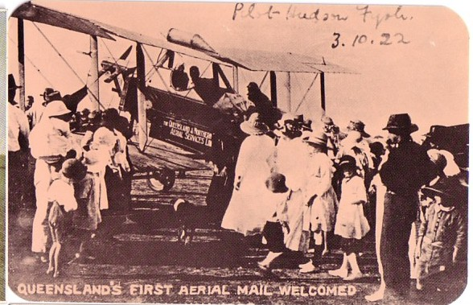
Cards of Qantas British built equipment also featured among British issues of the time and two cards of the Empire Flying Boat fleet operated by Qantas are shown. Qantas operated the Singapore- Australia section of the Imperial Air Route, under the name Qantas Empire Airways, initially with DH.86’s but later Empire flying boats. The anonymous top card shows Coolangatta at Townsville, Queensland, while the lower by Mowbray shows two boats ar Rose Bay, Sydney. Rose Bay was the scene of the destruction of Coolangatta in Oct 1944 after its return to Qantas after RAAF service in, amongst other duties, evacuations from New Guinea in 1942.
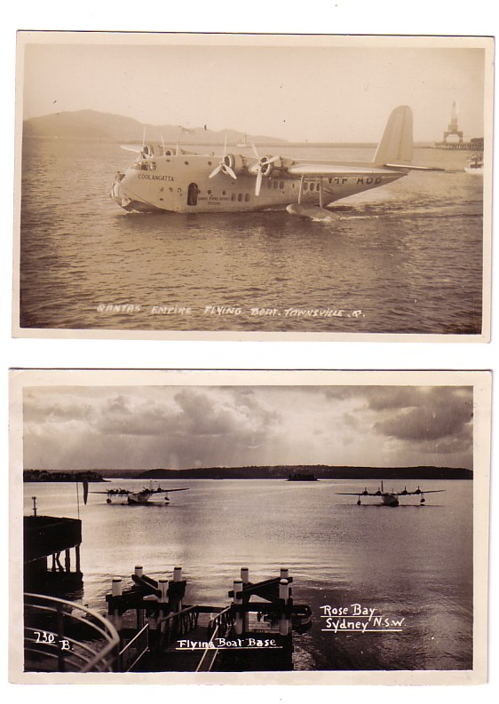
The celebrated Australian distance flying pioneers Sir Charles Kingsford Smith and Charles Ulm established the first unsubsidised Australian airline in 1930, using the Avro Ten an Avro built version of “Smithy’s” record breaking Fokker. It ceased trading in 1931 after the disappearance of Avro “Southern Cross” in March 1931 – its remains were not to be found until October 1958.
The name was revived in 1936 for a merger of two private operators Adelaide Airways from that city and Holymans Airways from Tasmania. Both of these operators issued cards, the former of a Short Scion and Monospar. A Leopard Moth card is also known. Holymans issued a DH86 card. The back text is “Maintaining a daily service between Hobart-Launceston-Melbourne via King and Flinders Islands and vice versa”
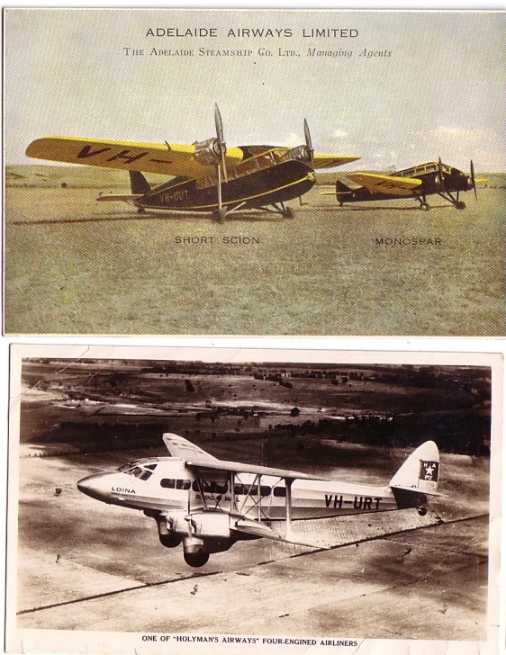
Adelaide had previously absorbed Perth based West Australian Airways. Meanwhile in Brisbane, Queensland, Airlines of Australia had developed routes to Sydney, taking over the equipment of the first ANA and absorbing other local carriers. Their card shows a Stinson Trimotor and is plain back, mailed with face overprint for Brisbane Airport Exhibition 1937.
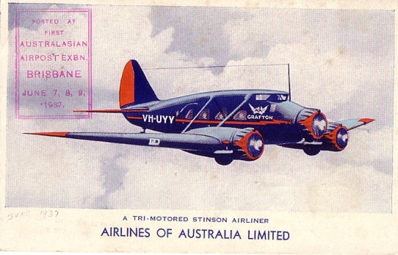
ANA took a share in A.of.A leading to complete absorption in 1943. Other pre 1939 carriers that survived post war were Butler Air Services, MacRobertson Miller, Airlines (WA) and Connellan (se their Heron on the back page) plus the longest survivor Ansett which was to absorb many others including ANA before finally collapsing in 2002. Post war all these airlines had to compete with a new state owned carrier Trans Australian but this also was to eventually disappear into Qantas in 1992. Now Qantas is both an international and domestic carrier which has so far fought off a succession of low cost carriers of which Virgin Blue is probably the most formidable.

