MONTHLY FEATURES

OLYMPIC AIRWAYS
…..is the Greek national carrier, but since 1936 airlines of the Games host nation have promoted their connections with the games and, in the age of sponsorship, have featured among the supporting companies. Following current trends, aircraft have been decorated with special “logo-jet” colour schemes. However, this happened first in 1936 with the Olympic rings symbol being painted on the side of Airships of Deutsche Zeppelin Reederei. The Editorial page shows these on Hindenburg in its Frankfurt hanger on a card from this company.
I am not aware of any special card yet by Olympic Airways for the 2004 games but the rings feature on their standard colour scheme. Most Olympic cards are the natural inhabitants of 10p boxes but there are a few rarer ones. Among these are the (very) large (9 in x 6 in) cards produced showing aircraft used on internal services. Both are shown and feature the Skyvan and YS-11. The YS-11 image has been cropped at the bottom, so losing the Olympic text as per the Skyvan.
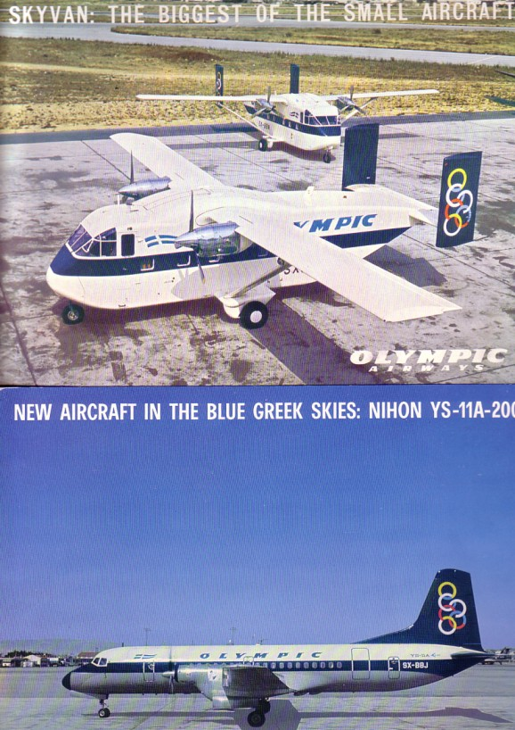
The rings appeared again on the card-backs of Aeroflot for the 1980 Moscow games including this of a landing IL-62, which also carries “Official Olympic carrier” titles.
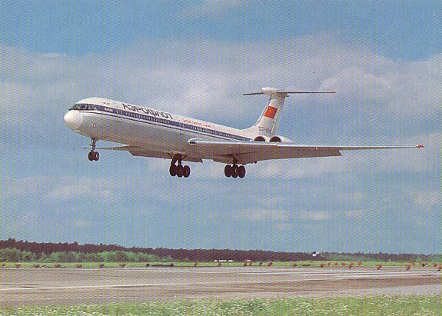
There do not appear to have been any airline Olympic related cards for Los Angeles 84, Seoul 88 or Barcelona 92 but the fancy colour schemes really got going for 1996 in Atlanta, home of Delta Airlines who displayed a specially painted 767. This card actually exists in two versions with different sky colour and positioning of the 767. It is believed that one of them was not in accordance with the corporate colour manual or somehow otherwise offended the marketing people.
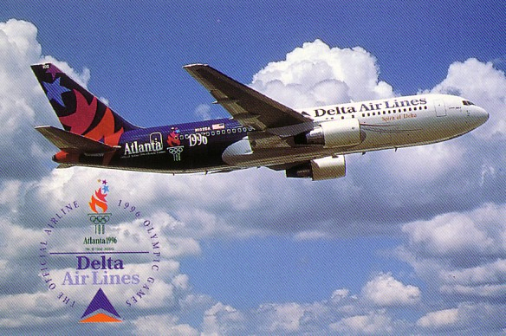
The trend continued with Ansett Australia for the Sydney games of 2000. While some recent Games have a reputation for bankrupting the host city, in this case it was the sponsoring airline which folded shortly afterwards. Ansett produced cards in two different large formats. Featured are 737-200, A.320 and 747-300. The A320 also includes the Games site.
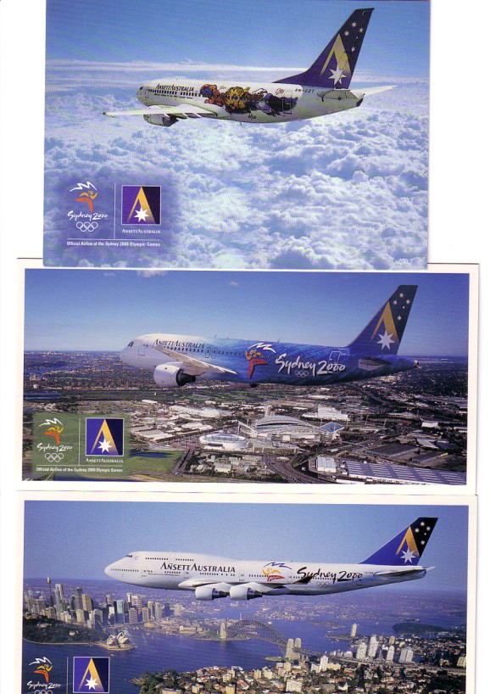

THE LAST DE HAVILLAND
First conceived in 1961 and flown in 1962 (How did they do it !?) the DH.125 was originally proposed to be named “Jet Dragon” but numbers were more fashionable and probably few of the potential clients would ever have heard or cared about the 1930s Dragon biplane. Card with painting of deHavilland prototype by anonymous publisher. Back text refers to “business executive airliner in miniature”.
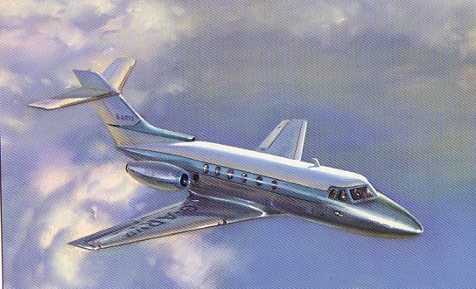
Forty-two years later the same basic design is still in production through the usual changes of engine, electronics and many changes of designation. It is also symptomatic that while the prototype was built in 15 months, its final UK manufacturer B.Ae can only dream of overruns that short in its current projects. Also, while other successful biz-jet, (as the breed came to be called), manufacturers went on to develop a family of models (Dassault) or stretched the concept (Canadair) into the regional jet market, B.Ae lost interest and sold off the whole programme to Raytheon. So the 125 is now a naturalized US product from the Raytheon corp in Wichita Kansas.
The psychology of the business-jet has gone through several cycles during the life of the 125. Initial customers were well known corporations who promoted their jet fleet as forward looking and dynamic – Shell in particular had a small fleet based at Heathrow. As time passed the idea of corporate jets became associated with executive excess and most current examples operate in anonymous paint schemes. The economics of owning an aircraft, let alone a fleet have been questioned and many companies have outsourced their biz-jet needs to specialist operators. It is therefore rare for business aircraft to appear on postcards – for any that do, the card may only be available to those on the inside of the business, or even the aeroplane itself. The fact that one that is available, the JCB card in the centrefold, is owned by a company which is a clear market leader perhaps shows a “nothing to hide” mentality.
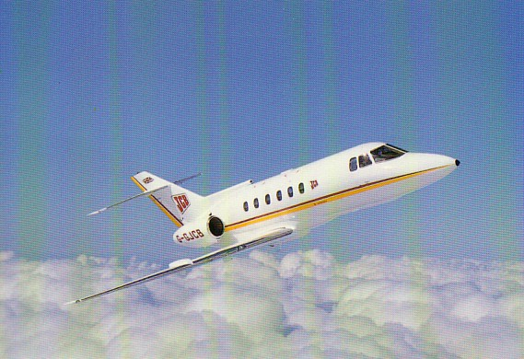
Having once been at an event at Staverton airport when the operators of a biz-jet insisted that no-one be in photo range of their aircraft, we should be grateful that no one seized the film of the airport shot of a Belgian operated 125 at Antwerp.
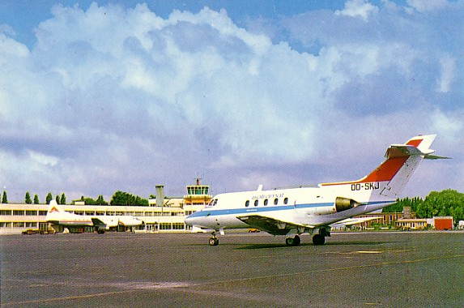
So, to get postcards of the 125, we have to look elsewhere than the corporate operators. Basically this means, the military, airlines and any other operators wishing to promote rather than conceal their services.
The card shown opposite shows not only 125 s but also their place of manufacture, the HS/B.Ae ex deHavilland factory at Hawarden, Chester. Actually in Wales, this now houses the Airbus wing plant. The Kuwait Airways 125s are shown in wet weather typical of the site but totally incongruous for their owner, who issued this card.
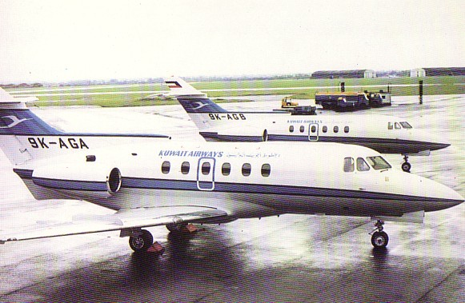

A growing use for small jets is as air ambulances. This, plus business travel is promoted on the back of this card from German Carrier Contiflug, which at that time was operating in conjunction with Condor as shown by the tail logo.

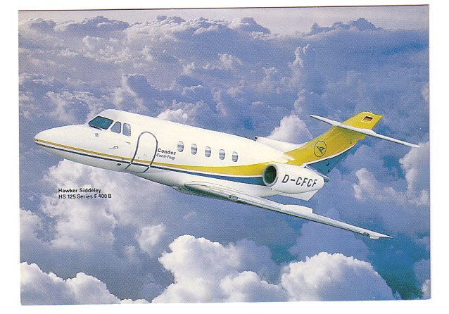

Another German rescue organization has promoted its own 125 with the postcard below
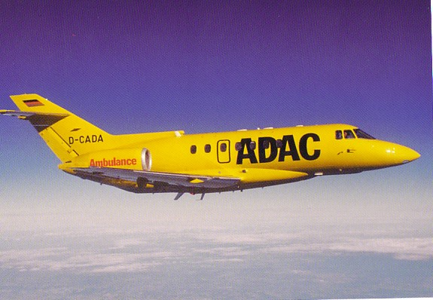
Even this one appears to be operated on long term contract as another card, this time showing the flightdeck, also carries the titles of Executive jet Service Aero Dienst Gmbh. The aforementioned changes in electronics are evident by comparing this view of a B.Ae 1000 with the other flightdeck shot of an HS125-600. This vertical card is by French operator Moet Aviation of Epernay .
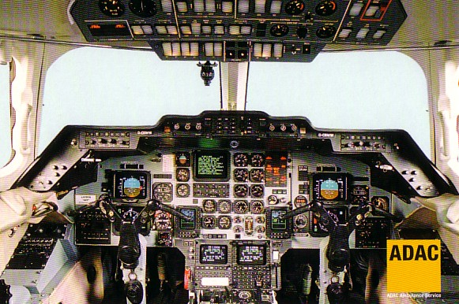
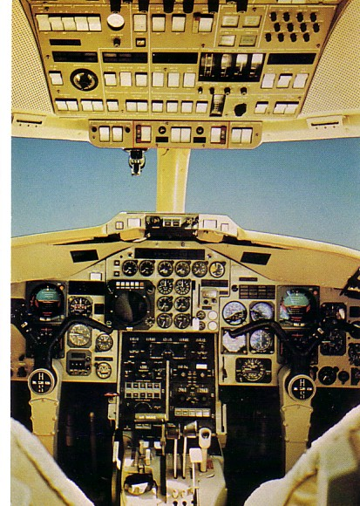

CONCLUDING CONCORDES
Member Ray Billings has moved in where all other publishers have failed miserably and produced a card of the absolutely last flight of Concorde. Taken from his own photo it shows G-BOAA on approach to Bristol-Filton passing over the Clifton Suspension Bridge which is crowded with spectators. The card is available from Ray.
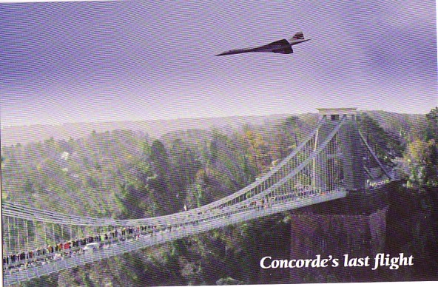
The last British Airways card to feature Concorde was produced for the Berlin World Travel Market in February. It is a large size card in a set with 2 others, a multiview of interiors with a 747 and a multiview of UK tourist sites with an A319. The German wording on the back of the Concorde card is a classic example of how to trivialize a significant event. Translated ,it reads “ With the withdrawal of Concorde, a great chapter of air transport history comes to an end – and with these prices a new one begins – for example Berlin-London return from 110 €……”


