MONTHLY FEATURES

APRIL 2003 NEWSLETTER US DIVISION
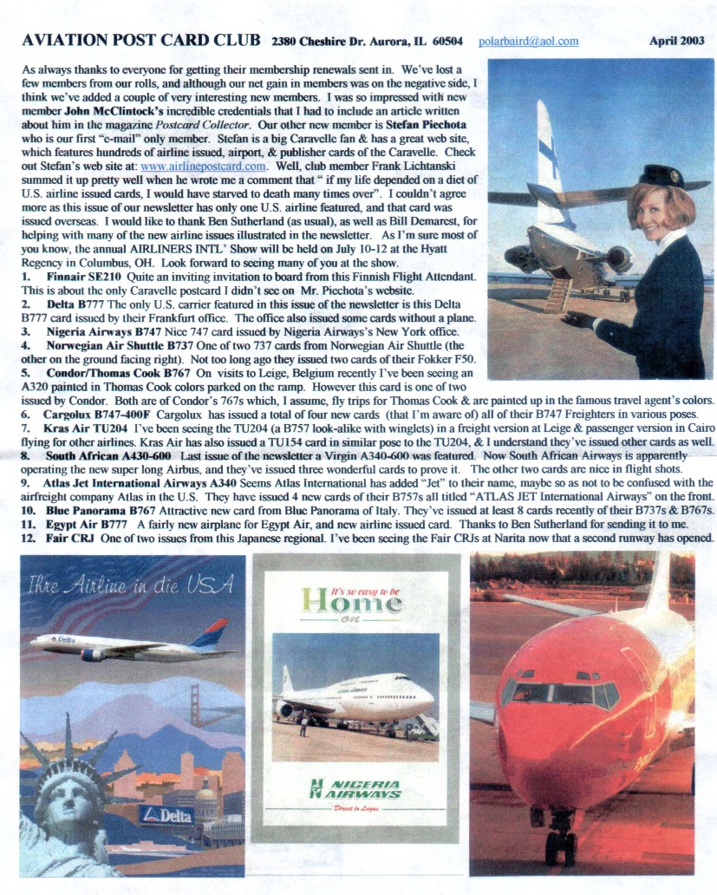
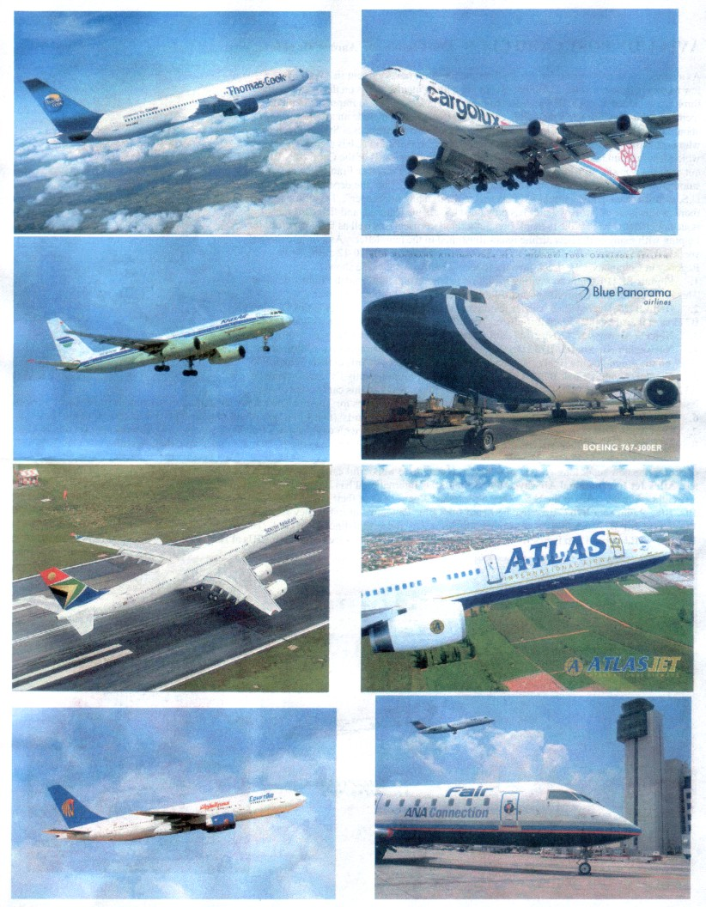

HIMALAYAN HIGHWAYS
By Leonardo Pinzauti & Doug Bastin
29 May 2003 is the 50th anniversary of the first verified ascent of Mount Everest by Edmund Hillary and Tensing Norgay. Today Everest has its own problems of tourist overload, in part occasioned by the opening up of the country to air travel. It was only in 1950, two years after Nepal opened up to the outside world, that aviation began to be seen as the answer to the county’s problems of surface transportation in a country divided by parallel mountain ranges.
Earlier, in 1933, when the Houston Everest expedition proposed an overflight of Everest, the nearest appropriate field was at Purnea in, then, British, India. The expedition used two aircraft, both from Westland, the specially adapted PV.3 and a modified Wallace, civilianized as G-ACBR, supported by 2 DH Moths. The Science Museum issued a card of a model of the Wallace from its collection. Both aircraft flew over Everest on April 3, over Kanchenjunga on April 4 and returned to Everest on April 19. The second flight added vertical photographs to the oblique views obtained on April 3rd.
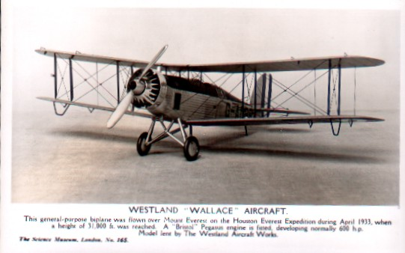
The first scheduled flights to Nepal were by Indian operators, Indian National to Katmandu from Calcutta, and Himalayan Aviation serving a domestic network to the 5 existing airports. The Indian carriers were nationalized in August 1953 as Indian Airlines Corp. It was not until 1958 that the Nepalese government set up its own flag carrier, Royal Nepal Airlines, with a fleet of a single DC-3, to take over the domestic network from IAC. IAC retained the international services until 1960 when Royal Nepal opened service to Calcutta, Delhi, Patna and Dakha in then E.Pakistan, now Bangladesh. A US aid programme provided both 3 more DC-3s and airfield building and upgrades. Both the Soviets and India regarded Nepal as a sphere of influence also as is demonstrated by the card of Katmandu airport featuring Royal Nepal (Ex IAL) DC-3 9N-AAB, DC-3 VT-CVC to be presented to the Nepal Royal Flight as 9N-RF2 and an Ilyushin IL-14 already in service in that flight as 9N-RF1.
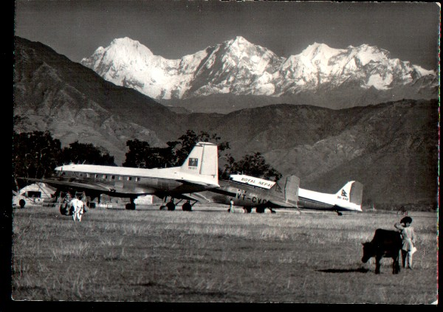
The co-incidence of these last two makes a date of 1958 near certain. Further DC-3s 9N-AAC and AAE, feature on two cards of Pokhara airfield. On the cover shot AAE, an ex USAF piece of US aid from 1960, is the foreground for 6997m Machhapuchhare n the Annapurna range. 9N-AAC, seen also at Pokhara on a tinted card by Das Photo Stores of Katmandu, also arrived in the 60s having been in China and Taiwan with Civil Air Transport, itself a US government (CIA?) backed operation.
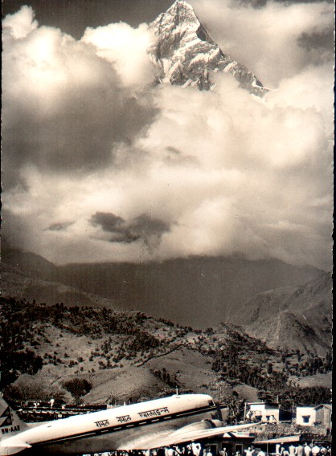

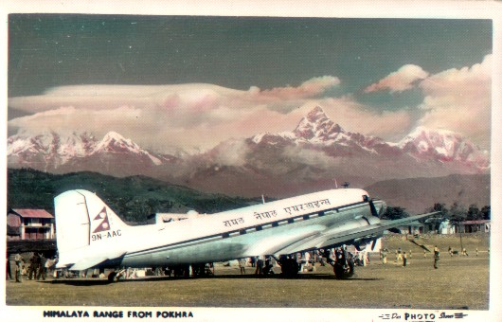
As part of his continued involvement with Nepal after 1953, Sir Edmund Hillary promoted the building of an airport to serve the Mt Everest region and this as realized in 1964 with the foundation of Lukla airstrip. This lies on a 5 degree slope rising to 15 at one end of the runway. French alpine Twin Otter operator Air Alpes was an advisor in the project, so it is not surprising that this type was chosen for Royal Nepal. The airline issued two smaller-than standard size cards of Twin Otter 9N-ABB at this airport which lies at over 8000ft(2770m). Much more recently the type still figures on a colour card by Himalyan MapHouse of Katmandu but also present is its Chinese equivalent the Harbin Y-12 of Nepal Airways. The Twin Otters are of the Nepal Civil Aviation Dept and Lumbini Airways. All of these carriers are now out of business.
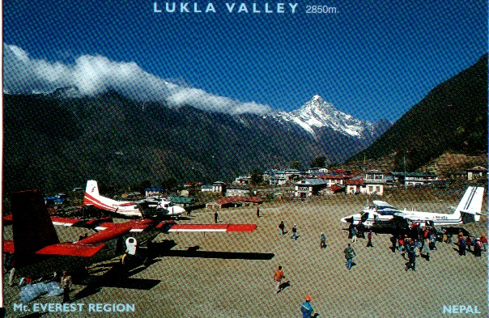
Royal Nepal have themselves issued cards of their aircraft at both Pokhara and Lukla. Their card of Twin Otter 9N-ABH gives an alternative name of “Fishtail” for Mt Machhapuchre, while Porter 9N-ABK features on their card of Lukla.
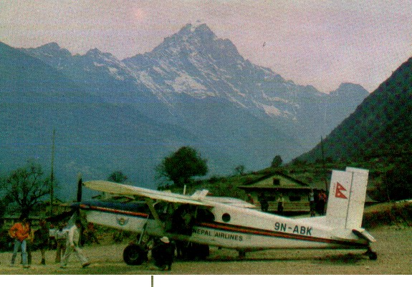
Other Royal Nepal cards with Himalayan backgrounds include a view of the range taken from the cabin of an HS748, an HS748 flying to the right, Twin Otter flying left and a Porter flying right. Curiously given the popularity of mountain backgrounds on airline-issue cards, none of the later cards of Royal Nepal of their 727 or 757 jet airliners feature prominent Himalayan backgrounds.
By contrast, Everest is the main reason for the existence of carrier Buddha Air whose cards promote their “Everest Experience Flights” in Beech B.1900Ds. The back text of this one, showing a Beech passing Everest at a distance of 5 nautical miles, claims “We show you Mt Everest like no other airline – closer, clearer and in a much better angle. All this in the comfort of our latest generation American aircraft”. Another text-back card includes in its promotional blurb “ you may even see mountaineers crawling up the slope” and “you need not worry if there are monsoon clouds…..these clouds are usually up to 20,000 ft and we being the only airline in Nepal to fly above these clouds , the spectacular Himalayas will not be hidden from you”
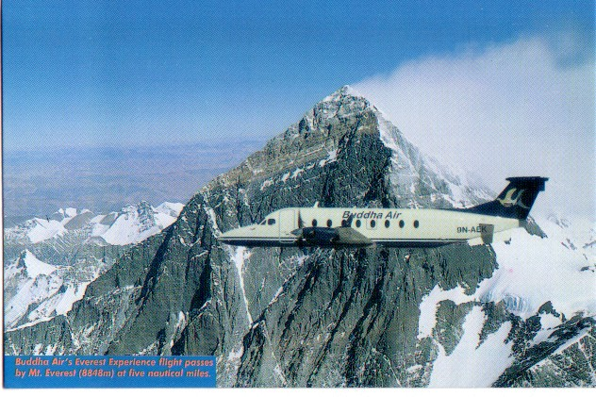
All a bit different from the ascent of 1953, news of which took 4 days to reach London on Coronation Day 2rd June and even more from the 1933 flight. But the 1933 flights discovered precisely the cloud effects described, reporting that the haze cleared at 19000 ft and that the best photography was achieved from 24000 to 31000ft – in fact the view from the part-open cockpit was probably much better even than Buddha Air, or would have been without the high altitude suit and goggles.

Note: Measurements are given in imperial or metric according to the source information. Names of mountains are similarly as per the source and may not be the most common usage.

49 NOT OUT - THE C-130 HERCULES
It is inconceivable that a Wright biplane would be in front line service in 1953, or a Vickers Vimy in 1969. Even the DC-3 only survived in backwaters in 1985 and the Constellation was a museum piece by 1993, as was the F-86 Sabre by 1998. But 49 years ago, on 23/8/54 there occurred the first flight of a type which is not only still in front line service but still in production. It is conceivable that a Lockheed employee could have spent his/her entire working life building variants of one aeroplane, the C-130 Hercules. Like the DC-3/C-47 before it this type has served with almost every world air force. Nothing demonstrates more effectively that airframe technology, as distinct from avionics, has pretty much plateaued from the second half of the 20th century as distinct from the incredible progress of speed, capacity and reliability of the first 50 years.
As a military aircraft , the type has not been heavily represented on cards, even though it has served with over 60 Air Forces. Anyway here is a selection of what is around. Firstly, a line up of early models, (no radome) on the flightline at the Marietta, Georgia plant. (Haynes/Dexter 58277-B)

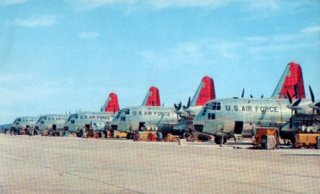

The extensive text on this next, possibly US navy issue, card says “Navy SKI-BIRD C-130BL Hercules ski-and-wheel propjet, flown by the US Navy’s VX-6 squadron have made aviation history in the South Pole region, opening up Antarctica as never before for scientific study and exploration. This Lockheed ski-bird is airlifting bulky equipment and supplies from McMurdo Sound to inland stations on the world’s biggest ice-cap. Designed and produced in sunny Marietta, GA by Lockheed-Gerorgia company, the 135,000 lb transport is the largest aircraft ever equipped with skis. C-130BLs support Operation Deep Freeze and are the heaviest airplanes ever to land at the South Pole. “

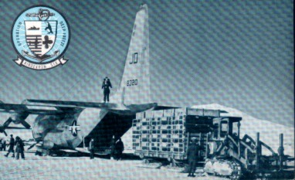

These were the first US Navy C-130s and were basically transports, although ski-equipped. Less likely to appear on postcards are the many “special duties” versions which include :-
AC-130 “Gunship” : DC-130 Drone control : EC-130E Command & Control Communications : EC-130H Electronic Countermeasures : Maritime Patrol HC-130H : Special Operations MC-130E,H,P : Tanker HC-130N, MC-130E,P KC-130 : Search & rescue HC-130H,N,P : Weather Reconnaissance WC-130.
One off modifications allowed a Marine Corps C-130 to make a deck landing on the carrier USS Forrestal in October 1963. Even more bizarre was the YMC-130H equipped with rockets facing rearward, forward and sideways. The idea was to enable a C-130 to land in an Iranian football stadium as part of a hostage rescue plan. Two were built, the first was wrecked when the rocket blast blew a wing off – the other was never used in action.
This card by Skilton, No.380/R1 shows C-130K XV294 from RAF Lynham at a battle of Britain display in 1978.
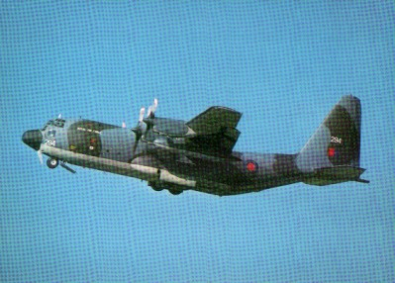

The UK never attempted a Hercules equivalent and the C-130 replaced and outlived all its contemporaries in RAF service, such as the Beverley, Belfast and Andover.
The Hercules has been present at most major and minor conflicts of the later 20th century but has equally been prominent as a bringer of relief to natural and man made disasters over the same time span. Here, military aircraft have been supplemented by civil operators. Civil versions of the Hercules were available with both 8ft and 15ft fuselage extensions. The operators tended not to be found among first line airlines and most operators were unlikely to file accounts, let alone publish postcards. However airline-issue cards are known from a few operators :-
In the US Southern Air Transport – widely believed to be a CIA front, but also Delta.
In the UK, Heavylift, Indonesian registered PK-PLV shown spraying anti-pollutants.
In Africa, Air Gabon, Air Botswana and Safair (S.Africa)
In France, SF Air.
This Delta card is oversize and shows N9268R. The back text says it has a capacity of 45,000 lbs and a freight compartment 8.5 ft high 10 ft wide and 40ft long with a roller tracked floor for container handling, enabling interchange with road rail or sea. The back of the card which measures 5 ½ x 7 inch is pre-printed to serve as an Arrival Notice with space to insert
Date, Send-location, Airbill No, Weight, Pick-up site and times and the time and rate at which storage charges will be incurred.


