MONTHLY FEATURES

DECEMBER 2004 NEWSLETTER US DIVISION
Members will have noticed that the US pages carry an earlier date than the main newsletter. This is because the US page is added to the main paper newsletter when it is circulated in the US in arrear of the UK edition, so it is actually published between UK paper editions.
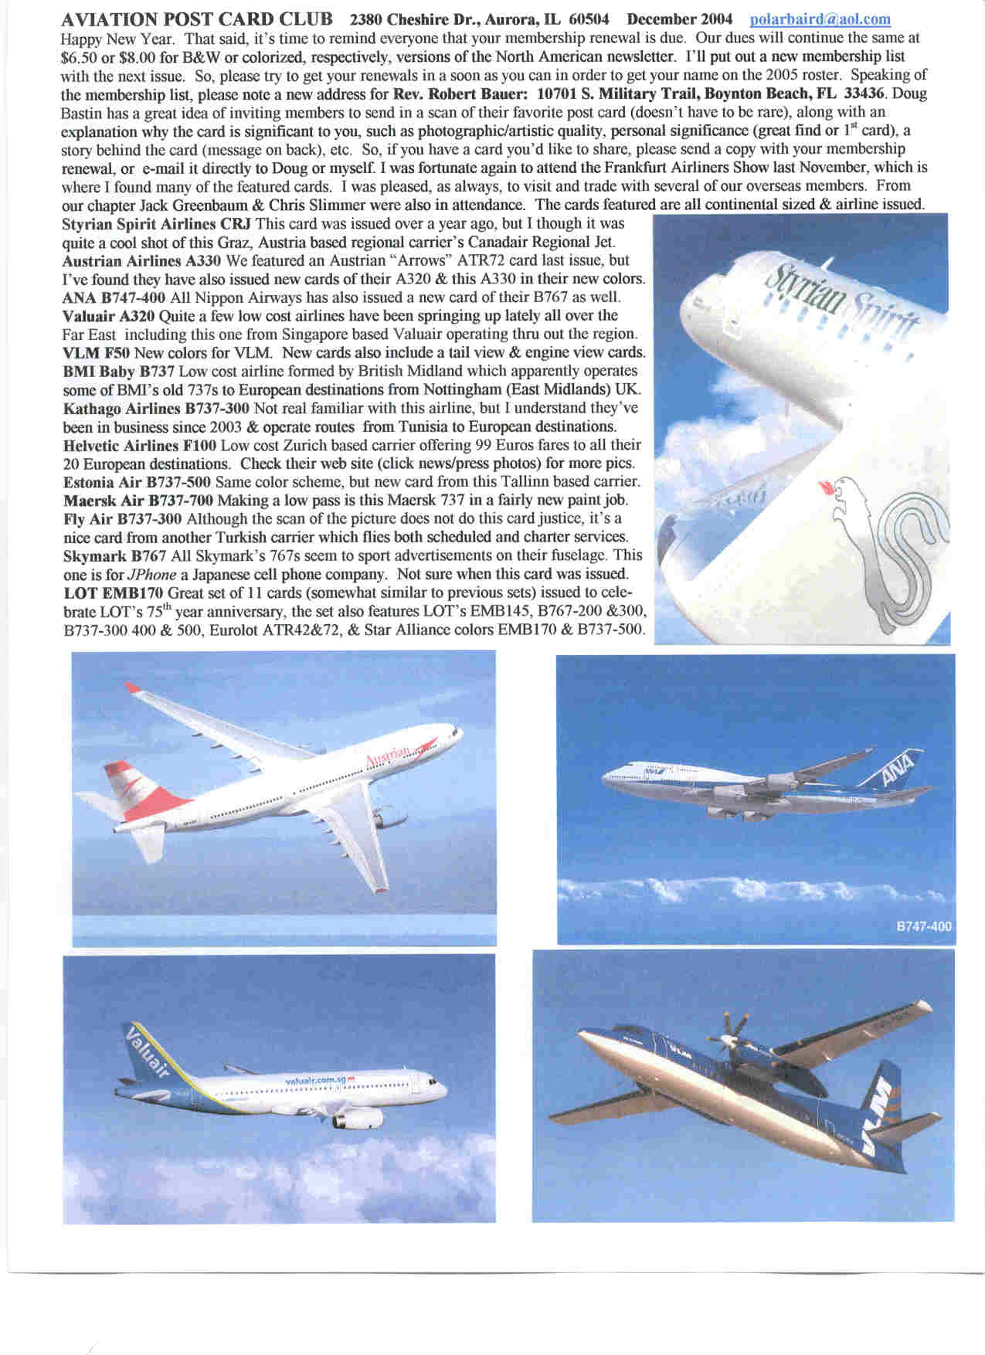
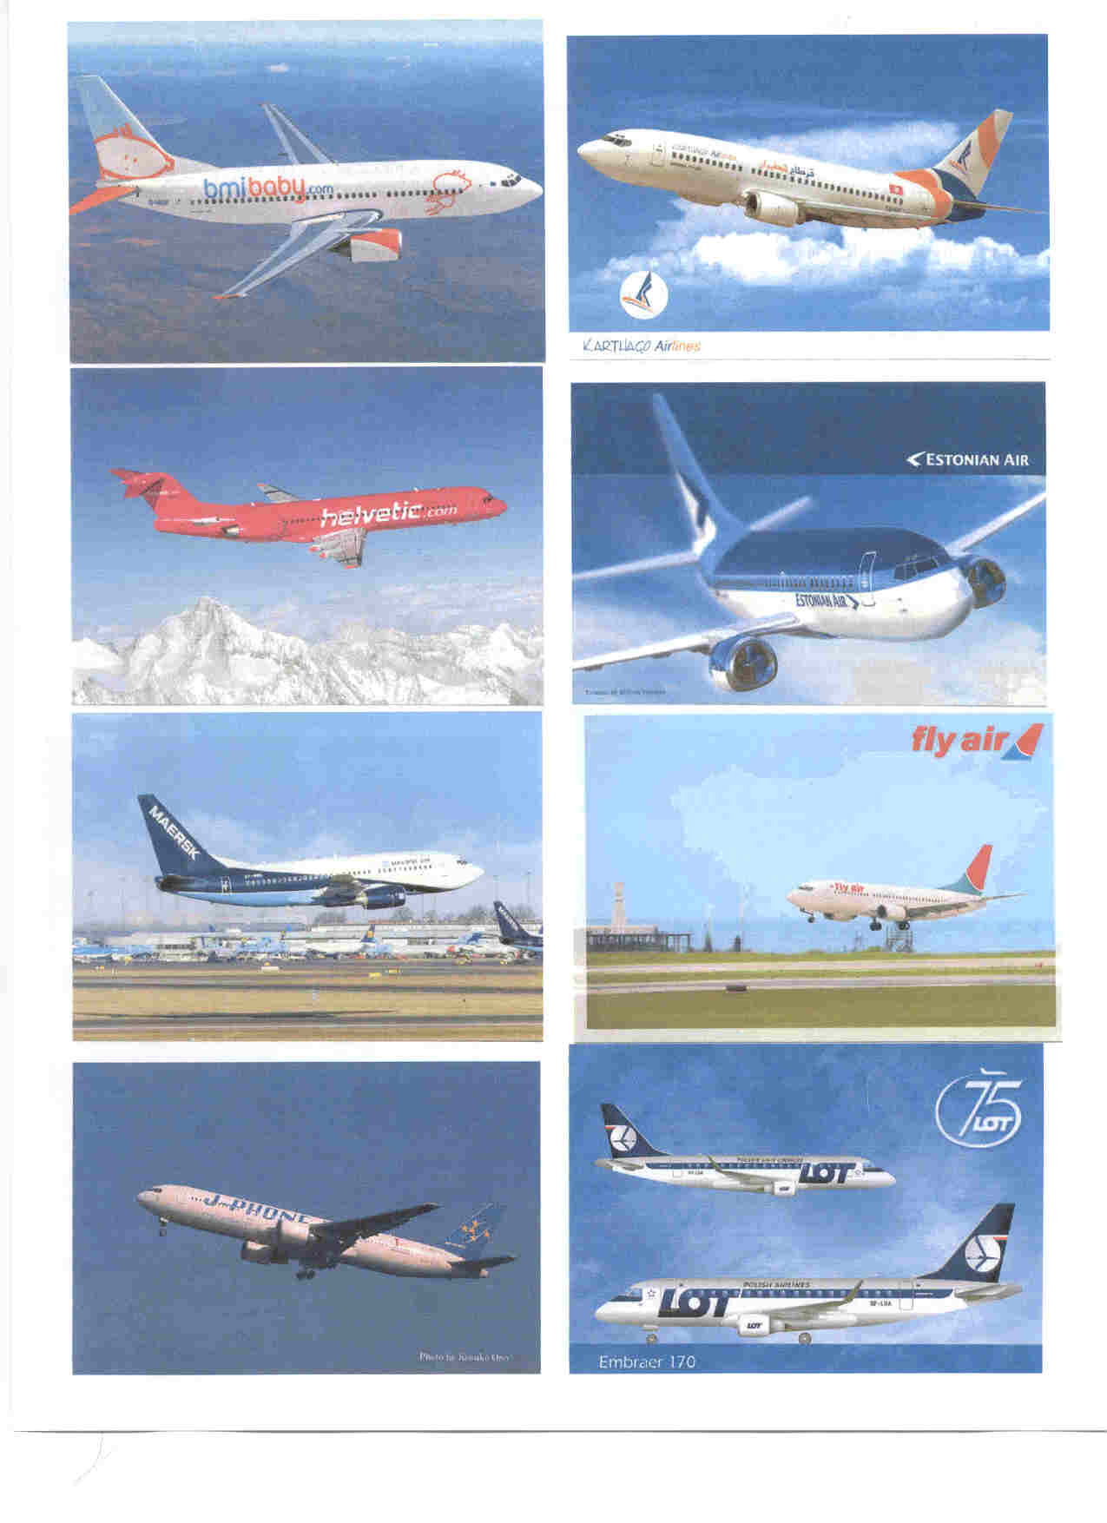

FIFTY FOR FIFTY
The submissions fall into two categories which I have subtitled :-
1) MEMORIES – cards that have a special meaning for members
2) THEMES - the pick of cards to illustrate members varied interests .
So here goes :_
PART 1 MEMORIES
Peter Little , Bromley UK …This is the first postcard I bought when I started collecting Amy Johnson, who typifies what I think of as my era, having been born in 1930. I later found that this was part of a set of 6 by Raphael Tuck and I now have them all in the original envelope.
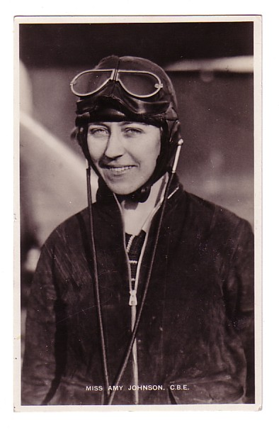
Ray Billings, Swindon, UK …”During October 1934 my mother took me, a 6 year old, to Croydon Airport to see “the biggest aircraft – too big to go into a hangar”. We arrived at the viewing area as the aircraft, a DC-2 swung round to present us its tail and ran up its engines. It filled my eyes with dust so that I buried my head in Mums coat. By the time I opened my eyes the DC-2 was airborne over the distant airfield boundary I still wonder which DC-2 it was Maybe even the KLM “Uiver. Or a Swissair as on this reprinted poster (Photoglob 1917).
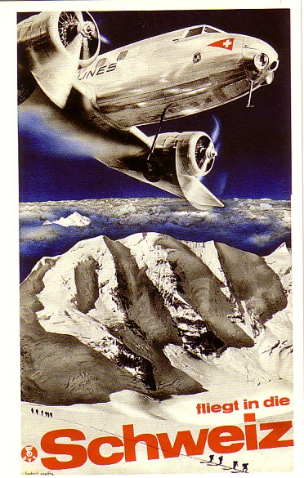
Peter White, London NW During WW2, my father, stationed in Egypt for three years or so, took with him a large selection of Salmon cards - ships , trains and aircraft - and used to send them to me (as a then very small boy) regularly. The Bannister painting of the Boulton Paul Overstrand is one that best brings back memories of that collection.
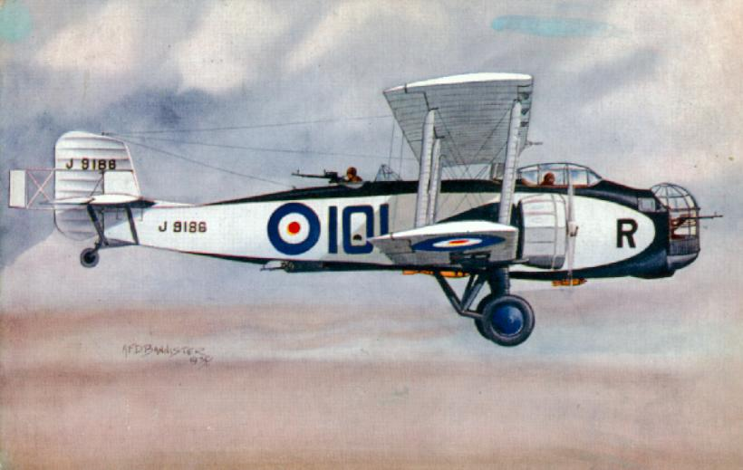
Doug Bastin, Chester UK 1949 first Heathrow visit, gleaming bare metal + red flash American Overseas Constellation, red hot steel seats, only a wooden fence from the taxiway – hooked!. 35 years on, ferreting in a “Transport” section for railway cards, this Wilson of Sunbury card. The rest is history.
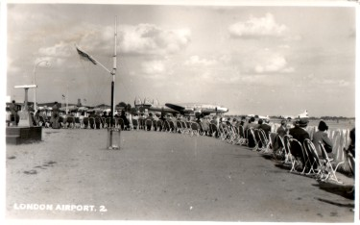
Jim Davidson, Canada Saw this monster (for the time anyway) at the Farnborough Air Show, at about the same time - it was absolutely huge compared with aircraft of the time and it's image has stuck with me for the past umpteen years. I took a Brownie Box 'snap' as it cleared the landing lights at the south east end. Made a big impression on a schoolboy.
Bristol Brabazon by Valentines.
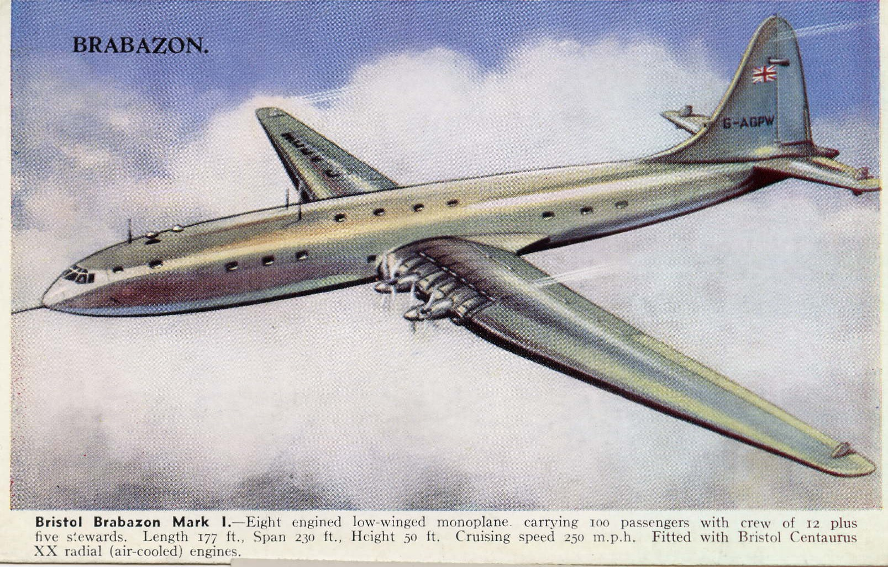
Meanwhile in Australia Ben Sutherland, now USA used to venture out to Mascot Airport (now Kingsford Smith) Sydney every weekend also with a Brownie Box camera. Around that time there were DC-3's, DC-4's, Viscounts, Convair 240's of TAA. DC-3's and Convair 340's of Ansett Airways. DC-3s, Bristol 170 Freighters, DC-4's, DC-6's, DC-6B's of ANA. DC-6's of TEAL. On the International side there were Constellations of KLM and Air India, Stratocruisers of PAA and Britannias of BOAC and DC-3's, DC-4's and Constellations of QANTAS. – and this Qantas issue L749 was the first postcard I bought.
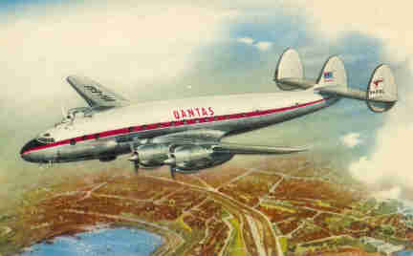
Alan van Wickler, USA was already “toiling with PanAm” in Germany and one of the classic 50s black and white German cards by Zobel of Stuttgart of a Stratocruiser on a winters night there is about as evocative as it gets.
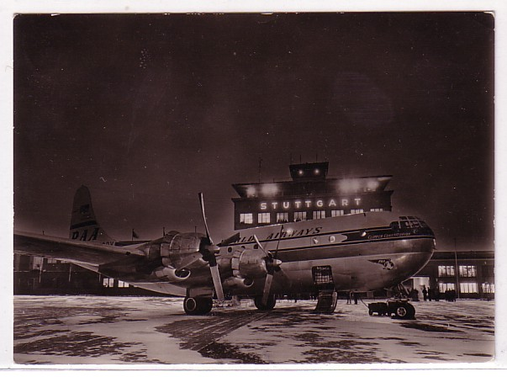

In Scotland Ken Thom, now Kent, Uk was living in Prestwick “I have both visited it and flown in and out of it many times. From a collecting point of view my favourite airline must be KLM. I inherited a lot of KLM postcards from an aunt who was a KLM employee in the 1940's and 1950's. So my choice of card has to be one which reflects all this - and so it is a KLM issued card of a Douglas DC-4 at Prestwick. This is only a recent acquisition. It is not in brilliant condition but rarity value makes up for this. It was mailed to an address in Sweden in August 1947.”
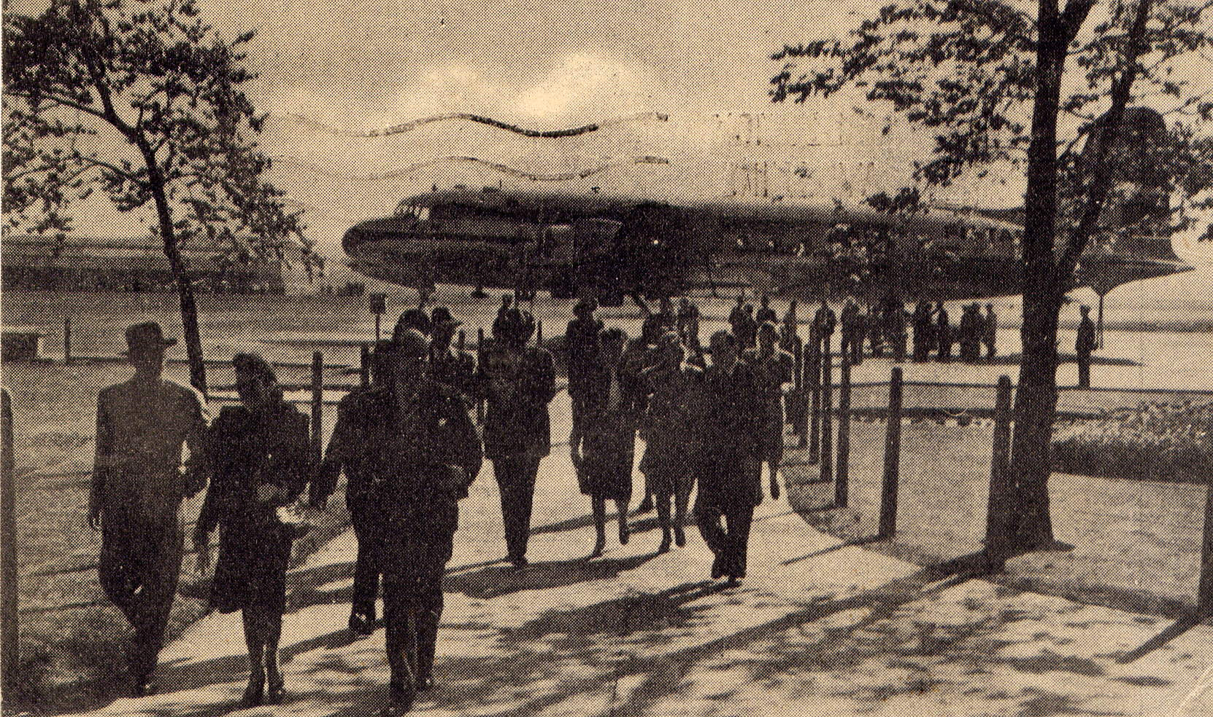
Over in the US of A, Bill Baird , was, like Ray Billings 20 odd years earlier, at the airport with mom. “ When I was a kid in Louisiana my mom would take me to Shreveport to go shopping (all day it seemed like), and the bribe was, if I was good, she'd take me to the airport to eat and watch airplanes which were mostly Delta DC7s, 6s, and Convair 440s with an occasional Trans Texas DC3 or Convair thrown in. Boy were those the days” Delta issue DC-7..
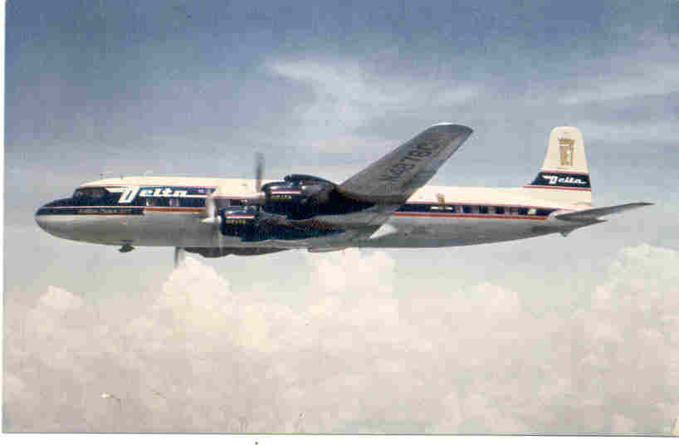
The world tour continues to Africa. Barbara Priddy, Wimbledon UK “ Sadly by the time I knew Kano airport, Northern Nigeria airport in the 1960s plane arrivals were rather more common then in the 50s and the trumpeter, as on this card with a BOAC Hermes, no longer announced them, but the airport hotel was the same. The cards have no publisher's name on the back, but the hotel one has actually been posted from Kano to Kent.”
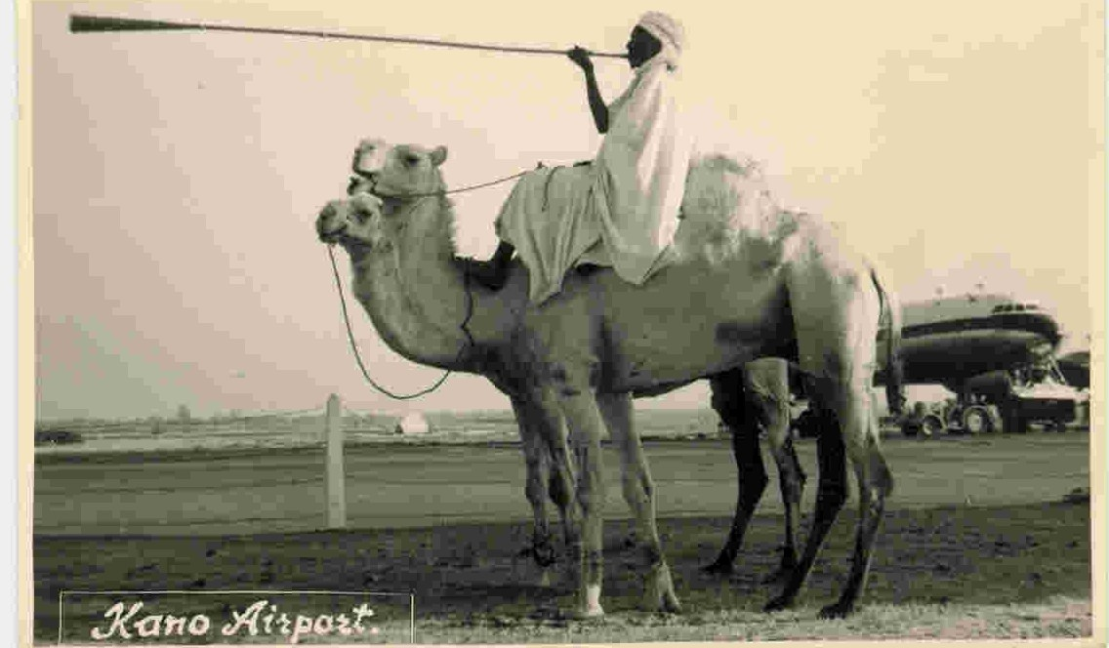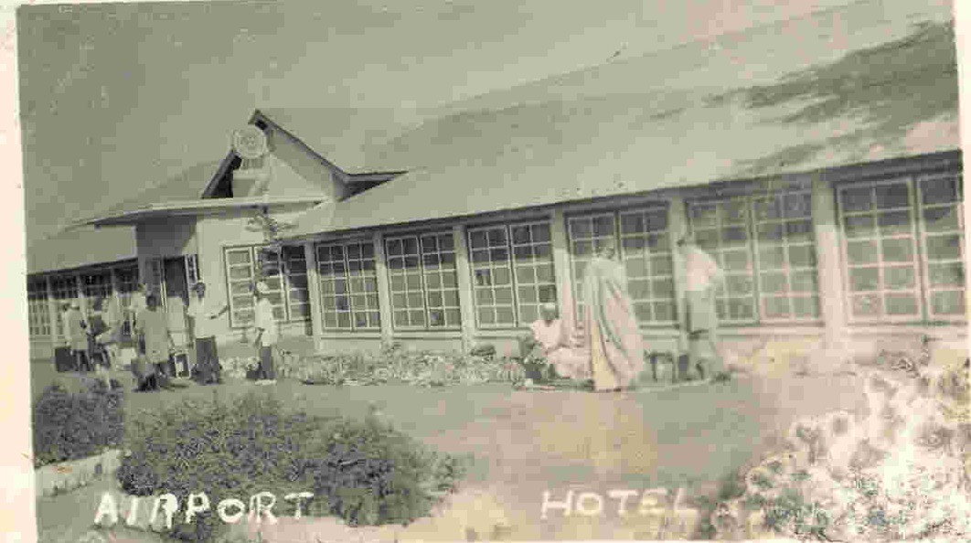

One more continent, Buenos Aires, Argentina, South America. Eugene Siklos, Canada “ OK , enough about the lost airport viewing areas, terraces etc, what I want to know is what happened to the pool” Ezeiza Airport with Canadian Pacific DC-8 attracted by this unique feature.
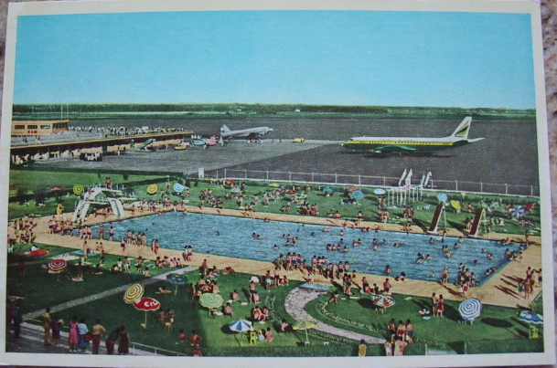
With that DC-8 we are into the jet age but the props still soldiered on. Terry Faragher, now Isle of Man was keeping Pratt & Whitneys going on this DC-4 of Liverpool operator Skyways, seen at Speke on a possible airline-issue, the part colour version of the same view definitely is
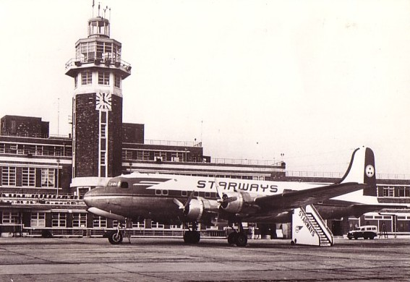
The Pratt & Whitneys were still going in the 1980s when Graham Stringwell, Lincolnshire, UK worked in the stores at Humberside Airport where the Eastern Airlines (UK version) DC-3 fleet was serviced. Card of G-AMRA by Skilton for the airline.
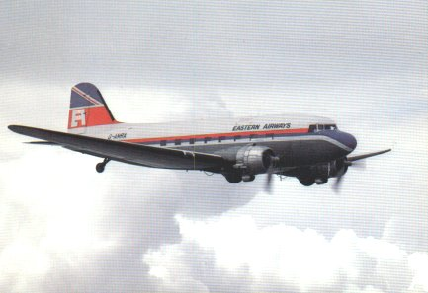
Liverpool old terminal was still in service when Tony Edwards, Cheshire UK started business flying in 1968 on British Eagle 1-11s. This Salmon card had the Eagle titles edited out when Eagle failed later that year. Tony’s actual first business flight was in a KLM DC-8 as on one of the KLM Aerocarto series of black and white cards. But he didn’t start collecting airline cards until some guy called Bastin did a slot at the Chester Postcard Club 20 years on.
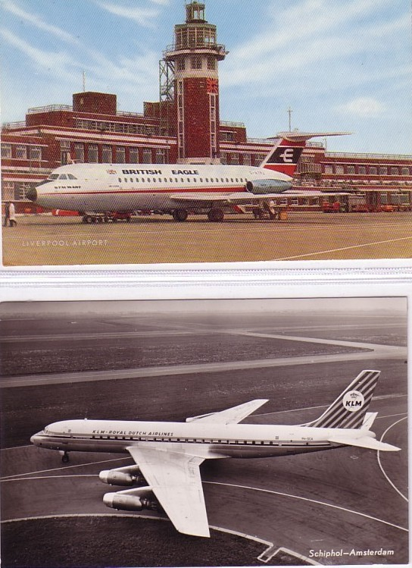
From passengers to pilots and cabin crew. Simon Penn, Sussex, UK. “ I flew as a First Officer on the B.707 with British Caledonian from 1980-84 and my fondness for the aircraft led me back to collecting. From the 1500 or so that I have of the 707/720. I choose this airline issued BCAL card, just a tail in view with examples of what really gave this airline it's character - the 'Caledonian Girls'. I particularly enjoy cards shot from unusual angles with crew.”
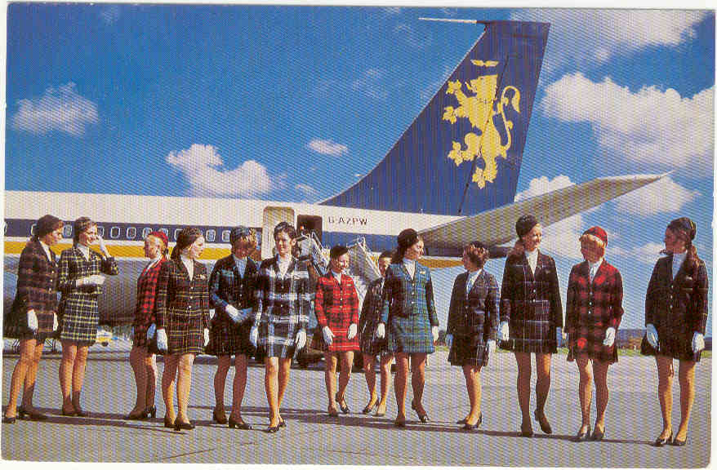
Simon made it to the flight deck, Ronny Vogt, Switzerland had the dream. “thirty years ago I should have decided to go for the pilot career. If I had done so I would see such a picture at every Airport ... every day ... stewardesses/flight attendants waving at my arrival .... a nice airplane waiting to be flown to some nice place.... Irish green colours everywhere .... a nice meal served by the most beautiful stewardess you might imagine who feels that you, the pilot, must be the most knowledgeable and desirable man in the world ... and postcards coloured by John Hinde (look at that marvel of an Esso tanker)! Isn't that reason enough to like that card? “ Boeing tail + stewardess again. This time Aer Lingus B720 at Shannon by John Hinde – we will see a lot more Hinde cards in the 50.
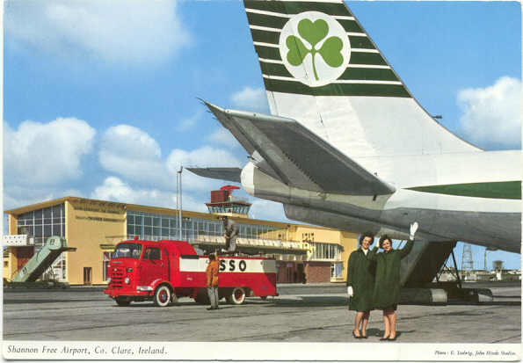
…and even if the reality is a bit more mundane it makes a good card. Aer Lingus issue from the DC-3 era also from Ronny – they did one of backroom engineers too, working on yet another Pratt & Whitney.
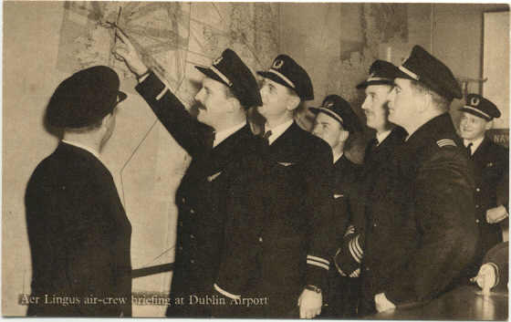
Staying with Irish publisher John Hinde Derek Card, Devon, UK submits one of their cards of Jersey Airport – Hinde loved brightly coloured fuel tankers. Derek writes “I bought this card after a Viscount flight to the island in 1963. “I was serving with the British Army in Berlin, an isolated city with a dark and forbidding atmosphere. On leave, I travelled to Jersey to meet friends and it was like entering a new world to step into the Viscount and be greeted by a smiling stewardess in the spacious well lit cabin. My previous flights had been in BEA DC-3s and Vikings and RAF Beverley and Hastings transports” Apart from Croydon pre-war and Heathrow post, Jersey in the Channel Islands has probably had more postcards published than any other UK airport.
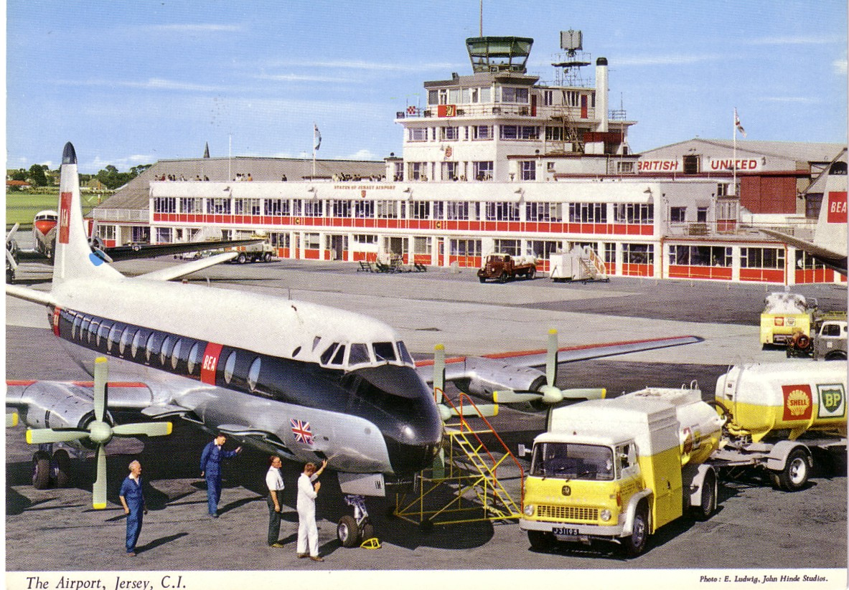

One more “starter” card sent home by US member Bill Demarest ‘s father and his collection no.1. Japan Air Lines issue early 747. For more recent additions see www.williamdemarest.com
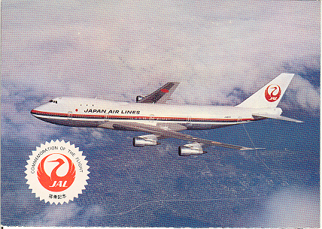
Now a very recent memory, of being part of the start up team for a new airline last year. Rohan Garnett , Australia. “ I have known publishers Australex for some years. In the Qantas days we didn't approve/endorse their cards on corporate fit/presentation grounds. But when we set up our low-cost operation JetStar up I thought it would be great to have some cards and was in a position to make it happen. The finished product you now have before you – one of a set of three of the A.320s.”
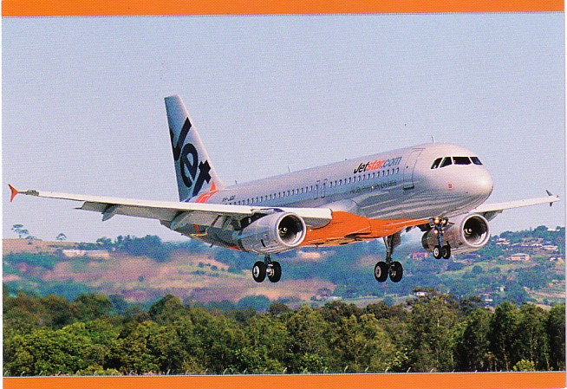

Rohan would not count himself among our member/publishers but John Johnston, Glasgow is. “This postcard was a photograph I took myself of my favourite aircraft, Concorde G-BOAE landing at Edinburgh Airport on the occasion of Concorde's last flight to Scotland. There must have been between 800/1000 enthusiasts of Concorde at the airport that day. The pilot (a Scot!) flew the Scottish Flag from the cockpit which pleased the crowd no end!
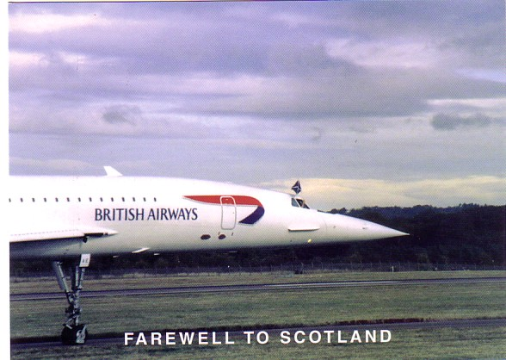

A different Concorde story comes from our Web-master Christian Gerbich, Germany “At the age of 15 or 16 I was lucky to get this card by trading it with another collector. But then I got an offer for that SIA Concorde card. At that time this offer seems to me as a good deal. The offer was a three card set of Spantax DC9, DC10 and CV990. At that time Spantax was one of the interesting airlines, producing incredible stories, like landing at the Airbus area at Finkenwerder, dropping their passengers there before they recognize their mix up with Hamburg-Fuhlsbüttel. Therefore I gave away the SIA card. At that time I thought it will be easy to get another copy, but after more than 20 years I am still looking for it. So, this card or this story made me learn my lesson: Never, never give away a collection card, no matter how amazing the offer is.”
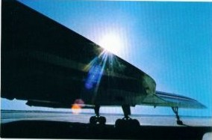
More collectors tales from Mike Charlton, Newcastle, UK. "On the last day of a family holiday to Corfu in 1980 and after spending 2 weeks looking for cards (as you do!), as we were boarding the bus from the resort,the small taverna 50mts from the hotel was paid a last visit for water. Another glance at the postcard spinner found a crumpled card of this Olympic DC6 at Corfu Airport. A quick chat to the owner and into his storeroom he went and produced around 25 of these cards in mint condition!!
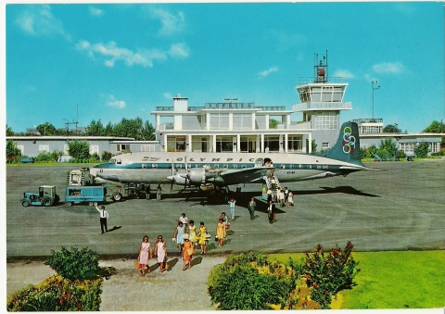
Colin Cohen, London UK ,temporarily displaced from his back page, would surely agree with both Christian and Mike. His message is “It WILL turn up” – and probably when least expected. I saw this Air Siam issue A300 at a postcard show in the USA in the late 1970s when I first started to attend the USA conventions and began to collect seriously. I dearly wanted that card but alas it was not to be at the time as the guy who had it wanted only to trade it I never saw that card again for years despite asking everywhere when I used to trade or buy, both here and abroad. Then some ten years later I was at a show at Heathrow and blow me down someone was selling about seven of the cards on his stand with also some rare Boeing 747 and DC10 cards of the same airline. I remember I just could not believe my luck. The guy was charging around £2.00 for each card which was a fortune in those days, however I dug deep into my pocket and bought the entire lot, I was so glad to find such a super lot for my collection and some traders to swop with my friends, many of whom had never heard of them, let alone seen them before. I have never had such an experience again and it will remain with me for ever.
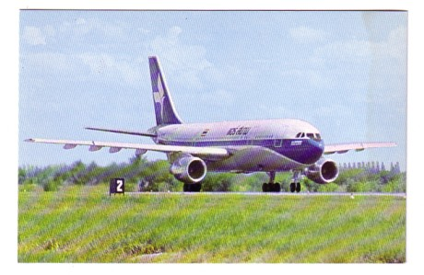
That seems a suitable theme on which to end the “memories “ section and go on to the many and various themes which provide members with, to steal Colins usual sign-off,

“HAPPY COLLECTING”

PART 2 THEMES
This section highlights popular collecting themes from members, with cards selected for mainly historic or artistic importance starting with :-PIONEERS
Too far back to feature in “memories” the pioneer age overlaps with the “golden age” of the picture postcard. John Worsley, Sheffield UK “ As my birthplace is Shoreham I naturally chose the “flying ground” as my special interest aerodrome. It is one of oldest commercial airfields in the UK, has a fascinating history, and is still going strong. The writer, in Jan 1911, says “I think these machines are so funny, don’t you”. They are Wrights licence built by Shorts. My second card, posted Oct 1911 shows B.C Hucks Blackburn (not his usual Bleriot) at Shaftesbury Park, Newport on his West Country/Welsh tour. The card was mailed to California with the message including “ Have you any of these flying machine in California ?”
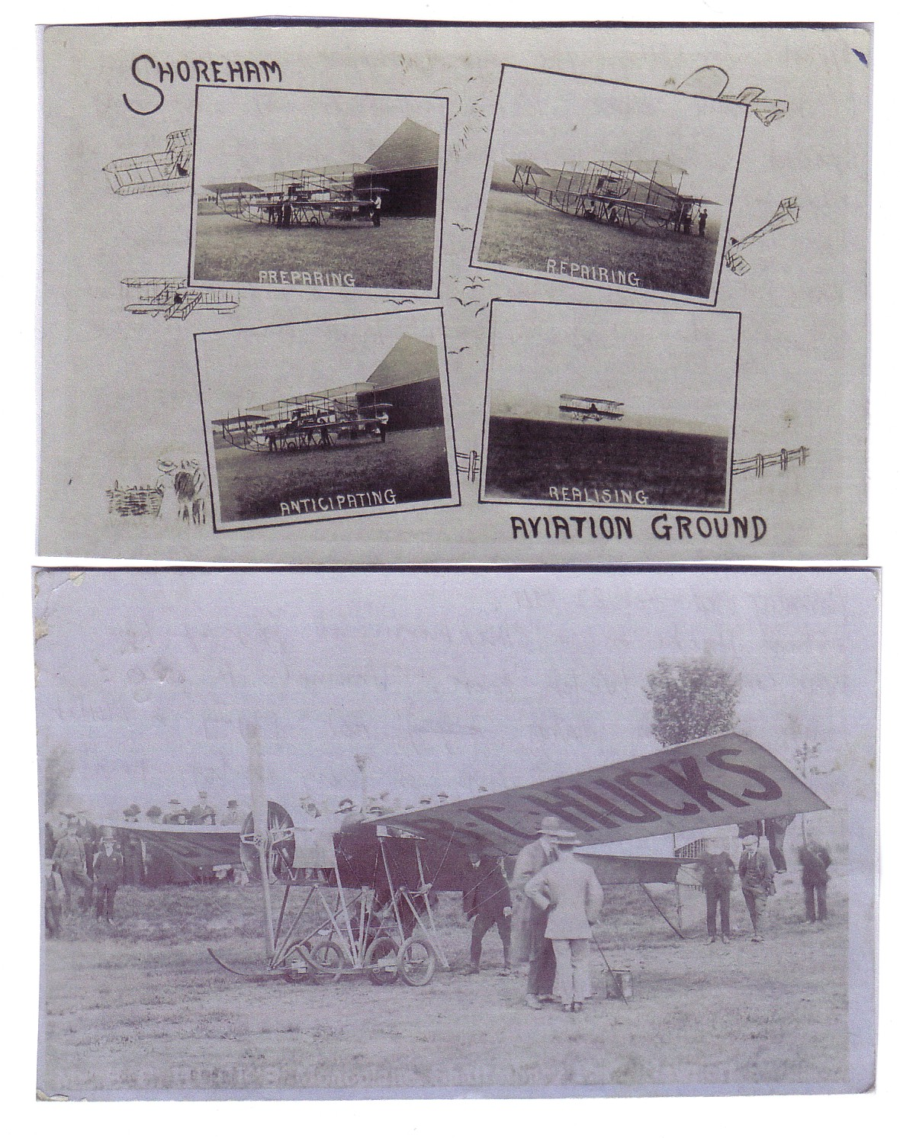
The USA surely did. One was aviatrix Ruth Law on this card from Charles Sterba, USA. Signed in ink, it was probably a souvenir card from the many aviation events she appeared at nationwide. Charles has another card featuring her at such an event in Iowa.
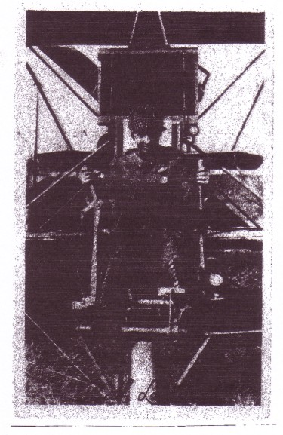

Colin White, Kent UK provided an example of the real photo cards of Mays of Aldershot – a fine portrait of Texas born Samuel Franklin Cody – first to build and fly an aeroplane in the UK.
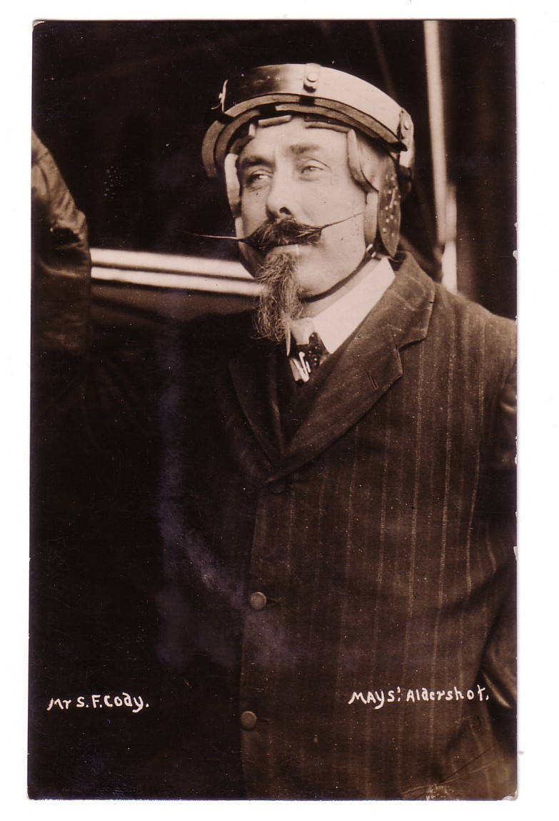
A link with Shoreham is that it was where O P Jones, later chief pilot of Imperial Airways and BOAC, learnt to fly. This shows him in his barnstorming days with an Avro 504 of Berkshire Aviation and is ink-autographed. This card will have to serve for the Imperial Airways interest, which, although strong, was not the subject of any submissions (card from Doug Bastin)
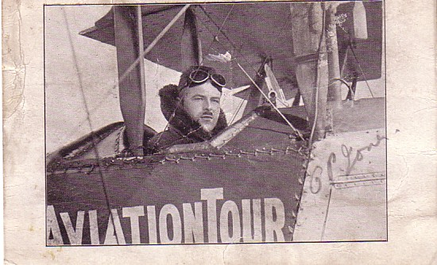
ZEPPELINS feature on 2 cards. First from Bill Trower, Essex, UK shows the “Graf Zeppelin” LZ127 and is a card written and postmarked on board on 17 Sep 1930, at Friedrichshafen . Both Zeppelin cards represent the link with the postal history interest.
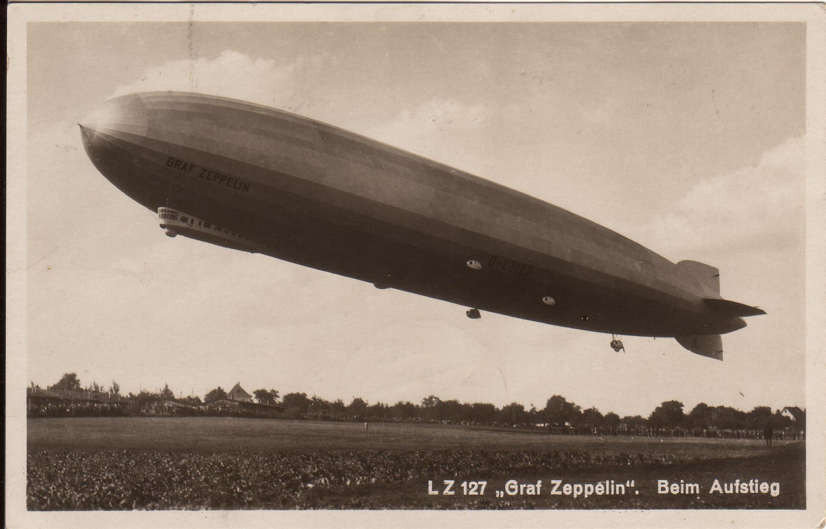
Brian Hyner, Birmingham, UK epitomises this. The card is actually of a warship, the German Cruiser Karlsruhe. The postal history/aviation link is on the back postmark. Background is that the Graf Zeppelin, on a scheduled service on 29 Sept 1932 was unable to land at Pernambuco Brazil due to the available ground crew being too few to cope with storm conditions. Assistance was sought from the crew of “Karlsruhe” which was anchored in the harbour. For services rendered, the crews’ mail was put aboard the Zeppelin, which reduced its transit time by approx one week. Naval mail used German stamps at inland rates and the cards carried both “Karlsruhe” ship mail and Zeppelin mail postmarks.
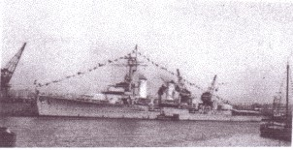
COMMERCIAL AVIATION of all periods dominates the rest of the entries but within that there are many sub-themes. AIRPORTS often yield rare types and airlines and show aircraft “as is” surrounded by people, vehicles and other apron clutter which are anathema to the “perfect aircraft shot” faction. An example of a “classic” U.S prop-era real photographic airport card is this one from Jack Greenbaum, USA, of Mills Field, San Francisco, 1940s with a United DC-3 “Mainliner”
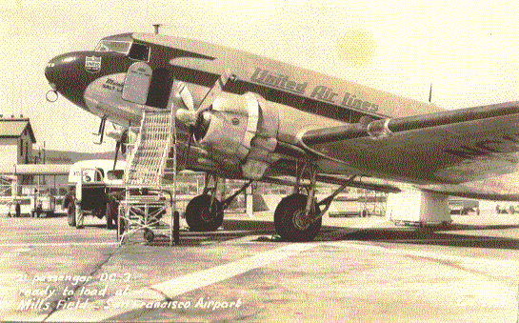
The once ubiquitous DC-3 is itself the object of many collections as also is the Lockheed Constellation as on this Eastern Airlines example at Detroit – Willow Run airport from Chris Slimmer, USA.
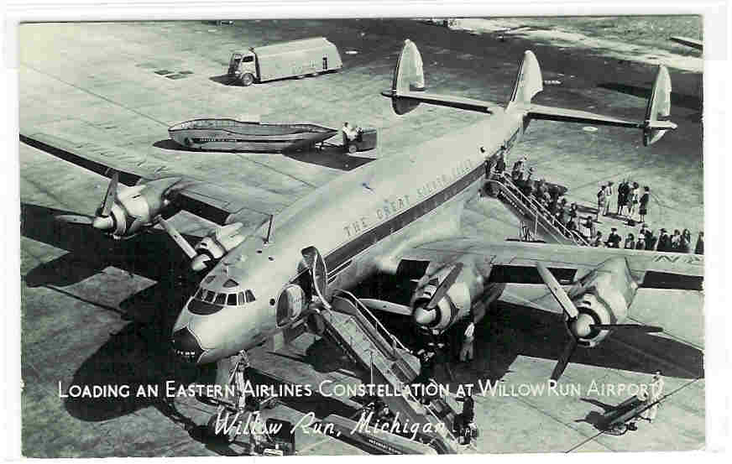
You can’t get much more obscure in Airport cards than this second card from Chris Slimmer USA. DC-4 of Royal Air Lao, at Vientiane airport, Laos, and showing the airport under floodwaters. The back text in French dates the flood to 1 Sept 1966. This also appeals to the hunter/gatherer instinct by turning up for a 25 cents at a flea market.
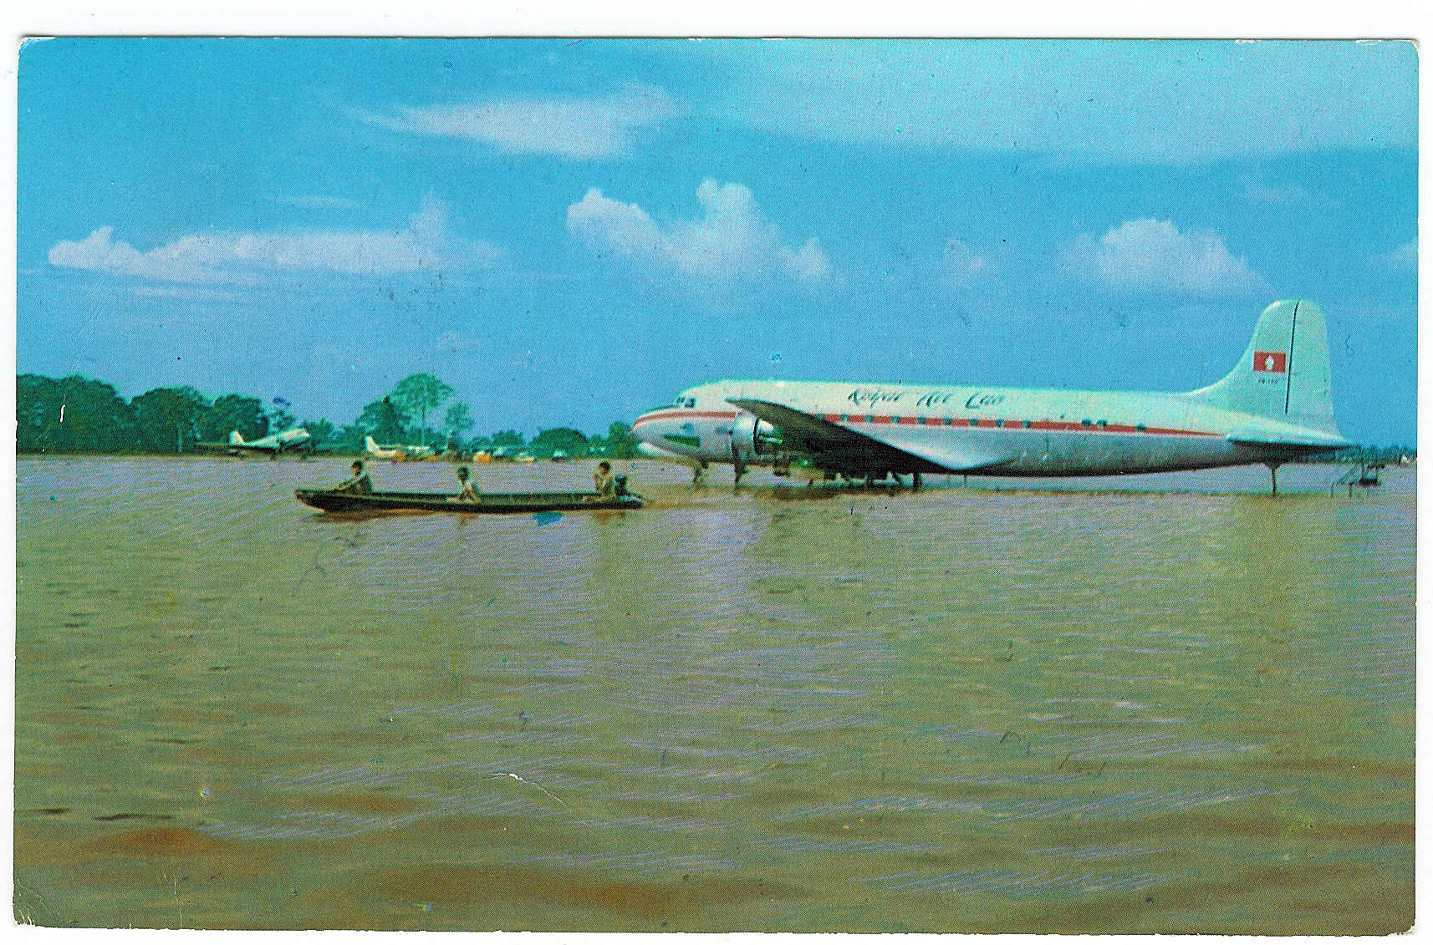
More water but this time in its right place and supporting a Short Solent of Aquila airways at Las Palmas, Canary Isles on a Dixon card. Submitted by Peter Marson, Surrey, UK but originally from Southampton, home of British flying boat operations. Flying Boats are another strong collecting theme.
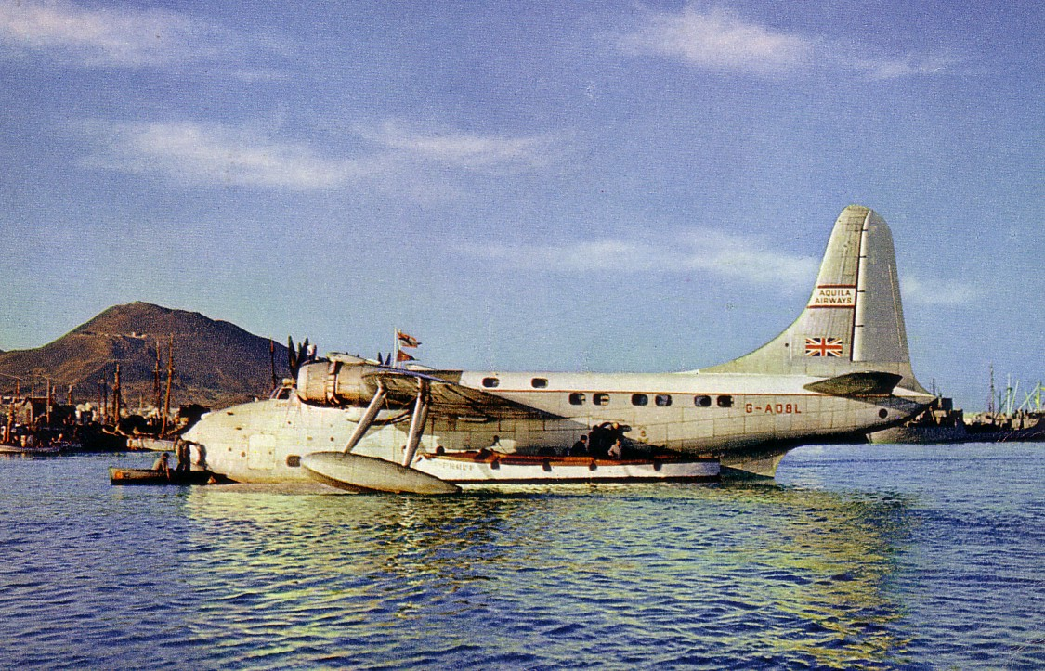
More John Hinde follows (and more Nigeria), this time from Carl McQuaide Tamworth, UK combining the airport theme with other favourites VC-10 and BOAC although this one at Lagos is leased to Nigeria Airways. Like for an old Edwardian photo postcard everybody has stopped to look at the camera.
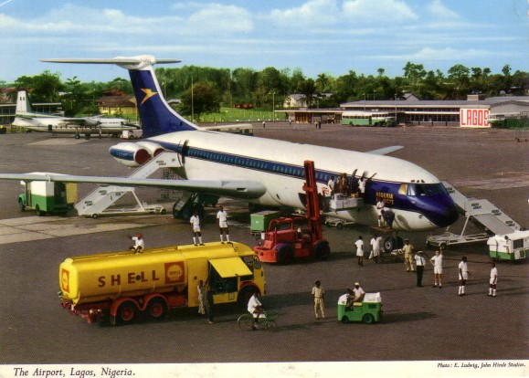
…and still they come from Irish publisher, John Hinde. A sub species of Airport, the heliport with BEA Helicopter at Penzance on the Scilly Isles service. Submitted by Brent Wallace, Canada who writes“. I selected this commonly available card for many reasons. It illustrates the first Sikorsky S-61 operated by BEA on its successful and long-lived scheduled service. The aircraft is in its original livery and the airline name and aircraft registration are visible. The image is colourful, documents the local countryside and shows the aircraft in service with all the usual activity (loading passengers, gate agent, flight crew, ground crew, vintage fire vehicle) rather than a sterile image of a lonely aircraft. I also like the fact that the card has been used. This adds context, tells a story and makes the card seem more historically significant in a folksy kind of way”
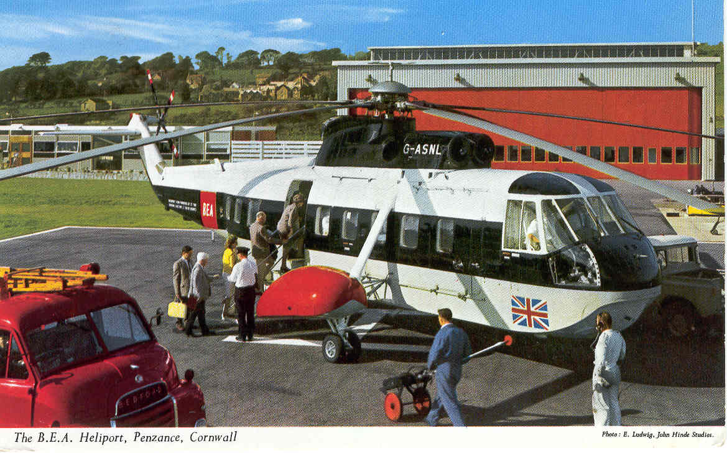
AIRLINE ISSUE cards are probably the most-collected sub set of commercial aviation, probably because they relate to how the airline wished itself to be seen, are set at a point in time, and, in the past, were often available, and written on, in flight.
As befits a UK based club BOAC & BEA have a strong following. Simon Penn, Sussex who flies for successor British Airways, submitted this late 40s BOAC issue of the Halton – a converted Halifax bomber which is one of a set of cutaway drawings over cities – this one being over London. He writes “it comes from the early post-war years when most cards were black & white. Other cards in the set include an orange York, Green Constellation, blue Hythe, green Solent & red Plymouth. I particularly like this series as they are rare, except for the York, are easy to date as they have the year included in the standard format BOAC print code and must have been impressive when they were produced. This card is of particular note as I have seen it only twice and Halton is my wife's maiden name !”
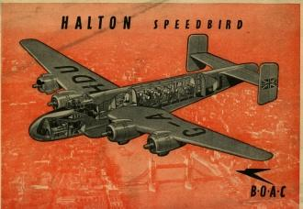
The types listed were supposed to be supplemented by a fleet of Avro Tudors but the type did not perform to specification and later , its bad safety record was a factor in the collapse of British South American Airlines. A prototype also killed its designed Roy Chadwick. Phil Munson, Surrey, Uk and Club Founder has this one, apparently a BOAC issue in their colours although they never operated it, finding the Constellation far superior – Constellations however needed scarce $ and BOAC/BEA were always under pressure to use UK built types.
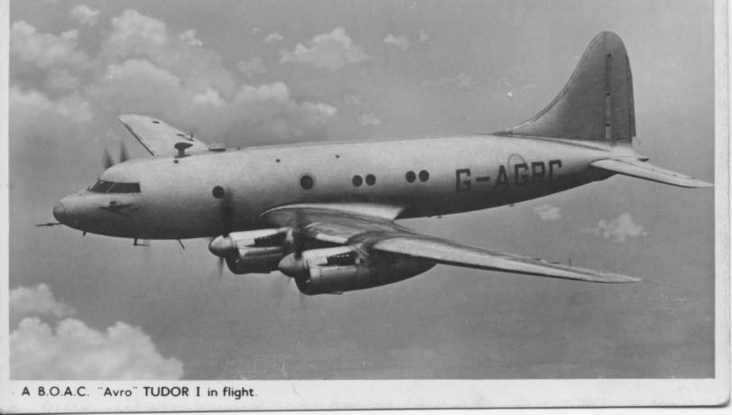
Of these the Comet and VC-10, have a good following among collectors, reflecting their technical, if not commercial success. The Comet 4 card from BOAC is fairly common but this example, from Tony Sturgeon, Lancashire, UK is set apart by its back message, being autographed by the Captain of the first eastbound transatlantic jet service 4 October 1958.

Geoff Dryden, Canada contributes a BOAC issue of the Super VC-10 model. Actually in the colours of the short lived BOAC-Cunard joint operation.
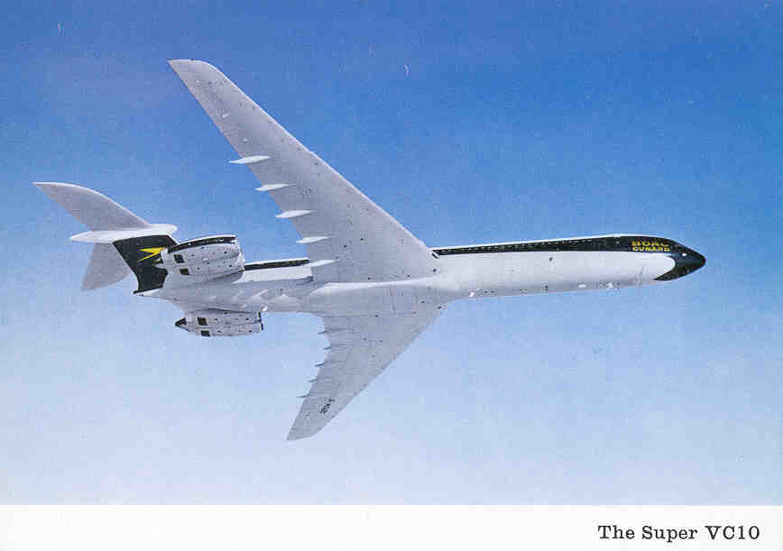
One BOAC Comet was sold to Ecuador for airline AREA who issued this card that Graham Cowell, Bingley, UK had once, sold, regrets it and has never seen it again – which is the second time we have had that story in this issue. (This is a scan of a copy so a little blurred)
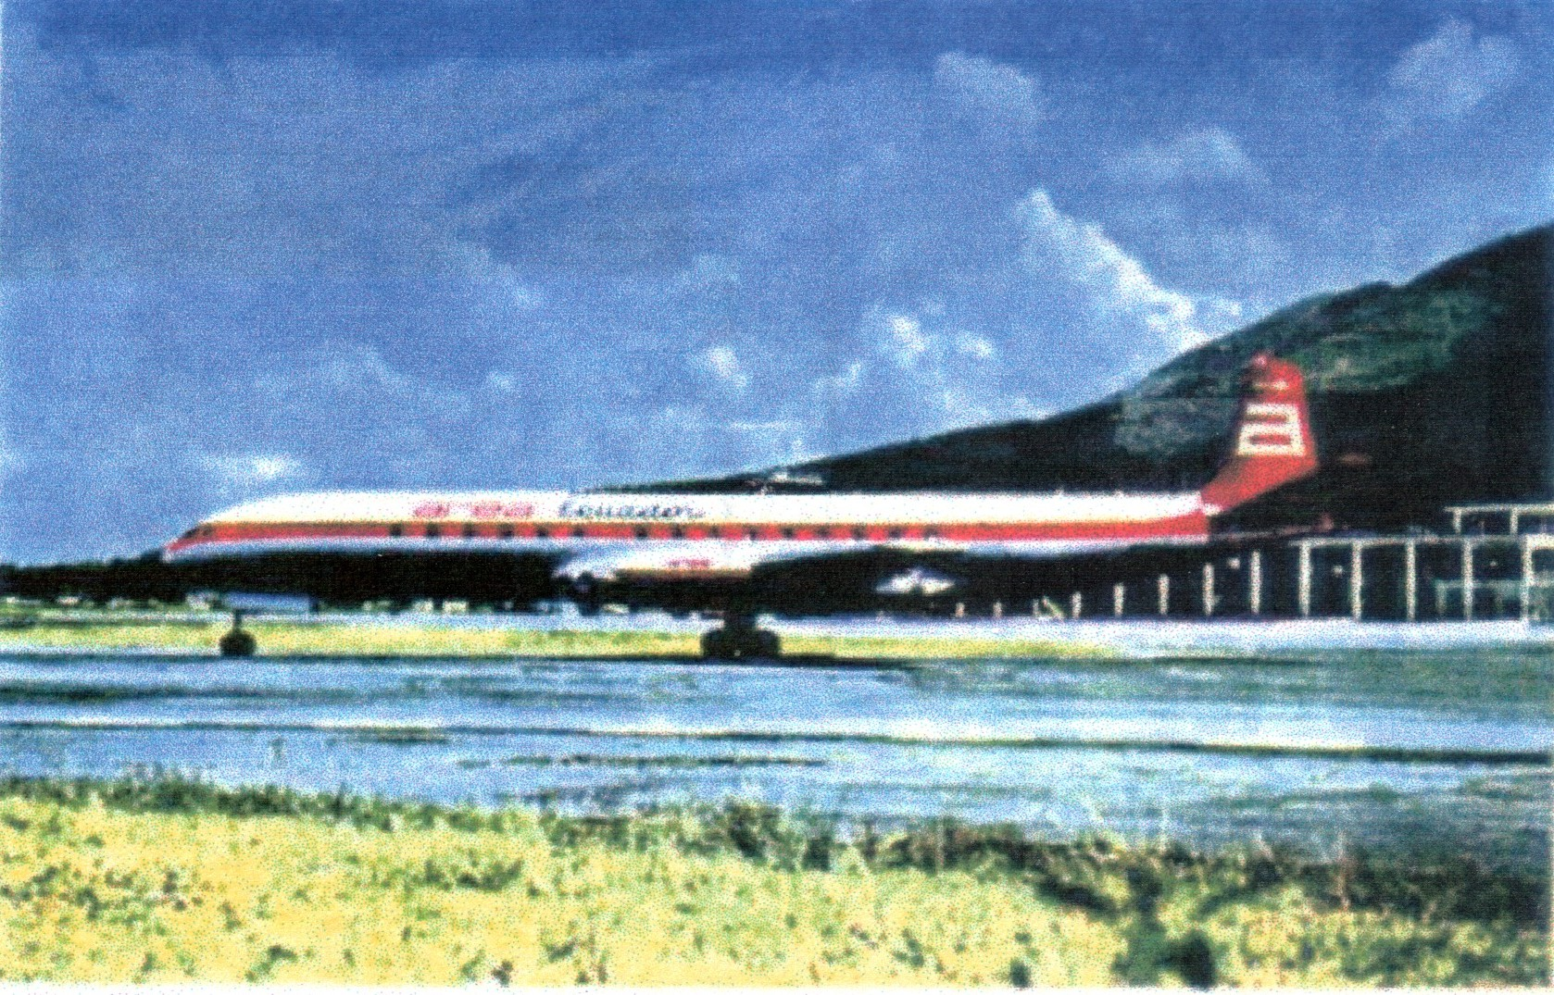
Many, especially defunct, US, airlines have a following as also, increasingly, have the 1st generation jets 707 and DC-8. Both are typified by this Western Airlines Boeing 707 from Frank Lichtanski, USA who writes “I wrote to Western Air Lines in late 1962 when I was 11 years old. They sent me a timetable and two postcards--a 720B and this one. This postcard is striking for several reasons. It is the quintessential 707 portrait. Vibrant...brightly lit...slightly banked...crystal blue sky...and snow on the mountains. The aircraft is painted bright white and red in an early version of Western's "Indian Head" paint scheme. The nose treatment particularly caught my attention. The slanted angle of the black radome is highlighted with a red pin. And it matches the angle of the Indian head dress that wraps around the bottom of the fuselage. The non-fan engines and the modified "tall" vertical tail bring elegance and balance to the image. Adding to the mystique of this wonderful photo is the fact that Western's first 707s were originally destined for Cuba. Although I never got to fly on one, as a youngster I was fortunate to have had several opportunities to view Western's 707s and 720Bs at LAX.”
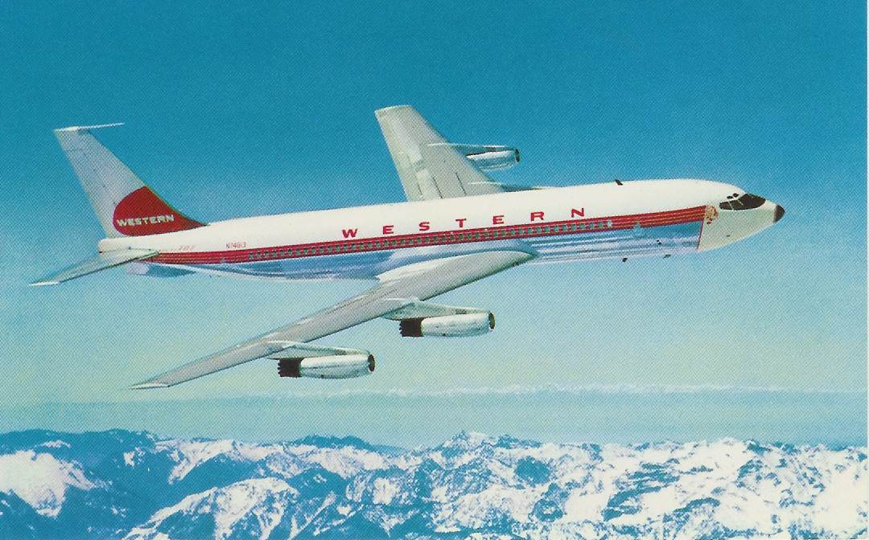
Representing BEA this card from Gordon Tutt, Sunbury, UK is also, in its way, a Channel islands card, although not an airport. The aircraft on this card from Valentine is in fact the prototype DH 114 Heron G-ALZL in BEA colours. The aircraft was later operated by Jersey Airlines named the 'Duchess of Paris'. “Not only is the quality of the photograph excellent but the printing of the card has retained the quality. It is a fine record of the Heron on a route more usually associated with BEA on routes in the Scottish Highlands and Islands. The aircraft provided not only a fast means of travel within the islands but acted a postal carrier and air ambulance for those communities. On examination of the postcard the passengers can be clearly seen looking out at the aircraft taking the photo as are also the flight crew (thankfully) The view below of St Helier is also a photographic record of the period, with some familiar features and landmarks which remain to date.”
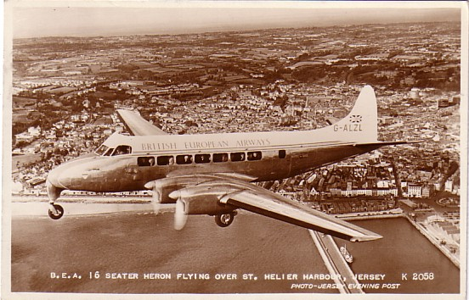
Cards aimed mainly at collectors by specialist publishers have had less of a following historically but that changes with age as many are now almost 50 years old. PI of Paris has always had a following. Frank Litaudon, France writes of them “PI started publishing airplanes and Parisian airport cards in 1953 as they obtained a monopoly for supplying Parisian airports shops with aviation related cards.This lasted over 40 years and a little less than 1000 cards where published till PI -which eventually was taken up by another editor :LECONTE- stopped publishing any aviation cards due to the end of their monopoly. Small numbers of airplane cards were not interesting any more compared to millions of Eifel tower cards that they were publishing”. This SAS Convair 990 on a B&W PI represents another early jet with a strong following in this and the earlier 880 version.
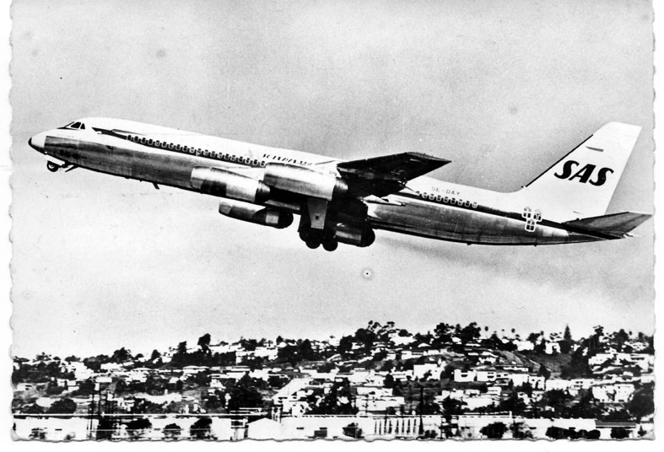
A unique publisher was Colombian company Movifoto. Their cards show mainly airliners, but also Colombian Air Force, types at, or in the sky near their home city of Medellin. They include many unusual airlines but most especially unusual angles, often showing aircraft taking off or landing viewed from above. These were made possible by the use of their own Cessna 206 lightplane and they produced this card of it, submitted by Geoff Dryden, Canada.
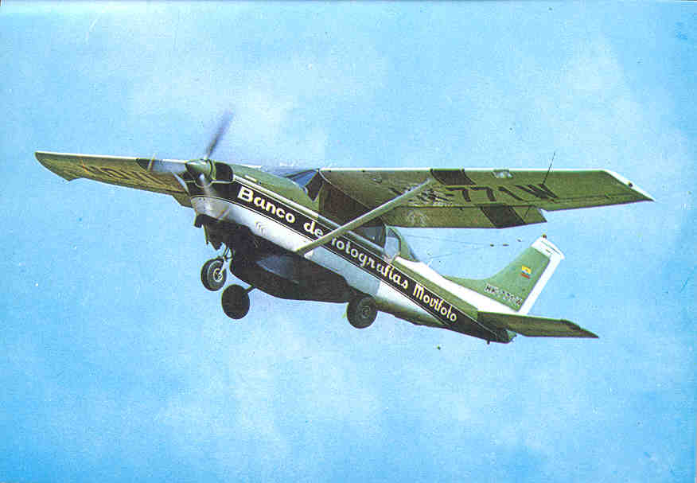
By comparison with airliners there a fewer Military collectors. Chris Watts, France submitted this of a late WW2 RAF Hamilcar troop and equipment carrying glider – one of a large series of French cards apparently made very soon after the end of the war.
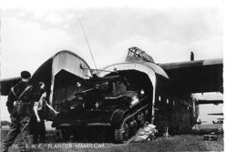
In the Uk there are probably more postcards of the Spitfire issued than any other military type with cards from the 30s, WW2 and, most commonly, retrospective and preserved example cards. But the only one submitted was from Paul Lindenblatt , USA of this Israeli card commemorating its role in the 1948 war with Arab states consequent upon the founding of that state. The odd thing is that, at the beginning of that war, it was Egypt that had the Spitfires, and, to defend against them, Israel acquired Messerschmitt 109 s from Czechoslovakia.
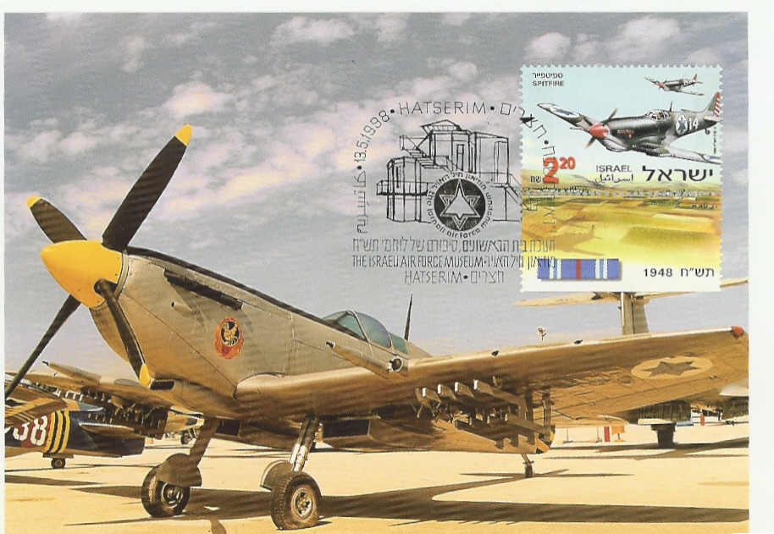
Uniting all themes are the oddball cards. Our regular features “Worth a Second Glance” and “What do you Know”, provide forums for members to respectively, highlight unusual features of a card and seek information about some odd aspect. Three cards submitted could well have appeared in these sections in a normal issue. Chris Watts, France submitted this card from a French publisher, found in France with a date of 1924 written on the back. The aircraft appeared to be French, but of an unidentified type. However the military surrounding it, cavalry by the spurs worn, are not in French uniform. Although initially appearing to be British, something in the style of uniform suggested US Army. But the type was not one known to have been operated by the AEF. It was later identified as a Boeing MB-3A of 1924 – the tail and skid are distinctive. This was far too late to have served in France, so the mystery remains of why a French publisher should feature an accident “somewhere in the USA” in 1924
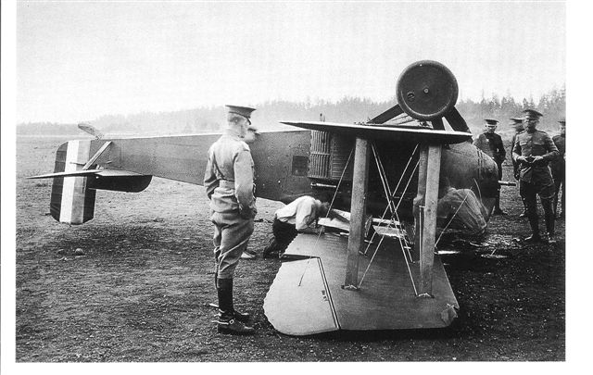
Frequent contributor Leonardo Pinzauti, Italy submitted an apparently Chinese DC-2 card. It was an Italian publicity card for the film, Lost Horizons, from 1937, starring Ronald Colman, in which a group of westerners, fleeing from a revolution in an unidentified Asian state, crash in a snowy valley in the Himalayas. They are rescued and escorted to “Shangri La” a hidden land unknown to outsiders. The card shows armed riders attempting to stop the take off. The DC-2 carries Chinese characters suggestive of the then Chinese airline CNAC. But in the 30s , whatever the supposed location, Hollywood films were shot either in the studio or on location a few miles away. Comparison of the skyline with desert airliner “boneyard” shots make it pretty clear that this is Mojave. A film history website confirms that the film was part shot at Victorville, CA , which is near to the desert airfield.
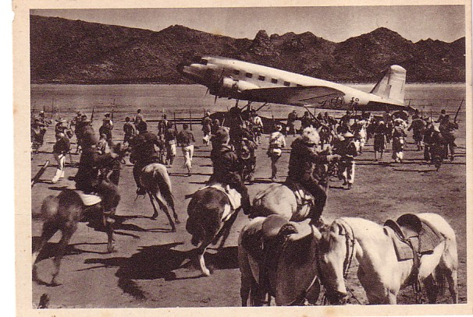
Next, the classic, “Worth a Second Glance”, Alan Daugherty, Isle of man submitted this card, supposedly of that island. It is a plausible picture of a late 40s Viking airliner, and, if it had been one of the BEA fleet it would have been unremarkable. But it is much rarely photographed Viking of British West Indian Airways – not pasted on to an I.o.M view, but with actually both it and the view having no connection with that island.
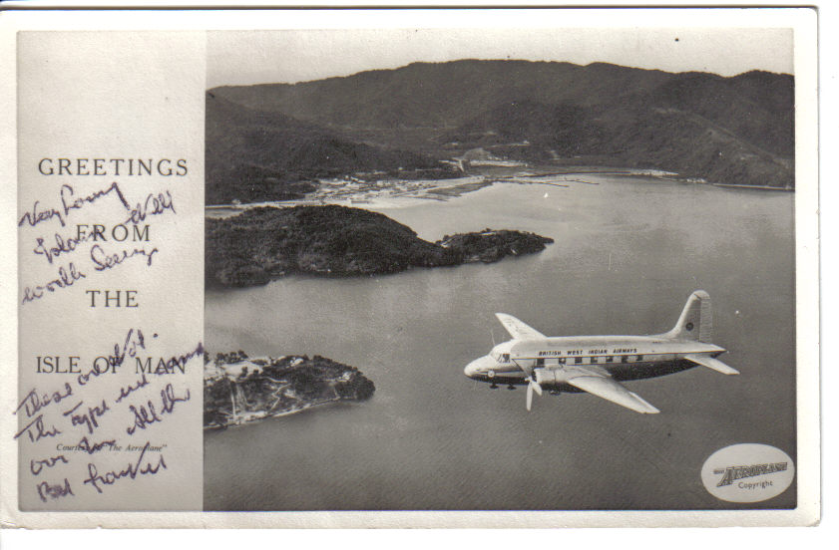
That about wraps it up. We showed 54 cards from 44 members with a good few multiple entries left over for future editions. Some subjects were not represented. Some may think others were over exposed, but that’s the way the membership responded. This last one is a good one to end on with its departing view of a Sikorsky S.76 from its Finnish operator, Copterline. Brent Wallace, Canada, describes it thus and summarises many of the reasons people collect.“. I selected this commonly available card because of its thoughtful and well illustrated qualities. It represents a successful independent helicopter airline flying on its route and it also manages to document this airline's main competition in the form of a ferry. It therefore reinforces some of the prime advantages marketed by Copterline: speed, comfort and a great view. From an enthusiast's point of view, it is always nice to see the airline's name and aircraft registration...but the prime reason for selecting this card is its beauty. The image is perfectly composed and exposed and the exotic lines of the aircraft are highlighted.”

