MONTHLY FEATURES

DECEMBER 2004 NEWSLETTER US DIVISION
Members will have noticed that the US pages carry an earlier date than the main newsletter. This is because the US page is added to the main paper newsletter when it is circulated in the US in arrear of the UK edition, so it is actually published between UK paper editions. So this month we have US pages dated December
Seasons Greetings. Hope you are all enjoying the Holidays. Also happy 100 years of powered flight. I was able to attend the Kitty Hawk celebration on Dec 16th & 17th, and though the second day was rather “damp”, & the Wright Flyer replica didn’t exactly fly, it was a fun event to be a part of. Thought the main newsletter did a nice tribute to the Wright Brothers as well. I was also lucky enough two months ago, after flying five round trips between Dubai & India, to arrange my commercial flight home thru Frankfurt just in time for the big Frankfurt Airline Show. Not only did I make some great purchases & trades, I had a nice visit with several of our European members as well as Chris Slimmer who was about to embark on another marathon airline journey around Europe. Speaking of members, please welcome new member Jim Davidson to the club.
Jim Davidson, 4664 Highland Blvd., North Vancouver, BC V7R 3A5 CANADA, Interest: DH106 Comet.
At this time of year most of our members are up for renewal. So, please check to see if you have a renewal notice enclosed. I was pleased that more North American airlines seem to be issuing cards, although for some of them I had to travel quite some distance to find.
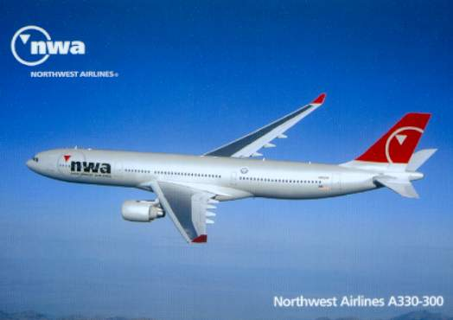
Northwest A330-300 The only OVERSIZED card featured in this issue. I understand this card was issued just for the Northwest employees.
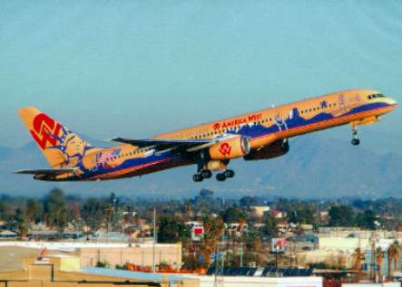
America West B757 One of 4 new issues (others are B757 nose, A320&B737 ramp, & in-flight cockpit shot) from the airline’s company store.

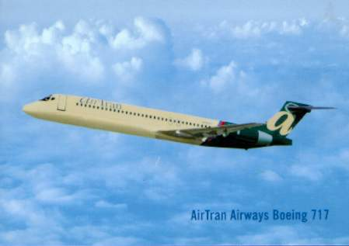
Air Trans B717 First in-flight shot (if you don’t count the old Value Jet DC9 in-flight card) from Air Trans of their B717.

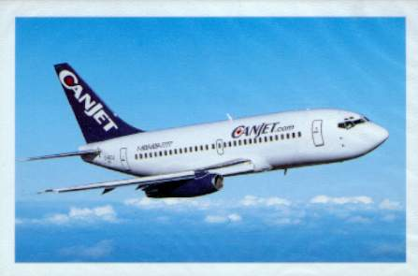
CanJet B737 Fairly new Canadian carrier offering low cost flights between Toronto, Montreal, Ottawa, the Canadian Maritimes, and Florida.

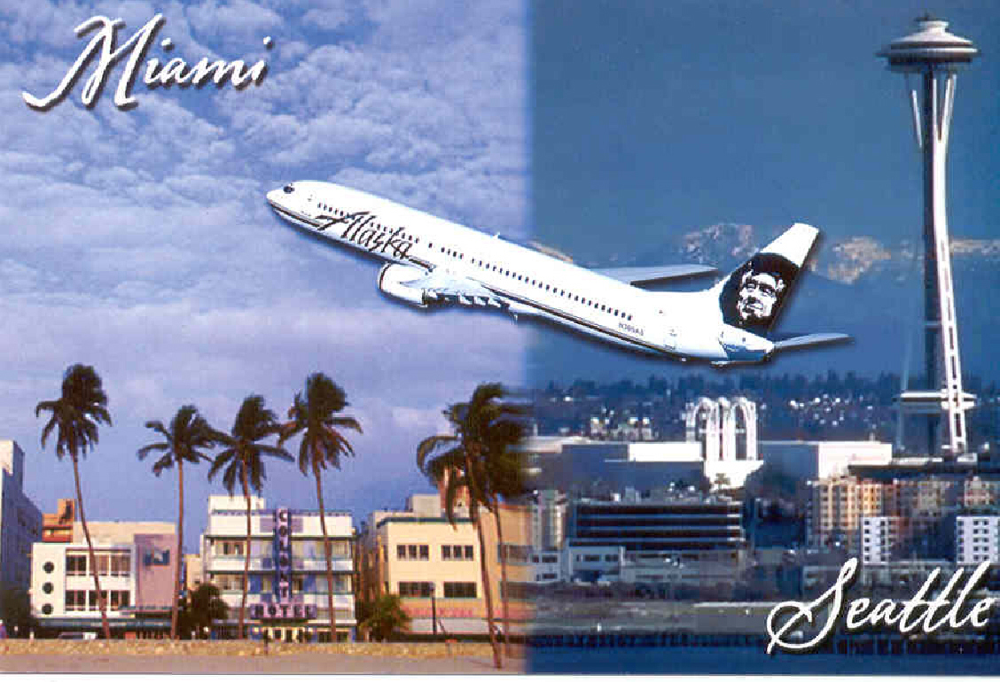
Alaska B737-400 Very similar to a card Alaska issued about three years ago promoting their Chicago to Anchorage service.

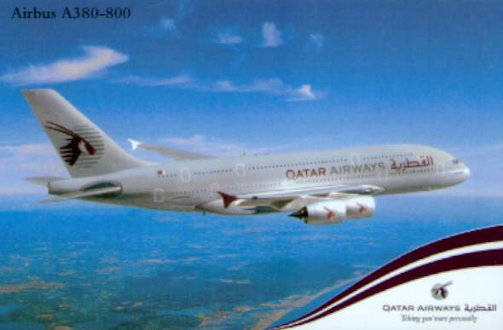
Qatar A380 Perhaps the first airline issue of the A380. This Qatar set also includes similar cards of their A319, A320, & A330.

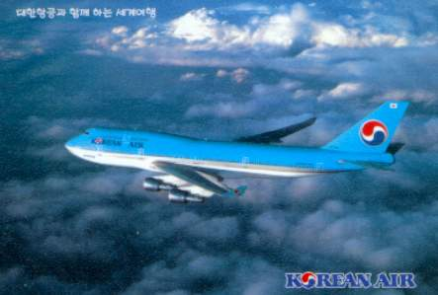
Korean B747-400 One of two new B747-400 issues from KAL.

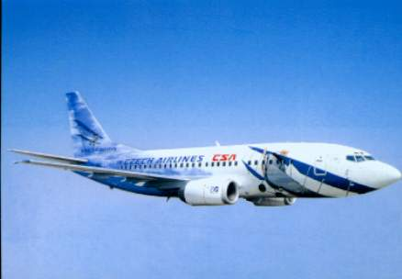
Czech Airlines B737 This CSA plane is painted up in 80 year anniver sary colors illustrating their first A-14 plane on the tail & fuselage.

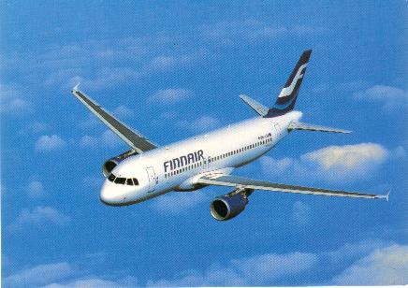
Finnair A320 Great inflight shot. Finnair has also issued ground shot cards of their MD11, MD80, MD87, B757, A320, & ATR72.

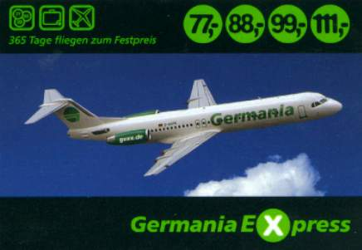
Germania Express F100 Apparently Germania Express is a low cost scheduled division of the old German charter company, Germania.
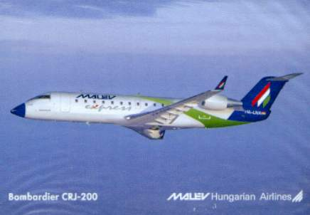
Malev CRJ-200 Set of 4 cards including the B767, B737-700, & F70.

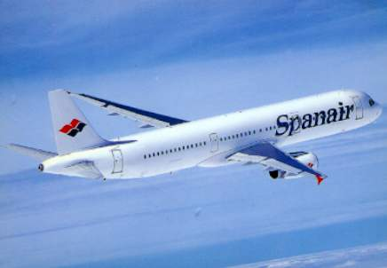
Spanair A321 Cool view of the 1stAirbus card from this Spanish carrier.

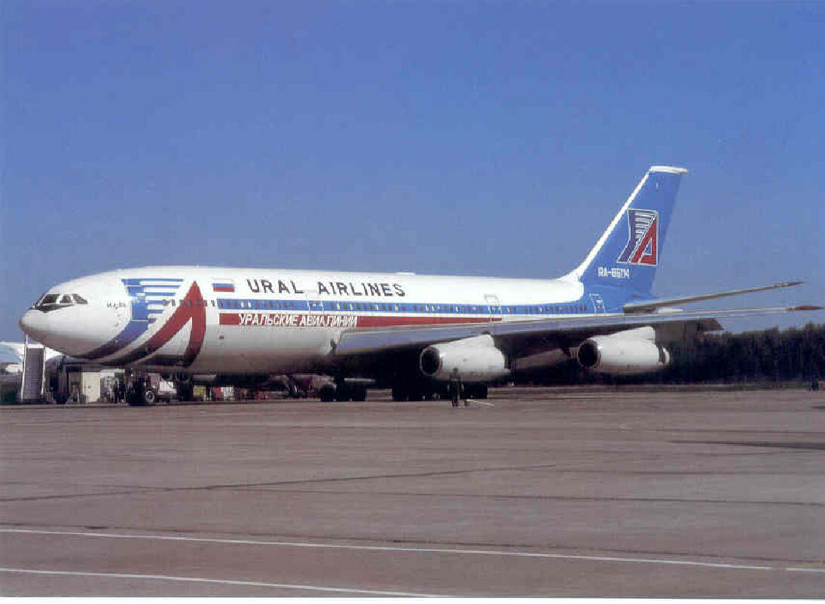
Ural Airlines IL86 One of two issues from this Russian carrier, the other of their TU154. I’ve seen Ural’s TU154 often at Dubai, & haven’t heard many kind words from our crew about the plane’s color scheme.
Thanks again to Ben Sutherland providing this and other cards.

THE FIRST IMPERIAL FLYING BOAT
By Doug Bastin with material from Daniel Kusrow
Mention of Imperial flying boats evokes images of the Short S.23 Empire boats and their post-war successors with BOAC. The story has been told many times, most recently in the book “Corsairville” which, although centred on the story of the retrieval of “Corsair” from a Congo forced landing also examined the wider history of this most nostalgia inducing form of transport.
However the first boat that Shorts of Rochester built for Imperial Airways was just as much state-of-the art, albeit somewhat less elegant. The Short Calcutta was the first flying boat ordered by Imperial and also the first metal flying boat to enter commercial service. Imperial had inherited a few Supermarine Sea Eagles with British Marine Air Navigation’s Channel Islands services but the Calcutta was intended for service on the long haul routes that were Imperial’s main development priority. Features of this 1927 design were :-
All duralumin structure (except fabric covered flying and control services and a few stainless steel item).
Three Bristol Jupiter (later Armstrong Siddeley Tiger – 840 hp) 540 h.p radial engines for multi-engine safety.
Fuel tanks in the upper wing - which allowed passengers to smoke in the 15 seat cabin.
Hot and cold meal service.
Freight and mail capacity.
The target route was the Mediterranean leg of the services to India and Africa. The first, G-EBVG, flew in Feb 1928 In August BVG landed on the Thames at Westminster where it was moored for exhibition to MP’s for 3 days. This is the view in the cover card which carries the Imperial Airways ref IA/C/63. Unlike most Imperial cards of the time it is not by Raphael Tuck. The name of Barratts Photo Press Ltd is on the card face and the back style is similar to many cards issued for Surrey Flying Services. This image was republished in the BBC-Hulton series of cards in the 1960s. After some trial services to the Channel Islands and a one week experimental Liverpool-Belfast service, the Mediterranean service commenced with BVG in April 1929, The Calcutta operated leg of the India route was Genoa-Rome-Naples-Corfu -Athens-Suda bay (Crete)-Tobruk-Alexandria. Passengers reached Genoa by AW Argosy from Croydon to Basle then by sleeper train. A DH Hercules operated the Egypt-India leg. Two additional Calcuttas were ordered followed by a third to replace the early loss of the third original G-AADN “City of Rome” lost in gales off Spezia. The fourth G-AATZ was named “City of Salonika” due to operations being re-routede through the Balkans and Greece due to disputes with Italy. The first Two, EBVG,H acquired the names City of Alexandria and City of Athens respectively. AASJ was City of Khartoum. This latter reflected the extension of Calcutta operations to the Africa route, specifically the Khartoum-Kisumu sector, opened in 1932. By mid 1932 the Calcutta fleet had flown 394,000 miles on the Mediterranean and African services. In 1935 AASJ City of Khartoum crashed off Alexandria and the surviving Calcuttas were withdrawn to training duties to raise a new generation of flying boat captains for the new Empire boats. AATZ now “City of Swanage” surveyed a number of French water landing sites as part of its homeward trip. The trainer fleet, based at Hamble was augmented by a converted RAF Short Rangoon, the military equivalent of the Calcutta built for the RAF.
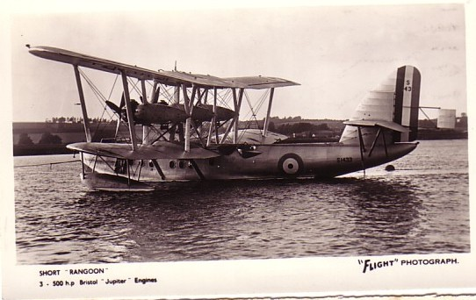
The following real photo cards show four boats from the Imperial fleet.
G-EBVH pre-delivery by photographer E Kelly of Rochester
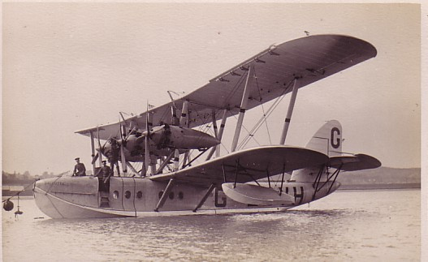
The next three cards are from the Daniel Kusrow collection.

G-AASJ City of Khartoum, retrospective 1940s issue by Real Photographs Ltd
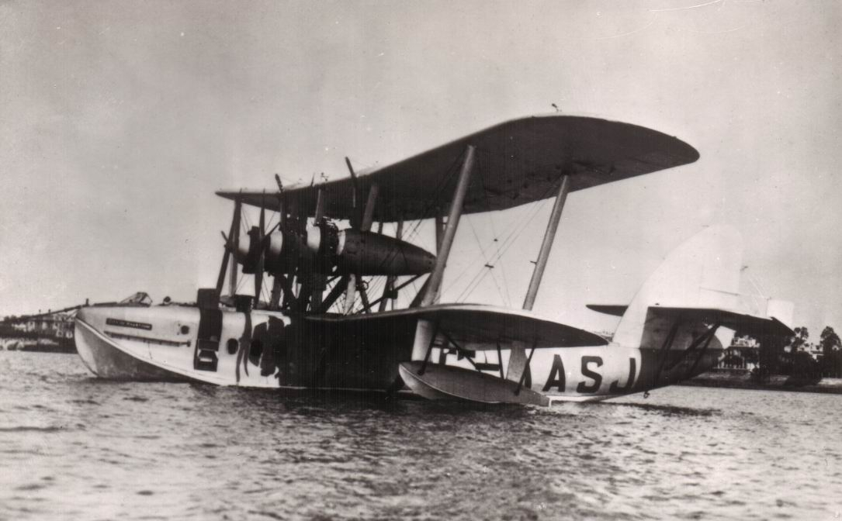
G-EBVG City of Alexandria at Alexandria. Postcard backed photo, probably by a passenger.
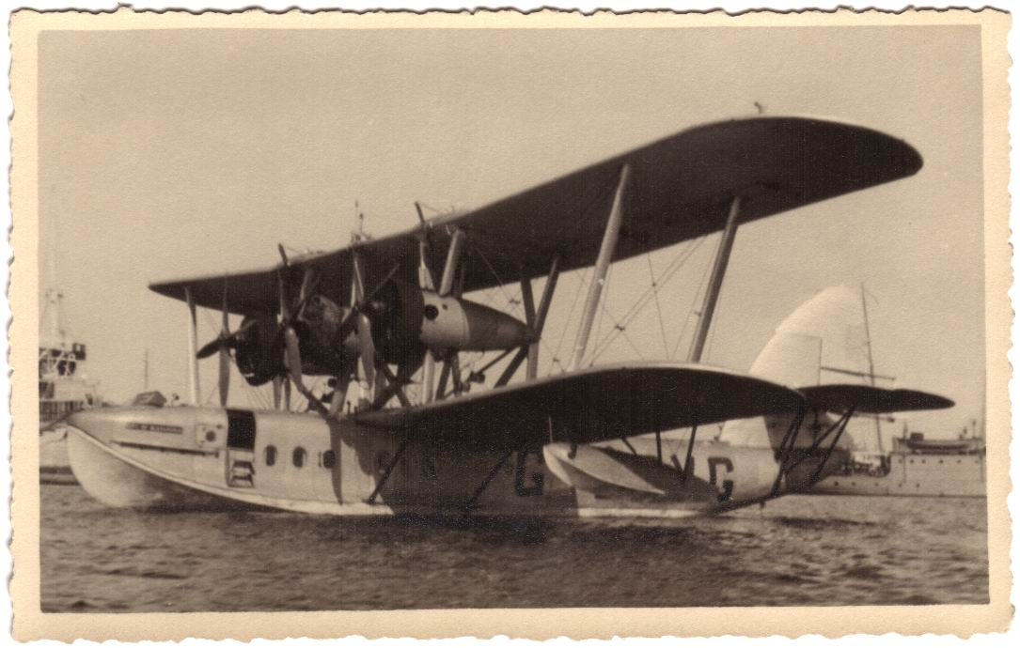
G-AAYZ City of Salonika at Salonika by a local photographer.
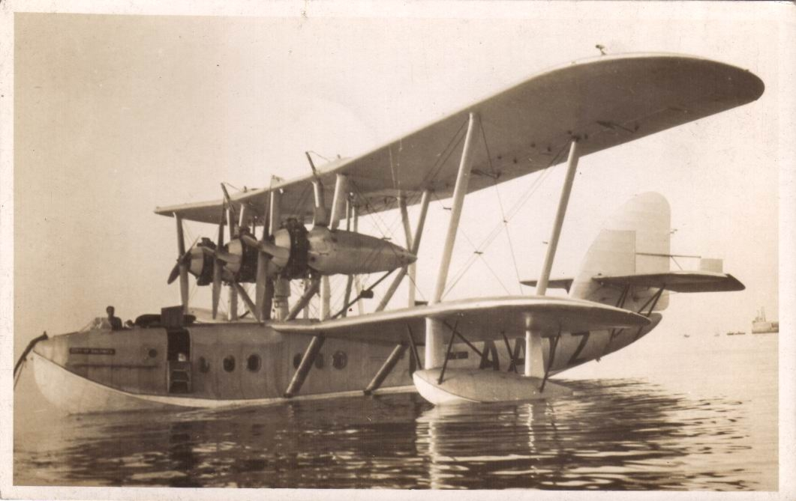

There remains to be mentioned one more civil Calcutta – shown below. This was F-AJDB supplied to the French Breguet company.
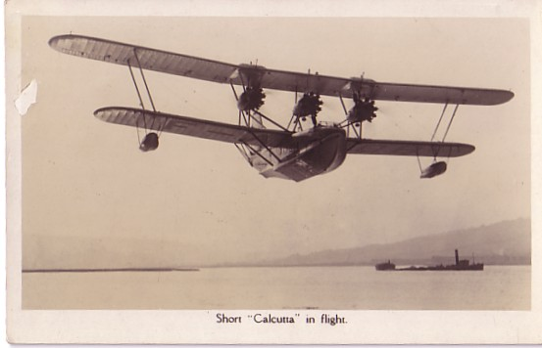
Another was supplied to the French Navy. Breguet built another five under licence and further developed its own variant, for both the Navy, who named it the Bizerte, and Air Union, who named their two, Saigon. The Air Union examples also operated in the Mediterranean, between Marseilles-Ajaccio and Tunis. The hull of the Bizerte/Saigon was little changed but the wing, tail and rudder were redesigned. The three engines were Gnome-Rhome radials.
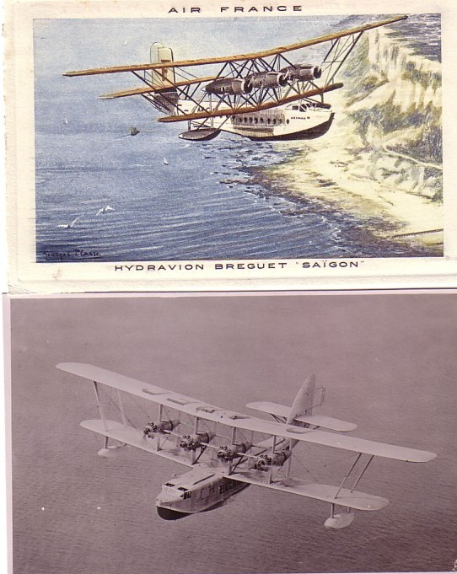
Conversely Shorts own development, the Kent (above on a Tuck card for Imperial) had a redesigned fuselage but the wings and tail were little changed in design but extended to accommodate a fourth engine. Three were delivered to Imperial and named Scipio Sylvanus and Satyrus. Later still, two examples of a clumsy landplane variant the Scylla were also delivered to Imperial. One Kent survived to be retired in 1938; Scipio sank after a heavy landing in Crete in 1936 and Sylvanus was destroyed by arson at Brindisi in 1935

URBAN SEAPLANES
Although the flying boat descendents of the cover view Calcutta are long gone, seaplanes continue to provide service in remote areas where there is water in plenty. Canada and Alaska in particular remain centres for such operators. In the British Columbian city of Vancouver there is an overlap between traditional seaplane use and a new role as provider of a “different” form of sightseeing for cities exploiting their waterfronts for tourist purposes. Peter White visited the city recently and came back with these cards, both from carrier Harbour Air. Currently three operators run scheduled floatplane services from Vancouver Harbour - Baxter Aviation, West Coast Air and Harbour Air - mainly providing links with Vancouver Island. Harbour Air, who also have two or three other bases in British Columbia, lay claim to being the world's largest floatplane operator. They operate Turbo Otters, Beavers and a few assorted Cessnas. Between the three operators, there are some 200 - 300 daily movements to/from the Harbour where traffic mixes with helicopters (mainly Helijet) landing/taking off close by, massive cruise liners coming and going right next to the terminal area, and assorted yachts, power boats, hovercraft, etc. constantly criss-crossing the landing/take-off area. The "control tower" for all this is on top of the skyscraper that appears in the company-issue card shown below. (This adds another element to the debate among airport collectors as to what aspects of water-based operations count as airports – DB)
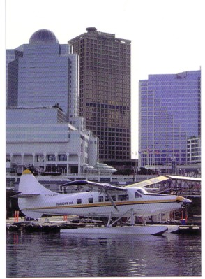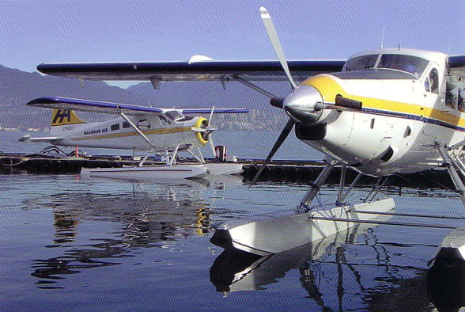
London so far lacks an urban seaplane operator, unlike Vancouver, New York and Sydney. On the face of it London City Airport could provide such a facility being equipped with two potential water runways alongside the landplane one. Remember that this issue is going out near April 1st.
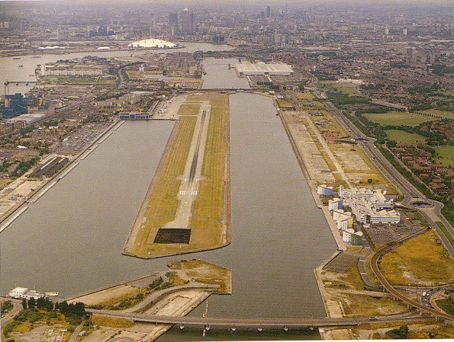
There is nothing new about using seaplanes to give a new angle to city sight-seeing. The pioneer US carrier Aeromarine, which has been researched by Daniel Kusrow operated Curtiss Flying Boats in two markets. Firstly there were winter operations from Miami to the Bahamas and Key West to Havana, both particularly attractive in the 1920’s when the US was “dry” under Prohibition but the Bahamas and Cuba were both “wet” The Bahamas service was promoted as the “High Ball express”. The second operation was the operation of summer services from New York to local resorts including Atalantic City and destinations on Long Island in summer. Later Cleveland to Detroit was added. The Florida services were promoted as“air cruises” as well as point-to-point services. Aeromarine scored a number of “firsts” for air travel. It had :-
- the first US international passenger and mail air services
- the first in-flight showing of a moving picture
- the first ticket office
- the first airline baggage label
Conversely, before the installation of radio, the Curtiss boats carried an emergency communication facility in the form of a carrier pigeon in a housing attached to the wing. When Aeromarine ceased operations in 1924 30,000 passengers had been carried. The New York base was at the Colubia Yascht Basin on the Hudson River. Most cards issued featured the Florida operations but this one is of a Curtiss over New York.


