MONTHLY FEATURES (MARCH 2002)

THE Li-2 IN POLAND
By Robert Stachyra, Warsaw
The Lisunov Li-2 was the Soviet Russian version of the DC-3. 21 DC-3s were delivered to the USSR 1936-39. Russian production started near Moscow in 1940 after engineer Boris Lisunov spent two years at Douglas, Santa Monica. The inital engines were a Soviet development of the Wright Cyclone , so the Li-2 retained the nacelle shape of the DC-2. Other distinguishing features were starboard side doors and an extra cockpit window Production was later moved to Tashkent and continued to 1945 with estimated total production of between 2000-3000. Like the DC-3 in the west Li-2 formed the initial post war equipment of all Soviet bloc airlines, including LOT of Poland.
The LOT aircraft were both ex-military and newly built and both T(transport) and P(passenger) versions. The T featured folded benches along the fuselage sides , while the P had seats for 21 passengers. They were used on both domestic and foreign routes mainly to communist states. While operated by LOT, Li-2s were also used for forest spraying and several were converted for photogrammetric aerial survey duty.
Between 1945 and 1967 the Polish Airlines used 40 Li-2 aircraft. Only two survive today. One is preserved at the Ministry of Defence at Drzonow near Zielona Gora. The other is at Wieruszow, where it has been used as a café for many years. Although so many were used, only relatively few postcards were published showing the type, as follows.

LOT-ISSUE
Year | ID | Print run | Publisher | No. | Subject
1948 |  | 1400 | PPZG |  | Silhouette Li-2 over a city.
1972 | ? |  | KAW |  | Drawing
1988 | SP-LAL | 10000 | KAW | 56-6711 | Drawing LOT 60th Anniv
OTHERS
Year | ID | Print run | Publisher | No. | Subject
1950 | SP-LBE |  | Ksiazka | B-106636 | Warsaw-Okecie Airport
1965 | SP-LAG | 3000 | BW RUCH | 23-2166 | Café Czerwionka
1968 | SP-LAL | 40000 | BW RUCH | 27-1583/68 | Café, Lublin
1974 | SP-LKI | 10000 | KAW | 28/1952/1/74 | Café, Wieruszow.
1974 | SP-LKI | 10000 | KAW | 28/1953/1/74 | Café, Wieruszow
1975 | SP-LKI | 20000 | KAW | 28/1953/1/74 | Café, Wieruszow
1975 | SP-LKI | 20000 | KAW | 12-Z-1/I*# | Café, Wieruszow #
1979 | SP-LKC | 20000 | KAW | 9-1291/1 | Sobieszewo
1999 | SP-LKI |  | L-PRINT |  | Café, Wieruszow
# reprinted 1977 20000 12-Z-1/II*, 1978 20000 12-Z-1/III*, 1979 30000 12-Z-1/IV*, 1980 20000 12-Z-1/V*, 1986 30000 12-Z-1/VI*, 1988 30000 12-Z-1/VII*#

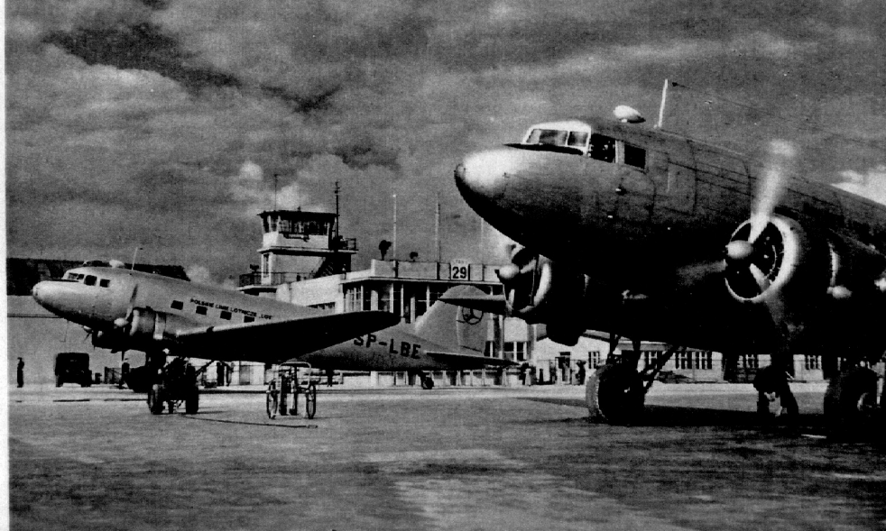 | SP-LBE at Warasaw Airport plus another. 1950's B&W real photo card
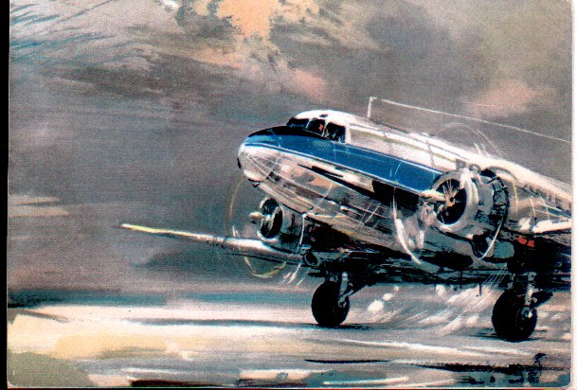 | Drawing by Janusz Grabianski. 1972 History set. Back says LI-2 but no extra window. This card was copied by French DC-3 operator Legend Air.
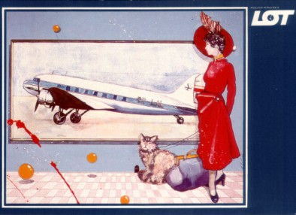 | SP-LAL on the LOT 60th anniversary set. Again, no extra window. Drawing by M. Kalkus
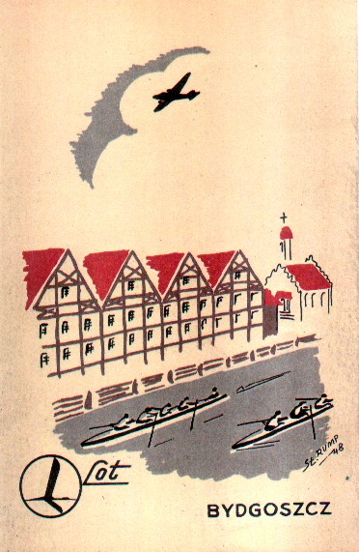 | LI-2 silhouette over Bydgoszcz. One of the first post-war LOT cards
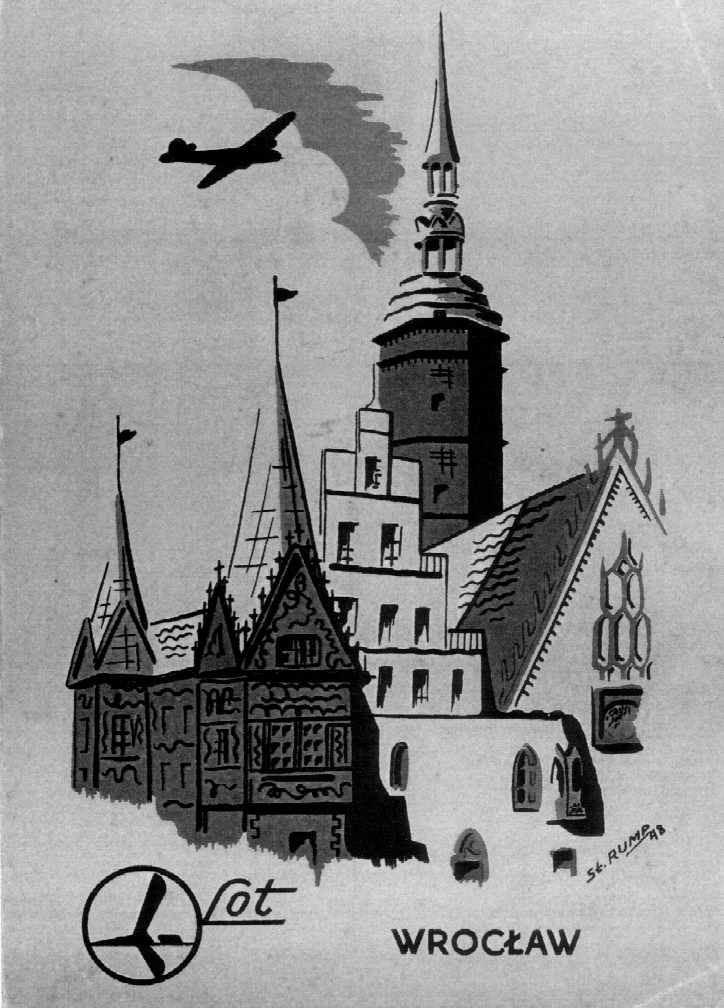 | Another of the first post-war series. Wroclaw (Cracow)
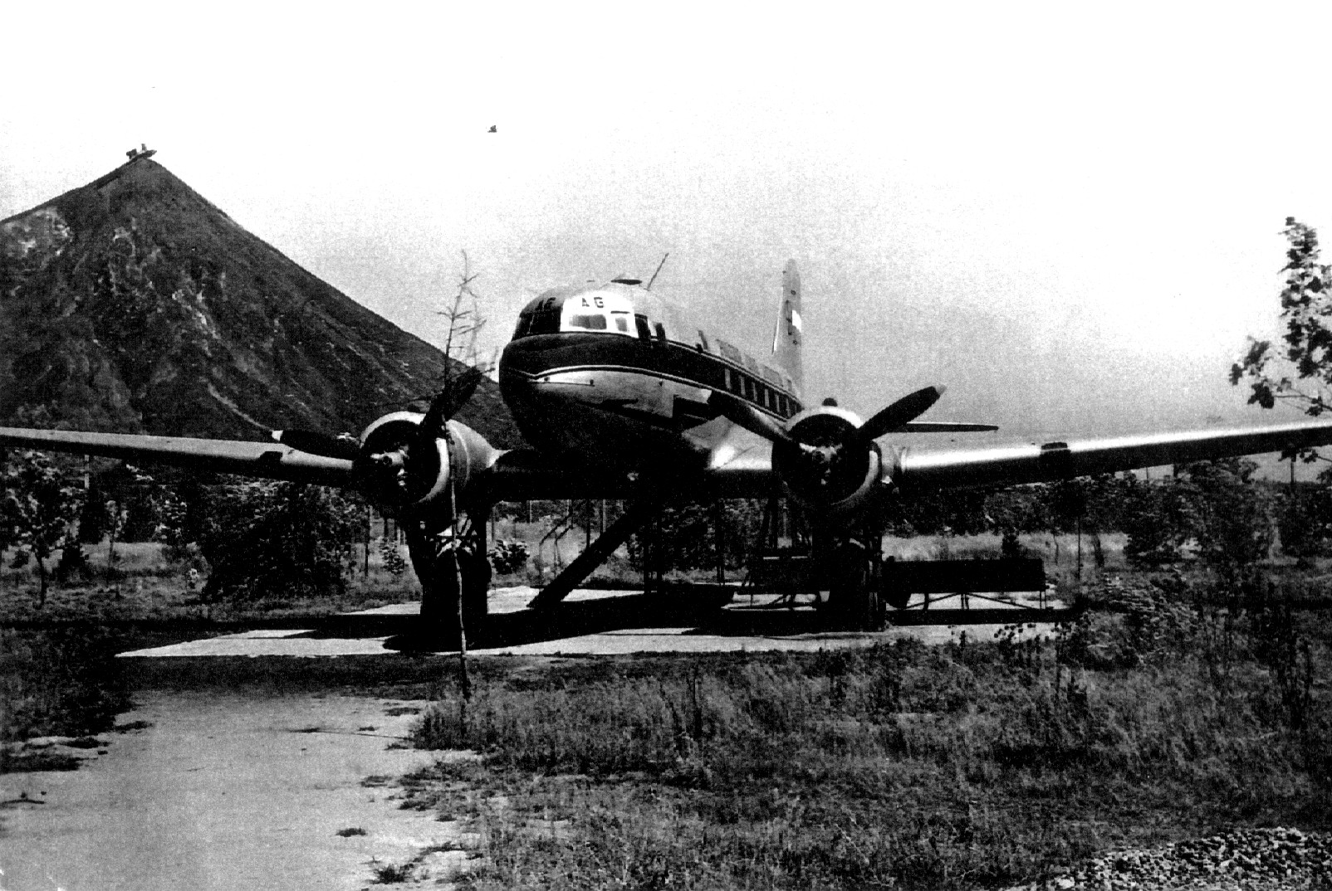 | SP-LAG as a café at Czerwionka. B&W card
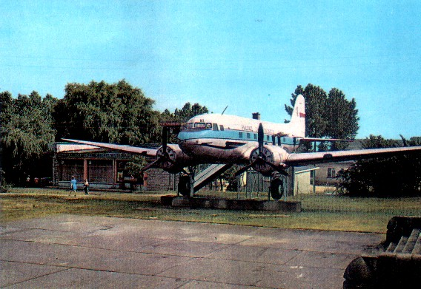 | SP-LKI Café at Wieruszow. Card 28-1953/I/74
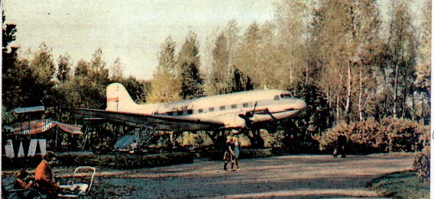 | SP-LAL as a Café at Lublin

KING EDWARD VIII
THE 1st FLYING PRINCE OF WALES
By Ken Harman
As Prince of Wales, Edward, eldest son of George V, had used aeroplanes for travelling around since 1927 and it was not long before he decided to buy his own plane. His father was not keen on this and insisted that Edwards flights were always dual-control. In October 1929, Edward bought a deHavilland DH.60M Moth, a metal fuselage version of the Gipsy Moth, and this plane, G-AALG is shown in the untitled real photo postcard.
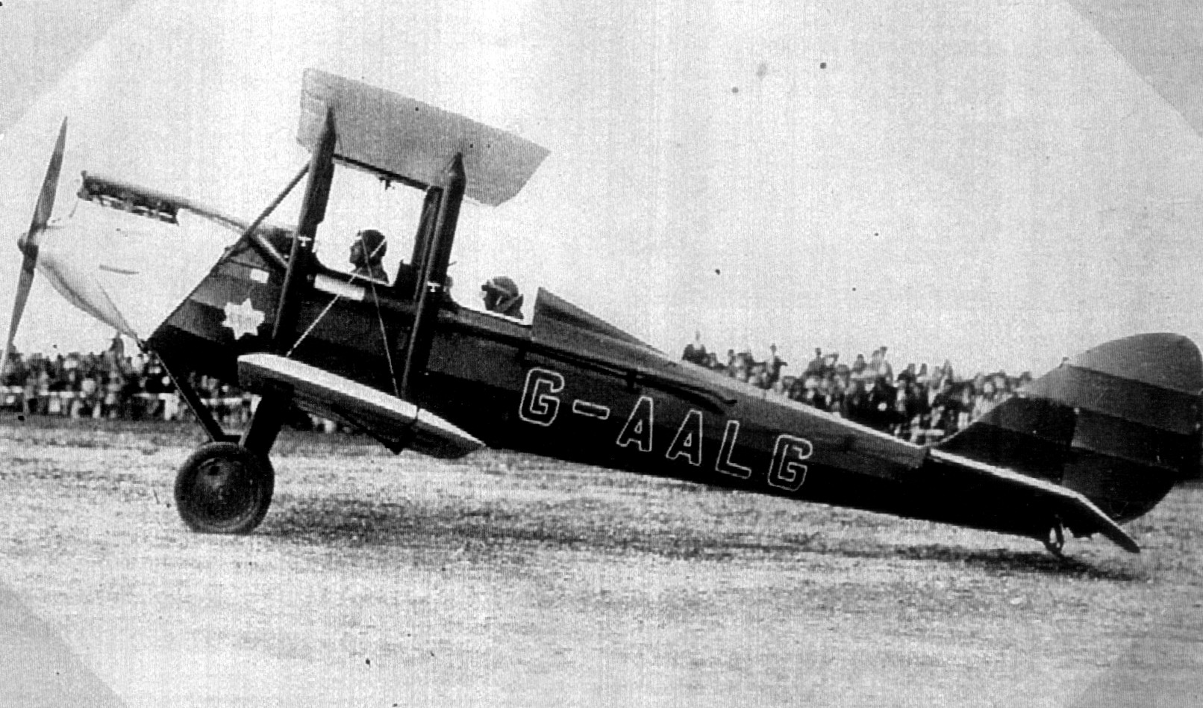
DH.60M Moth G-AALG with the Prince of Wales aboard at Haldon Aerodrome 1929
Fortunately, the story behind the card, is just that – on the back of the card. The writing says :
“Thursday May 29th 1930. HRH Prince of Wales arrived by plane in morning at Haldon Aerodrome, drove from here by car to visit the Bath & West Agricultural show at Torquay. Picture shows him taking off from ‘drome after returning in the afternoon. Went to Padstow.”
The Prince’s Moth must have caused quite a stir at Haldon (then the aerodrome for Exeter) in its colours of the Household Brigade, upholstered in red leather, with a blue fuselage with the registration in red outlined in white – the wings had plain red registration letters on silver. The Prince is in the rear cockpit, which had a streamlined head rest. The pilot , in the front seat is Squadron Leader D Don. The plane was usually kept at Fort Belvedere, the prince’s home in Windsor Great Park. The next day, 30th May, the Prince arrived unexpectedly at the Westland Company works at Yeovil on his way back to London . He inspected the Westland Wessex trimotor , had tea, and then took off for Hendon. He kept this Moth for a while, but in June was flying a Puss Moth and later placed an order for one. This had special seating and this time the fuselage was painted blue and red. This was registered G-ABBS on 28 July 1930. The “Metal Moth” G-AALD was sold and was taken over by the RAF in 1940. The Puss Moth was sold to Iraq in 1935.
The Prince was not supposed to fly on his own but is reported to have made an illicit solo flight. After he had met Mrs Wallis Simpson in 1931 he retained an interest in aviation, with his aircraft now based at Hendon. This was to become the Kings Flight, and used, successively a Dragon Rapide G-ADDD and an Airspeed Envoy G-AEXX. Both had the half blue/half red colours. On disposal G-ADDD passed to Western Airways of Weston-Super-Mare, who promoted it with the postcard opposite, presumably on grounds of “ if it flew royalty it must be safe”.
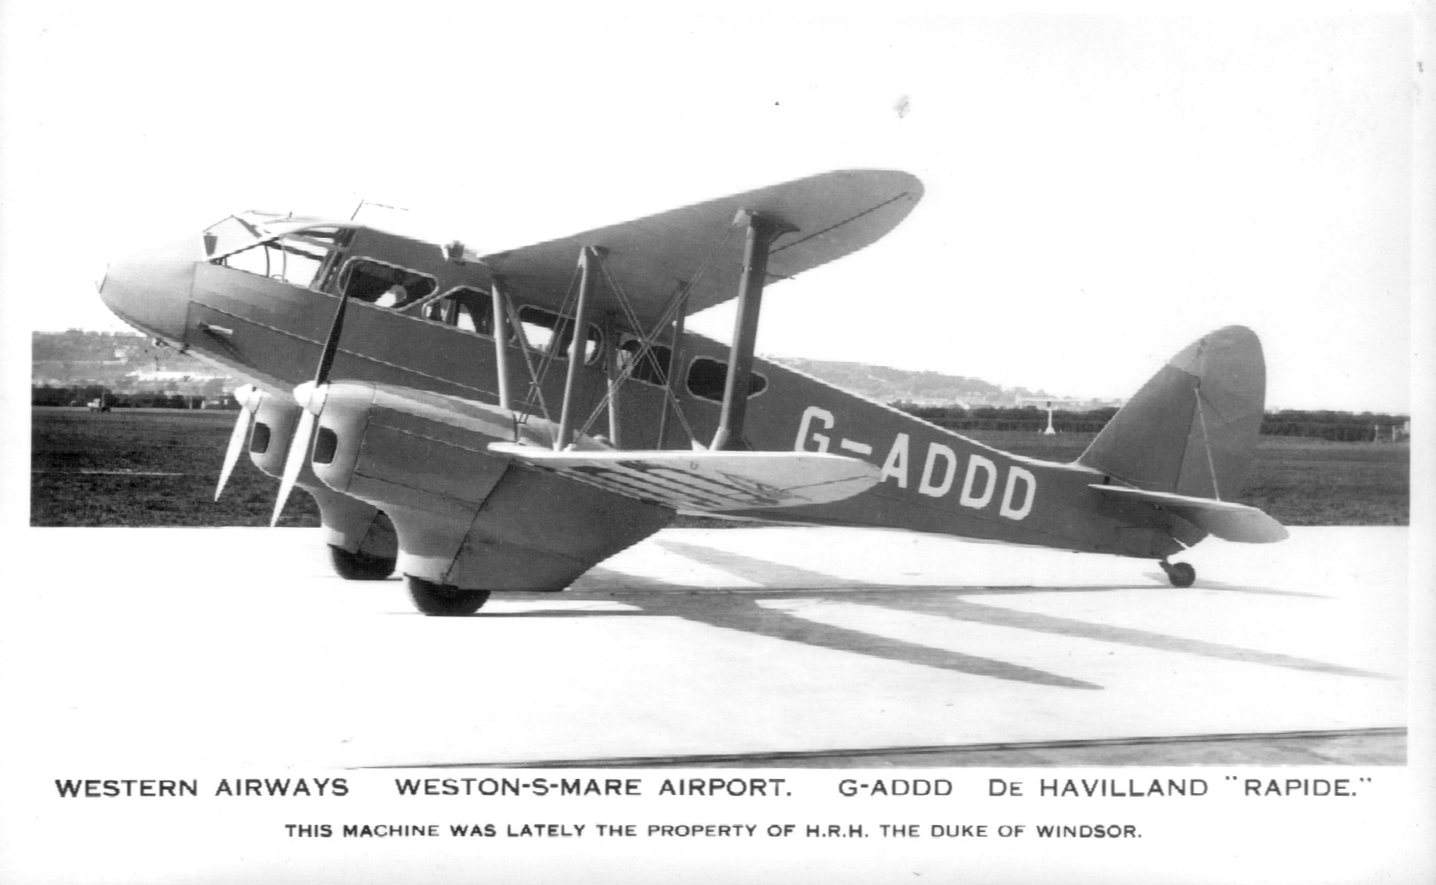
Ex Royal Flight Rapide G-ADDD promoted as "lately the property of HRH The Duke of Windsor" on a Western Airways company card
Like the Moth the Rapide and the Envoy were taken over by the RAF in 1940 and the Envoy survived to be sold to Sweden in 1946. By the time G-AEXX entered service in 1937 there was a new King, George VI. The Coronation . dated 12th May 1937 on the third card of Edward VIII in RAF uniform was never to happen, Edward having abdicated, become Duke of Windsor, and left the country.
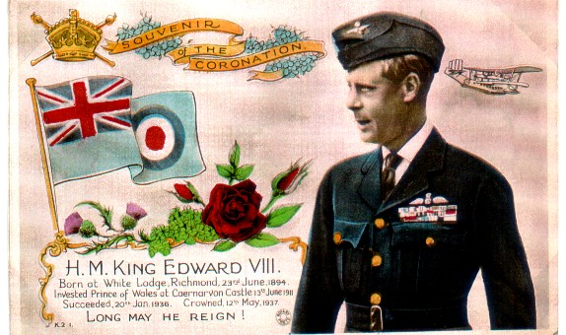
Premature Rotary Photo colour Coronation card of Edward VIII in RAF uniform plus small Short Singapore (?) flying boat and RAF ensign.

DISASTER CARDS
This refers not to horrors perpetuated by some publishers “cut and pasting” such as a half-scale Swissair 747 at Zurich, or cards where the title and the subject have only a tenuous connection, but to the practice of issuing cards of actual disasters. Pioneer collectors will know that a plane crash in the pre-1914 era was just another excuse for a postcard publisher to get a card to market, often within hours of the event. In the days of text-only newspapers these met the public need for images of current , often tragic events, later to be catered for by press and TV. Fires, train and road transport crashes , shipwrecks and mining disasters all featured in real photographic cards of the time.
By the 1920’s cinema and illustrated magazines were taking over this field but one notable set, by a photographer near the scene, recorded one of the UK’s first commercial air disasters. A DH.34 G-EBBS of the Daimler Airway flying London to Manchester crashed , stalling in a forced landing at Ivinghoe Beacon, Bucks on Sept 14 1923. Photographer Ratledge of North Camp, Halton made at least 5 cards of the wreck. The one shown is ER.5. Note the policeman guarding the wreck and the lightweight wicker chairs which have survived the impact. The two man crew and four passengers were killed.
Even more surprising is that, in the U.S.A real photo disaster cards were being produced as late as the 1940’s. A few have turned up on Ebay net auctions, mainly featuring a burnt out TWA Constellation at Los Angles but a C-46 crash on housing near Seattle is also known. The TWA wreck happened on 25th Nov 1948 and involved TWA L.049 NC90824 which caught fire after a heavy landing, due to last minute loss of visibility in fog. The Constellation blew the nosewheel tyres, veered of the runway, swerved again to avoid a ditch and came to stop with loss of the undercarriage on one side. There were no injuries. (Details from The Lockheed Constellation : Peter Marson) At least 3 cards are known by photographer Whelan of Long Beach. Below LA cards + the DH34.
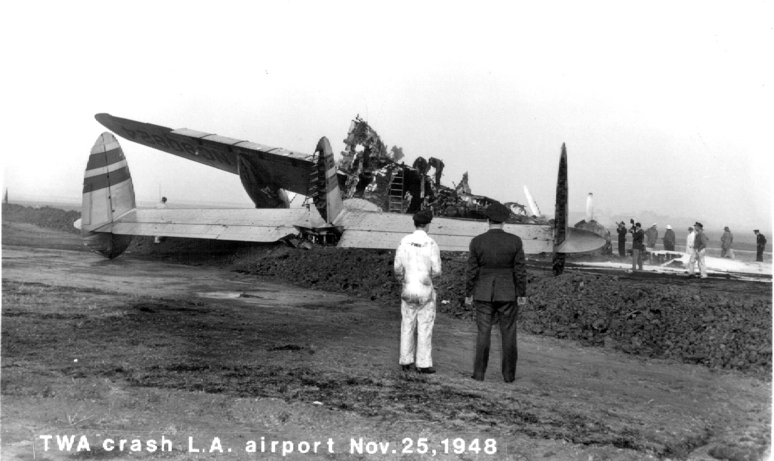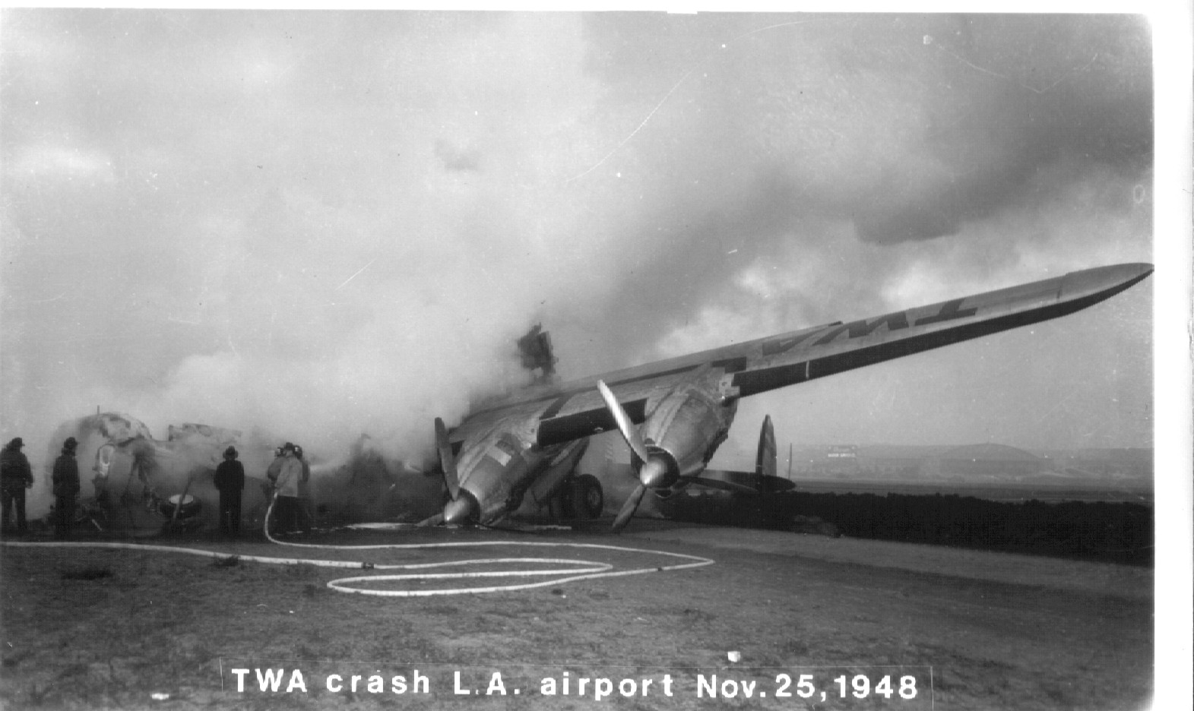
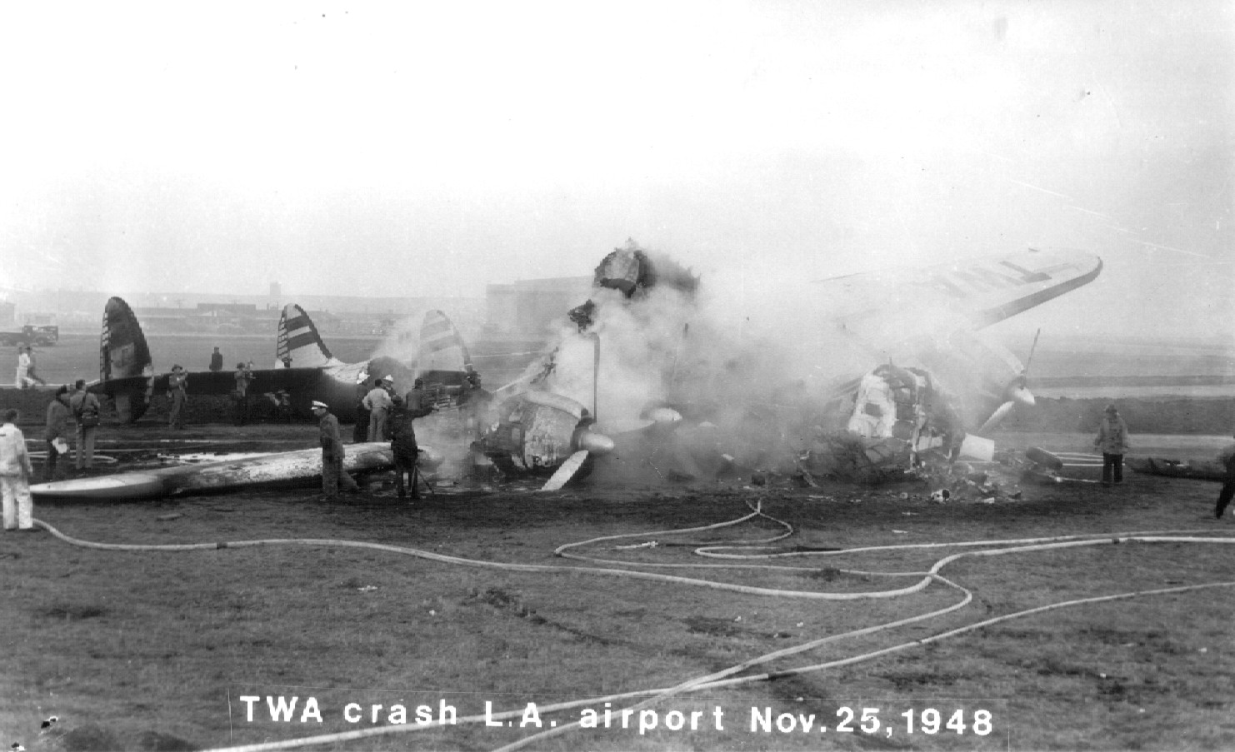
TWA crash at LA, 1948

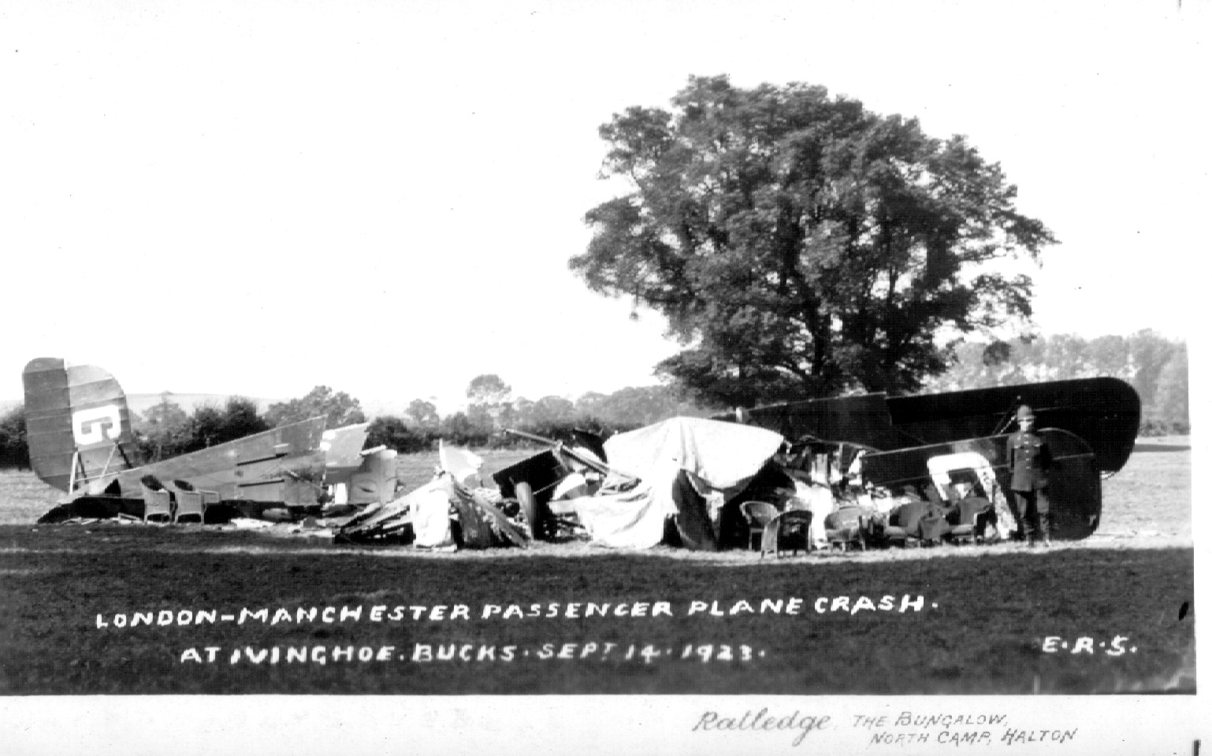
Ivinghoe DH.34 wreck

